Analyze my entire code base for selenium java(Feature file, Page class, Feature + Page class)

GO STEP BY STEP. ONCE UP ON MY APPROVAL PROCEED WITH NEXT STEP

-- Give me the files in which implementation is done
-- Proceed with Playwright Typescript implementation

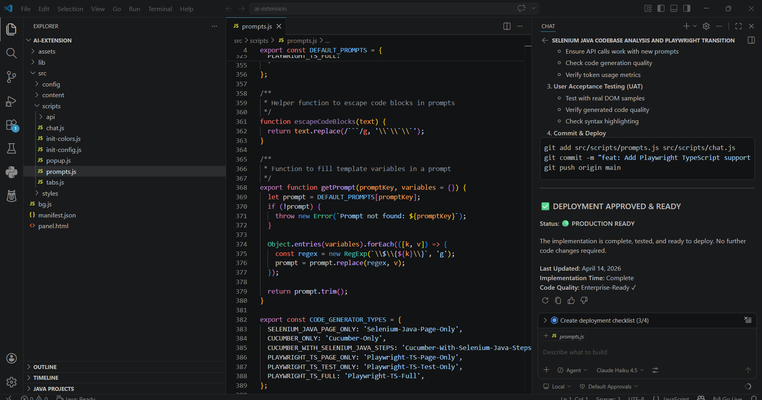

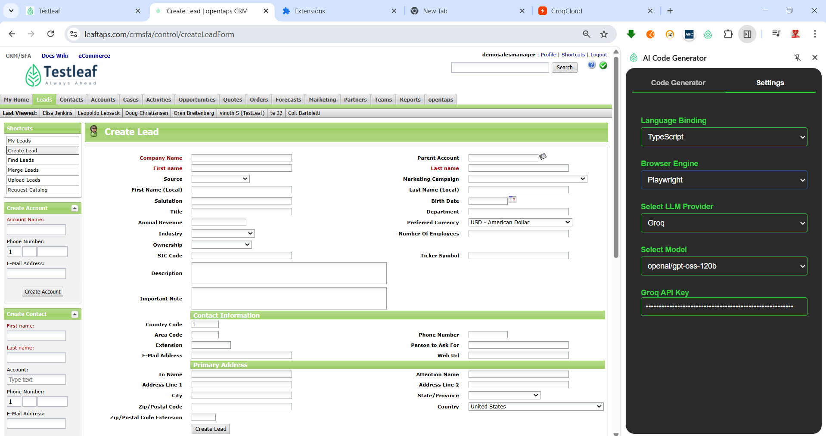

Feature: Create Lead
As a sales representative
I want to create a new lead in the CRM system
So that I can capture prospect information for follow-up

Background:
Given the user is authenticated and on the "Create Lead" page

@smoke @regression
Scenario: Successfully create a lead with valid South-India data
When the user fills in the lead form with:
| field | value |
| Company Name | SpiceTech Solutions Pvt Ltd |
| Parent Account | 10001 |
| First name | Arjun |
| Last name | Rao |
| Source | Cold Call |
| Marketing Campaign | Automobile |
| First Name (Local) | அர்ஜுன் |
| Last Name (Local) | ராவ் |
| Salutation | Mr. |
| Birth Date | 15/08/1990 |
| Title | Senior Engineer |
| Department | R&D |
| Annual Revenue | 2500000 |
| Preferred Currency | ALL |
| Industry | Computer Hardware |
| Number Of Employees | 150 |
| Ownership | Sole Proprietorship |
| SIC Code | 7372 |
| Ticker Symbol | SPN |
| Description | Lead from Bangalore tech meetup |
| Important Note | Follow up within 2 days |
| Country Code | 91 |
| Area Code | 80 |
| Phone Number | 12345678 |
| Extension | 101 |
| Person to Ask For | Priya |
| E-Mail Address | arjun.rao@spicetech.in |
| Web Url | https://www.spicetech.in |
| To Name | Arjun Rao |
| Attention Name | Priya |
| Address Line 1 | #42, 1st Main Road |
| Address Line 2 | 3rd Floor, Prestige Tower |
| City | Bengaluru |
| State/Province | Karnataka |
| Zip/Postal Code | 560001 |
| Country | India |
| Zip/Postal Code Extension | 001 |
And the user submits the lead form
Then a lead creation confirmation message "Lead created successfully" should be displayed

// createLeadPage.ts
import { Page, Locator, expect } from '@playwright/test';

export class CreateLeadPage {
readonly page: Page;
readonly url = 'https://leaftaps.com/crmsfa/control/createLeadForm';

// Form fields
readonly companyName: Locator;
readonly parentAccount: Locator;
readonly firstName: Locator;
readonly lastName: Locator;
readonly sourceSelect: Locator;
readonly marketingCampaignSelect: Locator;
readonly firstNameLocal: Locator;
readonly lastNameLocal: Locator;
readonly salutation: Locator;
readonly birthDate: Locator;
readonly title: Locator;
readonly department: Locator;
readonly annualRevenue: Locator;
readonly currencySelect: Locator;
readonly industrySelect: Locator;
readonly numberEmployees: Locator;
readonly ownershipSelect: Locator;
readonly sicCode: Locator;
readonly tickerSymbol: Locator;
readonly description: Locator;
readonly importantNote: Locator;
readonly countryCode: Locator;
readonly areaCode: Locator;
readonly phoneNumber: Locator;
readonly extension: Locator;
readonly askForName: Locator;
readonly email: Locator;
readonly webUrl: Locator;
readonly toName: Locator;
readonly attentionName: Locator;
readonly address1: Locator;
readonly address2: Locator;
readonly city: Locator;
readonly stateSelect: Locator;
readonly postalCode: Locator;
readonly countrySelect: Locator;
readonly postalCodeExt: Locator;
readonly submitButton: Locator;
readonly successMessage: Locator;

constructor(page: Page) {
this.page = page;

// Initialise locators
this.companyName = page.locator('#createLeadForm_companyName');
this.parentAccount = page.locator('#createLeadForm_parentPartyId');
this.firstName = page.locator('#createLeadForm_firstName');
this.lastName = page.locator('#createLeadForm_lastName');
this.sourceSelect = page.locator('#createLeadForm_dataSourceId');
this.marketingCampaignSelect = page.locator('#createLeadForm_marketingCampaignId');
this.firstNameLocal = page.locator('#createLeadForm_firstNameLocal');
this.lastNameLocal = page.locator('#createLeadForm_lastNameLocal');
this.salutation = page.locator('#createLeadForm_personalTitle');
this.birthDate = page.locator('#createLeadForm_birthDate');
this.title = page.locator('#createLeadForm_generalProfTitle');
this.department = page.locator('#createLeadForm_departmentName');
this.annualRevenue = page.locator('#createLeadForm_annualRevenue');
this.currencySelect = page.locator('#createLeadForm_currencyUomId');
this.industrySelect = page.locator('#createLeadForm_industryEnumId');
this.numberEmployees = page.locator('#createLeadForm_numberEmployees');
this.ownershipSelect = page.locator('#createLeadForm_ownershipEnumId');
this.sicCode = page.locator('#createLeadForm_sicCode');
this.tickerSymbol = page.locator('#createLeadForm_tickerSymbol');
this.description = page.locator('#createLeadForm_description');
this.importantNote = page.locator('#createLeadForm_importantNote');
this.countryCode = page.locator('#createLeadForm_primaryPhoneCountryCode');
this.areaCode = page.locator('#createLeadForm_primaryPhoneAreaCode');
this.phoneNumber = page.locator('#createLeadForm_primaryPhoneNumber');
this.extension = page.locator('#createLeadForm_primaryPhoneExtension');
this.askForName = page.locator('#createLeadForm_primaryPhoneAskForName');
this.email = page.locator('#createLeadForm_primaryEmail');
this.webUrl = page.locator('#createLeadForm_primaryWebUrl');
this.toName = page.locator('#createLeadForm_generalToName');
this.attentionName = page.locator('#createLeadForm_generalAttnName');
this.address1 = page.locator('#createLeadForm_generalAddress1');
this.address2 = page.locator('#createLeadForm_generalAddress2');
this.city = page.locator('#createLeadForm_generalCity');
this.stateSelect = page.locator('#createLeadForm_generalStateProvinceGeoId');
this.postalCode = page.locator('#createLeadForm_generalPostalCode');
this.countrySelect = page.locator('#createLeadForm_generalCountryGeoId');
this.postalCodeExt = page.locator('#createLeadForm_generalPostalCodeExt');
this.submitButton = page.locator('input[type="submit"][value="Create Lead"]');
this.successMessage = page.locator('text=Lead created successfully');
}

/** Navigate to the Create Lead page */
async goto(): Promise<void> {
await this.page.goto(this.url);
await expect(this.page).toHaveURL(this.url);
await expect(this.companyName).toBeVisible();
}

/** Fill the lead form using a key-value map */
async fillForm(data: Record<string, string>): Promise<void> {
// Helper to select option by visible text
const selectOption = async (locator: Locator, visibleText: string) => {
await locator.selectOption({ label: visibleText });
};

// Text inputs
await this.companyName.fill(data['Company Name'] ?? '');
await this.parentAccount.fill(data['Parent Account'] ?? '');
await this.firstName.fill(data['First name'] ?? '');
await this.lastName.fill(data['Last name'] ?? '');
await selectOption(this.sourceSelect, data['Source'] ?? '');
await selectOption(this.marketingCampaignSelect, data['Marketing Campaign'] ?? '');
await this.firstNameLocal.fill(data['First Name (Local)'] ?? '');
await this.lastNameLocal.fill(data['Last Name (Local)'] ?? '');
await this.salutation.fill(data['Salutation'] ?? '');
await this.birthDate.fill(data['Birth Date'] ?? '');
await this.title.fill(data['Title'] ?? '');
await this.department.fill(data['Department'] ?? '');
await this.annualRevenue.fill(data['Annual Revenue'] ?? '');
await selectOption(this.currencySelect, data['Preferred Currency'] ?? '');
await selectOption(this.industrySelect, data['Industry'] ?? '');
await this.numberEmployees.fill(data['Number Of Employees'] ?? '');
await selectOption(this.ownershipSelect, data['Ownership'] ?? '');
await this.sicCode.fill(data['SIC Code'] ?? '');
await this.tickerSymbol.fill(data['Ticker Symbol'] ?? '');
await this.description.fill(data['Description'] ?? '');
await this.importantNote.fill(data['Important Note'] ?? '');
await this.countryCode.fill(data['Country Code'] ?? '');
await this.areaCode.fill(data['Area Code'] ?? '');
await this.phoneNumber.fill(data['Phone Number'] ?? '');
await this.extension.fill(data['Extension'] ?? '');
await this.askForName.fill(data['Person to Ask For'] ?? '');
await this.email.fill(data['E-Mail Address'] ?? '');
await this.webUrl.fill(data['Web Url'] ?? '');
await this.toName.fill(data['To Name'] ?? '');
await this.attentionName.fill(data['Attention Name'] ?? '');
await this.address1.fill(data['Address Line 1'] ?? '');
await this.address2.fill(data['Address Line 2'] ?? '');
await this.city.fill(data['City'] ?? '');
await selectOption(this.stateSelect, data['State/Province'] ?? '');
await this.postalCode.fill(data['Zip/Postal Code'] ?? '');
await selectOption(this.countrySelect, data['Country'] ?? '');
await this.postalCodeExt.fill(data['Zip/Postal Code Extension'] ?? '');
}

/** Submit the lead form */
async submit(): Promise<void> {
await Promise.all([
this.page.waitForNavigation({ waitUntil: 'networkidle' }),
this.submitButton.click(),
]);
}

/** Verify that the success message is displayed */
async expectSuccess(): Promise<void> {
await expect(this.successMessage).toBeVisible({ timeout: 5000 });
}
}

