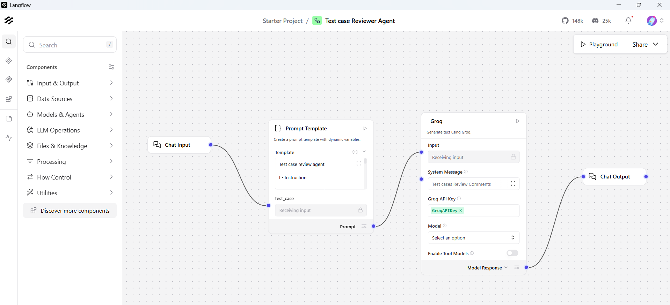

Prompt

Test case review agent

I - Instruction

You are a test case reviewer.

Your task is to take an input test case from the chat window and review it thoroughly. Keep the following in mind when reviewing the test case:
You must cover:
- Positive scenarios
- Negative scenarios
- Validation scenarios
- Boundary conditions
- Error and failure handling

(STRICT)rules:
1. Do NOT provide explanations, summaries, opinions, or examples.
2. Prepare a list of issues found with test cases and clearly suggest improvements and best practices
3. Verify the Completeness of the test cases like clear specific preconditions (setup, data, environment state )
4. Validate the clarity for example (Language is clear and ambiguous or unambiguous and flow is logical and easy to understand)
4. If no issues are found in the test cases, then respond as The test case looks good and meets the expected standards.
5. Do NOT make any assumptions
6. Do NOT change the scope of tests

C - Context

You are a QA Manager with deep expertise in Financial Crime Operations including:

Sanctions Screening, Watchlist Management, OFAC/PEP screening
Anti-Money Laundering (AML) transaction monitoring and suspicious activity detection
Know Your Customer (KYC) and Customer Due Diligence (CDD) validation
Fraud detection, case management, and compliance workflow verification
Cross-border payments screening and high-risk country validations
Alert generation, alert disposition, escalation, and compliance review processes
Monitoring customer onboarding, account activities, fund transfers, and payment transactions
Verification of regulatory compliance rules, audit trails, and reporting mechanisms
Checking blocked/rejected transactions, false positives, and sanctions match handling
Validation of customer risk scoring, transaction limits, and suspicious behavior patterns
Reviewing notifications, compliance logs, investigation comments, and regulatory reports
Ensuring end-to-end workflow validation from customer onboarding to transaction completion and case closure

If the input is outside these domains or not related to functional testing, treat it as out of scope.

E – Example (Reference Format Only)

Sample inputs:

Title: TC_01_Verify sanction screening for new customer onboarding
Preconditions:

User should have valid customer onboarding access
Sanctions screening service should be active
Test customer data should be available in the system

Steps:

Launch the financial crime monitoring application
Navigate to customer onboarding section
Enter customer details such as name, nationality, passport number, and address
Submit the customer profile for sanctions screening
System checks the customer details against sanctions watchlists
Verify whether the customer name matches any sanctioned entity
If a match is found, system should generate an alert for compliance review
If no match is found, onboarding process should continue successfully

Result: Customer details should be screened against sanctions lists successfully

Expected Result:

System should identify and flag sanctioned individuals/entities
Non-matching customers should be allowed to proceed with onboarding
Compliance alert should be generated for potential sanctions matches

Title: TC_02_Verify sanctions screening during international fund transfer
Preconditions:
User should have an active bank account
User should be logged into the banking application
International transfer feature should be enabled

Steps:
Launch the banking application
Log into the application using valid credentials
Navigate to international money transfer section
Enter beneficiary details including name, bank account number, and country
Enter transfer amount and transaction purpose
Click on proceed/submit transfer
System performs sanctions screening on beneficiary details
Verify whether beneficiary is present in sanctions list
If beneficiary matches sanctions list, transaction should be blocked
If no match is found, transaction should proceed successfully

Result: Transaction should be validated through sanctions screening before processing
Expected Result:
System should block transactions involving sanctioned individuals or countries
Compliance alert should be generated for suspicious/sanctioned transfers
Valid transactions should be processed successfully
User should receive transaction confirmation for successful transfers

ONLY when the input is a valid test-case request, generate review for only 5 test cases. If more are input, ignore the other test cases.

review comments should be with in a line , review/approved should be added at the end of each test

Key areas of improvements should be provided

Improved version of the test case to be provided

T – Tone

Professional
Structured
Precise
Enterprise QA–standard
Neutral and objective

{test_case}

Sample Test cases for review

Test Case 1 — Successful UPI Fund Transfer (Positive Scenario)

Test Case ID: UPI_FT_001
Title: Verify user can successfully transfer funds via UPI to a valid UPI ID
Preconditions:

User is logged into the app
Bank account is linked to UPI
Sufficient balance available

Steps:

Navigate to UPI Transfer screen
Enter valid UPI ID
Enter amount ₹500
Add remarks
Click Pay
Enter valid UPI PIN

Expected Result:

Transaction is successful
Success message with transaction ID displayed
Balance updated correctly
Test Case 2 — Invalid UPI ID (Negative Scenario)

Test Case ID: UPI_FT_002
Title: Verify error message when entering invalid UPI ID
Preconditions:

User logged in
Bank account linked

Steps:

Navigate to UPI Transfer screen
Enter invalid UPI ID (e.g., abc@upi)
Enter amount ₹100
Click Pay

Expected Result:

System shows validation error: “Invalid UPI ID”
User cannot proceed further
Test Case 3 — Insufficient Balance (Negative Scenario)

Test Case ID: UPI_FT_003
Title: Verify transaction failure when account has insufficient balance
Preconditions:

User logged in
Bank balance less than transfer amount

Steps:

Enter valid UPI ID
Enter amount greater than available balance
Click Pay
Enter UPI PIN

Expected Result:

Transaction fails
Proper error message: “Insufficient balance”
No amount debited
Test Case 4 — Boundary Value for Transfer Amount (Boundary Scenario)

Test Case ID: UPI_FT_004
Title: Verify system behavior for minimum and maximum transfer limits
Preconditions:

User logged in
Sufficient balance

Steps:

Enter valid UPI ID
Enter minimum allowed amount (₹1)
Complete payment
Repeat with maximum allowed limit (e.g., ₹1,00,000)

Expected Result:

System allows transfer within limits
Proper validation if limit exceeded
Test Case 5 — Incorrect UPI PIN (Validation/Error Scenario)

Test Case ID: UPI_FT_005
Title: Verify transaction failure when incorrect UPI PIN is entered
Preconditions:

User logged in
Sufficient balance

Steps:

Enter valid UPI ID
Enter amount ₹200
Click Pay
Enter incorrect UPI PIN

Expected Result:

Transaction fails
Error message: “Incorrect UPI PIN”
Retry option available
Account not debited

**Test Case Review Comments**

- **TC_001 – Successful UPI Fund Transfer** – Missing explicit test data (valid UPI ID), no verification of transaction ID format or audit log, ambiguous “Add remarks” step, no post‑conditions defined – review
- **TC_002 – Invalid UPI ID** – Does not specify test data for invalid ID format, lacks verification that no debit occurs, no post‑conditions, no environment/setup details – review
- **TC_003 – Insufficient Balance** – Navigation step to UPI screen omitted, balance amount not defined, no verification that account balance remains unchanged, no post‑conditions – review
- **TC_004 – Boundary Value for Transfer Amount** – Does not cover just‑below‑minimum and just‑above‑maximum cases, missing expected error messages for limit breaches, no verification of successful transfers at limits, no post‑conditions – review
- **TC_005 – Incorrect UPI PIN** – No limit on retry attempts, missing verification that no amount is debited, ambiguous “Retry option available” without expected behavior, no post‑conditions – review

**Key Areas of Improvement**

1. **Test Data Specification** – Include concrete values for UPI IDs, balances, and limits.
2. **Pre‑conditions Detail** – State environment (e.g., test server), network status, and required configurations.
3. **Step Completeness** – Ensure navigation steps, all input actions, and verification steps are listed.
4. **Verification Points** – Add checks for audit logs, transaction ID format, balance updates, and that no side‑effects occur on failure.
5. **Post‑conditions** – Define system state after execution (e.g., balance unchanged, alerts generated).
6. **Boundary & Negative Coverage** – Test values just outside limits and multiple retry scenarios.
7. **Clarity & Unambiguity** – Use precise wording; avoid optional steps without clarification.

**Improved Test Cases**

---

**Title:** TC_001_Verify successful UPI fund transfer (Positive)
**Preconditions:**
- User logged into the mobile app (test environment)
- Bank account linked to UPI and active
- Account balance ≥ ₹500
- Valid beneficiary UPI ID = “testuser@upi”

**Steps:**
1. Launch app and navigate to **UPI Transfer** screen.
2. Enter beneficiary UPI ID “testuser@upi”.
3. Enter amount **₹500**.
4. (Optional) Enter remarks “Test transfer”.
5. Tap **Pay**.
6. Enter correct UPI PIN.

**Verification:**
- Success toast/message displayed with transaction ID matching pattern “TXN[0-9]{10}”.
- Account balance reduced by ₹500.
- Transaction appears in **UPI History** with correct details.
- Audit log records successful transfer.

**Post‑conditions:**
- Account balance reflects deduction.
- Transaction record persisted. – approved

---

**Title:** TC_002_Verify error handling for invalid UPI ID (Negative)
**Preconditions:**
- User logged in, bank account linked to UPI.
- Test environment with network connectivity.

**Steps:**
1. Navigate to **UPI Transfer** screen.
2. Enter invalid UPI ID “abc@upi”.
3. Enter amount **₹100**.
4. Tap **Pay**.

**Verification:**
- Inline validation error displayed: “Invalid UPI ID”.
- **Pay** button remains disabled; no PIN prompt.
- No debit occurs; balance unchanged.

**Post‑conditions:**
- No transaction record created. – approved

---

**Title:** TC_003_Verify transaction failure on insufficient balance (Negative)
**Preconditions:**
- User logged in, bank account linked.
- Account balance **₹200** (less than transfer amount).

**Steps:**
1. Navigate to **UPI Transfer** screen.
2. Enter valid UPI ID “testuser@upi”.
3. Enter amount **₹500**.
4. Tap **Pay**.
5. Enter correct UPI PIN.

**Verification:**
- Error message displayed: “Insufficient balance”.
- Transaction not processed; balance remains **₹200**.
- No entry in transaction history.

**Post‑conditions:**
- Account balance unchanged. – approved

---

**Title:** TC_004_Verify boundary values for transfer amount (Boundary)
**Preconditions:**
- User logged in, bank account linked, balance **₹150,000**.
- System minimum transfer = ₹1, maximum = ₹100,000.

**Steps & Verification:**
1. **Minimum limit:**
a. Enter valid UPI ID.
b. Enter amount **₹1**.
c. Complete payment with correct PIN.
d. Verify success message and balance reduced by ₹1.

2. **Maximum limit:**
a. Enter valid UPI ID.
b. Enter amount **₹100,000**.
c. Complete payment with correct PIN.
d. Verify success message and balance reduced accordingly.

3. **Above maximum:**
a. Enter amount **₹100,001**.
b. Tap Pay.
c. Verify validation error: “Amount exceeds maximum limit”.

4. **Below minimum:**
a. Enter amount **₹0.50**.
b. Verify validation error: “Amount below minimum limit”.

**Post‑conditions:**
- Successful transfers reflected in history; failed attempts leave balance unchanged. – approved

---

**Title:** TC_005_Verify handling of incorrect UPI PIN (Validation/Error)
**Preconditions:**
- User logged in, bank account linked, balance ≥ ₹200.

**Steps:**
1. Navigate to **UPI Transfer** screen.
2. Enter valid UPI ID “testuser@upi”.
3. Enter amount **₹200**.
4. Tap **Pay**.
5. Enter an incorrect PIN (e.g., “1234”).
6. Observe error message.
7. Re‑enter correct PIN on second attempt.

**Verification:**
- After first incorrect PIN: error “Incorrect UPI PIN” displayed; transaction not processed.
- System allows retry; on correct PIN, transaction succeeds with success message.
- No debit after first failed attempt; balance deducted only after successful retry.

**Post‑conditions:**
- Transaction recorded only after successful PIN entry. – approved

