

**Faculty of Computing**

IT1120 – Introduction to Programming Year 1 Semester 1 (2024)

Tutorial 01

1. Write a java program to display,
   1. Hello! Welcome to SLIIT

public class WelcomeSLIIT

{

public static void main(String[] args)

{

System.out.print("Hello! Welcome to SLIIT");

}

}

* 1. first line

This is the second line

public class NextLine

{

public static void main(String[] args)

{

System.out.println("first line");

System.out.println("This is the second line");

**OR**

System.out.print("first line\n");

System.out.print("This is the second line");

**OR**

System.out.print("first line\nThis is the second line");

}

}

X

X X

X X

X X

X X

X X

* 1. X

public class DrawCircle

{

public static void main(String[] args)

{

System.out.println(" X");

System.out.println(" X X");

System.out.println("X X");

System.out.println("X X");

System.out.println("X X");

System.out.println(" X X");

System.out.println(" X");

}

}

1. Write pseudo code to solve the below problem

In an experiment, the heights of 5 people were recorded and the average height was computed. Due to negligence the height of two people has been lost. The lab assistant distinctly remembers that the two missing heights were almost the same. You are required to develop a pseudo code solution to input the heights of the known three people and the calculated average. Find and print the missing height.

MAIN

DEFINE **h1, h2, h3, mHeight** AS INTEGER

DEFINE **avg** AS FLOAT

INPUT **h1, h2, h3, avg**

**mHeight = ((avg * 5) - (h1 + h2 + h3)) / 2.0**

PRINT **mHeight**

ENDMAIN

1. The perimeter of a rectangular fence is known. If the width of the fence is ¾ the size of the length of the fence. Write the pseudo code to determine the width and length of the fence. First find the input and output.

MAIN

DEFINE **perimeter, length, width** AS FLOAT

INPUT **perimeter**

**length = perimeter / 3.5**

**width = (3 / 4.0) * length**

PRINT **length, width**

ENDMAIN

1. A rope is used to create a square fence. The length of a side of the square is known. Later this same rope is used to create a circular fence. Write the pseudo code to find the radius of the circular fence.

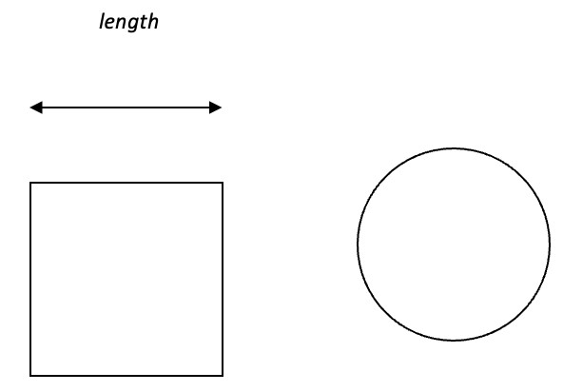

Perimeter of a square = 4 * length

Circumference of circle = 2 * pi * radius

Where pi = 22/7

MAIN

DEFINE **sideLength, radius, circumference** AS FLOAT

INPUT **sideLength**

**circumference = 4 * sideLength**

**radius = circumference / (2 * 22 / 7.0)**

PRINT **radius**

ENDMAIN