Optimisation of image file sizes. Looking through the image files some were rather large – with width (in pixels) greater than 5k – this explained the slow download time. As a first pass I went through all of the image files and made the maximum size around 1000 pixels wide. This made a huge difference.

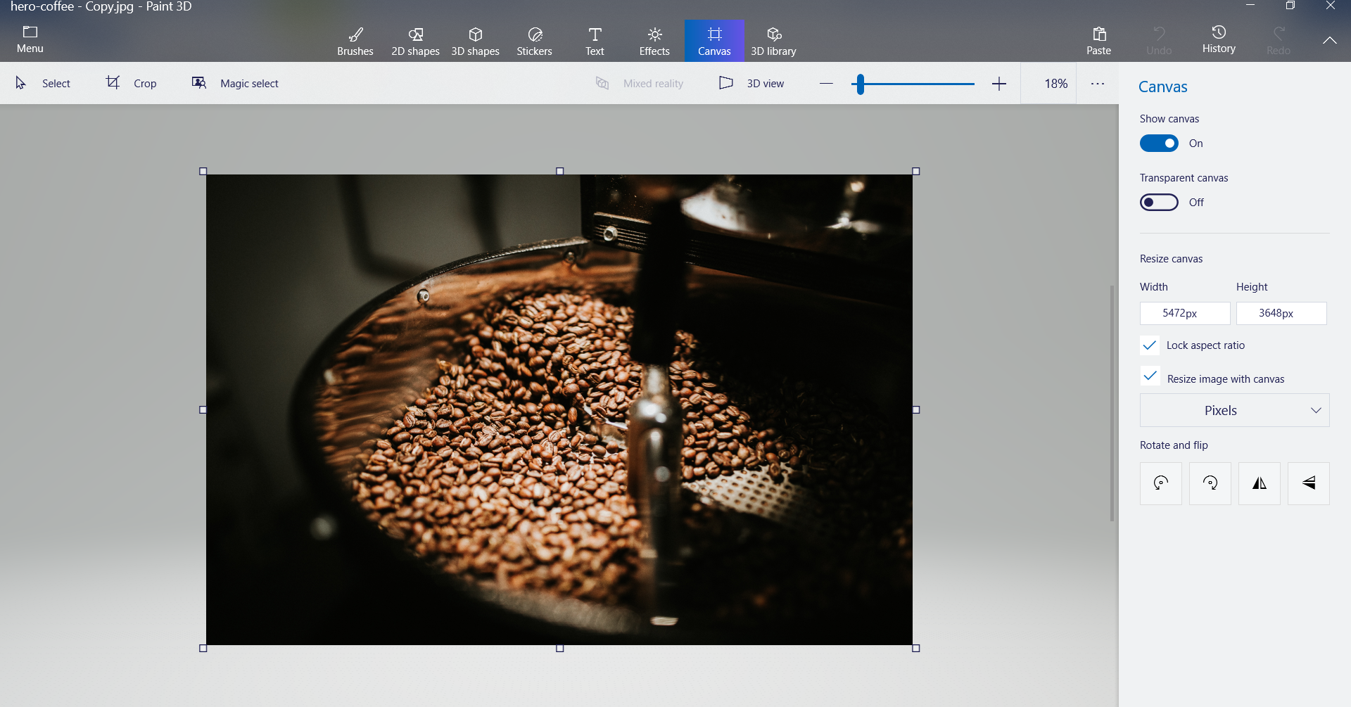

Decreased the file size to a much more reasonable value. We had a lot of images so this was significant. Luckily, it brough the KB down to below 200KB for each file! Big difference. It decreased the file above from over 3MB to 178KB – much better!