# RHO = 0.553523358025: ITERS = 2

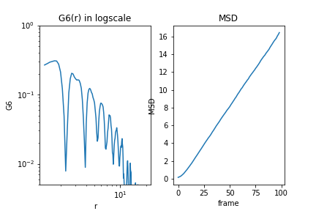

# RHO = 0.557620987654: ITERS = 2

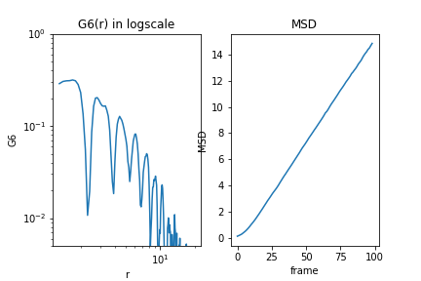

# RHO = 0.560361135802: ITERS = 2

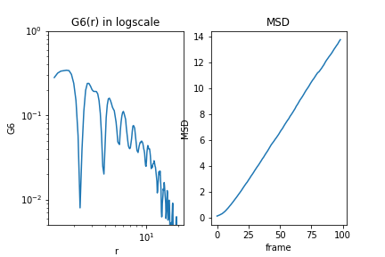

# RHO = 0.564483950617: ITERS = 2

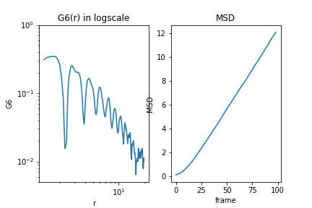

# RHO = 0.567240888889: ITERS = 2

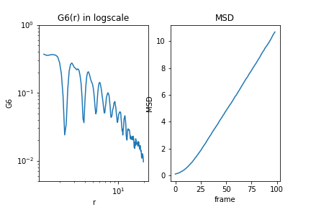

# RHO = 0.571388888889: ITERS = 2

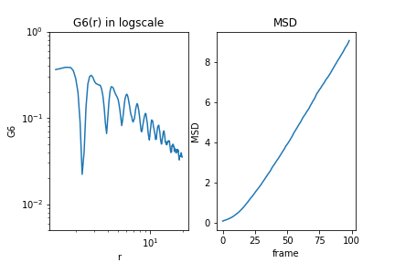

# RHO = 0.574162617284: ITERS = 2

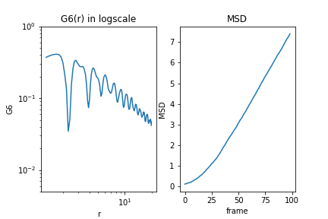

# RHO = 0.576943061728: ITERS = 2

