**ITERATIONS – 0**

PHI - 0.64

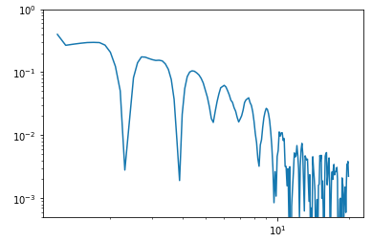

PHI - 0.6724

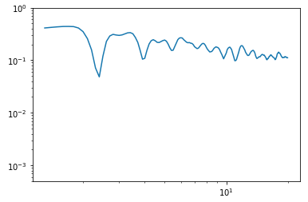

PHI - 0.7056

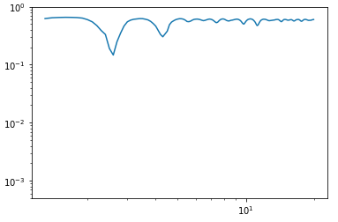

**ITERATIONS – 1**

PHI - 0.580740740741

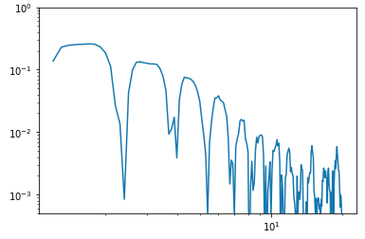

PHI - 0.610140740741

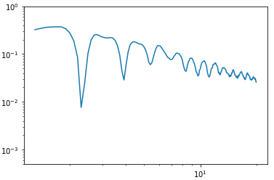

PHI - 0.640266666667

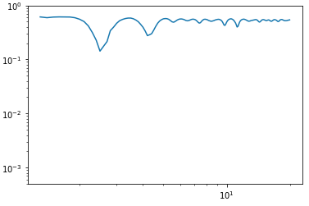

**ITERATIONS – 2**

PHI - 0.554403292181

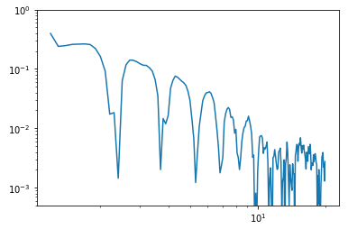

PHI - 0.582469958848

