Global Job Search App Final Report

Deep Patel
Student
Sheridan College
Oakville, Canada
patel795@sheridancollege.ca

Navneet Singh
Student
Sheridan College
Oakville, Canada
sing5831@sheridancollege.ca
Ghassem Tofighi
Faculty of Applied Science & Technology
Sheridan College
Oakville, Canada
ghassem.tofighi@sheridancollege.ca

Students and employers both need a platform to look at the jobs at international level. This app helps both of them to manage the process very easily at international level. There will be no requirement of any 3rd party in between.

Introduction
Students have been struggling to apply for jobs outside of their home country. They don’t have proper guidance to apply for jobs abroad. On the other end, employers also find it very difficult to find the perfect candidates outside of their country. This app makes it easier for both sides to resolve this issue. Similar applications in the current market are Indeed, Glassdoor, Jobs.Sheridan, etc. This app will not have any other party involved in the process. Both sides can contact each other for any queries.
Though many similar apps exist in the current market, no app provides the flexibility to provide the students still in the college to apply for the jobs which relates to them. Students find a lot number of jobs on such apps which makes it very hard for them to filter and then apply for it. This app allows the student to filter the job as per their requirement and then apply for it. They can also easily keep the track of jobs they have applied. Employers also have the same luxury to keep the track of posted jobs.

HCI Principles
Below are some of the concepts which we have considered before designing the interface. The concepts were very useful in many aspects especially when we need to consider the audience and also from core design prospective.

Familiarity – Build on users prior knowledge

Simplicity – Don’t compromise usability for function
GitHub link: https://github.com/patel795/GlobalJobSearchAppPrototype

Support – Place the user in control and provide proactive assistance

Safety – Keep the user out of trouble

Obviousness – Make objects and their controls visible and intuitive

Prototype Design

Requirement Analysis (NeedFinding)
We asked many questions to students during the Need finding stage. End users for this application are students and employers. We even asked some questions to professors since they can be considered as employers if they are hiring any student from college itself. Taking review from them can be very helpful at this time. Questions that we asked:
- What is the most important thing that should be there in a job search tool?
- The app should allow students and employers to keep the track of the jobs applied and posted.
- How can the current available job search apps in the market can be improved?
- By filtering the jobs as more as possible.
- What details matter a lot in job search tool?
- The ability for someone to filter the jobs easily without any problems and apply for it.

As per the feedback from the end users, app should be really user friendly. It should be attractive so that user don’t get bored. Texts and symbols should be similar so that it plays an important role in attracting people. But most importantly, app should be able to use it very easily and conveniently.

Competitive Analysis
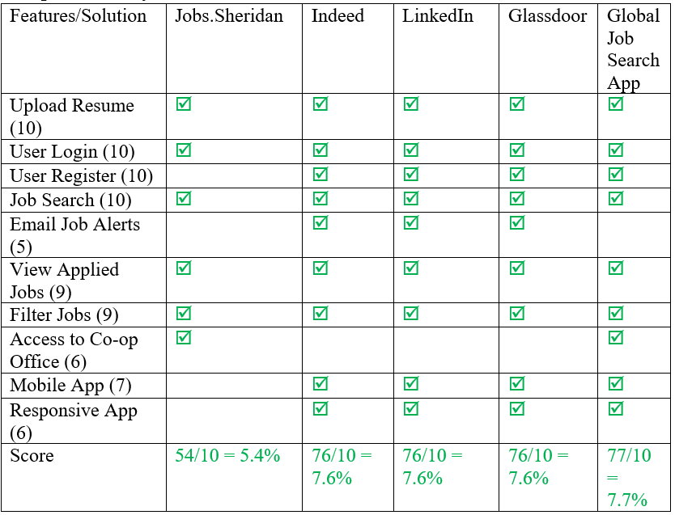
Some issues with competitor’s product:
- Ignoring Different Platforms – Jobs Sheridan is only a web-based application which also has certain responsiveness issues when opened on mobile phones. Indeed Jobs Is also a web application with no separate interface for android or iOS but is much better in terms of responsiveness when opened on any other smartphones web browser.
- No auto-filled customer data – Jobs Sheridan doesn’t allow to auto filter the counties or the programs in which the applicant wants to apply.
- Reporting – The option to report some fake jobs or some fake information is not provided on any of the competing apps.
- Completeness – In order to apply for a job, there should be a process shown that how far a user has completed his application while applying for the jobs. LinkedIn doesn’t have the tracked completeness of the job application.
- Action Context – The user applying for the jobs wants to know if they’ve searched or applied to any other job in the past, competitor’s app doesn’t keep a record of the jobs applied.
- Notifications – Indeed and Jobs Sheridan doesn’t notify whenever there’s a new job posted as per the user’s interests.
- Zooming and Colors – LinkedIn mobile app doesn’t allow to change the size of the reading text nor a user can zoom in or zoom out to read out the job description and other information.

First Initial Prototype Alternatives
Deep Patel’s initial prototype:
https://xd.adobe.com/view/86f343cd-a4d1-4f3f-460a-d7b4bd4c9db2-f0c2/

Navneet Singh’s initial prototype:
https://xd.adobe.com/view/58765c5b-8821-4bed-63c2-50e9c4ae61b7-2e47/

Final Prototype:
https://xd.adobe.com/spec/5631a487-ad85-41af-66ef-36c3efc3365d-2000/grid

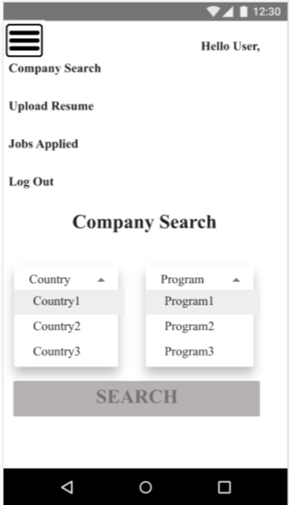

We focused more on simplicity concept of HCI. We tried to keep it as simple as possible. As shown in the screenshot, the app consists of very simple page views and very easy for any user to use it. Student can search for job easily by filtering the categories and clicking on search.
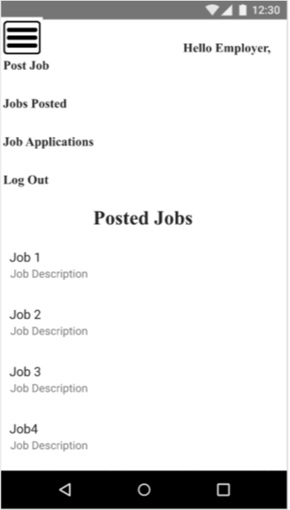

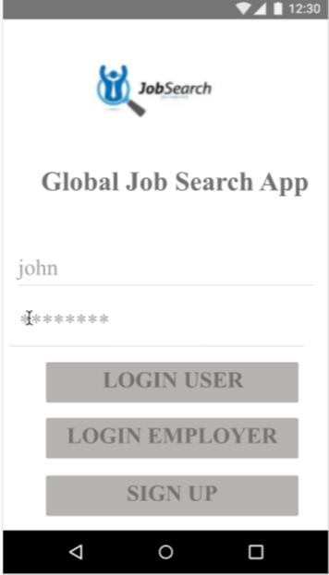

Other HCI concept we used was familiarity. Familiarity basically means building on some prior knowledge. We ourselves are students and who better than students can have a better experience in giving ideas on job search tools. We tried to keep it very simple and convenient as per what students needs.

Prototype evaluation
Scenario:
Imagine you are an employer and need to post the job with job details. On the other hand, also imagine you are a student and need to apply for various jobs.

Tasks:
- Launch URL: https://xd.adobe.com/spec/5631a487-ad85-41af-66ef-36c3efc3365d-2000/
Explore the application and please give your first impression and tell us how did you feel about the prototype?
- You are a new user. You want to sign up as an employer. How will you do it in the current prototype?
- Once you sign up. Try to login as an employer and open the employer post job page.
- Were you able to sign up and then login successfully? What were the complications you faced in doing so?
- You are an employer. You want to post the job with the job details. How will you do it in the current prototype?
- How will you define the simplicity of performing the above task? [Verbal Response]
- Assuming you have already posted many jobs. How will you check the list of posted jobs?
- You are a student. You want to filter the job search and apply for it. How will you do it in the current prototype?
- How will you define the simplicity of performing the above task? [Verbal Response]
- Assuming you have already applied for so many jobs. How will you check the list of applied jobs?
- How was the experience in using the prototype from both (student and employer view). Please mention any good or bad impression regarding the prototype. [Verbal Response]
Post Questions:
- What frustrated you most about this site?
- If you had a magic wand, how would you improve this site?
- What did you like about the site?
- How likely are you to recommend this site to a friend or colleague (0=Not at all likely, and 10=Very likely)?

Usability Analysis
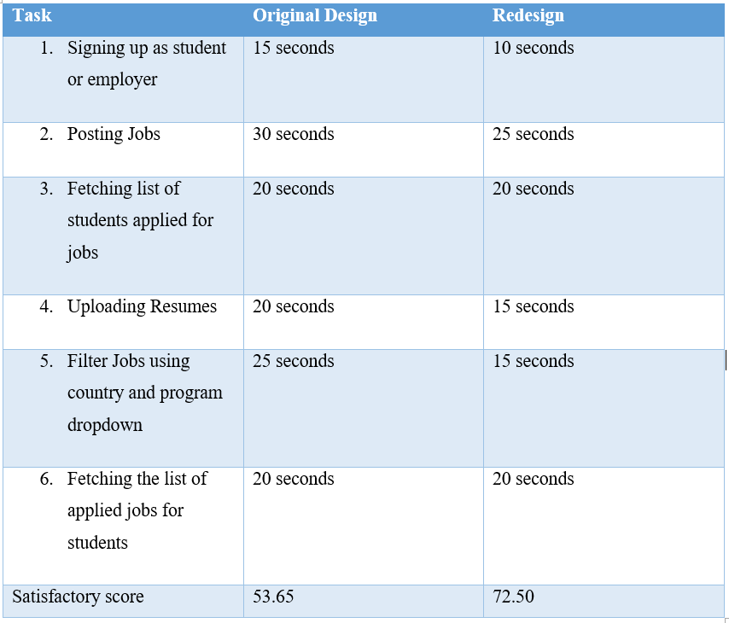
Measuring Success:
- Task 1: relative score 150% (improvement of 50%).

- Task 2: relative score 120% (improvement of 20%).
- Task 3: relative score 100% (improvement of 0%).
- Task 4: relative score 133% (improvement of 33%).
- Task 5: relative score 166% (improvement of 66%).
- Task 6: relative score 100% (improvement of 0%).
Geometric Mean of above scores is 125.85 which shows that there is an improvement of 25.85%
Summarizing Results:
Geometric mean averages the set of scores as: sqrt (1.25 * 1.35) = 1.29. This means that new design scores 129% compared with the baseline score of 100% for the control condition. The new design thus has 29% higher usability than the old one.
Report Feedback Analysis:
Signing up as student or employer: It was very straight forward for both the testers. Both were quite obvious of what the app is all about in the first thought that it is a job tool. Both testers had no issue regarding that.
Posting Jobs: Initially, one of the testers took some time to understand the concept of posting job. However, both of them were able to eventually understand and post the job. One of the tester suggested to add more filters to make it more attractive.
Fetching list of students applied for jobs: This task was very easy to implement since it is accessed directly from menu bar on top left. They mentioned it was quite obvious what the functionality is about and how to access it. However, they suggested to add some more css colour which is quite obvious will be applied in the final product.
Uploading Resumes: This feature can be accessed from many places for student part. It can be accessed from menu bar at top left. It can also be opened if you click on apply job from job search page. Testers were able to understand it easily and were able to know the importance of the page.
Filter Jobs using country and program dropdown: This functionality is very important from both student and employer aspect. Testers were able to understand the importance. However, they suggested to add more filters which would make it more valuable.
Fetching the list of applied jobs for students: This task is also straightforward like fetching list of students. Even testers were able to find it easily. List can be fetched from top left menu bar.

Revised Prototype

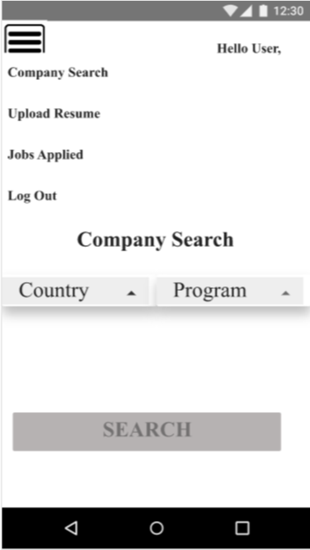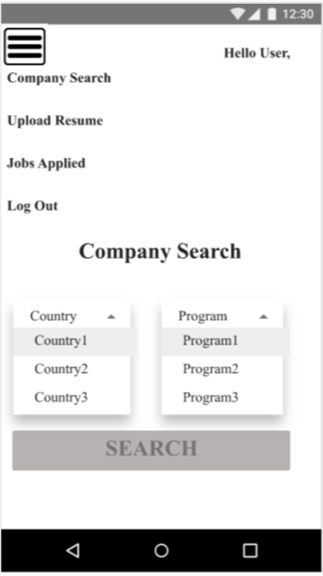
The final prototype link which we have mentioned above in this doc is our revised prototype. We decided to make the filters open and close when user clicks on it.

Future works & Conclusions
After getting the feedback from user testing testers, we will try to add some css to the design to even make the app more attractive. We will also try to put some hints to follow the steps in order to make it easier for tester to test the prototype.
In conclusion, people found it very simple and convenient to test. Functionality is quite simple and there is no complex tasks to do. Maybe next time, we will try to add even more filters to allow the users to filter it more deeply. Also, we will try to include proper instructions in the app as we progress.

References
- Branscomb, L. M., & Thomas, J. C. (1984). Ease of use: A system design challenge. IBM Systems Journal, 23(3), 224–235. doi: 10.1147/sj.233.0224
- Finstad, K. (2013). Response to commentaries on The Usability Metric for User Experience. Interacting with Computers, 25(4), 327–330. doi: 10.1093/iwc/iwt005
- Patnaik, D., & Becker, R. (2010). Needfinding: The Why and How of Uncovering Peoples Needs. Design Management Journal (Former Series), 10(2), 37–43. doi: 10.1111/j.1948-7169.1999.tb00250.x

[4] “About Indeed: Indeed.com” Indeed.com/about,
12 Dec 2019.
[5] “About Us. (n.d.)” Glassdoor.com/about-us/, 12
Dec 2019
[6] “Jobs.Sheridan (n.d.)” Jobs.Sheridancollege.ca/,
12 Dec 2019

