**Web Development Test**

**Folder Structure**

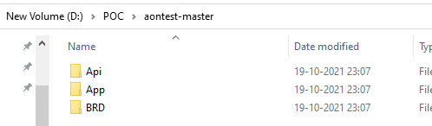

* Api 🡪 .Net 5 based Api
* App 🡪 Angular SPA
* BRD 🡪 Requirements given by AON

**Prerequisite**

* .Net 5, Node js, Visual Studio

**Running Api Application**

* Navigate inside the Api folder and open the ***PopulationAnalyzer.sln***
* It will open the solution in Visual Studio

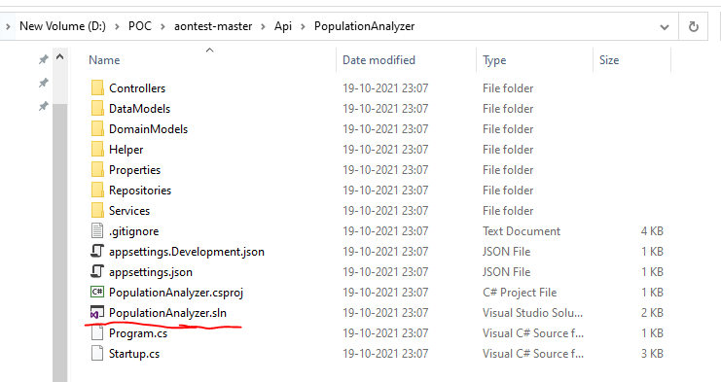

* Open the appSettings.json file and make sure the DataFilePath is as per your local machine. The file can be found under “Api” folder.

Eg: DataFilePath: “D:\\POC\\aontest-master\\Api\\populationData.csv”

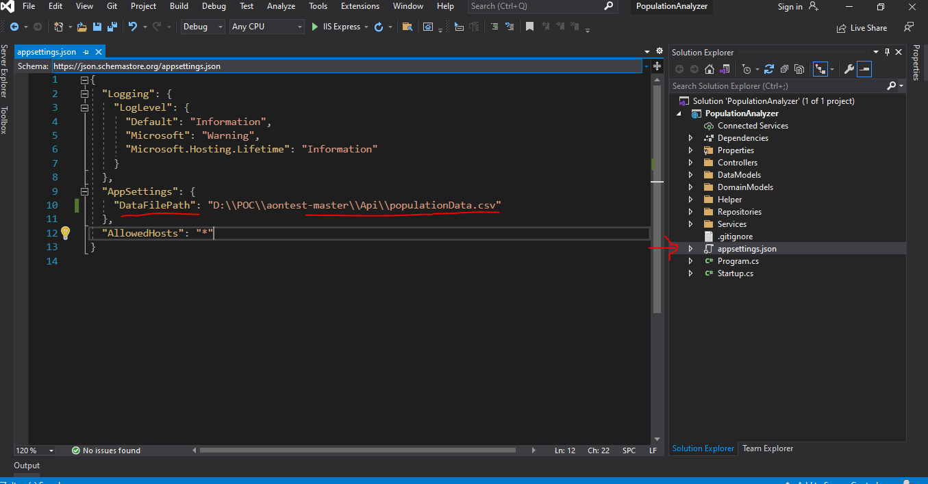

* Run the solution

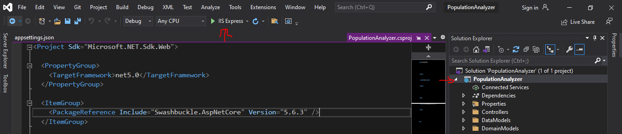

* Once after building successfully, it will launch the api in browser as <https://localhost:44396/swagger/index.html> . Verify whether you were able to see the screen as below.

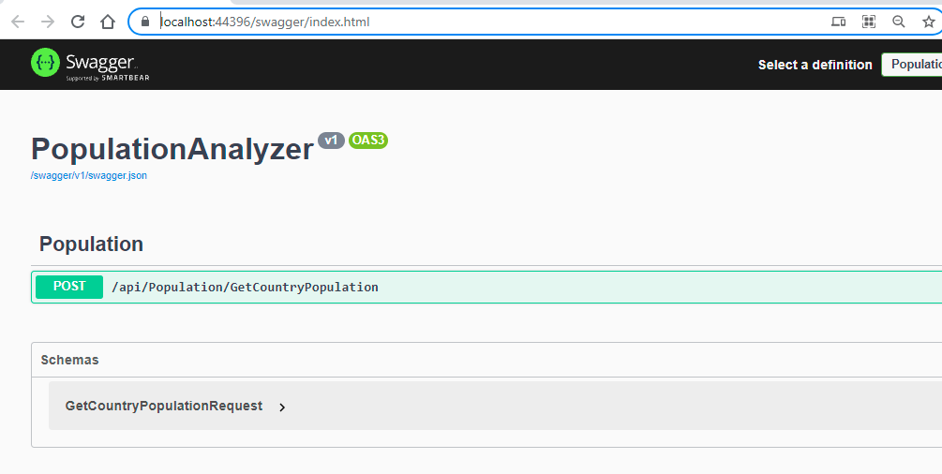

* Verify the Api response by clicking ***try it out*** in swagger as below.

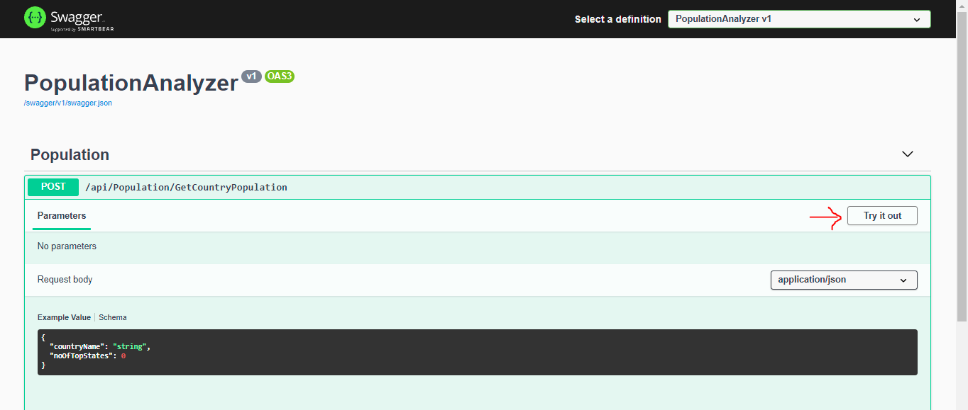

* Update the request parameter as below and click execute

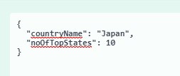

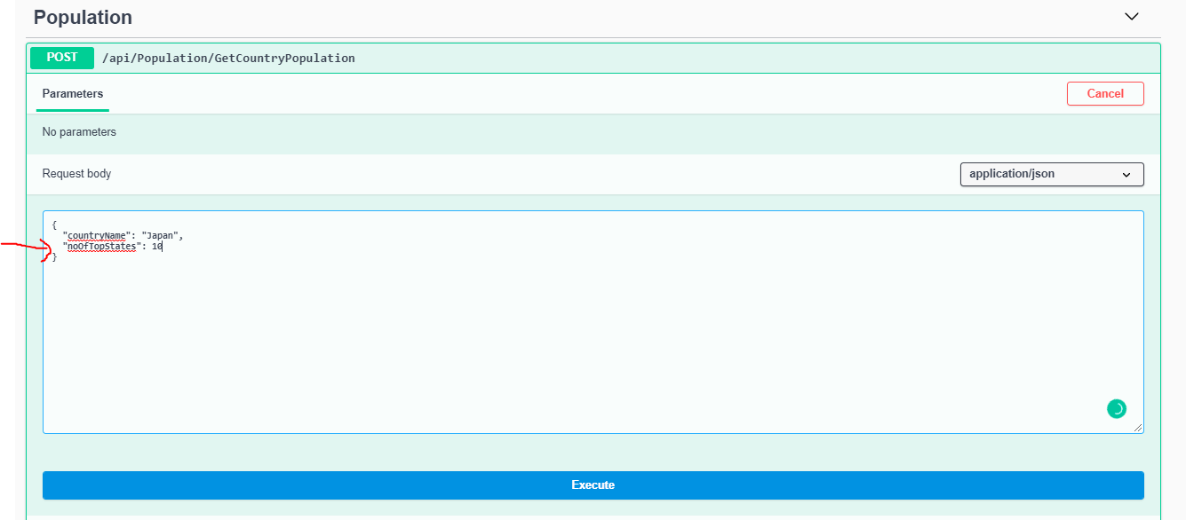

* Verify and make sure the response as below. Great now the api is ready.

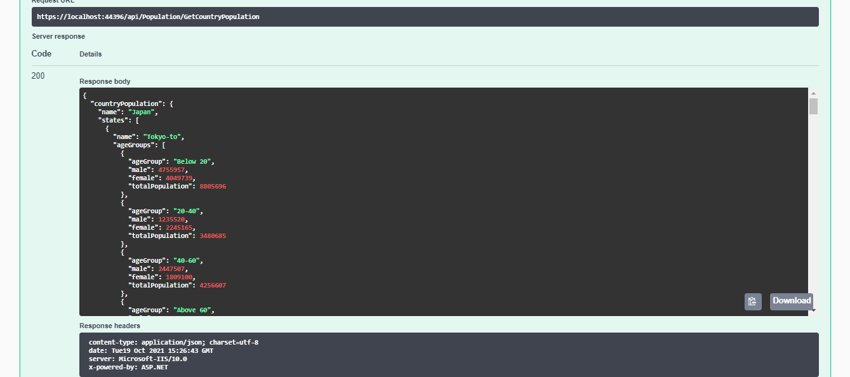

**Running SPA**

* Open command prompt in the root of “AonNG” under “App” folder as below. Make sure Nodejs installed already.

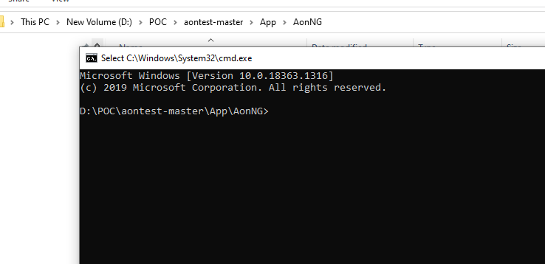

* Run “***npm install***” on the root of the “AonNG” folder. It will install all dependencies.

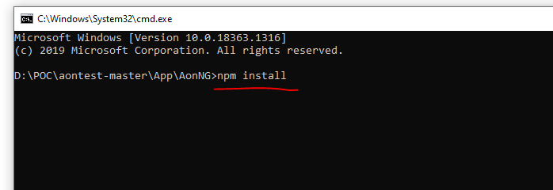

* Verify the installation completion status. The terminal will look like below.

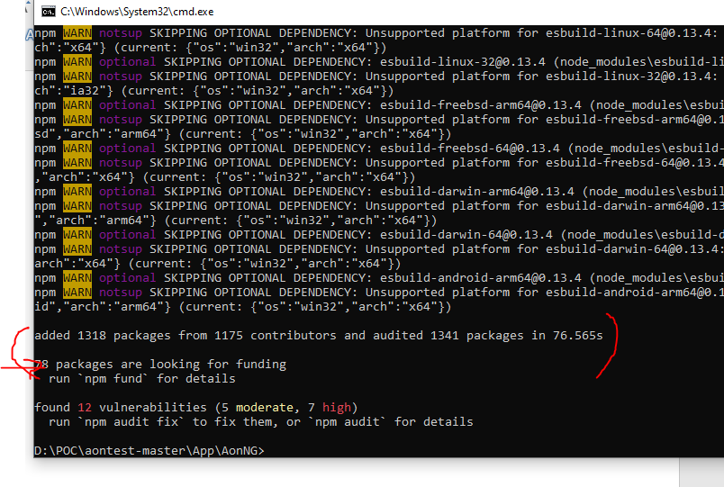

* Run “***npm run start***” command in the same folder path. It will start building the application

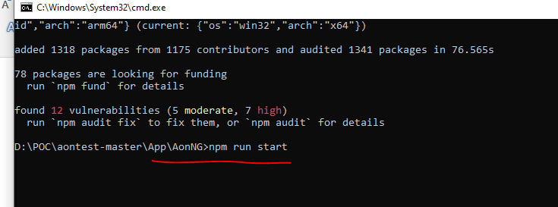

* After few minutes you will be able to see build completion and the application url as below

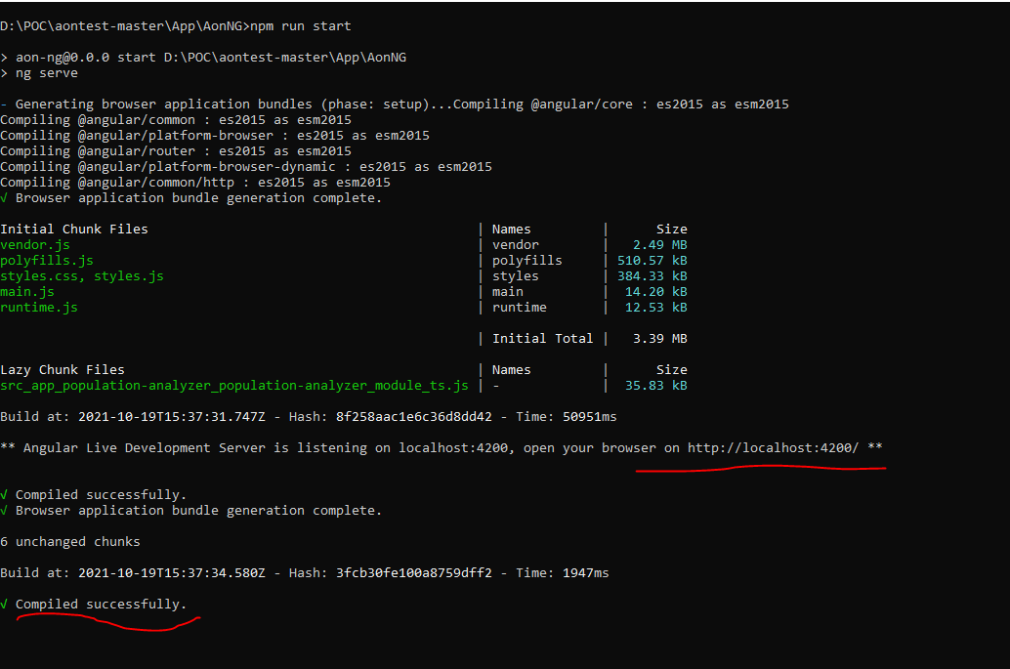

* Open the url in browser <http://localhost:4200/>

The web page will appear as below

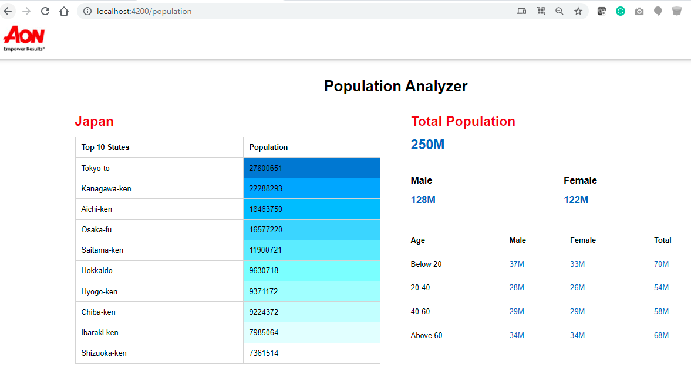

* Great now the UI also running. On mouser over on the states, you shall see the respective state’s data.

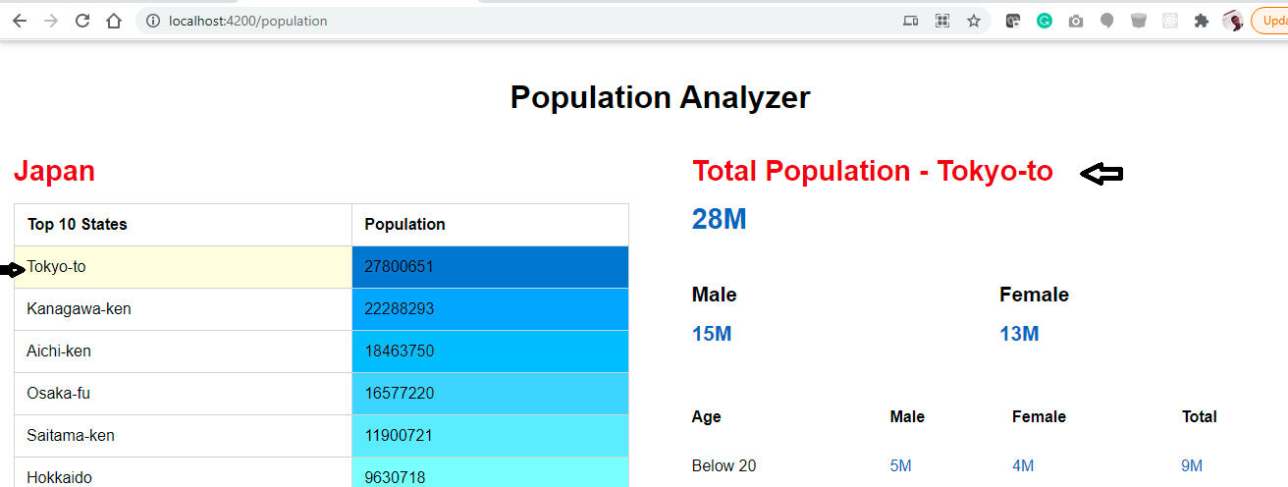

* For quick testing purpose, by default the Front-end app configured to run from fake Backend(json). Please verify whether you were able to run the apps in respective ports.
  + **API🡪** <https://localhost:44396/swagger/index.html>
  + **SPA 🡪** <http://localhost:4200/>
* If the apps are running in preconfigured ports, please procced to ***environment.ts*** file. Which can be find under “AonNG/src/environments” folder as below.

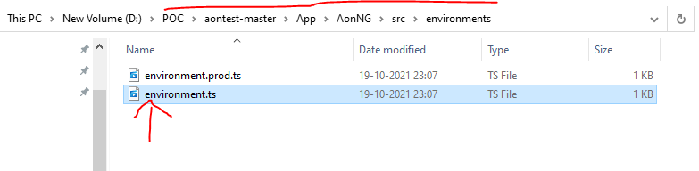

* Open the “***environment.ts***” file in notepad and update the “***IsEnableFakeBackend***” as false.

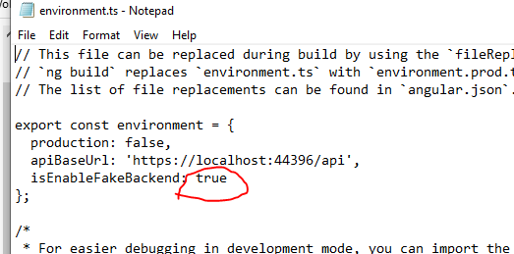

* Save and close the “***environment.ts”*** file. After saved successfully, the web page will reload. Now the SPA is fully integrated with API.

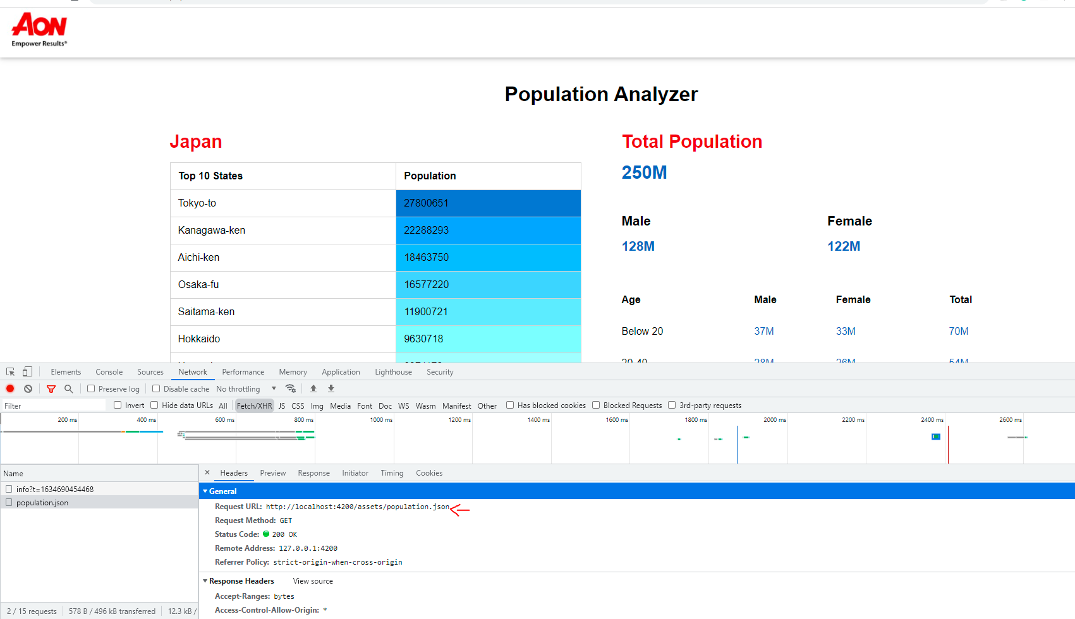

**Note:**

Source code available on GitHub as well.

https://github.com/singara-velan/aontest