Azure Essentials

Welcome to the course, **Azure Essentials!**

In this course, we will explore the broad range of ***services offered by Azure*** and deep dive into few of services that you can use for your applications.

**Azure Essentials** is the first of the series of courses on **Azure**. Have a great learning!

Please note that this course has been curated using the materials/resources received through our partnership with Microsoft. Hence, you could see that the content for this course has been taken from [Microsoft official sites](https://openedx.microsoft.com/).

##### What is Microsoft Azure?

Microsoft Azure is a set of unified cloud services, which help IT professionals and developers to **build, deploy** and **manage applications** through the global network of Azure data centers.

Watch this video to get a big picture of Window Azure!

##### Overview of Azure Services

**Azure provides cloud services** that can be used to design and implement your customized cloud solution and infrastructure. They allow you to:

* Migrate on-premises datacenter to Azure cloud
* Deploy cloud-based applications
* Host workload in the Azure cloud
* Integrate Azure cloud services with an on-premises infrastructure

Azure cloud services can be categorized as **Compute**, **Network**, **Data and Storage**, **App Services**, etc. These are few to name and there are much more to help with **Identity and Access Management**, **Automation**, **Security**, **Availability**, etc.

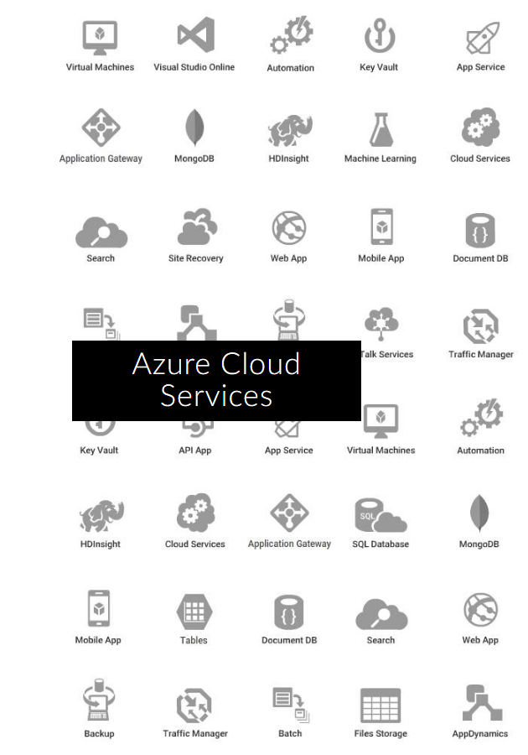

##### Azure as IaaS (Infrastructure as a Service)

Allows the user to **access, manage and monitor the data centers**. Thus, giving **complete control**of the OS and the application platform stack to the developers.

* The virtual machine can be completely modified to meet business requirements.
* IaaS facilitates efficient **design time portability**. Hence an application can be migrated to Mirosoft Azure without rework.
* IaaS allows a **quick transition of services to cloud**, which helps the vendors to offer services to their clients easily.

IaaS is perfect for the applications where complete control is required.

##### Azure as PaaS (Platform as a Service)

The client is provided with the **platform to develop and deploy software**, without having to think about hardware and infrastructure. It takes cares of most of the OS, servers and networking issues.

***PaaS is fast*** with less hassle for developers; applications can go from idea to availability more quickly.

***PaaS is cost-effective*** with lower upfront investment and less admni / management work for organizations.

***PaaS lowers risk*** as platform is upto date with latest technology stack and tools for automation.

Azure as SaaS (Software as a Service)

**Software as a service (SaaS)** allows users to connect to and use cloud-based apps over the Internet, such as Office365.

SaaS customers use the software running on the provider’s infrastructure. SaaS is also referred as **software delivered over the web**.

**Advantages:**

* Gained access to sophisticated enterprise applications
* Pay only for what you use
* Use free client software
* Mobilise your workforce easily
* Access app data from anywhere

Azure is backed by a **global network of data centers** that aims to meet global customer needs, ensure high application performance and maintain availability.

##### Accessing Azure

Azure can be accessed and managed through:

* Azure Classic Portal
* Azure ARM portal
* Azure Resource Manager
* Client Tools like
  + PowerShell
  + Azure CLI
  + Visual Studio with Azure SDK for .NET

##### Azure Classic Portal

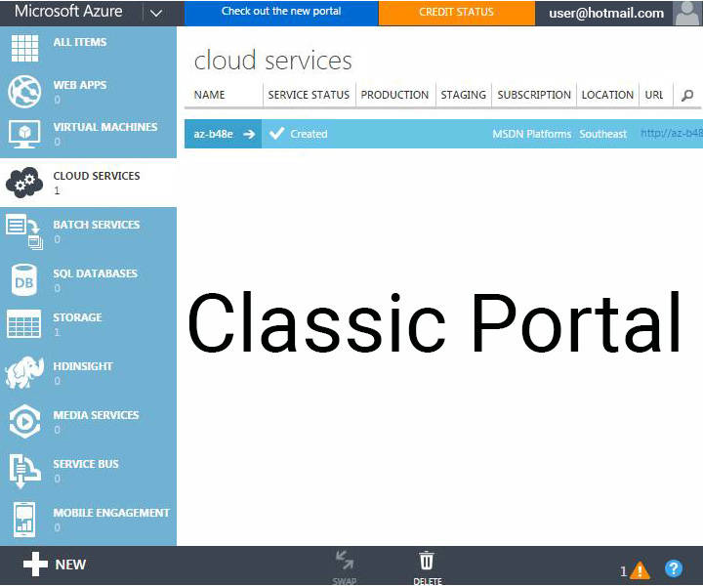

This was the first portal in Azure that was being used before the launch of Azure Resource Manager (ARM). It was based on the **Service Management model** and provides **limited Role-Based Access Control (RBAC) support**.

Azure Resources Manager

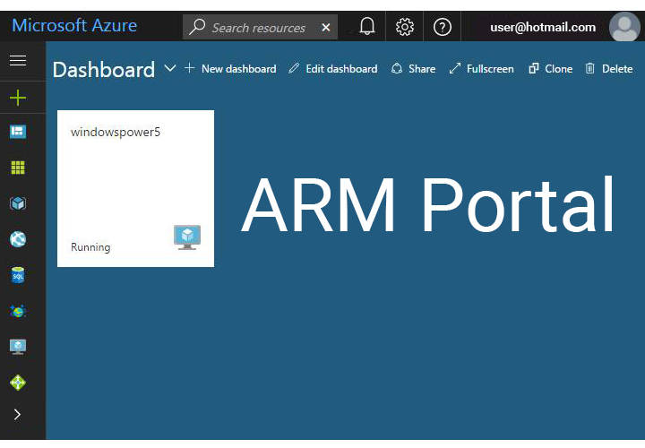

***Azure Resources manager (ARM portal)*** is now the default portal for Azure cloud services management. It supports new features like:

* Templates based deployments
* Role-based Access Control (RBAC)
* Customized dashboards to view key resources

##### Client Tools

While Azure portals provide a GUI for managing your Azure subscriptions and services, in some scenarios, these portals may not offer the most optimal management capabilities.

For teams that want to **perform service management in an automated fashion** by using REST API and creating scripts for repetitive or cumbersome administrative tasks, Azure offers options like:

* **Azure PowerShell modules** - to run scripts from Windows.
* **Azure command-line interface (CLI)** - to run scripts on all operating systems like Windows, Linux, and iOS.

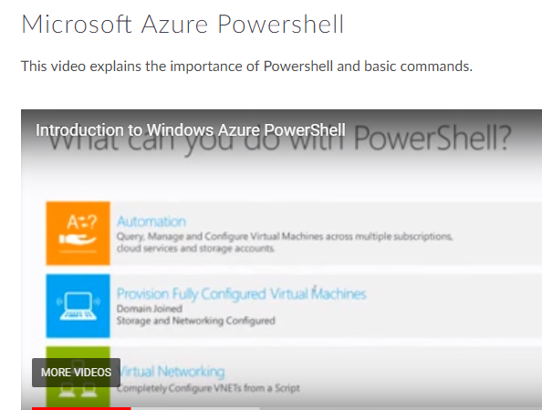

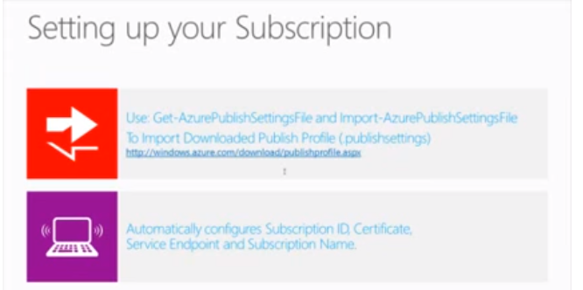

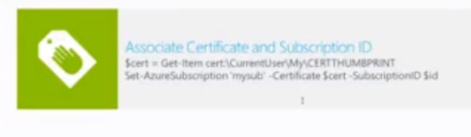

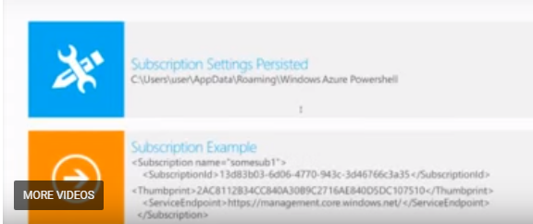

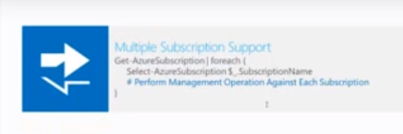

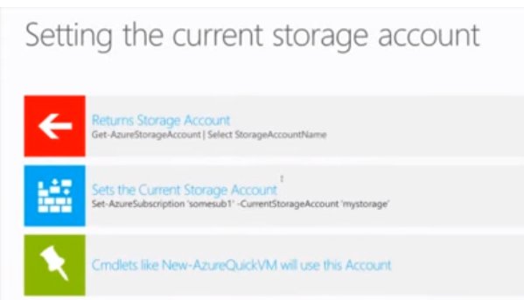

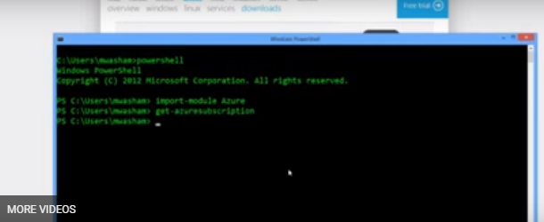

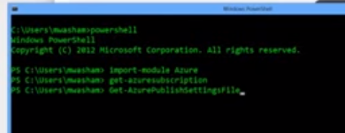

##### Azure Network Services

**Microsoft Azure Network Services** offer the foundation for developing hybrid cloud solutions with the help of following essential resources.

* **Azure Virtual Network**: Isolated network within the Microsoft Azure cloud.
* **Azure Traffic Manager**: Controls how user traffic is distributed between geographies in cloud services.
* **Name Resolution Service**: For internal hostname resolution within a cloud service.
* **Azure ExpressRoute**: Extend on-premises networks into the virtual network over a dedicated private connection facilitated by a connectivity provider.
* **Application Gateway**: works at the application layer and acts as a reverse-proxy service, terminating the client connection and forwarding requests to back-end endpoints.

##### What is Virtual Network?

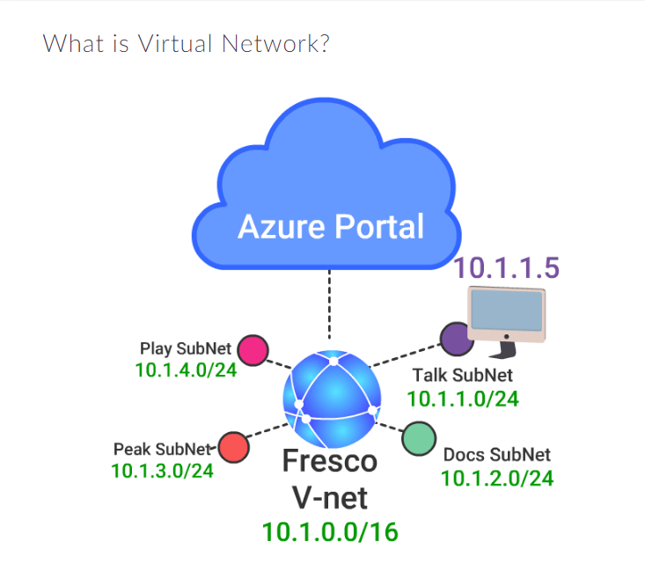

Virtual Network, also known as a **VNet** constitutes a **logical boundary defined by a private IP address space** that you designate. You can distribute IP address space into one or more subnets. ***This makes it functionally equivalent to on-premises networks.***

VNets are similar to AWS VPC (Virtual Private Cloud), offering various networking features like the **ability to customize inter-VM connectivity, Virtual Private Networks (VPN), access control, DNS, routing, and DHCP blocks**.

##### Why Virtual Network?

Azure Virtual Network allows to **securely connect cloud infrastructure to your on-premises datacenter**.

* Virtual Networks allow to set up a virtual lab in the cloud by enabling connectivity to on-premises resources with the help of **Point-To-Site** and **Site-to-Site** VPN connections.
* Virtual Network also acts as a DHCP server, which allows configuring a **DNS server** to be leased out when a virtual machine is a spin up in the cloud.

##### VNet Capabilities

* **Isolation** - VNets are isolated from one another. One can create **separate VNets for development, testing, and production** that use the same CIDR address blocks.
* **Internet Connectivity** - By default, all Azure Virtual Machines (VM) and Cloud Services role instances are connected to a VNet and have access to the Internet.
* **VNet Connectivity** - VNet to VNet gateway needs to be configured to establish a connection between VNets.
* **On-premises Connectivity** - VNets can be connected to on-premises networks through **point to site, site to site**.
* **Azure Resource Connectivity** - Azure resources such as Cloud Services and VMs can be connected to the same VNet. These ***resources can connect to each other using private IP addresses***, even if they are on separate subnets.

***Azure offers default routing between subnets, VNets, and on-premises networks, thus avoiding the need to configure and manage routes.***

* **Traffic Filtering** - VM and Cloud Services role instance network traffic can be filtered outbound and inbound by destination IP address and port, source IP address and port, and protocol.
* **Routing** - Azure allows User-defined routes and BGP routes.
* **Load balancing and traffic direction** - Load balances traffic to servers.

##### VNet Components - Subnets

**A subnet is a range of IP addresses in the VNet**. We can divide a VNet into multiple subnets for organization and security.

Additionally, we can configure VNet routing tables and Network Security Groups (NSG) to a subnet.

##### VNet Components - IP Addresses

There are two types of IP addresses that can be assigned to an Azure resource:

* **Public IP Address** is used for internet/public-facing communication.
* **Private IP Address** is used for communication within a VNet, and when using VPN gateway or ExpressRoute.

Both Public and Private IP Address can be assigned through DHCP (Dynamic Host Configuration Protocol).

* **Dynamic IP** is allocated by default to the VM from the subnet via DHCP. When VM is started/stopped, the IP may be released/renewed based on the DHCP lease.
* **Static IP** can be allocated to a VM, which is only released when the VM is deleted.

##### VNet Components - NSGs

Network Security Groups (NSGs) **allow or deny traffic** (through a rule base), to either a network interface or a subnet. **By default the outbound and inbound rules include an *implied deny all***.

**NSGs are stateful**, meaning that the TCP sequence numbers are checked in addition to checking if the connection is already established.

##### VNet Components - NSGs

Network Security Groups (NSGs) **allow or deny traffic** (through a rule base), to either a network interface or a subnet. **By default the outbound and inbound rules include an *implied deny all***.

**NSGs are stateful**, meaning that the TCP sequence numbers are checked in addition to checking if the connection is already established.

##### Network Services - Load balancing

Azure provides three different load balancing solutions:

* **Azure Traffic Manager**: DNS is used to direct traffic to the necessary destination. There are three destination selection methods - failover, performance or round robin.
* **Azure Load Balancer**: Performs L4 load balancing within a Virtual Network. Currently only supports round robin distribution.
* **Azure Application Gateway**: Performs L7 load balancing. Supports HTTP request based load balancing, SSL Termination, and cookie-based persistence.

Network Services - DNS and Routing Tables

* **DNS name resolution** - Built-in (default) and support for custom (customer-owned) DNS.
* **Routing Tables** - Azure provides user defined routes and forced tunneling methods.

Intersite Connectivity - Methods

There are two types of gateways.

* **VPN** - Traffic is encrypted within the endpoints by the following modes:
  + **Site-to-Site** - Traffic is secured using IPSEC/IKE between two VPN gateways, for example between Azure and an on-premise firewall.
  + **Point-to-Point** - Via a VPN client, a user connects to Azure, and traffic is encrypted using TLS (Transport Layer Security).
  + **VNet-to-VNet** - Traffic is secured between two Virtual Networks using IPSEC/IKE.
* **Express Route** - It provides a dedicated peered connection into Azure.

Intersite Connectivity Detailed

* **VNet to VNet Connectivity** - VPN can be used to connect two or more Azure VNets. Such connections are termed VNet-to-VNet VPNs.
* **A Point-to-Site VPN** - connects a single computer to a VNet. To create this connection, you must ***configure each on-premises computer*** that you want to use, with the resources in the VNet.
* **A Site-to-Site VPN** - connects an on-premises network and all its computers to a VNet. To create this connection, you must configure a gateway and IP routing in the on-premises network. But it is ***not necessary to configure individual on-premises computers***.
* **ExpressRoute Connectivity** - An ExpressRoute connection is a ***dedicated server*** that does not connect to the Internet. By using ExpressRoute, you can ***increase security, reliability, and bandwidth***.

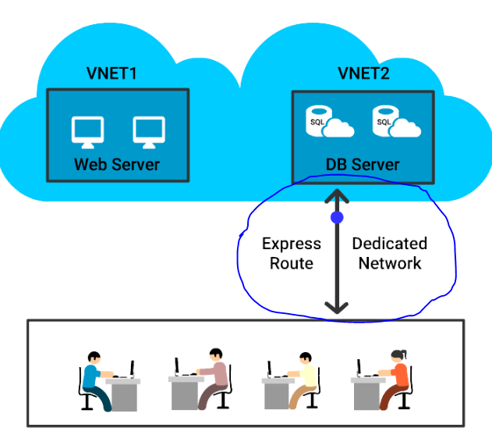

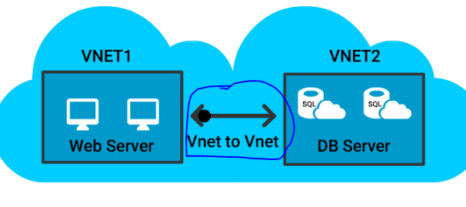

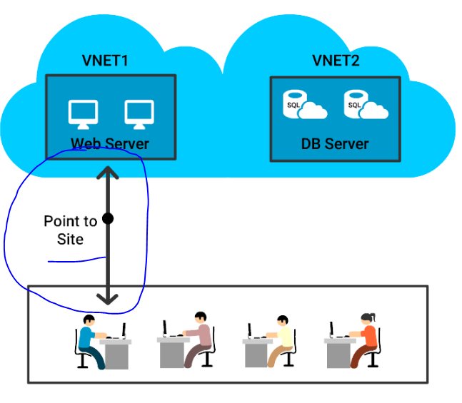

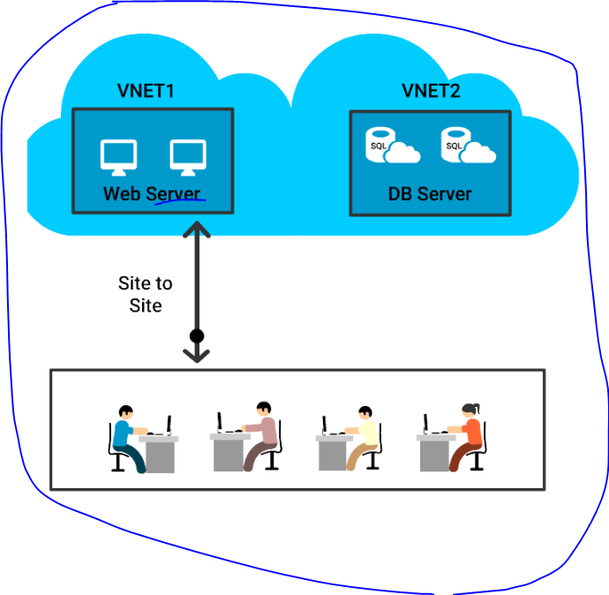

##### Azure Compute Services

Microsoft Azure Compute Services **offer the processing power for running cloud applications**.

The Microsoft Azure Compute Service can run many different kinds of applications. A principal goal of this platform, however, is to **support applications that have a substantial number of simultaneous users**.

##### Compute Options in Azure

* **Virtual Machines** is an IaaS service that allows you to deploy and manage VMs inside a VNet.
* **App Service** is a managed service to host mobile app backends, web apps, RESTful APIs, or automated business processes.
* **Service Fabric** is known as a distributed systems platform that operates in numerous environments. Service Fabric is an orchestrator of microservices across a cluster of machines.
* **Azure Batch** is called a managed service for operating large-scale parallel and high-performance computing (HPC) applications.
* **Cloud Services** is a managed service for operating cloud applications and utilizes a PaaS hosting model.

##### Resource Groups

Resource groups are **containers that are automatically created** for VMs, DBs, and other assets that are required for your solution or only the resources that you want to manage as a group.

They provide a way to **monitor, control access, provision and manage billing** for collections of assets that are required to run an application.

##### Resource Groups - Points to Remember

* All the **resources in a group should share the same lifecycle** i.e. deploy, update, and delete them together.
* If a resource (e.g. DB server), needs to exist on a different deployment cycle, it should be in another resource group.
* **A resource can only exist in one resource group**. It can be added, moved and deleted from a resource group at any time.
* A resource group can include resources that **reside in different regions**.
* A resource group can be used to **control access**.
* A resource can **interact with resources in different resource groups.** (Scenarios where two resources are related but do not share the same lifecycle).

##### Logical View of a Resource Group

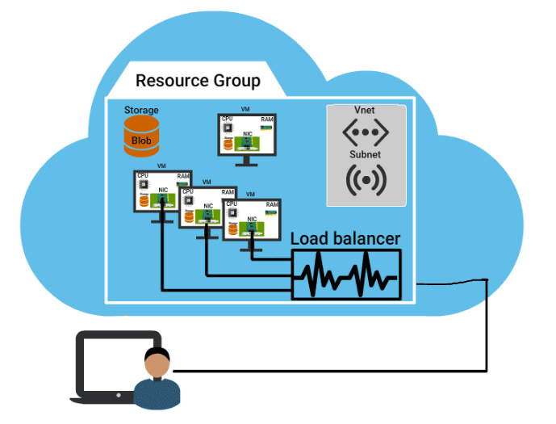

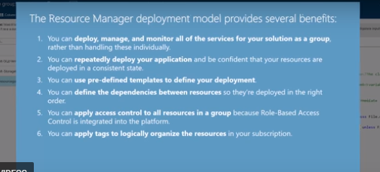

What is Azure VM?

It is a **general-purpose computing environment** that lets you create, deploy, and manage VMs running in the Microsoft Azure cloud.

Azure VM's can be used in following ways:

* **Development and test** - Azure VMs provide a fast and effortless way to create a computer with particular configurations needed to code and test an application.
* **Extended datacenter** - VMs in an Azure virtual network can easily be connected to organization’s network.
* **Applications in the cloud** - since the demand for an application can fluctuate, it might create economic sense to operate it on a VM in Azure. Thus one has to pay for additional VMs only when required and shut them down when they don’t.

##### Different Ways to Create VM

* **Azure CLI** - used to create and manage Azure resources from the command line or by using scripts.
* **Azure Portal** - provides a browser-based user interface for creating and configuring virtual machines and all related resources.
* **Azure PowerShell** - used to create and manage Azure resources from the PowerShell command line or scripts.
* **Resource Manager template** - a JSON file is used to define one or more resources to be deployed to a resource group and define the dependencies between the deployed resources. **This template can be used to deploy the resources consistently and repeatedly**.

##### VM Size

The VM size is determined by the workload that you want to run. The size then determines factors such as processing power, memory, and storage capacity.

Following VM sizes are available:

* **A-series:** is basic with no load balancing or auto-scaling support.
* **D-series:** offers faster CPUs and local Hyper-V host SSD (temporary disk).
* **Dv2 series:** provides largest VMs with configuration up to 448 GB of RAM and 64 data disks. CPU is 35% faster than D-series.
* **DS, DSv2, and GS series:** Support for Premium Storage (SSD for operating system and data disks).

##### VM Creation - Demo

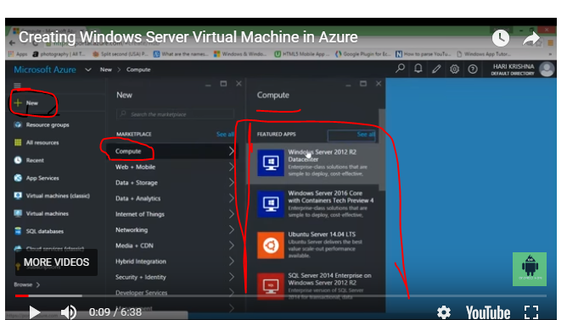

Once you select above one and click on one of the operating system and then in next page,select deployment model as Classic if you want to add new storage else do select resource manager if you want to merge with exisisting storage.

##### VM Availability

To **ensure high availability** of an application, Azure places VMs into a logical grouping called a **Availability Set**.

When deployed with a service, Azure ensures that the VMs in the Availability set are arranged across Fault Domains on different Racks. In case of a maintenance event or failure of one fault domain, at least one VM keeps running.

Along with Load balancers, availability sets can provide up to 99.9% SLA for VMs.

##### VM Availability - Fault Domain

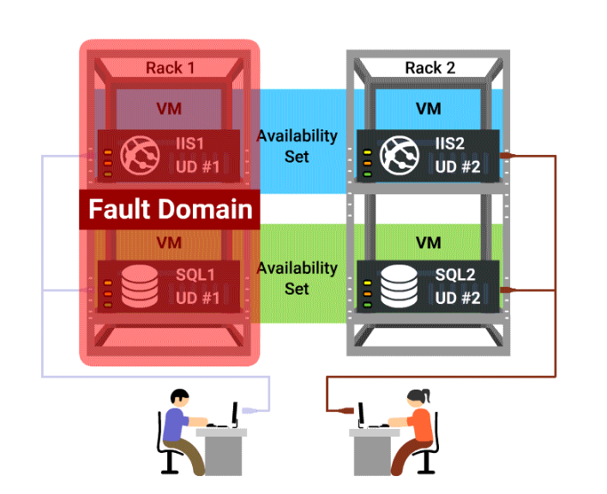

A fault domain is a set of hardware components (rack of resources like servers, power, etc.) that share a single point of failure. Web, worker and Virtual Machines are arranged in this hardware.

Azure deploys an application or service across multiple fault domains.

##### VM Availability - Update Domain

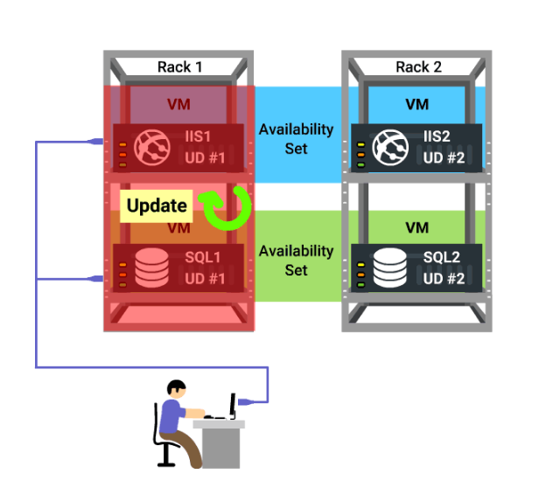

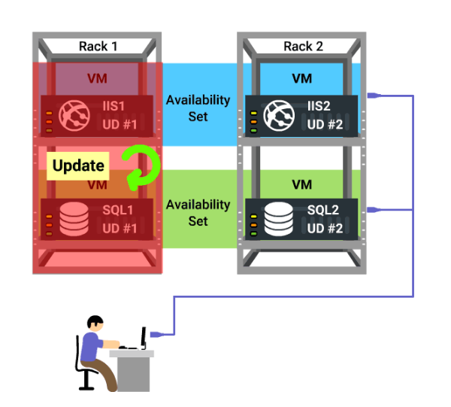

Update domain in Azure means, that all physical servers in one update domain will get host updates like firmware, drivers and OS updates at the same time.

In the Illustration UD#1 is getting updated but the user can access the content from UD#2.

It provides Web or Worker role (within rack) instances with high availability by ensuring that only one of the Instances is down for an update at one time.

##### VM Scaling

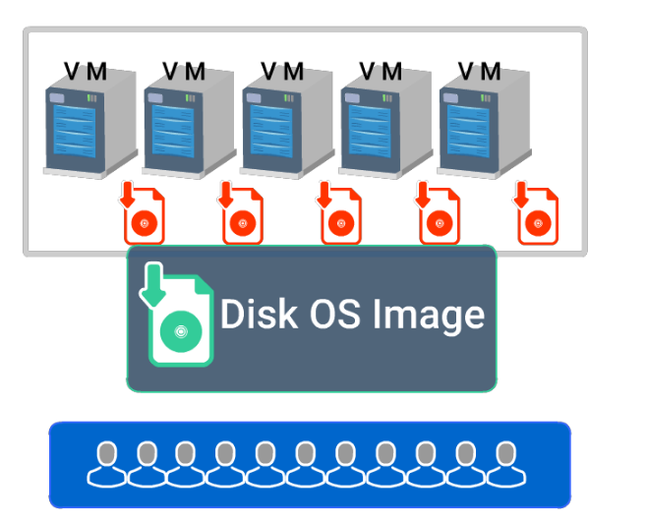

Scalability is known as the ability of a process, network, or system to acoomodate fluctuating workl oad/demand.

* **Vertical scaling**, also known as scale up and scale down, ***involves increasing or decreasing virtual machine (VM) sizes*** in response to the workload, without creating additional VMs.
* **Horizontal scaling** also known as scaling out and in, ***involves adding or removing instances of a resource***. The application continues operating without interruption as new resources are provisioned.
  + Once provisioning process is complete, the solution is deployed on the additional resources.
  + If demand drops, additional resources can be shut down cleanly and deallocated.

##### Azure Storage Introduction

Microsoft Azure Storage is a highly scalable and robust storage solution for your applications. Watch this video to get a high-level picture about the Storage Services.

Once you store the data in Azure,you can access via RESTApi’s or azure web portal.

Data will be stared in Blob storage,

Disk storage,

Primium disk storage for high IO workloads.

Table storage,

Queue storage

File storage

StorSimple is used to extemd storage from On premises to azure cloud.

Azure Site Recovery for disaster recovery purpose.

Azure backup is used for backup.

Azure is intergrated with number of partners to get the better solutions for azure cloud.

##### Azure Storage Services

Azure Storage offers four storage types.

* **Blob Storage** - for unstructured object data like images, videos, documents, etc.
* **Table Storage** - a NoSQL key attribute data store for structured datasets.
* **Queue Storage** - for storing a large number of messages. (***Example***: Creating backlog requests to be processed asynchronously OR for passing messages between various components.)
* **File Storage** - shared storage for sharing files across application components via File service REST API.

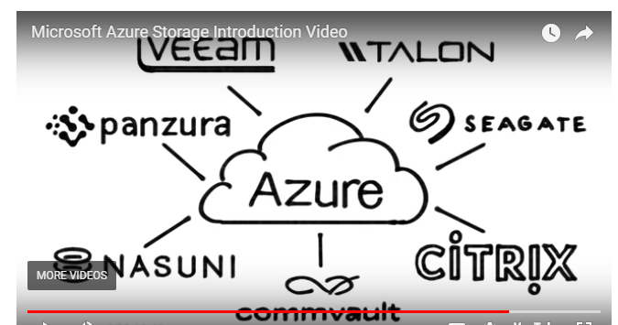

##### More about Azure Storage

* Is elastic and can **scale applications on demand**
* Uses auto-partitioning system that **automatically load balances** based on the traffic
* **Accessible** from any application, running on the cloud/desktop /on-premises server/mobile device
* Exposes data resources through **REST APIs**

##### Azure Storage Services

Azure Storage offers four storage types.

* **Blob Storage** - for unstructured object data like images, videos, documents, etc.
* **Table Storage** - a NoSQL key attribute data store for structured datasets.
* **Queue Storage** - for storing a large number of messages. (***Example***: Creating backlog requests to be processed asynchronously OR for passing messages between various components.)
* **File Storage** - shared storage for sharing files across application components via File service REST API.

##### Azure Storage Account

Azure Storage account is a secure account that provides access to Azure Storage Services. There are two types of Storage Accounts.

* **General Purpose Storage Accounts** that give access to blobs, tables, queues, files and Azure virtual machine disks.
* **Blob Storage Accounts**, are specialized storage accounts for unstructured data as blobs. This type of account is recommended for applications that require just the **block or append blob storage**.

##### Storage Replication

Azure Storage Account offers multiple options to replicate data in a single data center / across facilities / across geographies to:

* **Ensure durability**
* **Higher availability**
* **Protect data** (against hardware failures or unforeseen catastrophes).

**Options available:**

* Locally redundant storage
* Geo-redundant storage
* Zone-redundant storage
* Read-access geo-redundant storage

##### StorSimple

StorSimple is a **Hybrid Cloud Storage Solution** to manage storage tasks between on-premise devices and cloud storage.

It has **physical arrays** for deployments in data centers and **virtual arrays** for smaller enterprise environments, which require network-attached storage (NAS).

Local storage gives the flexibility to retain part/entire data locally and could be useful for getting higher performance.

**StorSimple is ideal for applications requiring high performance and capacity.**

##### Azure Backup

Azure Backup is a multi-tenant Azure service to back up and store data.

* Backup all your critical applications and data using the Azure Backup Agent.
* Azure **Backup data is encrypted** at the source, in transit, and at rest in the Azure.
* **Configure the retention policy** of backups as required (for example, 30 days, 99 years).
* **Azure Site Recovery** delivers a seamless portal experience for taking backups and operational recovery.

##### Azure Database Services

Azure provides many Database services to cater to the wide range of needs of enterprises. Few them are:

* **Relational Database Services** - Azure provides SQL, MySQL, and PostgreSQL services as PaaS, making it easier to move existing workloads to Azure.
* **SQL Data Warehouse** - SQL based fully managed elastic data warehouse that can scale up and down as per demand.
* **Azure Redis Cache** - SAAS offering of Redis Cache that provides secure, dedicated cache for applications requiring low latency.

##### Data Lake Store

Azure Data Lake Store is known as a **Highly Scalable Apache Hadoop file system** that can be used for enterprise-wide big data analytics workloads.

**Key Features:**

* **Unlimited storage** and variety of data formats.
* Can **store data in native format** without the need for any transformation.
* Built for workloads requiring **massive read throughput** and analysis of large amounts of data.
* **Can be accessed from Hadoop** using the WebHDFS-compatible REST APIs.

##### Azure Cosmos DB

Microsoft has developed Azure Cosmos DB to **support global distribution and horizontal scale**. It extends the idea of a **index-free database system**.

* Offers **turnkey distribution** by enabling seamless scaling based on user demand in any region or geography.
* Support various new data types, making it flexible to **work as a graph database** or **key-value database**.
* **Experience Low latency**, owing to read and write from the nearest region.

##### What are App Services?

App Service is a **Platform as a Service (PaaS)** that offers development framework to build and deploy mobile, web, logic, and API apps.

Create web and mobile apps for any platform or device. Azure runs these apps on **fully managed virtual machines (VMs)**, with users choice of shared VM resources or dedicated VMs.

Also, App Services allows connecting these apps to any SaaS or enterprise system within minutes and unlock the data.

##### Key features and Capabilities of App Service

* **Multiple languages and frameworks** - supports ASP.NET, Node.js, Java, PHP, Python, etc.
* **DevOps optimization** - can set up continuous integration and deployment with Visual Studio Team Services, GitHub, or BitBucket.
* **Global scale with high availability** - can Scale up or down manually or automatically.
* **Security and compliance** - is ISO, SOC, and PCI compliant.
* **Application templates** - can choose from an extensive list of templates in the Azure Marketplace.
* **Visual Studio integration** - to streamline the work of creating, deploying, and debugging.

##### Web App Services

Web App Services help in hosting your websites and web applications. **Main features include:**

* Support for .NET, Java, PHP, Node.js, and Python.
* High availability with auto-patching.
* Continuous deployment with Git, TFS, GitHub.
* Azure Marketplace based solutions that simplify the development and deployment.
* Multiple Deployment slots to run two or more versions of the same app (production and dev) concurrently on the same virtual machine.
* Azure WebJobs to execute background processes.
* Hybrid connections from web apps to access on-premises resources or VMs within an Azure virtual network.

##### Mobile App Services

Mobile Apps is a highly scalable, globally available mobile application development platform for Enterprise Developers and System Integrators. With Mobile Apps you can:

• **Build native and cross platform apps** using native SDKs.

• Connect mobile apps to your enterprise on-premises or cloud resources.

• **Build offline-ready apps with data sync** - make your mobile workforce productive by building apps that work offline.

• **Push Notifications to millions in seconds** and engage your customers.

##### Logic App Services

Use **Logic Apps** for automating business processes and integrating systems and data across clouds without writing code. Main features of Logic Apps:

* Visually create business processes and workflows
* Deliver integration capabilities in Web, Mobile, and API Apps
* Integrate with your SaaS and enterprise applications
* Automate business processes
* Connect to on-premises data

##### API App Services

Azure API App Service offer a rich platform and ecosystem for **building, consuming, and distributing APIs** in the cloud and on-premises. Main features of this service are:

* Integrate with SaaS and enterprise applications
* Generate client proxies or APIs in language
* Automate versioning and deployment of API Apps
* Secure APIs with Single Sign-On, OAuth, and Active Directory
* Share APIs internally with organizational gallery

##### Azure HD Insight

Azure HD Insight is widely used to deliver ***Hadoop as a service* on top of the Azure platform**. It uses the **Hortonworks Data Platform** (HDP) Hadoop distribution.

Azure HD Insight gives **open-source analytic clusters** for Spark, Hive, Storm, Kafka, MapReduce, HBase, and R Server to deploy these big data technologies.

**Organizations can use HD Insight to:**

* Create Hadoop-powered big data solution and services
* Manage and monitor Hadoop clusters
* Analyze and report statistics on big data utilization and availability

##### Azure Machine Learning

Azure Machine Learning is known as a **cloud predictive analytics service** that allows quick *creation and deployment of predictive models.

It comes with **ready-to-use library of algorithms**, to create models and deploy your predictive solution quickly.

Azure Machine Learning offers **tools to model predictive analytics** and offers a **fully managed service** for using predictive models as ready-to-consume web services.

##### Azure Stream Analytics

Azure Stream Analytics strives to **gather knowledge structures from the continuous ordered streams of data** with real-time analysis.

The streams may comprise web searches, ATM transactions, sensor readings, phone conversations, social network data, or computer network traffic.

**It offers a ready-made solution for business requirement that involve handling large volumes of information and react very quickly to changes in data.**

##### Azure Stream Analytics Usage

* **Connected devices** - Monitor and diagnose real-time data from connected devices to generate alerts, respond to events, or optimize operations.
* **Business operations** - Analyze real-time data to respond to dynamic environments to take immediate action.
* **Fraud detection** - Monitor financial transactions in real-time to detect fraudulent activity.
* **Website analytics** - Collect real-time metrics to gain instant insight into a website’s usage patterns or application performance.

##### Event Hubs

AzureEvent Hubs is a **event ingestion service and scalable data streaming platform** that receives and processes numerous events per second.

Event Hubs processes and stores events, data, or telemetry created by distributed devices and software. Data transmitted to an event hub can be transformed and stored with the help of any real-time analytics provider or storage/batching adapters.

**Offering publish-subscribe capability with low latency and huge scale, Event Hubs acts as the "on ramp" for Big Data!**

##### Azure Active Directory

Azure AD is known as an identity management solution that **offers access and identity services** for cloud resources. It is available as both on cloud and on-premises service. It helps to:

* Configure access to applications.
* Configure SSO to cloud-based SaaS applications.
* Manage users and groups.
* Provision users.
* Enable federation between organizations.
* Provide an identity management solution.
* Identify irregular sign-in activity.
* Multi-factor authentication.
* Extend existing on-premises AD implementations to Azure AD.

Features of Azure AD

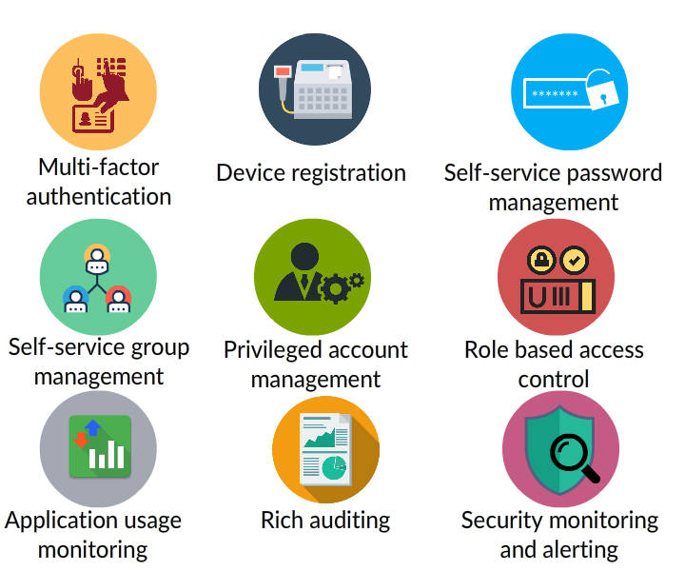

Azure AD includes a **full suite of IDM capabilities** such as,

**Access & Authentication**

* Multi-factor authentication
* Device registration
* Role based access control

**Management**

* Self-service password management
* Self-service group management
* Privileged account management

**Monitoring & Auditing**

* Application usage monitoring
* Rich auditing
* Security monitoring and alerting

These capabilities can help **secure cloud-based applications, streamline IT processes, cut costs** and also help **assure corporate compliance goals are pan**.

Azure AD vs ADDS

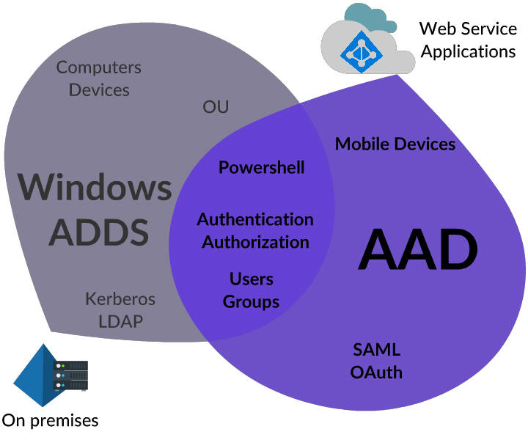

Azure AD and Windows Server Active Directory (AD) are used for Authentication. But Azure AD differs in many aspects, such as;

* It doesn't have,
  1. Active Directory forest and Trust relations
  2. Organizational Units
  3. Group Policies
* It uses Open AD connect, O-Auth, WS-federation and SAML protocols for Authentication and Authorization.

##### Azure AD Editions

Azure AD is available in free and paid editions such as,

* Free
* Basic
* Premium 1
* Premium 2

To know **Azure AD Pricing and Edition Comparison** visit [Azure AD features & Pricing](https://azure.microsoft.com/en-us/pricing/details/active-directory/)

For deep dive read [Azure Identity Management](https://play.fresco.me/course/263)

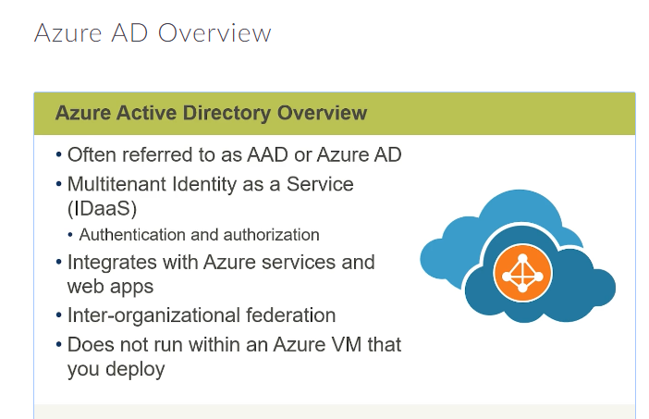

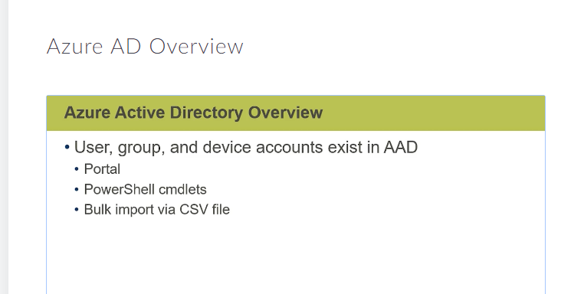

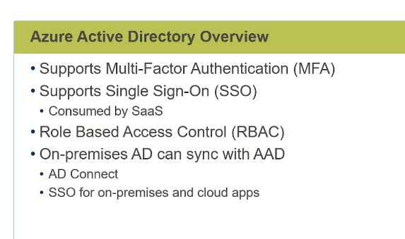

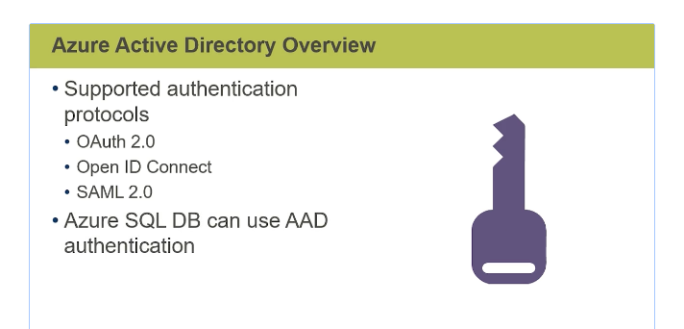

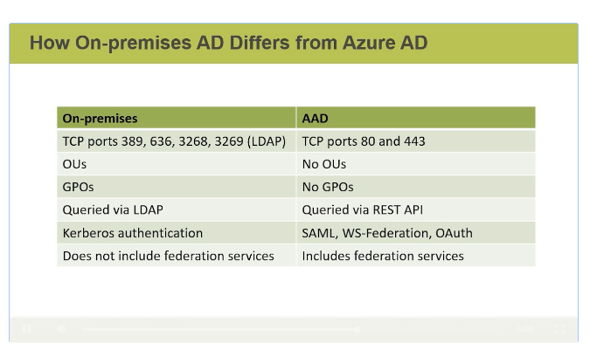

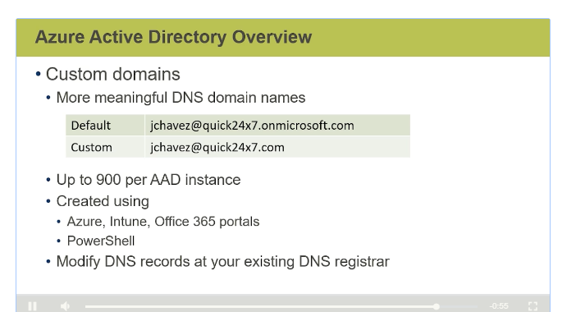

##### Azure Security Center

Azure Security Center aids to **prevent, detect, and respond to threats** with increased visibility into and control over the security of Azure resources.

* Offers ***integrated security monitoring* and *policy management*** across Azure subscriptions.
* Aids in **detecting threats** that might otherwise go unnoticed.
* **Works with a broad ecosystem** of security solutions.

##### Azure Key Vault

Azure Key Vault helps **safeguard cryptographic keys and secrets used by cloud applications and services**. It streamlines the key management process and enables to maintain control of keys.

By using Key Vault, you can **encrypt keys and secrets** (such as authentication keys, storage account keys, data encryption keys, etc.) by using keys that are protected by **Hardware Security Modules (HSMs)**.

Developers can create keys for testing and development in minutes, and then easily migrate them to production keys.