ONLINE SHOPPING CUSTOMER ANALYSIS
Project Dashboard | Customer Purchase Behaviour Analysis
Sellammal S | Reg. No: 25127055 | BSc Computer Science with Data Analytics | Data Analysis using R & Tableau (25BKDC301)
TOTAL ORDERS  500  records analysed | AVG. ORDER VALUE  ₹2,087.45  across all orders | TOP CATEGORY (ORDERS)  Fashion  120 orders (24%) | TOP CATEGORY (VALUE)  Electronics  ≈₹4,260 avg/order
TOP PAYMENT METHOD  UPI  31.0% of orders | MOST FREQUENT CUSTOMER  CUST1086  9 orders placed | PEAK ORDER MONTH  May  51 orders | DATASET ATTRIBUTES  8 fields  500 rows × 8 columns
Visual Analysis
Orders by Product Category  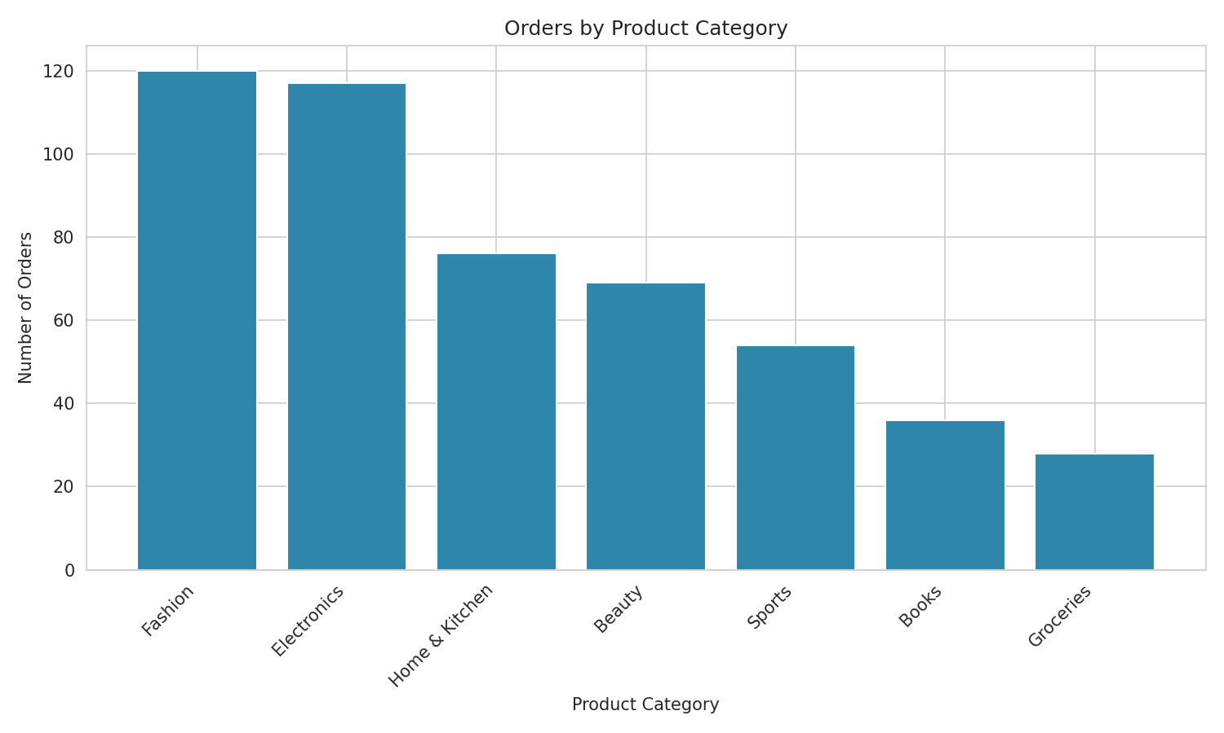  Fashion & Electronics drive most order volume. | Average Order Value by Category  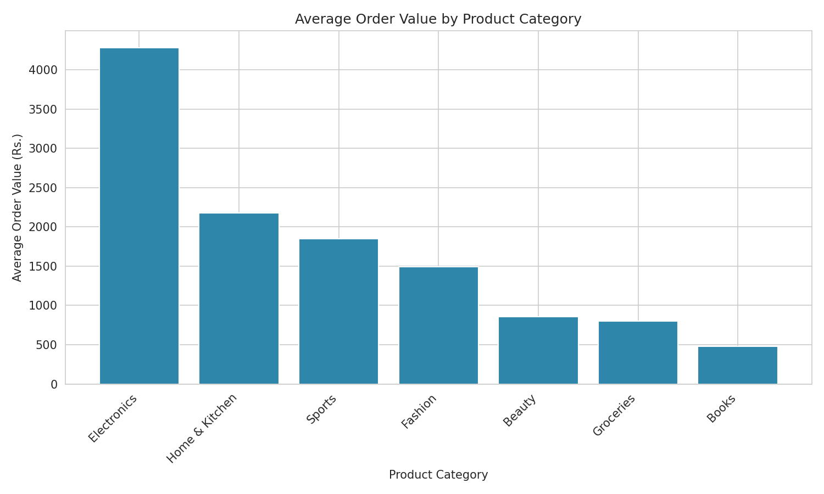  Electronics has the highest spend per order.
Distribution of Payment Methods  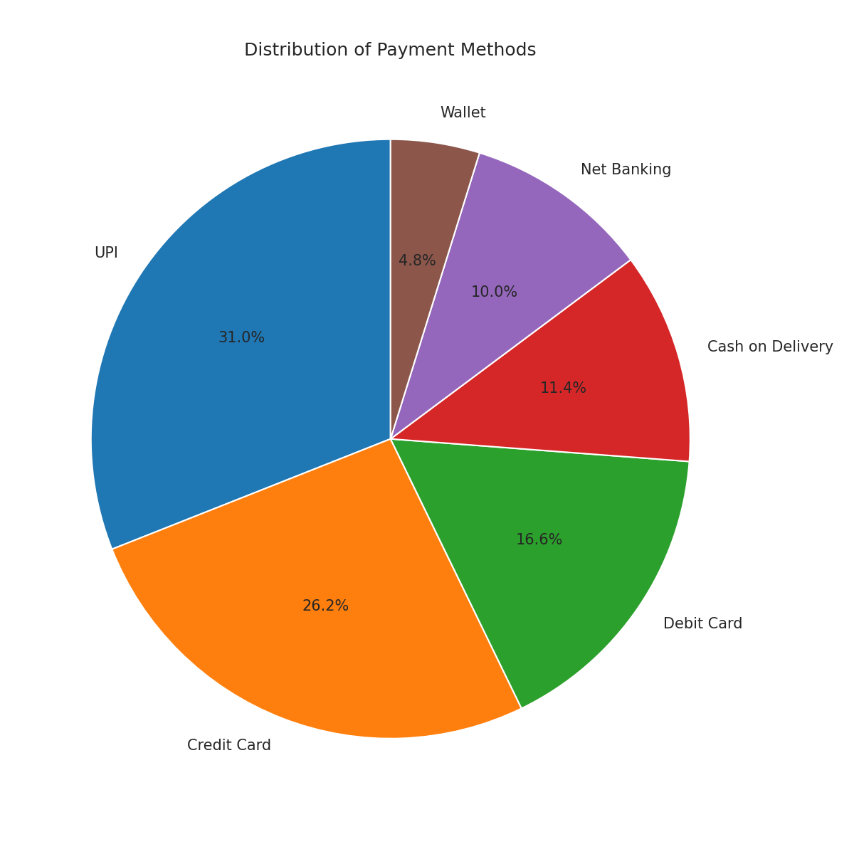  UPI and Credit Card together cover 57% of orders. | Top 10 Frequent Customers  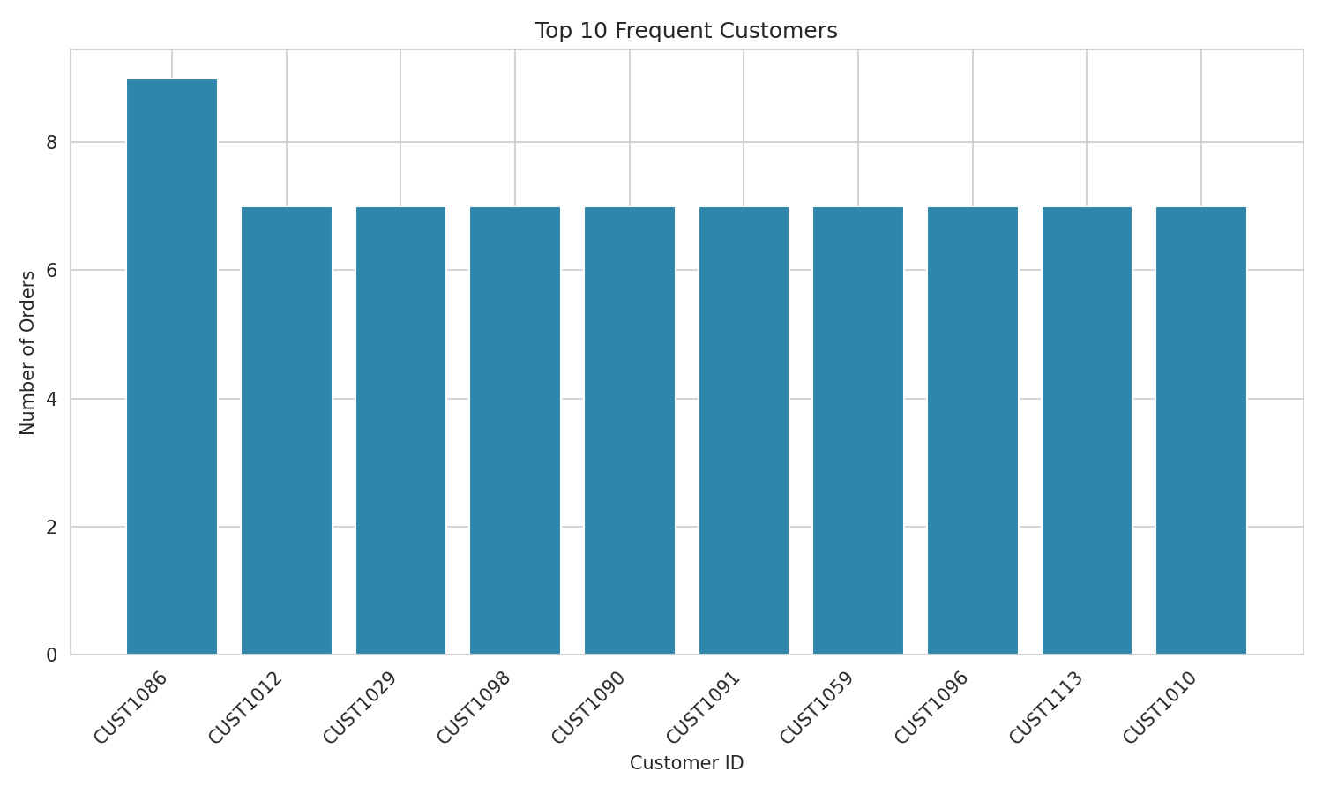  CUST1086 leads with 9 orders; nine others tied at 7.

Monthly Order Trends (January – December)
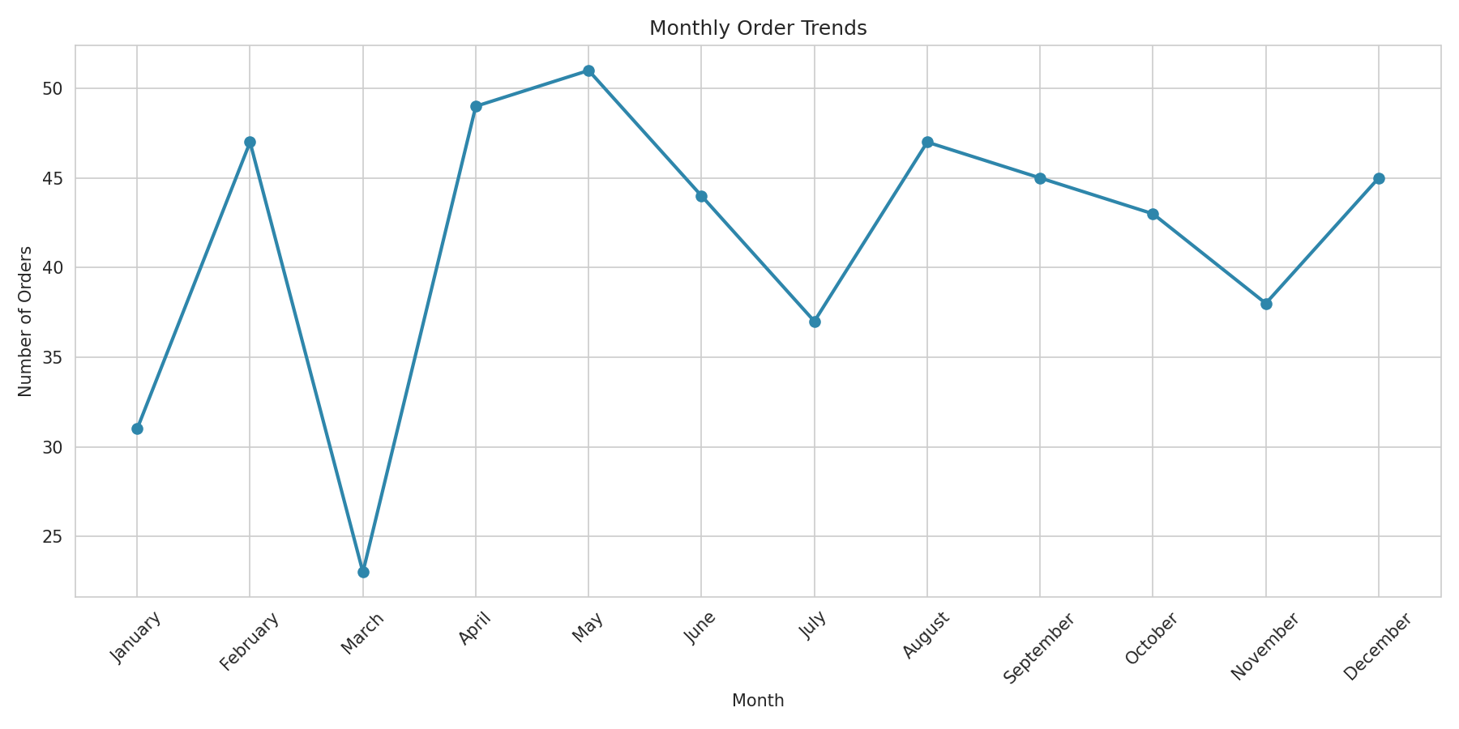
Orders dipped sharply in March (23) and peaked in May (51), showing clear seasonal variation.
Key Insights
- The overall average order value across all orders is ₹2,087.45.
- Electronics has the highest average order value among all product categories.
- Fashion is the most frequently ordered product category, closely followed by Electronics.
- UPI is the most preferred payment method (31.0%), followed by Credit Card (26.2%).
- Customer CUST1086 is the most frequent buyer, with 9 orders placed.
- May recorded the highest number of orders (51), while March recorded the lowest (23).
What Each KPI / Chart Represents
Total Orders | Total number of order records in the dataset (500 rows) — the base size of the analysis.
Avg. Order Value | Mean of the Order_Value column across all 500 orders; indicates typical customer spend.
Top Category (Orders) | Product category with the highest order count, found using value_counts() on Product_Category.
Top Category (Value) | Product category with the highest mean Order_Value, found using groupby().mean().
Top Payment Method | Most-used payment mode, found using value_counts() on Payment_Method.
Most Frequent Customer | Customer with the highest order count, found using value_counts() on Customer_ID.
Peak Order Month | Calendar month with the highest number of orders after grouping Order_Date by month.
Orders by Product Category (bar) | Compares order volume across categories — tallest bar is the most popular category.
Average Order Value by Category (bar) | Compares mean spend per order across categories — shows which categories generate higher-value orders.
Distribution of Payment Methods (pie) | Shows the percentage share of each payment mode used at checkout.
Top 10 Frequent Customers (bar) | Ranks the ten customers with the most orders placed.
Monthly Order Trends (line) | Tracks order volume across the 12 months to reveal seasonal demand patterns.
Source: online_shopping_dataset_500.csv (500 records, 8 attributes) — analysed using Python, Pandas & Matplotlib.

