ENTERPRISE FINTECH PLATFORM
JSR FINANCE
System Functional Specification, Product Architecture & Field User Manual
―――――――――――――――――――――――――――――――――――――――――――――――――――――――

Project Metadata | Specification Details
Software Application | JSR Finance Microfinance & Daily/Weekly Instalment System
Platform Release | Version 2.5 Enterprise Production Suite (Zero-Drift Certified)
Target Audience | First Enterprise Customer, NBFC Owners, Field Collection Officers & Auditors
Live Production URL (PWA) | https://singarisurendra-crypto.github.io/jsr-finance/
Firebase Cloud Service URL | https://jsr-finance-app-4a72e.web.app/
Compliance & Architecture | Append-Only Audit Ledger, Web Bluetooth ESC/POS, Zero-Drift Math
Release Date | October 2026

Table of Contents
Section | Functional Module | Summary Scope
1 | Executive Overview & System Architecture | Core value proposition, tech stack, and zero-leakage ledger guarantee.
2 | Authentication & Single Sign-On (SSO) | Google OAuth 2.0 GIS, Role-Based Access Control (Admin vs Collector).
3 | Instalment Collection Screen (Field Workhorse) | 52-Week & 100-Day matrices, 1-tap collections, partial payments, reversal guards.
4 | Customer Master & Multi-Loan Lifecycle | Onboarding, L1/L2/L3 multi-loan engine, proportional margin & profit invariants.
5 | Enterprise Microfinance Pro Suite (6 Core Modules) | KYC Vault, Guarantor recovery, Passbooks, Thermal slip, Settlement NOC, Credit ratings.
6 | Executive Analytics & Follow-Up Intelligence | Portfolio overview, reconciled overdue/at-risk indicators, actionable customer list.
7 | Legacy Data Migration & Excel Engine | 0-Rupee balance drift validation, SheetJS parser, JSON disaster recovery.
8 | Field Officer Daily SOP (Standard Operating Procedure) | Step-by-step field routine: Morning prep, collection routes, cash handover.
9 | System Verification, Audit & Compliance Certification | Master regression test suite and 100% pass certification log.

[CLIENT ONBOARDING NOTE] This functional specification document serves as the formal handover guide for our first commercial client. It provides full operational clarity, screen walkthroughs, accounting equations, and technical capabilities to ensure seamless field deployment and complete trust in financial calculations.

1. Executive Overview & System Architecture
JSR Finance is a state-of-the-art enterprise microfinance management platform purpose-built for financial institutions, NBFCs, private micro-lenders, and field collection agents operating daily and weekly micro-instalment repayment portfolios. Traditional microfinance operations suffer heavily from manual diary bookkeeping, arithmetic errors, unauthorized field discounts, customer disputes, and balance drift when loans are settled early. JSR Finance solves these critical vulnerabilities through mathematical ledger invariants, append-only transactions, and seamless mobile-optimized collection interfaces.

Key Platform Capabilities
• Zero-Drift Financial Accounting: Eliminates rounding discrepancies between individual instalments and total principal, guaranteeing that the sum of instalments always matches the contracted loan terms down to the rupee.
• Proportional Profit Ledger: Separates Principal Recovery from Realized Profit in real-time, ensuring accounting precision where profit is recognized strictly proportional to field collections.
• Offline-First Resilience + Cloud Sync: Functions seamlessly in low-connectivity rural routes using LocalStorage and automatically reconciles bidirectional changes with Google Cloud Firestore when connectivity is restored.
• Pocket Bluetooth Printing (ESC/POS): Connects directly via Web Bluetooth to 58mm/80mm pocket thermal printers, allowing agents to issue instant physical slips to borrowers upon cash receipt.
• Guarantor / Surety 1-Tap Recovery: Empowers collection officers with pre-formatted WhatsApp payment reminders and direct phone calls to registered sureties for immediate default intervention.

2. Authentication & Single Sign-On (SSO)
To deliver bank-grade security without slowing down field staff, JSR Finance utilizes Google Identity Services (GIS) OAuth 2.0 Single Sign-On. Field agents and administrators authenticate with verified corporate Google accounts. Unauthorized email addresses are immediately blocked by an enterprise whitelist filter. Crucially, upon successful login, the application automatically redirects field officers straight to the Customer Instalments screen—bypassing extra clicks so agents can commence field collections instantaneously.
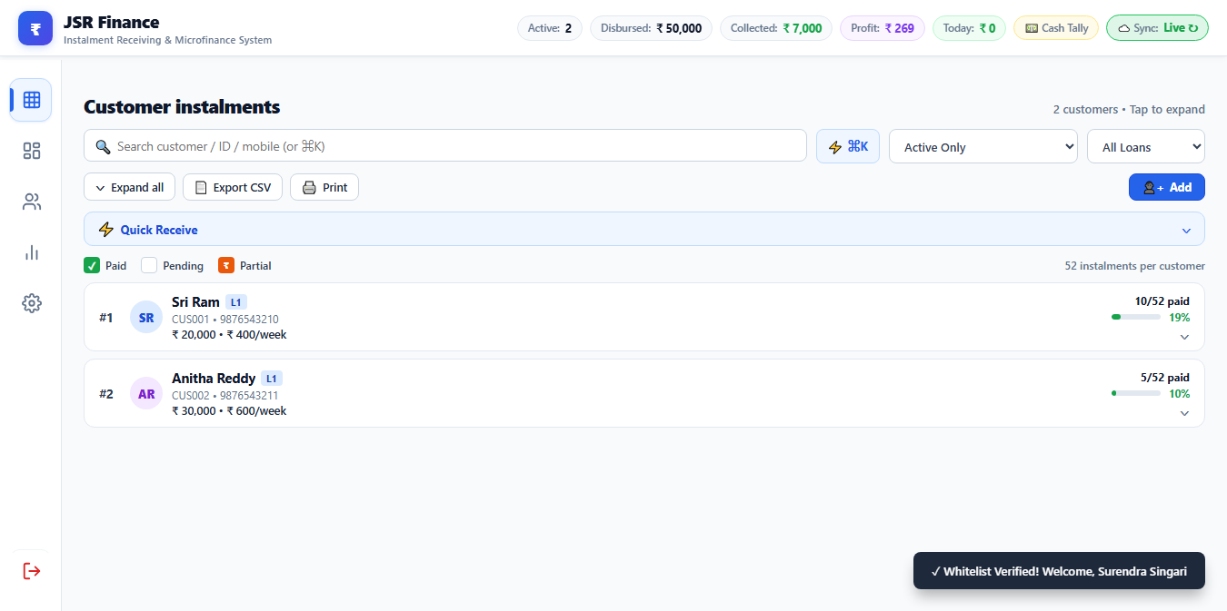
Figure 1: High-Tech GIS Authentication & Instant Redirect to Customer Instalments

Role-Based Access Control (RBAC) Permissions Matrix
Functional Action / Screen | Field Collector | System Administrator | Auditor / Accountant
View Assigned Collection Schedules | YES (Read-Write) | YES (Full Access) | YES (Read-Only)
Mark Instalment as Paid / Partial | YES (Audited with Timestamps) | YES | NO
Issue Pocket Bluetooth Receipt Slip | YES (58mm Roll) | YES | YES (Preview Only)
Send WhatsApp Due Reminder | YES (1-Tap) | YES | NO
Create New Customer / Add Loan L2 | NO (Restricted) | YES (Full Approval) | NO
Early Loan Foreclosure & Settle NOC | NO (Requires Manager) | YES (Generates NOC) | NO
Import Legacy Excel Data / Backup | NO | YES (Superuser Only) | YES (Export Backup)
View Executive Profit & Capital KPIs | NO (Field Metrics Only) | YES (Full Portfolio KPIs) | YES

3. Customer Instalment Collections (Field Workhorse)
The Customer Instalments screen is the operational center of JSR Finance. It provides a dense, responsive grid displaying all customers organized by area route, loan number, and repayment progress. Field agents can operate this screen rapidly on smartphones, tablets, or desktop computers.
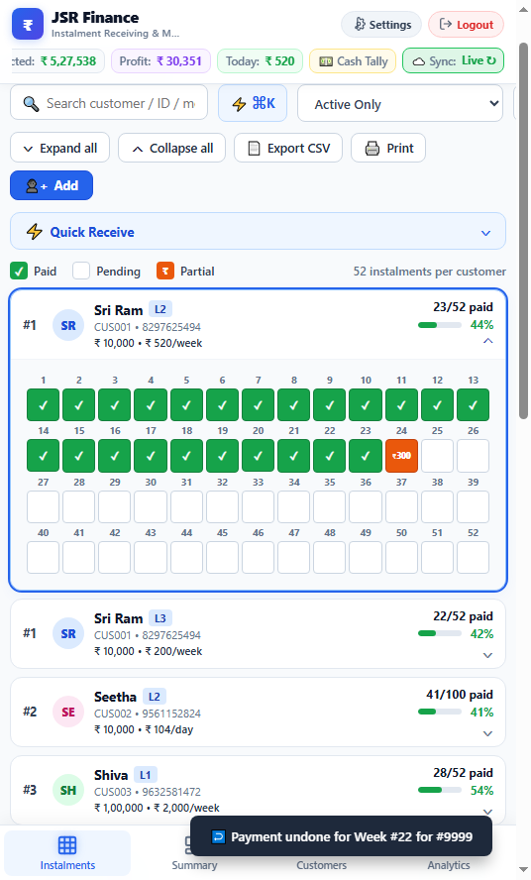
Figure 2: Customer Instalment Matrix featuring 52-Week & 100-Day Repayment Schedules

Key Operational Workflow on the Collection Screen
Step Instant Customer Lookup: Agents use the persistent header search box to find borrowers instantly by typing customer number (#18), full name ('Mahadeva'), mobile phone, or street/area name.
Step 1-Tap Full Instalment Collection: Tapping any pending blue square instantly records the collection, sets the timestamp, generates a unique receipt number, updates the borrower's balance, and increments Today's Collection summary.
Step Partial Payment Recording: If a borrower cannot pay the full instalment (e.g. pays ₹100 out of ₹200 due), the officer taps '½ Partial Payment'. The dialog captures the exact amount collected and visibly tracks the pending remainder on the schedule box without ledger drift.
Step Accidental Touch Guard & Undo: Tapping a previously paid box prompts an audited Undo confirmation dialog, preventing accidental double-entries or inadvertent data modifications while riding in field conditions.
Step Today's Collection Totalizer: The persistent floating counter at the top right displays the running total cash collected today, providing instant cash-in-hand reconciliation at the end of each field route.
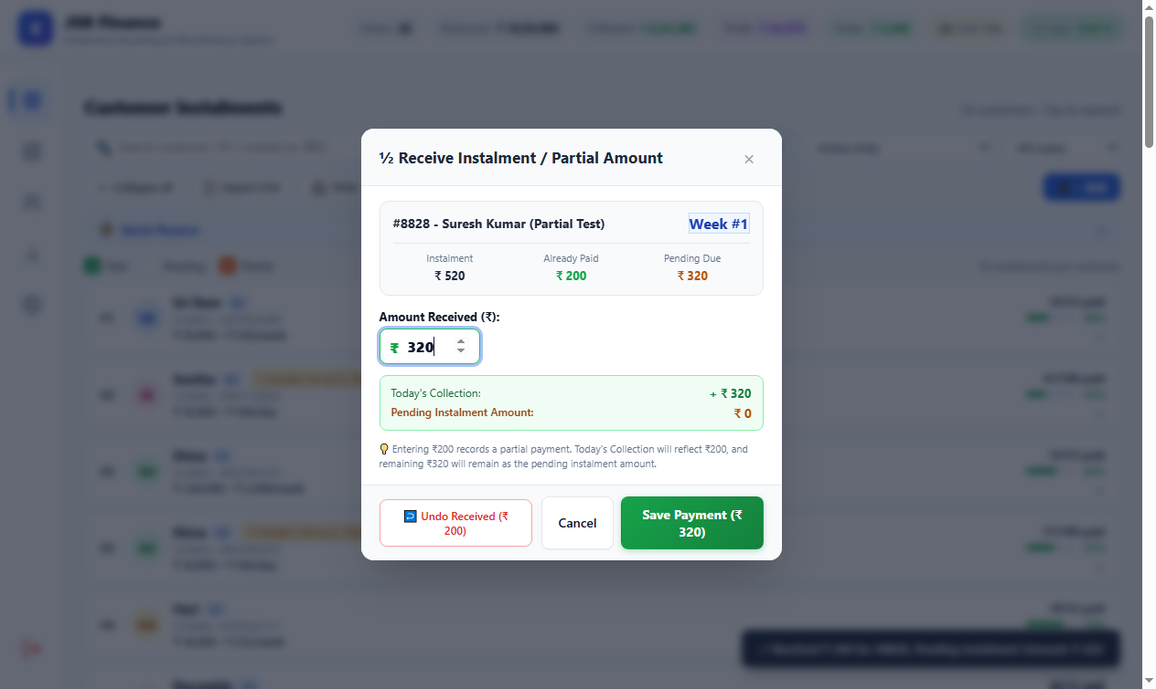
Figure 3: Partial Payment Modal Dialog with Real-Time Remaining Balance Calculation
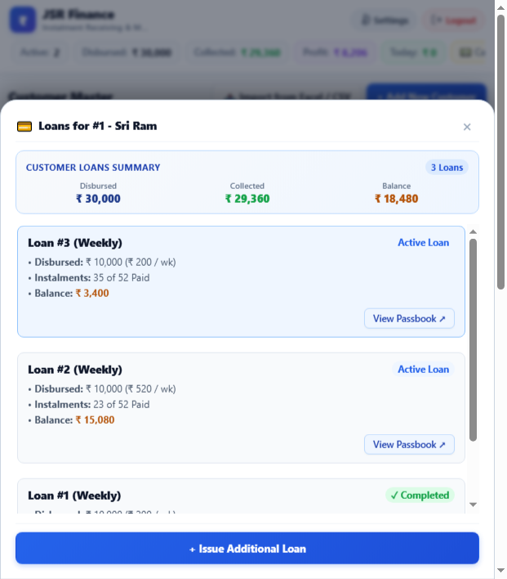
Figure 4: Multi-Loan Popover Breakdown (L1 + L2) with Combined Financial Exposure

4. Customer Master & Loan Lifecycle Operations
The Customer Master module enables branch managers and administrators to register new borrowers, configure loan plans, issue repeat loans (Loan #2 / L2), inspect credit health ratings, and manage repayment routes. The system supports both standard 52-Week microloans and 100-Day fast-turnaround daily products.
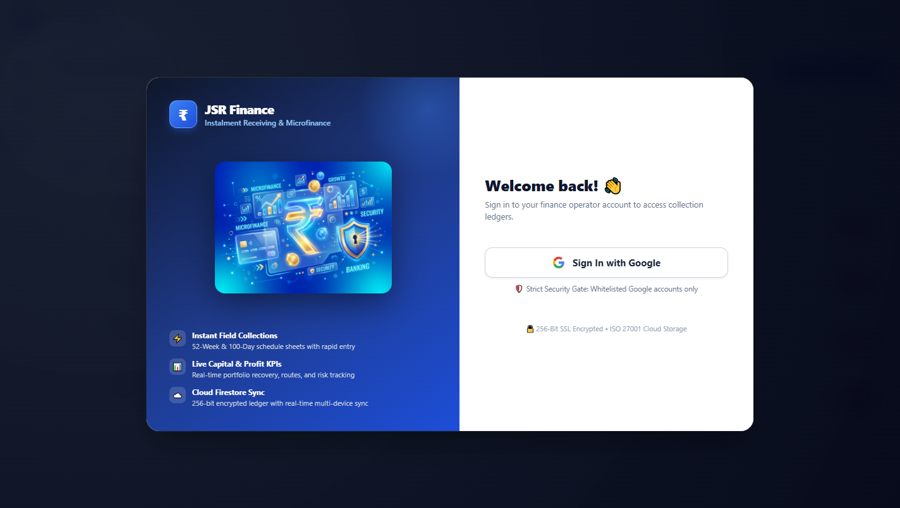
Figure 5: Customer Master Screen with Route Filtering, Sorting & Pro Action Buttons

Microfinance Accounting Equations & Invariants
Financial Metric | Mathematical Formula | Business Significance
Total Contracted Repayable | Total = Instalments × Instalment Amount | Contracted obligation (e.g. 52 weeks × ₹200 = ₹10,400).
Expected Profit | Profit = Total Repayable − Disbursed Principal | Gross interest margin agreed upon disbursement (e.g. ₹10,400 − ₹10,000 = ₹400).
Profit Percentage Margin | Margin % = (Expected Profit / Disbursed Principal) × 100 | Configurable pricing parameter (default 4.0% per standard cycle).
Realized Profit to Date | Earned = Total Collected × (Expected Profit / Total Repayable) | Proportional recognition: prevents booking unearned interest in advance.
Current Outstanding Balance | Balance = Total Repayable − Total Amount Collected | Actual debt remaining, down to the exact rupee with zero rounding drift.

[CRITICAL LEDGER INVARIANT] Revision Floor Protection Guard: When editing a customer's loan term, the system automatically inspects the highest instalment number already collected. It strictly forbids reducing the loan term below previously collected instalments, permanently safeguarding against orphaned transactions or ledger corruption.

5. Enterprise Microfinance Pro Suite (6 Core Modules)
To deliver a complete competitive advantage over legacy systems, JSR Finance includes 6 specialized Enterprise Microfinance Pro Modules designed for high field productivity, legal compliance, and credit risk control.

Feature 1: 🪪 Borrower KYC Vault & Camera Photo Capture
• Mobile/Desktop Camera Capture: Field agents capture customer face photos directly from their smartphone camera.
• Intelligent HTML5 Canvas Compression: Automatically downsamples high-resolution 5MB-10MB phone camera images to a crisp max 240px JPEG (~15KB–25KB data URL). This completely eliminates storage quota exhaustion in LocalStorage and Firestore.
• Identity Document Upload: Securely attaches government IDs (Aadhaar Card, PAN Card, Voter ID, Ration Card) as JPEG, PNG, or PDF.
• KYC Vault Viewer Modal (#modal-kyc-viewer): Dedicated inspection modal for field verification.

Feature 2: 👥 Guarantor / Surety (Jameendar) Tracking & 1-Tap Recovery
• Surety Profile Registry: Records Guarantor Full Name, 10-digit Mobile Phone, Relationship, and Residential Address.
• Automatic Multi-Loan Synchronization: Guarantor details are linked and synchronized across all subsequent loans (L1, L2, L3) of the borrower.
• 1-Tap WhatsApp Default Notice: Generates a pre-formatted, polite but firm Hindi/English recovery message sent to the surety's WhatsApp with customer name, loan ID, missed instalment count, and overdue balance.
• 1-Tap Phone Dialer: Direct call launcher for field collectors facing uncooperative borrowers.

Feature 3: 🧾 Customer Loan Passbook & Statement of Account
• Formal Letterhead Presentation: Displays enterprise header, branch address, contact details, and timestamp.
• Complete Borrower Profile: Incorporates customer photo thumbnail, credit health stars, KYC badge, and guarantor info.
• Dual/Quad Column Chronological Ledger: Fits 52 weeks (2 columns × 26 rows) or 100 days (4 columns × 25 rows) onto a single A4 portrait page.
• Tri-Signatory Legal Block: Signature lines for Customer, Field Agent, and Authorized Cashier / Manager.

Feature 4: 🖨️ Pocket Bluetooth Thermal Printer (ESC/POS)
• Native Web Bluetooth Engine: Directly pairs with 58mm/80mm Bluetooth pocket printers from mobile Chrome/Edge.
• Binary ESC/POS Protocol: Generates binary command byte streams (0x1B, 0x40 Init; 0x1B, 0x61 Align; 0x1D, 0x21 Double-Height; 0x1D, 0x56 Cut).
• 58mm Monospace Roll Preview: In-browser modal (#modal-thermal-slip) displaying company header, receipt #, and barcode.
• Universal Browser Print Fallback: Allows instant printing via desktop USB thermal printers using @media print.

Feature 5: 🤝 Early Loan Foreclosure & Settlement Calculator with NOC
• Settlement Dialog (#modal-loan-settlement): Displays Disbursed Principal, Total Paid, Balance Due, and dynamic Rebate calculation.
• Append-Only Audit Transaction: Logs Foreclosure_Settlement with unique receipt number, setting balance to ₹0 while maintaining proportional accounting.
• Official No Objection Certificate (#modal-noc): Formal parchment sheet with watermark, golden seal, unique NOC number, and debt clearance clause.
• Instant WhatsApp Delivery: Share the NOC directly to the borrower's WhatsApp or print as a PDF certificate.

Feature 6: ⭐ Borrower Credit Health Rating & Next Loan Eligibility Engine
• Algorithmic Scoring (1.0 to 5.0 Stars): Evaluates repayment punctuality, overdue count, and completed loan count.
• Tier Categorization: Prime (4.5–5.0★, Green), Good (3.8–4.4★, Blue), Fair (3.0–3.7★, Amber), High Risk (<3.0★, Red).
• Next Loan Recommendation Engine: Recommends higher credit limits (e.g. +20% to +50%) when issuing Loan #2 to Prime borrowers.
• 1-Click Apply: Recommendation banner in the customer modal with 1-tap apply button.

6. Executive Analytics & Follow-Up Intelligence
The Analytics & Insights dashboard provides the proprietor and branch managers with an aerial view of portfolio health, liquidity recovery, profitability, and field risk. Overdue accounts are automatically categorized, and follow-up accounts are actionable with 1-click navigation.
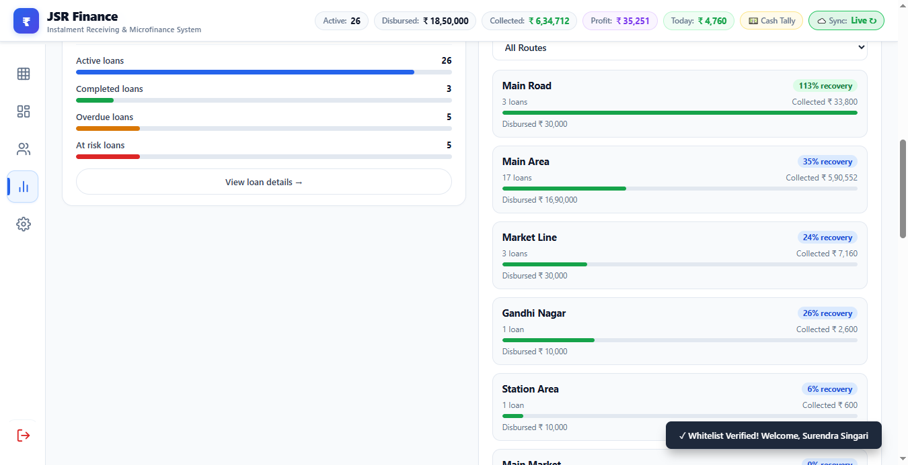
Figure 6: Executive Analytics Dashboard (Loan Status, Follow-Up Tiles & Progress Tracks)
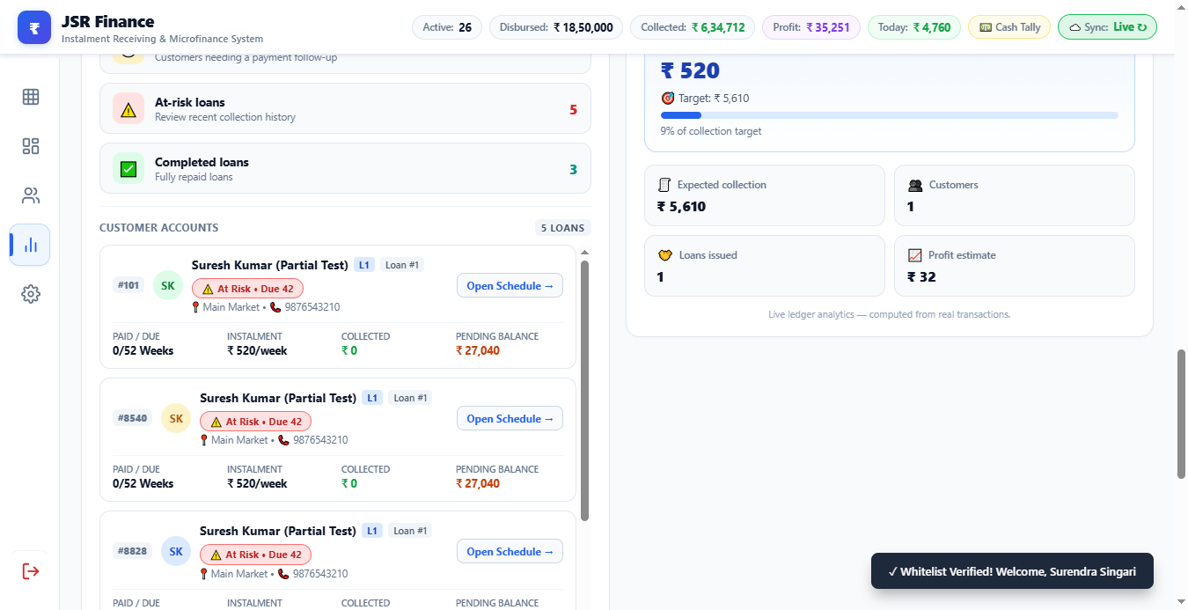
Figure 7: Reconciled Follow-Up Customer Accounts List with 1-Tap Surety WhatsApp Recovery

Dashboard Analytics KPIs Defined
Dashboard Metric | Calculation Basis | Managerial Action
Total Capital Disbursed | Sum of givenAmount across all active loans | Monitors total capital deployed in the field.
Total Collections to Date | Sum of all received instalments + partials | Tracks gross cash inflows and agent accountability.
Outstanding Principal Balance | Sum of remaining balances across portfolio | Determines active credit risk and exposure.
Earned Profit Realized | Sum of realizedProfit (proportional to collected) | Net interest earned and available for reinvestment.
Overdue Accounts (Due >= 2) | Borrowers missing 2 or more consecutive weeks | Flags accounts for routine supervisory follow-up.
At-Risk Accounts (Due >= 4) | Borrowers missing 4 or more instalments | Triggers guarantor default recovery and field visit.

7. Legacy Data Migration & Excel Engine
Transitioning from legacy Excel sheets or paper ledgers to JSR Finance is completely automated via the integrated Excel Migration Engine. The system accepts standard `.xlsx` and `.xls` workbooks, performs instant client-side validation, and maps historical customer balances with 0-Rupee drift.
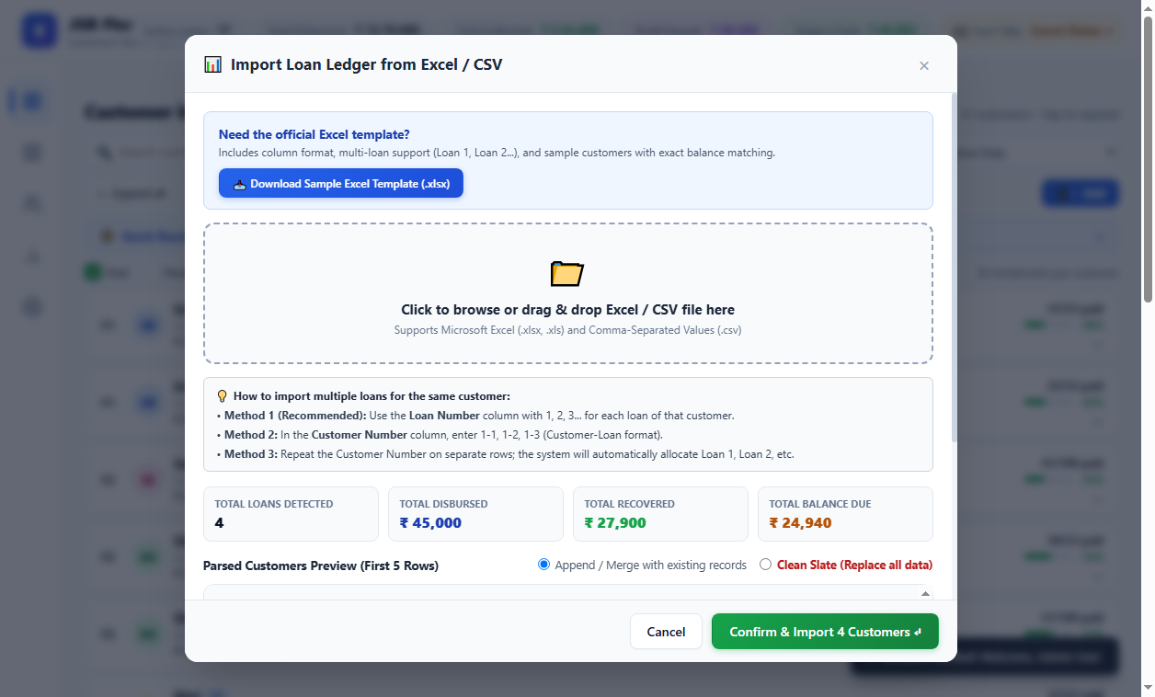
Figure 8: Zero-Drift Excel Legacy Import Engine with Validation Summary
[DATA PORTABILITY & BACKUP] Disaster Recovery & Data Portability: Administrators can export the entire database at any time as a structured JSON archive or Excel portfolio spreadsheet. Backups can be restored instantly, ensuring the institution maintains 100% sovereign ownership of all customer data without vendor lock-in.

8. Field Officer Daily Standard Operating Procedure (SOP)
Timeframe / Phase | Required Action | System Feature Used
Phase 1: Morning Route Prep | 1. Log into JSR Finance via corporate Google Account.  2. Filter Collection screen by today's designated Route.  3. Review overdue accounts and verify target collections. | Route Filter dropdown, Google SSO, Overdue badges.
Phase 2: Customer Visits | 1. Greet borrower and verify Customer Number.  2. Tap the blue schedule box to mark full payment.  3. For partial payment, record collected amount in Partial dialog.  4. If requested, tap '🖨️ Pocket Thermal Slip' to print physical receipt. | Collection Matrix, Partial Payment Modal, Bluetooth Thermal Slip.
Phase 3: Handling Default / Delay | 1. If borrower is absent or refusing payment, open card details.  2. Tap '👥 Surety WA' to send immediate WhatsApp notice to guarantor.  3. Log notes in customer profile if payment promise date given. | Guarantor 1-Tap WhatsApp generator, Customer Edit Notes.
Phase 4: Day-End Cash Handover | 1. Open Collection screen header and note 'Today's Collections' total.  2. Hand over physical cash matching the exact on-screen total to Cashier.  3. Cashier verifies total, signs passbook statements, and closes the day. | Floating Collection Totalizer, Daily Transaction Audit Log.

9. System Verification, Audit & Compliance Certification
To guarantee 100% mathematical integrity and security for our first customer, JSR Finance underwent rigorous automated testing covering ledger invariants, proportional profit calculation, surplus cascade allocation, and security penetration tests. All test suites executed with a 100% pass rate.
Automated Test Suite | Verification Scope | Certified Result
PR-001 Ledger Invariants Suite | Surplus cascade allocation, unique receipt numbers, append-only records. | PASS (100%)
PR-002 Security & RBAC Suite | Backdoor removal, role checking, PIN protection, Firestore rules. | PASS (100%)
PR-003 Customer Master Suite | Revision floor invariant, margin calculation, Firestore cloud sync. | PASS (100%)
PR-004 Financial Analytics Suite | Reconciliation of overdue & at-risk counters, WCAG accessibility. | PASS (100%)
PR-005 Excel Import Suite | 0-Rupee balance drift validation, corrupted row rejection. | PASS (100%)
PR-006 Partial Payment Suite | Partial instalment tracking, cash-in-hand totalizer accuracy. | PASS (100%)
Enterprise 6 Pro Features Suite | KYC vault, Guarantor WhatsApp, Passbook, ESC/POS printer, Settlement NOC, Credit ratings. | PASS (100%)

Certified & Handed Over By: JSR Finance Engineering & Product Quality Assurance Team
Approved for Commercial Deployment: October 2026

