Scrip file pushed to git hub.

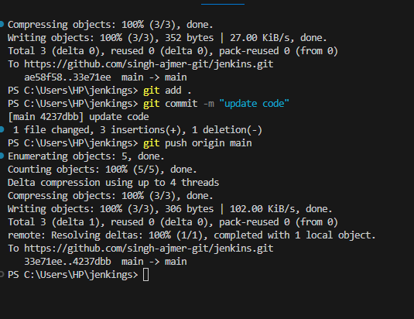

Created a webhook on git hub repo.

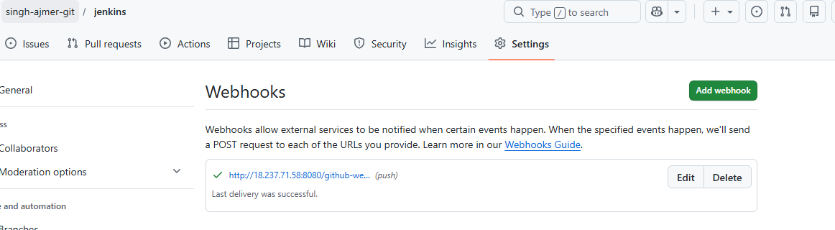

Job auto trigger in jenkings
Projects in jenkings
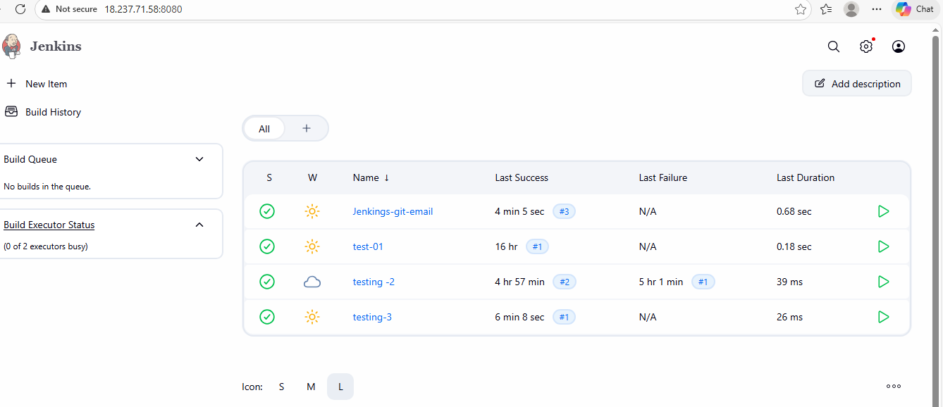

Job run auto as webhooks push the update to jenkings
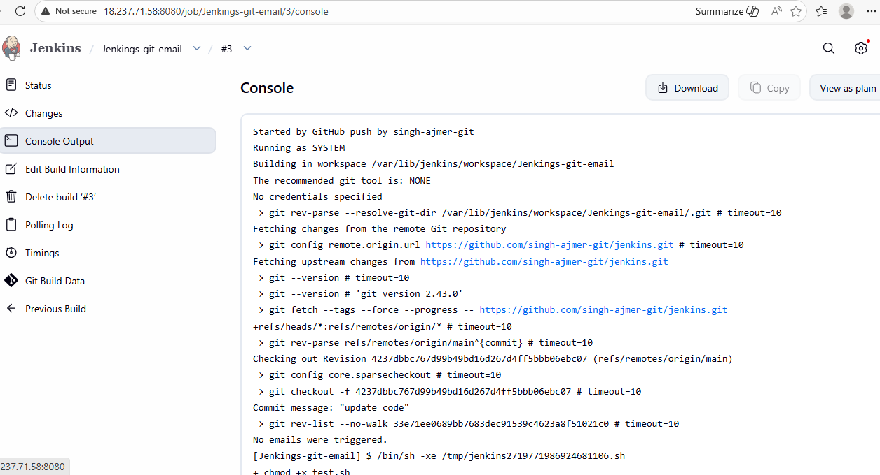

Build completed and email notification sent to gmail.
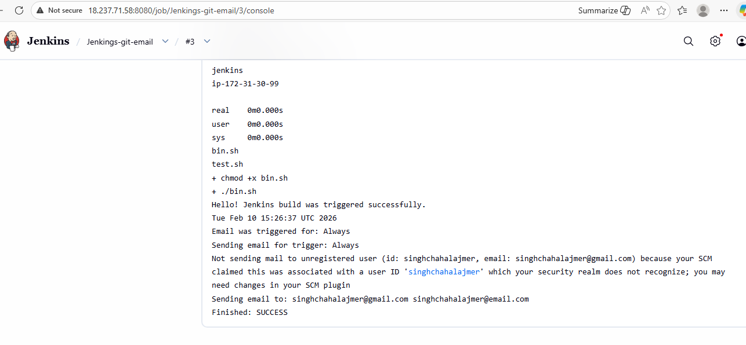

Email notification in gmail.
