Terraform Code to deploy Nginx with nging basic setup and service restart.

us-west-2
us-east-1
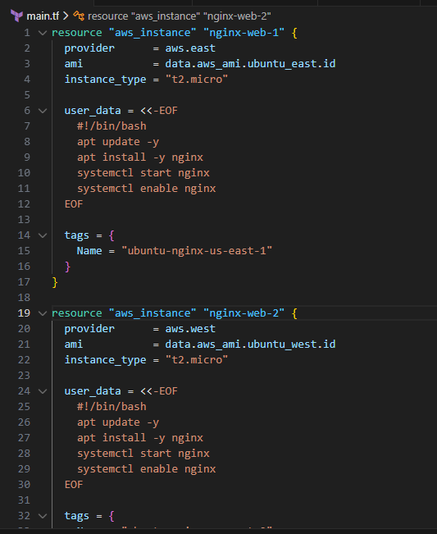
Resources are running in infra
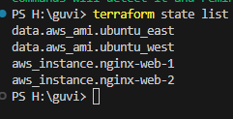
Nginx is running post deployment as have enabled port 80 under security group to enable the public traffic
