**LAB EXERCISE 12**

**BANKER’S ALGORITHM**

## Name: Akash Kumar Singh

## Roll No: 201460

## Batch: CS 48

## **//Code:**

#include<iostream>

using namespace std;

int main()

{

int n;

cout<<"Enter the number of processes:";

cin>>n;

int max[n],alloc[n],need[n];

int avail;

int inst;

cout<<"Enter the total number of instances:";

cin>>inst;

cout<<"Enter the maximum need of each process:";

for(int i=0;i<n;i++)

cin>>max[i];

cout<<"Enter the current allocation of all the processes:";

for(int i=0;i<n;i++)

cin>>alloc[i];

for(int i=0;i<n;i++)

need[i]=max[i]-alloc[i];

int total_alloc=0;

for(int i=0;i<n;i++)

total_alloc+=alloc[i];

avail=inst-total_alloc;

cout<<"The number of instances available at the beginning is "<<avail<<endl;

cout<<"Process\tMax\tAlloc\tNeed\n\n";

for(int i=0;i<n;i++)

cout<<"P"<<i<<"\t"<<max[i]<<"\t"<<alloc[i]<<"\t"<<need[i]<<"\n";

cout<<endl;

int seq[3];

int j=0;

for(int i=0;i<n;i++)

{

for(int i=0;i<n;i++)

{

if(need[i]<=avail and need[i]!=0)

{

avail=avail-need[i];

avail=avail+max[i];

need[i]=0;

seq[j]=i;

j++;

}

}

}

cout<<"The number of instances available at the end is "<<avail<<endl;

cout<<"Process\tMax\tAlloc\tNeed\n\n";

for(int i=0;i<n;i++)

cout<<"P"<<i<<"\t"<<max[i]<<"\t"<<alloc[i]<<"\t"<<need[i]<<"\n";

cout<<endl;

int flag=0;

for(int i=0;i<n;i++)

{

if(need[i]!=0)

{

cout<<"Safe Sequence does not exist!!!\n\n";

flag=1;

break;

}

}

if(flag==0)

{

cout<<"The sequence is:";

for(int i=0;i<n;i++)

cout<<"P"<<seq[i]<<"\t";

}

return 0;

}

**//Output:**

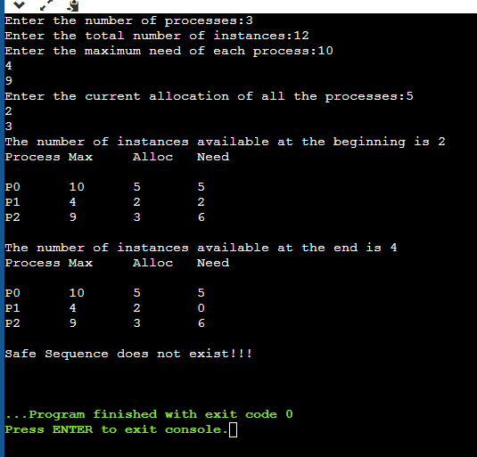

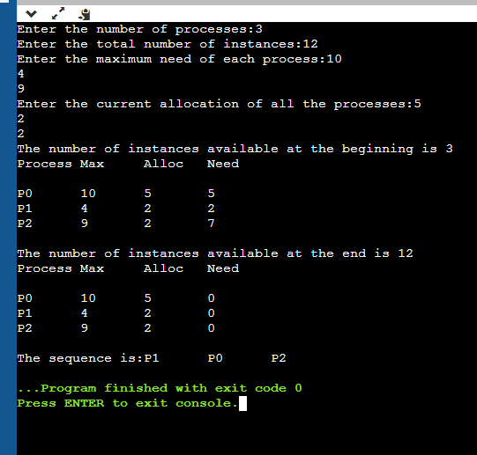

**//Code:**

#include<iostream>

using namespace std;

int main()

{

int n,m;

cout<<"Enter the number of processes:";

cin>>n;

cout<<"Enter the number of types of resources:";

cin>>m;

int max[n][m],alloc[n][m],need[n][m];

int avail[m];

int inst[m];

cout<<"Enter the total number of instances of each resource:";

for(int i=0;i<m;i++)

cin>>inst[i];

cout<<"Enter the maximum need of each process:";

for(int i=0;i<n;i++)

for(int j=0;j<m;j++)

cin>>max[i][j];

cout<<"Enter the current allocation of all the processes:";

for(int i=0;i<n;i++)

for(int j=0;j<m;j++)

cin>>alloc[i][j];

for(int i=0;i<n;i++)

for(int j=0;j<m;j++)

need[i][j]=max[i][j]-alloc[i][j];

int total_alloc[m];

for(int i=0;i<m;i++)

total_alloc[i]=0;

for(int i=0;i<m;i++)

for(int j=0;j<n;j++)

total_alloc[i]+=alloc[j][i];

for(int j=0;j<m;j++)

avail[j]=inst[j]-total_alloc[j];

cout<<"The number of instances available at the beginning is"<<endl;

for(int j=0;j<m;j++)

cout<<avail[j]<<"\t";

cout<<endl;

for(int i=0;i<n;i++)

{

cout<<"P"<<i<<"\t";

for(int j=0;j<m;j++)

cout<<max[i][j]<<" ";

cout<<endl;

}

cout<<endl;

for(int i=0;i<n;i++)

{

cout<<"P"<<i<<"\t";

for(int j=0;j<m;j++)

cout<<alloc[i][j]<<" ";

cout<<endl;

}

cout<<endl;

for(int i=0;i<n;i++)

{

cout<<"P"<<i<<"\t";

for(int j=0;j<m;j++)

cout<<need[i][j]<<" ";

cout<<endl;

}

int seq[n];

int k=0;

for(int i=0;i<n;i++)

{

for(int i=0;i<n;i++)

{

if(need[i][0]<=avail[0] && need[i][1]<=avail[1] && need[i][2]<=avail[2] && need[i][0]!=-1 && need[i][1]!=-1 && need[i][2]!=-1)

{

avail[0]=avail[0]-need[i][0];

avail[1]=avail[1]-need[i][1];

avail[2]=avail[2]-need[i][2];

avail[0]=avail[0]+max[i][0];

avail[1]=avail[1]+max[i][1];

avail[2]=avail[2]+max[i][2];

need[i][0]=-1;

need[i][1]=-1;

need[i][2]=-1;

seq[k]=i;

k++;

}

}

}

cout<<"The number of instances available at the end is"<<endl;

for(int j=0;j<m;j++)

cout<<avail[j]<<"\t";

cout<<endl;

for(int i=0;i<n;i++)

{

cout<<"P"<<i<<"\t";

for(int j=0;j<m;j++)

cout<<need[i][j]<<" ";

cout<<endl;

}

int flag=0;

for(int i=0;i<n;i++)

{

for(int j=0;j<m;j++)

if(need[i][j]!=-1)

{

cout<<"Safe Sequence does not exist!!!\n\n";

flag=1;

break;

}

}

if(flag==0)

{

cout<<"The sequence is:";

for(int i=0;i<n;i++)

cout<<"P"<<seq[i]<<"\t";

}

return 0;

}

**//Output -**

