

Safety Plan Lane Assistance

**Document Version: [Version]**

**Template Version 1.0, Released on 2017-06-21**



# Document history

**[Instructions: Fill in the date, version and description fields. You can fill out the Editor field with your name if you want to do so. Keep track of your editing as if this were a real world project.**

**For example, if this were your first draft or first submission, you might say version 1.0. If this is a second submission attempt, then you'd add a second line with a new date and version 2.0]**

|  |  |  |  |
| --- | --- | --- | --- |
| Date | Version | Editor | Description |
| 5/15/18 | 1.0 | Atul Singh | First attempt |
|  |  |  |  |
|  |  |  |  |
|  |  |  |  |
|  |  |  |  |

# Table of Contents

**[Instructions: We have provided a table of contents. If the table of contents is not showing up correctly in your word processor of choice, please update it. The table of contents should show each section of the document and page numbers or links. Most word processors can do this for you. In** [**Google Docs**](https://support.google.com/docs/answer/116338?co=GENIE.Platform%3DDesktop&hl=en)**, you can use headings for each section and then go to Insert > Table of Contents.** [**Microsoft Word**](https://support.microsoft.com/en-us/help/285059/how-to-create-a-table-of-contents-by-marking-text-in-word) **has similar capabilities]**

Document history

Table of Contents

Introduction

Purpose of the Safety Plan

Scope of the Project

Deliverables of the Project

Item Definition

Goals and Measures

Goals

Measures

Safety Culture

Safety Lifecycle Tailoring

Roles

Development Interface Agreement

Confirmation Measures

# Introduction

## Purpose of the Safety Plan

**[Instructions: Answer what is the purpose of a safety plan?]**

The purpose of safety plan is to give an overview of how to achieve a safe system. It enumerates the safety culture of an organization which includes the safety management roles and responsibilities.

## Scope of the Project

**[Instructions: Nothing to do here. This is for your information.]**

For the lane assistance project, the following safety lifecycle phases are in scope:

Concept phase

Product Development at the System Level

Product Development at the Software Level

The following phases are out of scope:

Product Development at the Hardware Level

Production and Operation

## Deliverables of the Project

**[Instructions: Nothing to do here. This is for your information.]**

The deliverables of the project are:

Safety Plan

Hazard Analysis and Risk Assessment

Functional Safety Concept

Technical Safety Concept

Software Safety Requirements and Architecture

# Item Definition

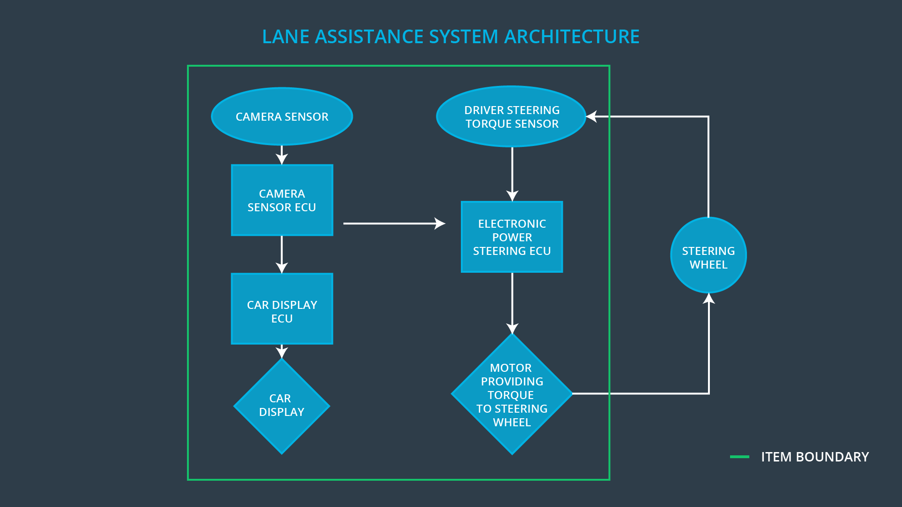

**Discuss these key points about the system:**

**What is the item in question, and what does the item do?**

The item investigated in the project is an Advance Driver Assistance System also known as ADAS systems.

**What are its two main functions? How do they work?**

It has two main functions:

1. Lane departure warning
2. Lane keep assistance

**Lane Departure Warning:** When the driver moves out of the lane the steering wheel will vibrate to warn the driver. This is detected by the camera sensor which sends data to the camera ECU this will ultimately cause the Power steering subsystem to generate the torque to vibrate the steering wheel.

**Lane keep assistance:** It help in moving the vehicle back to the lane by applying some amount of torque for a specific duration of time.

**Which subsystems are responsible for each function?**

The subsystem that are responsible for the implementation of these functionalities are:

* Camera​ ​subsystem
* Power Steering Subsystem
* Electronic​ ​Power​ ​Steering​ ​subsystem
* Car​ ​Display​ ​subsystem

**What are the boundaries of the item? What subsystems are inside the item? What elements or subsystems are outside of the item?**

Items are classified by drawing the boundaries around the subsystems. These boundaries are known as item boundaries. In our project the item boundaries were drawn to include three subsystems:

• Camera system

• Electronic Power Steering system

• Car Display system

Subsystems like the steering wheel lie outside of this item

**OPTIONAL**

**Optionally, include information about these points as well. These were not included in the lectures, but you might be able to find this information online:**

* **Operational and Environmental Constraints. This could especially be limited to camera performance; lane lines are difficult to detect in snow, fog, etc**
* **Legal requirements in your country for lane assistance technology**
* **National and International Standards Related to the Item**
* **Records of previously known safety-related incidents or behavioral shortfalls**

**]**

# Goals and Measures

## Goals

**[Instructions:**

**Describe the major goal of this project; what are we trying to accomplish by analyzing the lane assistance functions with ISO 26262?]**

The goal of this project is to analyze the Lane ​Assistance​ ​system​ ​components to Identify​ ​and evaluate the risk​ ​and​ ​hazardous​ ​situations, and finally to apply systems engineering in order to lower risk to a reasonable level.

## Measures

**[Instructions:**

**Fill in who will be responsible for each measure or activity. Hint: The lesson on Safety Management Roles and Responsibilities.**

**The options are:**

**All Team Members**

**Safety Manager**

**Project Manager**

**Safety Auditor**

**Safety Assessor**

**]**

|  |  |  |
| --- | --- | --- |
| Measures and Activities | Responsibility | Timeline |
| Follow safety processes | All​ ​Team Members | Constantly |
| Create and sustain a safety culture | All​ ​Team Members | Constantly |
| Coordinate and document the planned safety activities | Safety Manager | Constantly |
| Allocate resources with adequate functional safety competency | Project Manager | Within 2 weeks of start of project |
| Tailor the safety lifecycle | Safety Manager | Within 4 weeks of start of project |
| Plan the safety activities of the safety lifecycle | Safety Manager | Within 4 weeks of start of project |
| Perform regular functional safety audits | Safety Auditor | Once every 2 months |
| Perform functional safety pre-assessment prior to audit by external functional safety assessor | Safety Manager | 3 months prior to main assessment |
| Perform functional safety assessment | Safety Assessor | Conclusion of functional safety activities |

# Safety Culture

**[Instructions:**

**Describe the characteristics of your company's safety culture. How do these characteristics help maintain your safety culture. Hint: See the lesson about Safety Culture**

**]**

Safety is the highest priority of any company. So to ensure the safety culture following characteristics need to be observed:

* **High​ ​priority:** In-spite of cost and productivity being important for any successful organization safety is given the highest priority.
* **Accountability:** Decisions are traceable back to the people​ ​and​ ​teams​ ​who​ ​made​ ​the​ ​decisions so as to ensure accountability.
* **Rewards:** Organizations support and motivate functional safety by rewarding when the functional safety is kept on daily basis.
* **Penalties:** If the essential requirements for the functional safety are not kept and neglected then the organization puts penalties.
* **Independence:** Auditing team and designing team should be independent from each other. i.e. teams who design and develop a product should be independent from the teams who audit the work
* **Well​ ​defined​ ​processes:** Company should clearly define its design and management process.
* **Resources:** A functional safety project should have all the necessary resources along with the people having appropriate skills.
* **Communications:** Communication between the team should include full discloser of problems.

# Safety Lifecycle Tailoring

**[Instructions:**

**Describe which phases of the safety lifecycle are in scope and which are out of scope for this particular project. Hint: See the** **Intro section** **of this document**

**]**

For the lane assistance project, the following safety lifecycle phases are in scope:

Concept phase

Product Development at the System Level

Product Development at the Software Level

The following phases are out of scope:

Product Development at the Hardware Level

Production and Operation

# Roles

**[Instructions:**

**This section is here for your reference. You do not need to do anything here. It is provided to help with filling out the development interface agreement section.**

**]**

|  |  |
| --- | --- |
| Role | Org |
| Functional Safety Manager- Item Level | OEM |
| Functional Safety Engineer- Item Level | OEM |
| Project Manager - Item Level | OEM |
| Functional Safety Manager- Component Level | Tier-1 |
| Functional Safety Engineer- Component Level | Tier-1 |
| Functional Safety Auditor | OEM or external |
| Functional Safety Assessor | OEM or external |

# Development Interface Agreement

**[Instructions:**

**Assume in this project that you work for the tier-1 organization as described in the above roles table. You are taking on the role of both the functional safety manager and functional safety engineer.**

**Please answer the following questions:**

1. **What is the purpose of a development interface agreement?**

The purpose of a development interface agreement(DIA) is to delineate the roles and responsibilities between OEM and tier-1 involved in developing this product so as ​to​ ​ensure​ ​its​ ​development​ ​in​ ​compliance​ ​with​ ​ISO​ ​26262.

1. **What will be the responsibilities of your company versus the responsibilities of the OEM? Hint: In this project, the OEM is supplying a functioning lane assistance system. Your company needs to analyze and modify the various sub-systems from a functional safety viewpoint.**

**]**

The responsibilities of the OEM are to provide the requirement for lane keeping system and our company responsibility will be to develop and produce the system for the OEM and also to analyze and modify the various systems from a functional safety standpoint

# Confirmation Measures

**[Instructions:**

**Please answer the following questions:**

1. **What is the main purpose of confirmation measures?**

The​ ​purpose​ ​of​ ​the​ ​confirmation​ ​measures​ ​is to ensure that the functional safety measures have actually reduced the risk to levels that can be accepted by society

1. **What is a confirmation review?**

**​​**Confirmation​ ​review​​ ​ensure​ ​the​ ​projects​ ​comply​ ​with​ ​ISO​ ​26262. As the product is designed and developed another person will do the functional safety audit of the work to make sure that the ISO 26262 is being followed.

1. **What is a functional safety audit?**

Functional safety audit is to confirm that the implementation of the project conforms to the safety plan or not.

1. **What is a functional safety assessment?**

And functional safety assessment confirms​ ​that​ ​the​ ​plan,​ ​design​ ​and​ ​developed product​ ​actually​ ​achieve​ ​functional​ ​safety.

**]**

A safety plan could have other sections that we are not including here. For example, a safety plan would probably contain a complete project schedule.

There might also be a "Supporting Process Management" section that would cover "Part 8: Supporting Processes" of the ISO 26262 functional safety standard. This would include descriptions of how the company handles requirements management, change management, configuration management, documentation management, and software tool usage and confidence.

Similarly, a confirmation measures section would go into more detail about how each confirmation will be carried out.