

Functional Safety Concept Lane Assistance

**Document Version: [Version]**

**Template Version 1.0, Released on 2017-06-21**



# Document history

**[Instructions: Fill in the date, version and description fields. You can fill out the Editor field with your name if you want to do so. Keep track of your editing as if this were a real world project.**

**For example, if this were your first draft or first submission, you might say version 1.0. If this is a second submission attempt, then you'd add a second line with a new date and version 2.0]**

|  |  |  |  |
| --- | --- | --- | --- |
| Date | Version | Editor | Description |
| 18-5-2018 | 1.0 | Atul Singh | First Attempt |
|  |  |  |  |
|  |  |  |  |
|  |  |  |  |
|  |  |  |  |

# Table of Contents

**[Instructions: We have provided a table of contents. If you change the document structure, please update the table of contents accordingly. The table of contents should show each section of the document and page numbers or links. Most word processors can do this for you. In** [**Google Docs**](https://support.google.com/docs/answer/116338?co=GENIE.Platform%3DDesktop&hl=en)**, you can use headings for each section and then go to Insert > Table of Contents.** [**Microsoft Word**](https://support.microsoft.com/en-us/help/285059/how-to-create-a-table-of-contents-by-marking-text-in-word) **has similar capabilities]**

Document history

Table of Contents

Purpose of the Functional Safety Concept

Inputs to the Functional Safety Analysis

Safety goals from the Hazard Analysis and Risk Assessment

Preliminary Architecture

Description of architecture elements

Functional Safety Concept

Functional Safety Analysis

Functional Safety Requirements

Refinement of the System Architecture

Allocation of Functional Safety Requirements to Architecture Elements

Warning and Degradation Concept

# Purpose of the Functional Safety Concept

**[Instructions: Answer what is the purpose of a functional safety concept?]**

The purpose of functional safety is to identify safety requirements and then allocate those requirements to different parts of the item architecture. It looks at the general functionality of the item without going into its technical details.

# Inputs to the Functional Safety Concept

## Safety goals from the Hazard Analysis and Risk Assessment

**[Instructions:**

**REQUIRED:**

**Provide the lane departure warning and lane keeping assistance safety goals as discussed in the lessons and derived in the hazard analysis and risk assessment.**

**OPTIONAL:**

**If you expanded the hazard analysis and risk assessment to include other safety goals, include them here.**

**]**

|  |  |
| --- | --- |
| **ID** | **Safety Goal** |
| Safety_Goal_01 | Lane Departure Warning(LDW) should provide a limited amount of oscillating steering torque. |
| Safety_Goal_02 | Lane Keep Assistance should be time limited so that driver cannot misuse the system for autonomous driving |

## Preliminary Architecture

**[Instructions: Provide a preliminary architecture for the lane assistance item. Hint: See Lesson 3: Item Definition]**

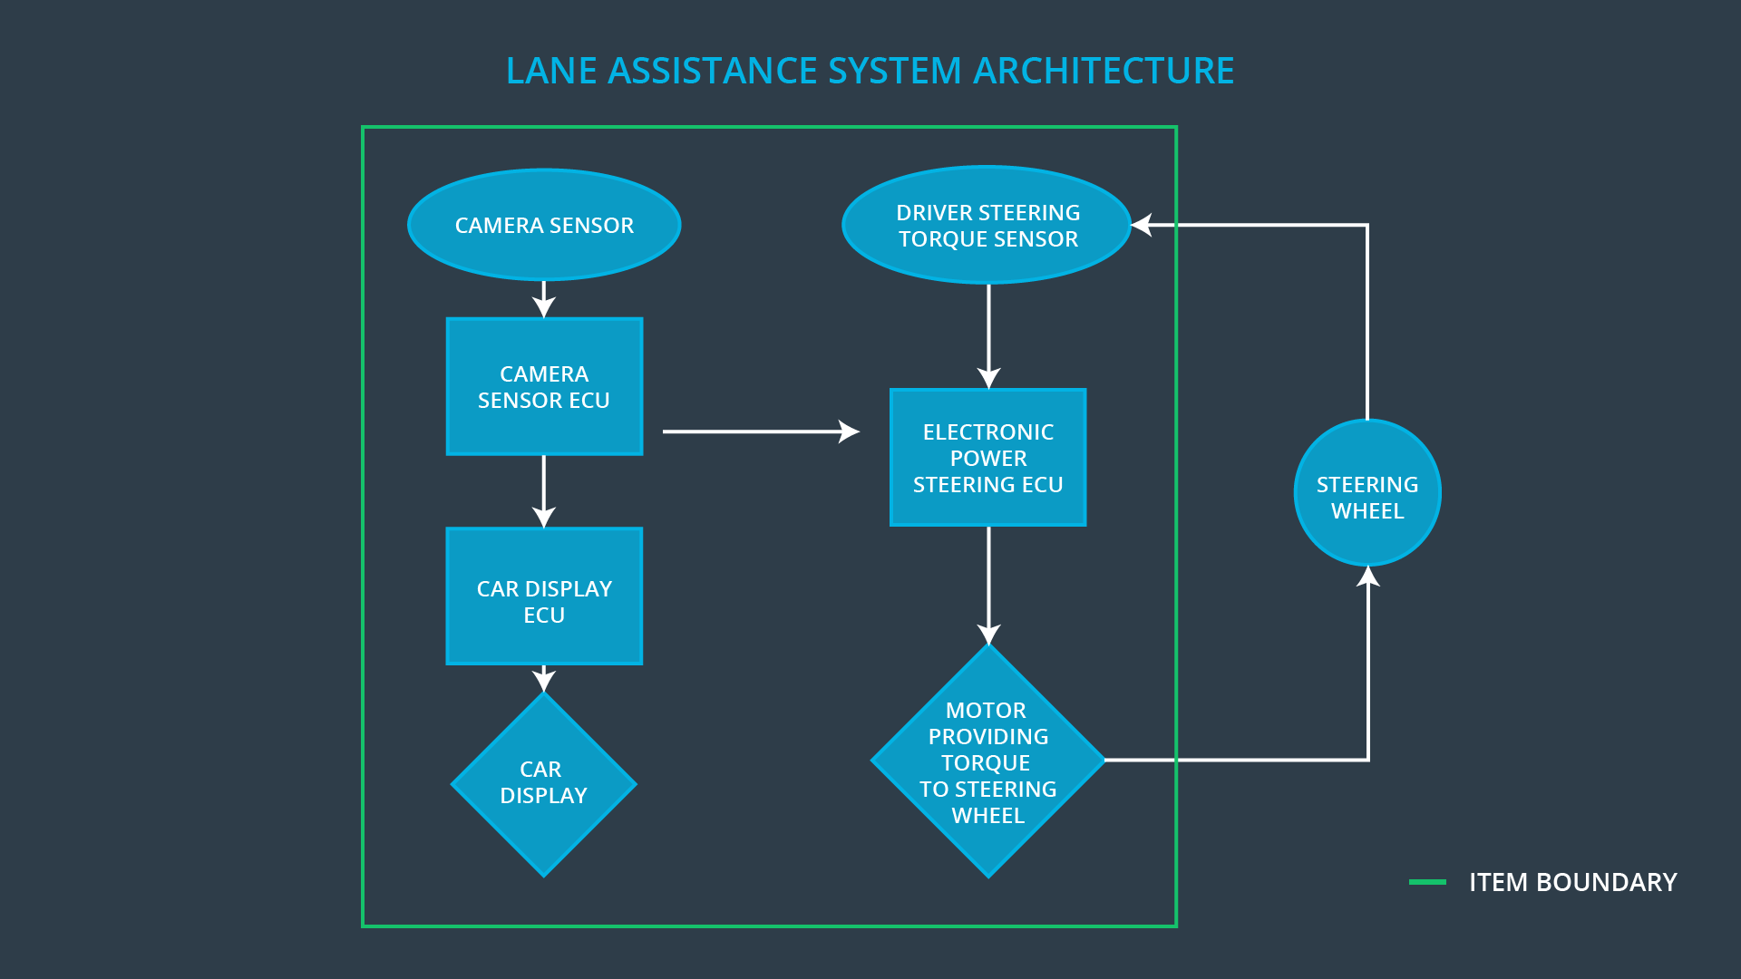

### Description of architecture elements

**[Instructions: Provide a description for each of the item elements; what is each element's purpose in the lane assistance item? ]**

|  |  |
| --- | --- |
| **Element** | **Description** |
| Camera Sensor | Provides lane images to the Camera Sensor ECU |
| Camera Sensor ECU | Checks whether the car is leaving the lane or is in the lane by going through the image provided by the camera sensor . |
| Car Display | It is uses to display warnings to the driver |
| Car Display ECU | It is responsible for the warnings that are displayed by the car Display. The warning can be for the activation and deactivations for LKA and LDW. |
| Driver Steering Torque Sensor | Measure the torque applied by the driver on the steering wheel by the driver. |
| Electronic Power Steering ECU | It process the inputs from Camera Sensor ECU and Driver Steering Torque Sensor to produce a torque that is transferred to the steering wheel motor to provide Lane Assistance Functionality |
| Motor | Receives the torque from the ECU and applies it to the steering wheel |

# Functional Safety Concept

The functional safety concept consists of:

* Functional safety analysis
* Functional safety requirements
* Functional safety architecture
* Warning and degradation concept

## Functional Safety Analysis

**[Instructions: Fill in the functional safety analysis table below.]**

|  |  |  |  |
| --- | --- | --- | --- |
| **Malfunction ID** | **Main Function of the Item Related to Safety Goal Violations** | **Guidewords (NO, WRONG, EARLY, LATE, MORE, LESS)** | **Resulting Malfunction** |
| Malfunction_01 | Lane Departure Warning (LDW) function shall apply an oscillating steering torque to provide the driver a haptic feedback | MORE | The torque amplitude provided by lane departure warning function may be very high(above limit) |
| Malfunction_02 | Lane Departure Warning (LDW) function shall apply an oscillating steering torque to provide the driver a haptic feedback | MORE | The torque amplitude provided by lane departure warning function may be very high (above limit) |
| Malfunction_03 | Lane Keeping Assistance (LKA) function shall apply the steering torque when active in order to stay in ego lane | NO | Since the LKA is not limited to a time duration, the driver may misuse it as an autonomous driving function. |

## Functional Safety Requirements

**[Instructions: Fill in the functional safety requirements for the lane departure warning ]**

Lane Departure Warning (LDW) Requirements:

|  |  |  |  |  |
| --- | --- | --- | --- | --- |
| **ID** | **Functional Safety Requirement** | **ASIL** | **Fault Tolerant Time Interval** | **Safe State** |
| Functional  Safety  Requirement  01-01 | ECU should make sure that the oscillating torque amplitude is below Max_Torque_Amplitude | C | 50 ms | Lane Assistance functionality is kept in off state |
| Functional  Safety  Requirement  01-02 | ECU should make sure that the oscillating torque frequency is below MAX_Torque_Frequency | C | 50 ms | Lane Assistance functionality is kept in off state |

Lane Departure Warning (LDW) Verification and Validation Acceptance Criteria:

|  |  |  |
| --- | --- | --- |
| **ID** | **Validation Acceptance**  **Criteria and Method** | **Verification Acceptance**  **Criteria and Method** |
| Functional  Safety  Requirement  01-01 | The MAX_Torque_Amplitude is chosen high enough to be detected by the driver and low enough so that the driver may not loose control | As the MAX_Torque_Amplitude is crossed the system should turn off |
| Functional  Safety  Requirement  01-02 | The MAX_Torque_Fequency is chosen high enough to be detected by the driver and low enough so that the driver may not loose control | As the MAX_Torque_Fequency is crossed the system should turn off |

**[Instructions: Fill in the functional safety requirements for the lane keeping assistance]**

Lane Keeping Assistance (LKA) Requirements:

|  |  |  |  |  |
| --- | --- | --- | --- | --- |
| **ID** | **Functional Safety Requirement** | **ASIL** | **Fault Tolerant Time Interval** | **Safe State** |
| Functional  Safety  Requirement  02-01 | It should be ensured by the electronic power steering ECU that the torque is applied only for Max_Duration | B | 500ms | Lane Assistance functionality is kept in off state |

Lane Keeping Assistance (LKA) Verification and Validation Acceptance Criteria:

|  |  |  |
| --- | --- | --- |
| **ID** | **Validation Acceptance**  **Criteria and Method** | **Verification Acceptance**  **Criteria and Method** |
| Functional  Safety  Requirement  02-01 | Test and validate that the Max_Duration chosen really dissuades drivers from taking their hands off the wheel. | The lane keep assistance system should turn off if max_duration is exeeded |

## Refinement of the System Architecture

**[Instructions: Include the refined system architecture. Hint: The refined system architecture should include the system architecture from the end of the functional safety lesson including all of the ASIL labels.]**

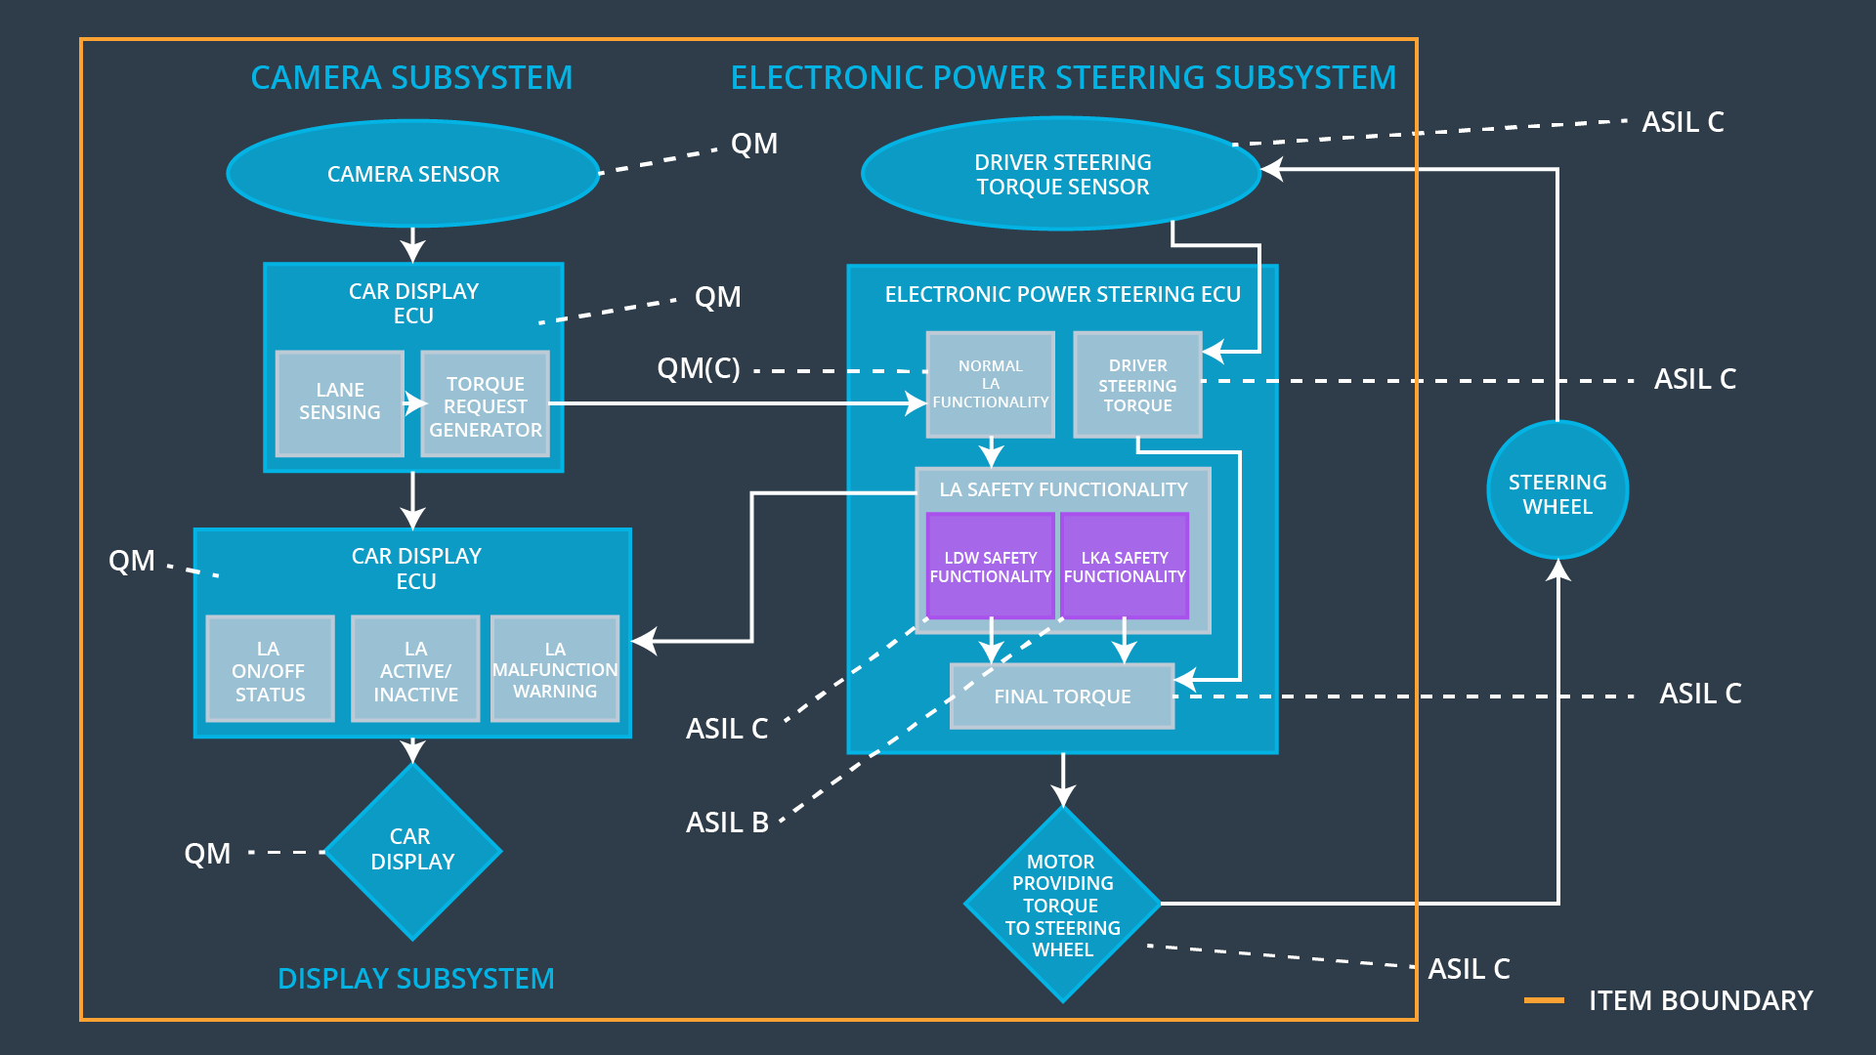

## Allocation of Functional Safety Requirements to Architecture Elements

**[Instructions: Mark which element or elements are responsible for meeting the functional safety requirement. Hint: Only one ECU is responsible for meeting all of the requirements.]**

|  |  |  |  |  |
| --- | --- | --- | --- | --- |
| **ID** | **Functional Safety Requirement** | **Electronic Power Steering ECU** | **Camera ECU** | **Car Display ECU** |
| Functional  Safety  Requirement  01-01 | It should be ensured by the electronic power steering ECU that the torque is applied only for Max_Duration | **X** |  |  |
| Functional  Safety  Requirement  01-02 | ECU should make sure that the oscillating torque amplitude is below Max_Torque_Amplitude | **X** |  |  |
| Functional  Safety  Requirement  02-01 | ECU should make sure that the oscillating torque frequency is below MAX_Torque_Frequency | **X** |  |  |

## Warning and Degradation Concept

**[Instructions: Fill in the warning and degradation concept.]**

|  |  |  |  |  |
| --- | --- | --- | --- | --- |
| **ID** | **Degradation Mode** | **Trigger for Degradation Mode** | **Safe State invoked?** | **Driver Warning** |
| WDC-01 | Turn off lane assistance functionality | Malfunction_01 | Yes | Car Displays shows the  Lane Assistant Malfunction Warning |
| WDC-02 | Turn off lane assistance functionality | Malfunction_02 | Yes | Car Displays shows the  Lane Assistant Malfunction Warning |