Arrays

Compared to matrices, arrays can have more than two dimensions.

We can use the array() function to create an array, and the dim parameter to specify the dimensions:

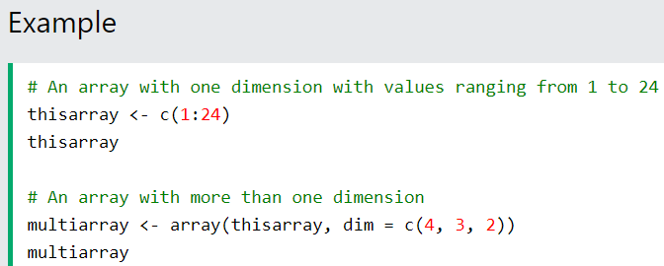

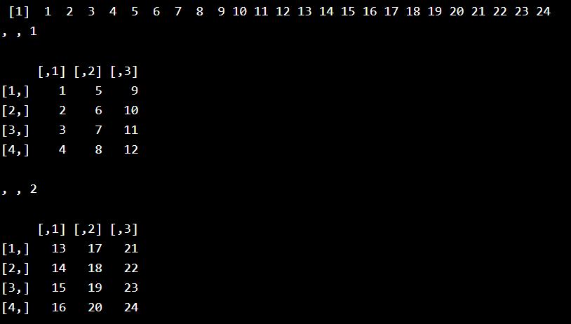

Example Explained

In the example above we create an array with the values 1 to 24.

How does dim=c(4,3,2) work?  
The first and second number in the bracket specifies the amount of rows and columns.  
The last number in the bracket specifies how many dimensions we want.

**Note:** Arrays can only have one data type

Access Array Items

You can access the array elements by referring to the index position. You can use the [] brackets to access the desired elements from an array:

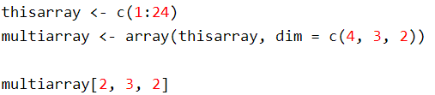

The syntax is as follow: array[row position, column position, matrix level]

You can also access the whole row or column from a matrix in an array, by using the c() function:

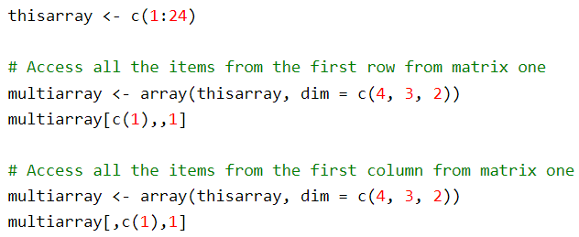

A comma (,) before c() means that we want to access the column.

A comma (,) after c() means that we want to access the row.

Check if an Item Exists

To find out if a specified item is present in an array, use the %in% operator:

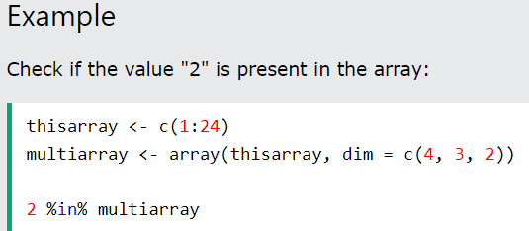

Amount of Rows and Columns

Use the dim() function to find the amount of rows and columns in an array:

Array Length

Use the length() function to find the dimension of an array: