Attributes:

**Attributes** are metadata associated with objects that provide additional information about the object, such as dimensions, class, or names. Attributes do not change the content of an object but define certain properties or characteristics. Common attributes include:

1. **names()**: Used for naming the elements of a vector or other objects.
2. **dim()**: Defines the dimensions of matrices or arrays.
3. **dimnames()**: Provides names for the dimensions of matrices or arrays.
4. **class()**: Specifies the class (or type) of the object, like "data.frame", "matrix", etc.
5. **length()**: Returns the number of elements in the object.
6. **rownames() / colnames()**: Assigns or retrieves the row or column names of a matrix or data frame.
7. **tsp()**: Represents the time series attributes of an object.

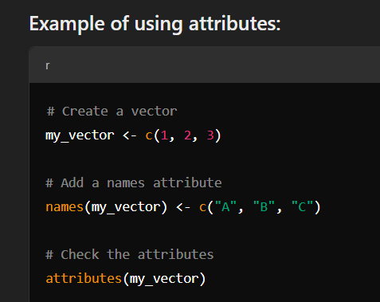

**Symbols**

* A **symbol** in R is essentially the name of an object (e.g., variable, function) rather than the object itself. Symbols are used as placeholders to refer to values or objects stored in environments.
* For example, when you define x <- 5, x is a symbol representing the value 5.
* The function as.symbol() or quote() can be used to explicitly create symbols in R.

**Environments**

* An **environment** in R is a collection of symbol-value pairs (like a dictionary or hash table) where symbols (names) are mapped to their corresponding values (objects).
* Every R session has a chain of environments, with the **global environment** (your workspace) at the top.
* Functions in R operate in environments, which allows for **lexical scoping**. This means a function looks for values first in its local environment and then moves up through parent environments if necessary.
* The **base environment** is the root of all environments in R.