Name:vishal singh

Roll no:12939

1) <!DOCTYPE html>

<html lang="en">

<head>

    <meta charset="UTF-8">

    <meta name="viewport" content="width=device-width, initial-scale=1.0">

    <title>Document</title>

</head>

<style>

    .box {

        border: 10px solid;

        text-align: center;

        height: 500px;

        width: 700px;

        margin: auto;

        margin-top: 100px;

        background-color: lightcoral;

        border-radius: 10px;

        box-shadow: 2px 4px 18px 5px;

        padding: 10px;

        box-sizing: border-box;

    }

    body {

        background-color: saddlebrown;

    }

    .hr {

        border: 1px solid black;

    }

    textarea {

        resize: none;

    }

    .btn {

        margin-left: 300px;

        margin-top: 20px;

        padding: 5px;

        border: 3px solid black;

        color: whitesmoke;

        background-color: crimson;

        cursor: pointer;

    }

    .btn:hover {

        background-color: darkgoldenrod;

    }

    .fname {

        border: 3px solid black;

        margin: auto;

        padding: 5px;

    }

    .tarea {

        border: 3px solid black;

        margin: auto;

        padding: 5px;

    }

</style>

<body>

    <div class="box">

        <h1>SEND FEEDBACK</h1>

        <hr class="hr">

        <form action="welcome.html"><br>

            <input type="text" class="fname" size="50" placeholder="Email" autocomplete="off"><br><br>

            <textarea class="tarea" cols="46" rows="5" placeholder="Message" autocomplete="off"></textarea>

            <br><br>

            <input type="submit" value="Send" class="btn">

        </form>

    </div>

</body>

</html>

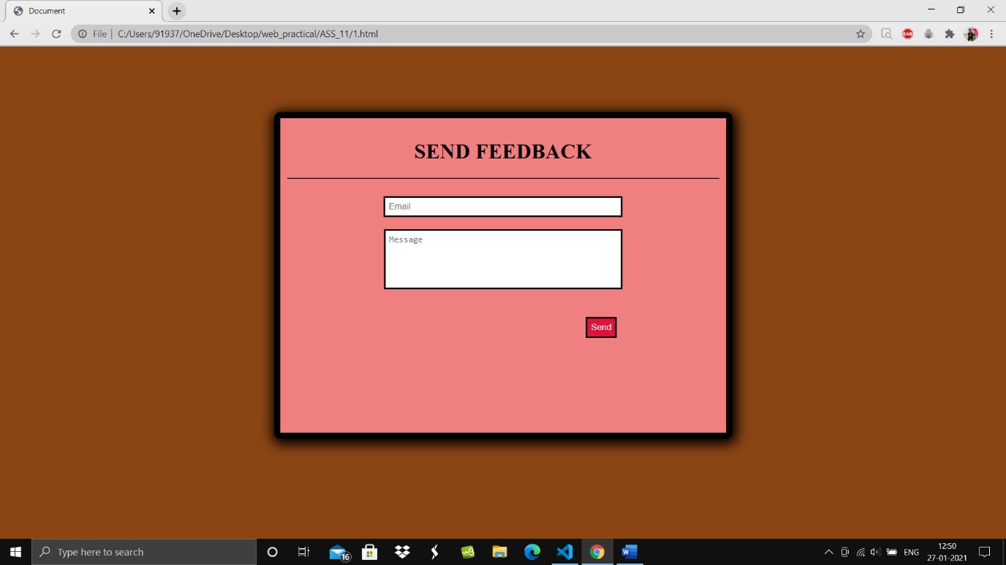

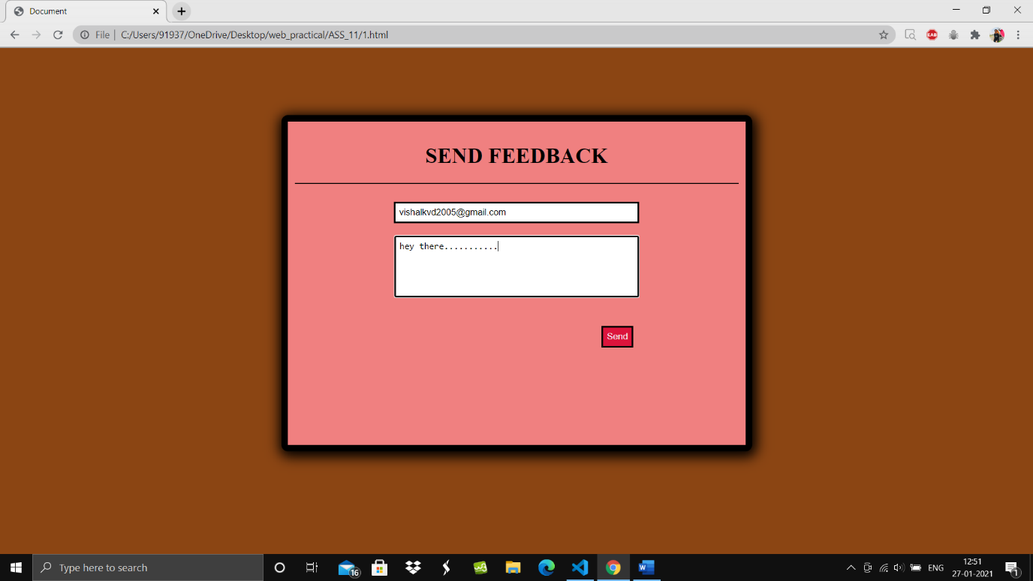

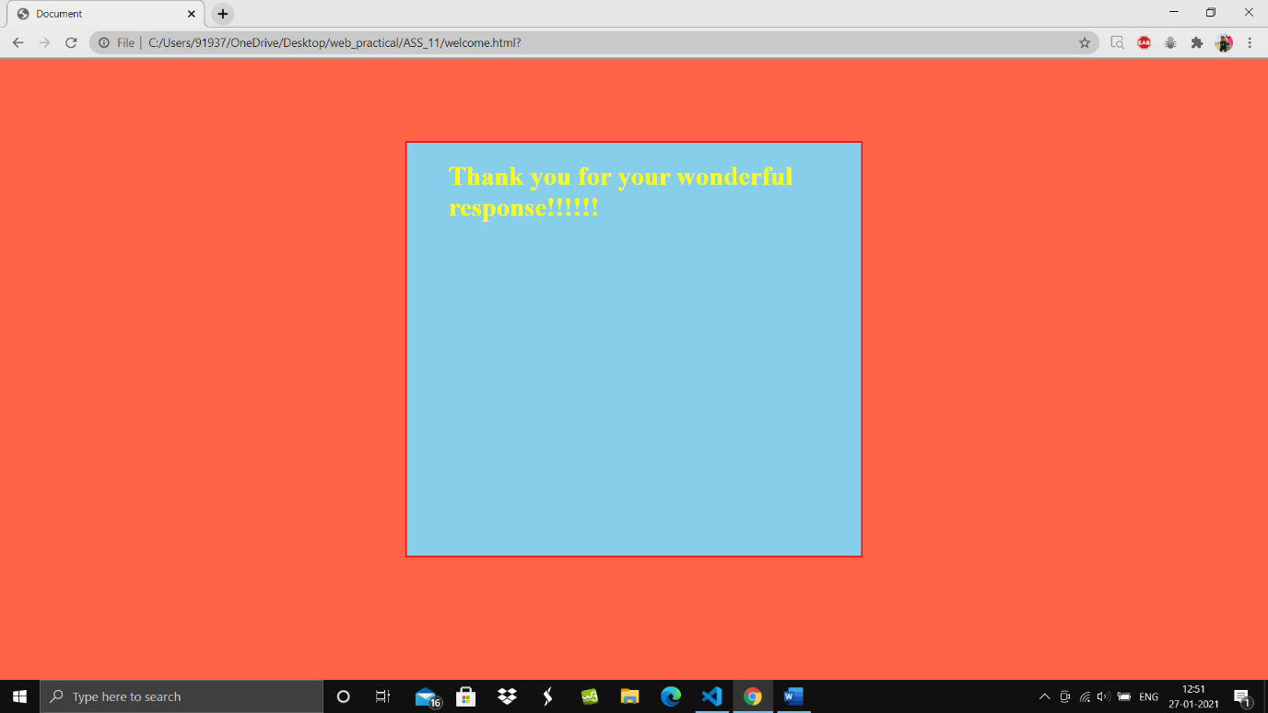

2) <!DOCTYPE html>

<html lang="en">

<head>

    <meta charset="UTF-8">

    <meta name="viewport" content="width=device-width, initial-scale=1.0">

    <title>Document</title>

    <link rel="preconnect" href="https://fonts.gstatic.com">

    <link href="https://fonts.googleapis.com/css2?family=Ubuntu:wght@300&display=swap" rel="stylesheet">

    <!--this is from google fonts -->

</head>

<style>

    .box {

        border-style: dotted;

        height: 500px;

        width: 500px;

        margin: auto;

        margin-top: 100px;

        padding: 50px;

        font-family: Ubuntu, sans-serif;

        border-color: black;

        font-weight: 40;

        background-color: cadetblue;

        border-radius: 10px;

    }

    body

    {

        background-color: darkgoldenrod;

    }

    .btn {

        border-radius: 7px;

        padding: 5px;

        background-color: grey;

        font-weight: bold;

        text-align: center;

    }

    .fname {

        border: 3px solid black;

        margin: auto;

        padding: 5px;

    }

    .spa {

        margin-left: 150px;

        color: red;

    }

    .star {

        position: relative;

        margin-left: 300px;

        float: left;

    }

</style>

<body>

    <div class="box">

        <h1 class="head">Subscribe to our mailing list</h1>

        <br><br>

        <form action="">

            <label><b>Email Address</b></label>

            <span class="spa"><small>* indicates required</small></span>

            <br>

            <div> <input type="text" class="fname" placeholder="Email" size="50" required>

            </div>

            <br><br>

            <label><b>First Name</b></label>

            <br>

            <div><input type="text" class="fname" placeholder="Email" size="50" required></div>

            <br><br>

            <label><b>Last Name</b> </label>

            <br>

            <input type="text" class="fname" placeholder="Email" size="50" required>

            <br><br>

            <br>

            <input type="button" size="12" value="Subscribe" class="btn">

        </form>

    </div>

</body>

</html>

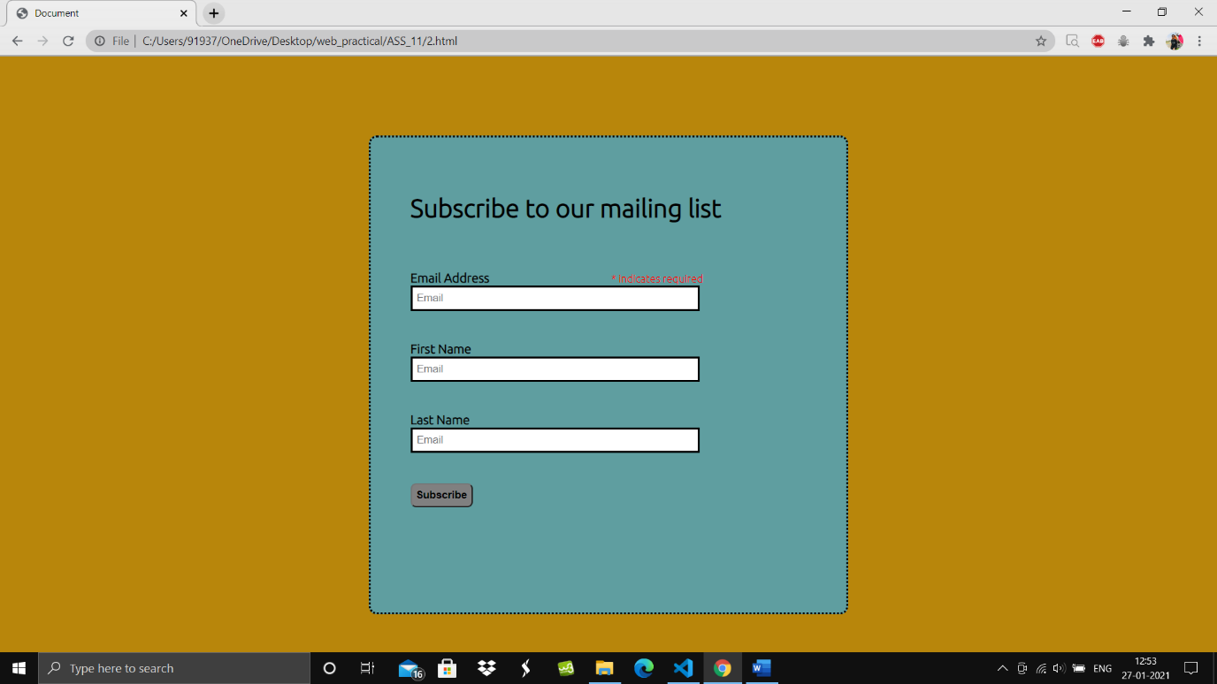

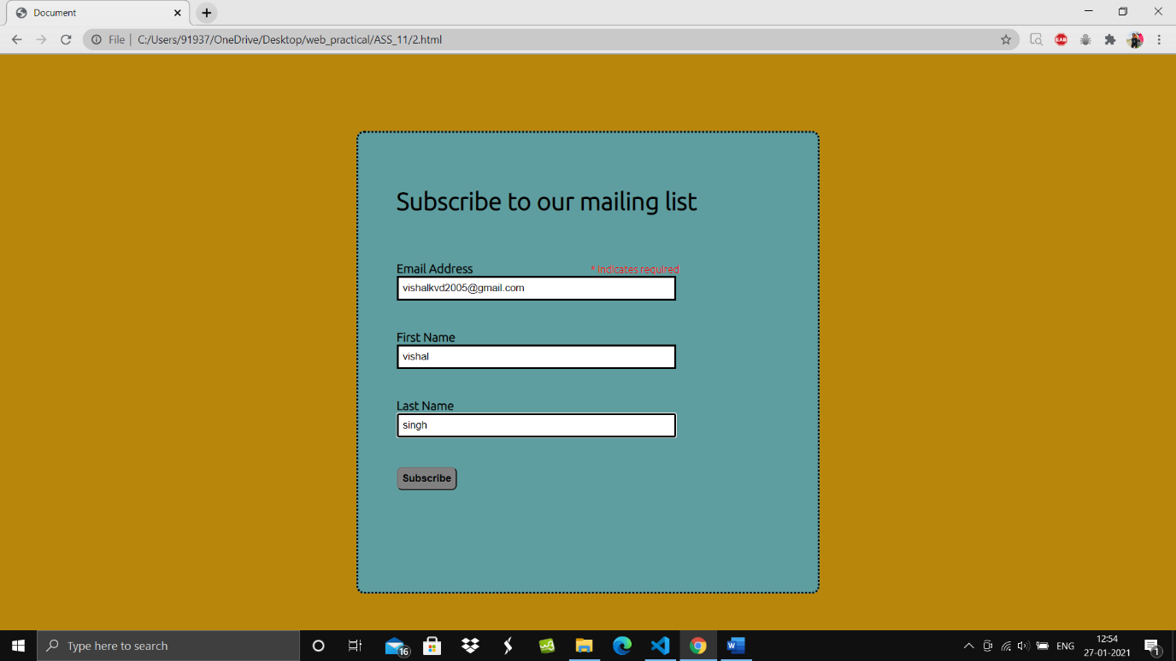

3) <!DOCTYPE html>

<html lang="en">

<head>

    <meta charset="UTF-8">

    <meta name="viewport" content="width=device-width, initial-scale=1.0">

    <title>GOA beach</title>

    <link rel="stylesheet" href="style.css">

</head>

<style>

    /* *

    {

        margin:0;

        padding: 0;

    } */

</style>

</body>

<body>

    <div class="selection">

        <h1>The 6 Best Resorts in Goa</h1>

        <span>check out our pick of great resorts in goa.</span>

        <br>

        <br>

        <strong>Filter by:</strong>

        <br>

        <br>

        <span><b>Review score</b></span>

        <br>

        <input type="checkbox">

        <label> Superb:9+</label><br><br>

        <input type="checkbox">

        <label> Very good:8+</label><br><br>

        <input type="checkbox">

        <label> Good:7+</label><br><br>

        <input type="checkbox">

        <label> Pleasant:6+</label><br><br>

        <input type="checkbox">

        <label> Average:5+</label><br><br>

        <button class="btn"><b>Submit</b></button>

    </div>

    <div class="box1">

        <div class="container1">

            <img src="images/circle-cropped (1).png" alt="">

        </div>

        <div class="tone">

            <h2>Calangute Beach</h2>

            <img src="images/1.png" alt="" height="20px">

            <span>Agonda</span>

            <p>Known as the “Queen of Beaches” in Goa, Calangute Beach caters to all types of travellers, from nature

                lovers to adventure junkies to party freaks. Acting as a haven for nature lovers, in particular, this

                beach is the biggest and the most popular one in North Goa, boasting of scintillating charm as well as

                beauty.</p>

        </div>

        <div class="spa1">

            <span><b>Superb</b></span>

            <br>

            <small>220 Reviews</small>

        </div>

        <div class="rev1">

            <b>9.3</b>

        </div>

    </div>

    <div class="box2">

        <div class="container2">

            <img src="images/circle-cropped (2).png" alt="">

        </div>

        <div class="ttwo">

            <h2>Candolim Beach</h2>

            <img src="images/1.png" alt="" height="20px">

            <span>Vasco</span>

            <p>The finesse of Goa lies in beaches flanked with shacks, pubs and interspersed shopping places. Candolim

                Beach is one of the best places to explore if you want to have an immersive Goan experience. It is a

                part of the Goan trio of Baga, Calangute and Candolim beaches where all the happening parties take

                place.</p>

        </div>

        <div class="spa2">

            <span><b>Superb</b></span>

            <br>

            <small>220 Reviews</small>

        </div>

        <div class="rev2">

            <b>9.0</b>

        </div>

    </div>

    <div class="box3">

        <div class="container3">

            <img src="images/circle-cropped (3).png" alt="">

        </div>

        <div class="tthree">

            <h2>

                Vagator Beach</h2>

            <img src="images/1.png" alt="" height="20px">

            <span>Juhu</span>

            <p>Vagator Beach in Goa offers tourists and travel enthusiasts the opportunity to have an experience of a

                lifetime. It is situated on the absolute northern fringes of Bardez Taluka, on the opposite side of the

                river Chapora, which starts from Morjim in Pernem. Towards the south of the Vagator Beach lies Anjuna,

                one of the oldest tourist destinations in Goa. </p>

        </div>

        <div class="spa3">

            <span><b>Superb</b></span>

            <br>

            <small>220 Reviews</small>

        </div>

        <div class="rev3">

            <b>8.1</b>

        </div>

    </div>

    <div class="box4">

        <div class="container4">

            <img src="images/circle-cropped (4).png" alt="">

        </div>

        <div class="tfour">

            <h2>Arambol Beach</h2>

            <img src="images/1.png" alt="" height="20px">

            <span>Kutin</span>

            <p>The newest beach developed in Goa, Arambol Beach is a part of a fisherman’s village, and attracts a

                number of tourists across the year. Arambol Beach is considered to be the most beautiful beaches in Goa,

                and borders the Mandrem Beach and Keri Beach on two sides.</p>

        </div>

        <div class="spa4">

            <span><b>Superb</b></span>

            <br>

            <small>220 Reviews</small>

        </div>

        <div class="rev4">

            <b>8.4</b>

        </div>

    </div>

    <div class="box5">

        <div class="container5">

            <img src="images/circle-cropped (5).png" alt="">

        </div>

        <div class="tfive">

            <h2>

                Morjim Beach</h2>

            <img src="images/1.png" alt="" height="20px">

            <span>Vagmolo</span>

            <p>Morjim Beach in Goa is one of the best beaches to visit in the course of your holiday. The scenic beauty

                of changing colours of the sky and setting sun defines this place. The Morjim beach is

                acknowledged as one of the pristine beaches in Goa for its tranquil environment</p>

        </div>

        <div class="spa5">

            <span><b>Superb</b></span>

            <br>

            <small>220 Reviews</small>

        </div>

        <div class="rev5">

            <b>7.5</b>

        </div>

    </div>

    <div class="box6">

        <div class="container6">

            <img src="images/circle-cropped (1).png" alt="">

        </div>

        <div class="tsix">

            <h2>

                Ashwem Beach</h2>

            <img src="images/1.png" alt="" height="20px">

            <span>Calangute</span>

            <p>Ashwem Beach is located in the coastal village of Mandrem in North Goa in the Pernem district. It is

                located between the Morjim beach and Mandrem beach and is very close to the capital city of Panaji. It

                is one of the most popular beaches in North Goa, along with a few other beaches such as the Junas beach.

            </p>

        </div>

        <div class="spa6">

            <span><b>Superb</b></span>

            <br>

            <small>220 Reviews</small>

        </div>

        <div class="rev6">

            <b>6.2</b>

        </div>

    </div>

</body>

</html>

STYLE.CSS

    div {

        /* outline: 2px solid red;  */

        height: 250px;

        float: left;

    }

    .container1 {

        width: 200px;

        height: 200px;

        float: left;

    }

    .tone {

        width: 500px;

        float: left;

    }

    .box1 {

        width: 60%;

        margin-left: 500px;

        margin-top: 50px;

        position: absolute;

    }

    .box2 {

        width: 60%;

        margin-left: 500px;

        margin-top: 370px;

        position: absolute;

    }

    .container2 {

        width: 200px;

        height: 200px;

        float: right;

    }

    .ttwo {

        width: 500px;

        float: right;

    }

    .box3 {

        width: 60%;

        margin-left: 500px;

        margin-top: 700px;

        position: absolute;

    }

    .container3 {

        width: 200px;

        height: 200px;

        float: left;

    }

    .tthree {

        width: 500px;

        float: left;

    }

    .box4 {

        width: 60%;

        margin-left: 500px;

        margin-top: 1000px;

        position: absolute;

    }

    .container4 {

        width: 200px;

        height: 200px;

        float: right;

    }

    .tfour {

        width: 500px;

        float: right;

    }

    .box5 {

        width: 60%;

        margin-left: 500px;

        margin-top: 1300px;

        position: absolute;

    }

    .container5 {

        width: 200px;

        height: 200px;

        float: left;

    }

    .tfive {

        width: 500px;

        float: left;

    }

    .box6 {

        width: 60%;

        margin-left: 500px;

        margin-top: 1600px;

        position: absolute;

    }

    .container6 {

        width: 200px;

        height: 200px;

        float: right;

    }

    .tsix {

        width: 500px;

        float: right;

    }

    body {

        background-image: linear-gradient(120deg, #84fab0 0%, #8fd3f4 100%);

        font-family: 'Segoe UI', Tahoma, Geneva, Verdana, sans-serif;

    }

    .selection {

        height: 500px;

        width: 400px;

        padding: 40px;

    }

    .btn {

        background-color: #eeeeee;

        border-radius: 8px;

        padding: 10px;

        cursor: pointer;

    }

    .btn:hover {

        background-color: #fcbad3;

    }

    .spa1 {

        position: absolute;

        margin-left: 100px;

        padding: 10px;

        width: 150px;

        margin-left: 800px;

    }

    .rev1 {

        position: absolute;

        height: 30px;

        width: 30px;

        padding: 5px;

        border-radius: 15px;

        background-color: greenyellow;

        margin-left: 890px;

        margin-top: 12px;

    }

    .spa2 {

        position: absolute;

        margin-left: 40px;

        padding: 10px;

        width: 150px;

    }

    .rev2 {

        position: absolute;

        height: 30px;

        width: 30px;

        padding: 5px;

        border-radius: 15px;

        background-color: indianred;

        margin-right: 400px;

        margin-top: 12px;

    }

    .spa3 {

        position: absolute;

        margin-left: 100px;

        padding: 10px;

        width: 150px;

        margin-left: 800px;

    }

    .rev3 {

        position: absolute;

        height: 30px;

        width: 30px;

        padding: 5px;

        border-radius: 15px;

        background-color: orange;

        margin-left: 890px;

        margin-top: 12px;

    }

    .spa4 {

        position: absolute;

        margin-left: 40px;

        padding: 10px;

        width: 150px;

    }

    .rev4 {

        position: absolute;

        height: 30px;

        width: 30px;

        padding: 5px;

        border-radius: 15px;

        background-color: tomato;

        margin-right: 400px;

        margin-top: 12px;

    }

    .spa5 {

        position: absolute;

        margin-left: 100px;

        padding: 10px;

        width: 150px;

        margin-left: 800px;

    }

    .rev5 {

        position: absolute;

        height: 30px;

        width: 30px;

        padding: 5px;

        border-radius: 15px;

        background-color: springgreen;

        margin-left: 890px;

        margin-top: 12px;

    }

    .spa6 {

        position: absolute;

        margin-left: 40px;

        padding: 10px;

        width: 150px;

    }

    .rev6 {

        position: absolute;

        height: 30px;

        width: 30px;

        padding: 5px;

        border-radius: 15px;

        background-color: palevioletred;

        margin-right: 400px;

        margin-top: 12px;

    }

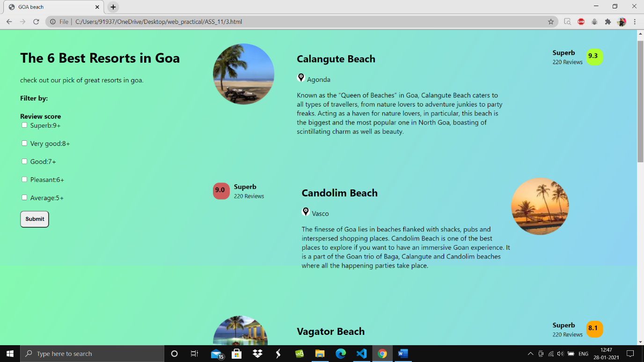

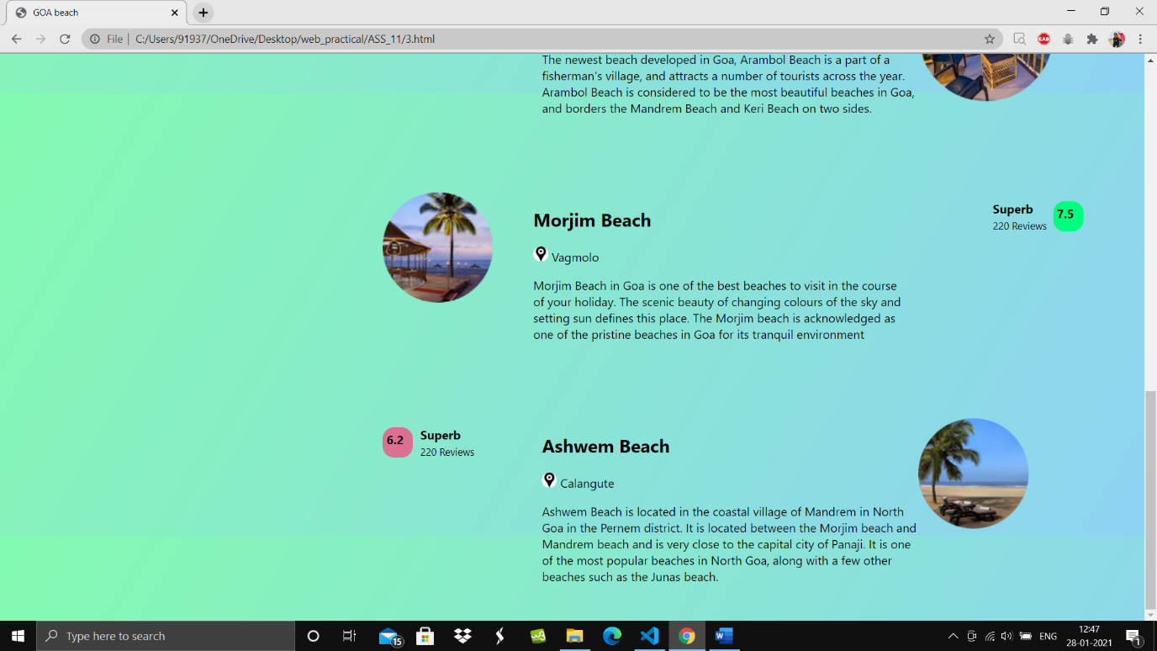

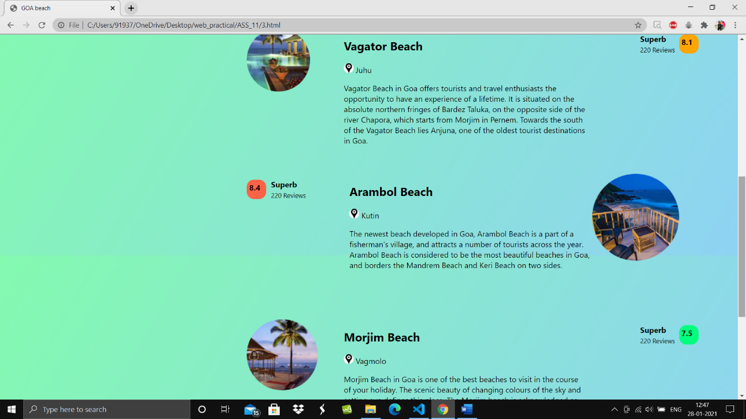

4) <!DOCTYPE html>

<html lang="en">

<head>

    <meta charset="UTF-8">

    <meta name="viewport" content="width=device-width, initial-scale=1.0">

    <title>Document</title>

</head>

<style>

   .box {

        border: 10px solid;

        text-align: center;

        height: 500px;

        width: 700px;

        margin: auto;

        margin-top: 100px;

        background-color: lightcoral;

        border-radius: 10px;

        box-shadow: 2px 4px 18px 5px;

        padding: 10px;

        box-sizing: border-box;

    }

body{

    background-color: #8EC5FC;

background-image: linear-gradient(62deg, #8EC5FC 0%, #E0C3FC 100%);

}

.input

{

    padding:8px;

}

.btn

{

    padding: 8px;

    background-color: burlywood;

}

.car

{

    margin-left:20px;

}

.span

{

    color:olive;

}

</style>

<body>

    <div class="box">

        <h1><b>SUBSCRIBE</b></h1>

<img class="car"src="images/car2.png" alt="">

<br><br>

<strong><b>Subscribe to get the latest</b></strong> <span class="span">news & updates.</span>

<br><br>

<input type="text" size="30"placeholder="Your email address" class="input">

<button class="btn">Subscribe</button>

    </div>

</body>

</html>

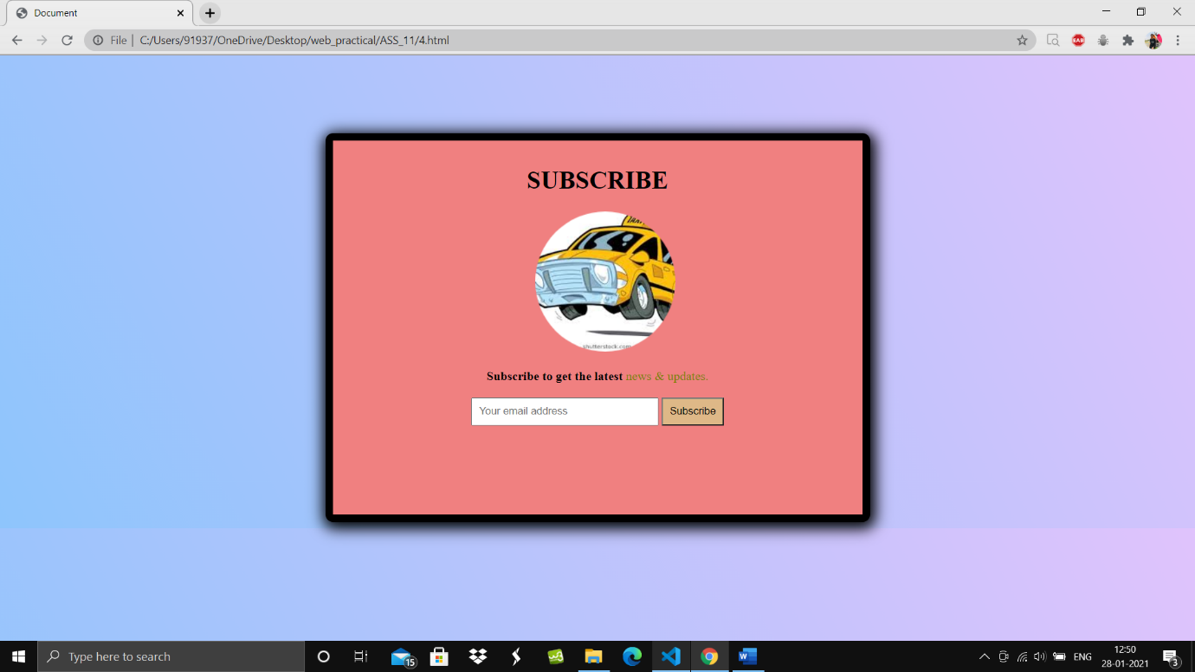

5) <!DOCTYPE html>

<html lang="en">

<head>

    <meta charset="UTF-8">

    <meta name="viewport" content="width=device-width, initial-scale=1.0">

    <title>Document</title>

    <link rel="preconnect" href="https://fonts.gstatic.com">

    <link href="https://fonts.googleapis.com/css2?family=Montserrat:wght@300;400&display=swap" rel="stylesheet">

</head>

<style>

    .box2 {

        background: #FEAC5E;

        /* fallback for old browsers */

        background: -webkit-linear-gradient(to right, #4BC0C8, #C779D0, #FEAC5E);

        /* Chrome 10-25, Safari 5.1-6 */

        background: linear-gradient(to right, #4BC0C8, #C779D0, #FEAC5E);

        /* W3C, IE 10+/ Edge, Firefox 16+, Chrome 26+, Opera 12+, Safari 7+ */

    }

    body {

        background-color: cadetblue;

    }

    * {

        margin: 0;

        padding: 0;

    }

    div {

        /* outline: 2px solid red;  */

        float: left;

        font-family: 'Montserrat', sans-serif;

    }

    .box1 {

        height: 745px;

        width: 50%;

        float: left;

    }

    .box2 {

        position: relative;

        height: 745px;

        width: 50%;

        float: left;

        background-color: gainsboro;

    }

    .box4 {

        padding: 100px;

        margin-top: 200px;

        position: absolute;

        margin-left: 120px;

    }

    .box3 {

        position: absolute;

        padding: 15px;

        margin-top: 120px;

        margin-left: 200px;

    }

    .in1 {

        padding: 8px;

        background-color: #eaeaea;

        color: white;

    }

    .in:focus {

        background-color: lightblue;

        border: 3px solid #555;

    }

    .sub {

        width: 200px;

        padding: 8px;

        background-color: black;

        color: cornsilk;

        border-radius: 14px;

        cursor: pointer;

        text-align: center;

        font-size: 20px;

    }

    .logo {

        margin-left: 5px;

    }

    .box5

    {

        width:100px ;

        height: 70px;

       margin-right: 15px;

       margin-top: 15px;

        float: right;

    }

    .btn1

    {

        padding: 15px;

        border-radius: 14px;

        cursor: pointer;

        background-color: #4CAF50;

    }

    .btn1:hover{

        background-color: darkolivegreen;

    }

</style>

<body>

    <div class="box1">

        <img src="images/newguy.jpg" alt="" width="766px" height="745px">

    </div>

    <div class="box2">

        <div class="box5">

            <button class="btn1"><b>REGISTER</b></button>

        </div>

        <div class="box3">

            <img src="images/aaa.png" alt="" height="100px" width="100px">

            <h1 class="logo">LOGO</h1>

        </div>

        <div class="box4">

            <span><b>Sign into your account.</b></span>

            <br><br>

            <input type="text" placeholder="Email address" autocomplete="off" size="40" class="in1">

            <br><br>

            <input type="password" placeholder="Password" autocomplete="off" size="40" class="in1">

            <br><br>

            <input type="submit" value="Login" size="40" class="sub">

            <br><br>

            <span>Forgot password?</span>

            <br><br>

            <small><b>Don't have an account?Register here</b></small>

            <br><br><br>

            <small>Terms of use privacy policy.</small>

        </div>

    </div>

</body>

</html>

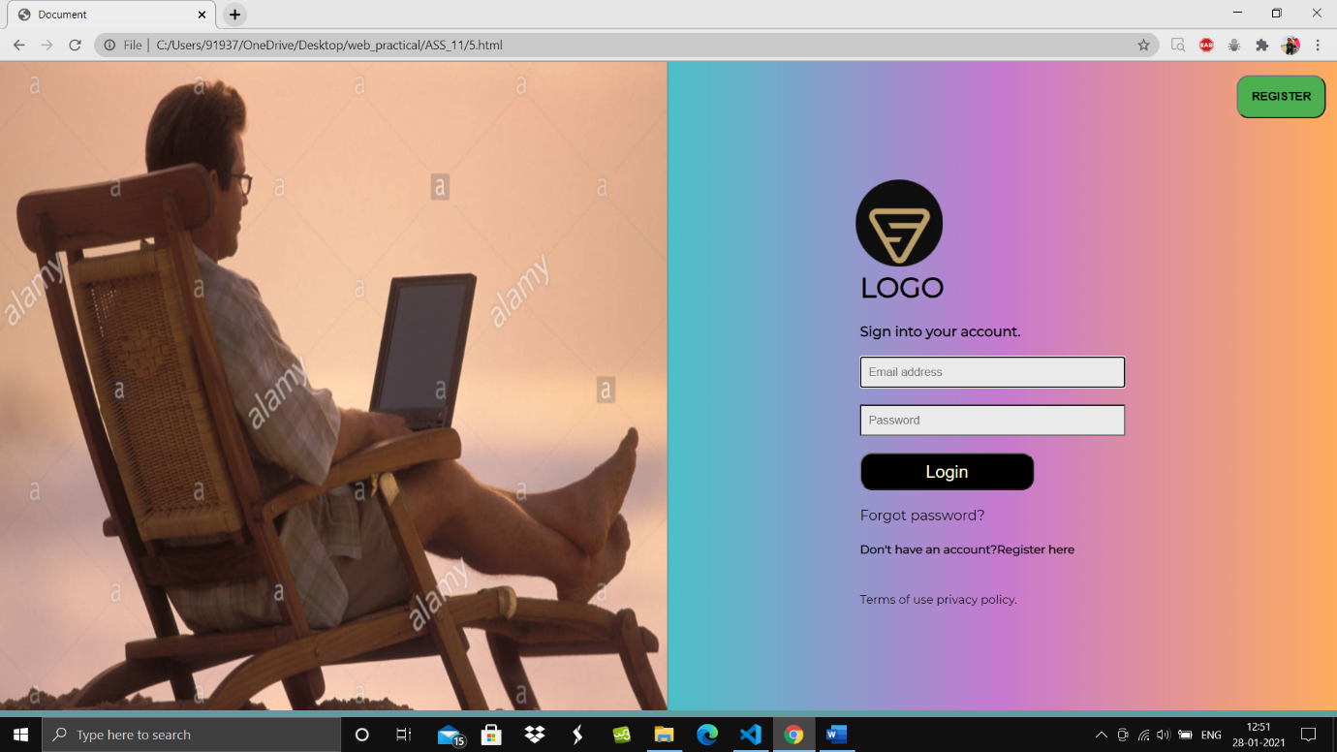

6) <!DOCTYPE html>

<html lang="en">

<head>

    <meta charset="UTF-8">

    <meta name="viewport" content="width=device-width, initial-scale=1.0">

    <title>Document</title>

    <link rel="preconnect" href="https://fonts.gstatic.com">

    <link href="https://fonts.googleapis.com/css2?family=Bebas+Neue&display=swap" rel="stylesheet">

    <link rel="preconnect" href="https://fonts.gstatic.com">

    <link href="https://fonts.googleapis.com/css2?family=Roboto+Slab:wght@500&display=swap" rel="stylesheet">

</head>

<style>

    div {

        /* outline: 2px solid red; */

        height: 500px;

        width: 300px;

    }

    /* .container

    {

        height:100%;

        width: 100%;

    } */

    body {

        background: #4DA0B0;  /* fallback for old browsers */

background: -webkit-linear-gradient(to right, #D39D38, #4DA0B0);  /* Chrome 10-25, Safari 5.1-6 */

background: linear-gradient(to right, #D39D38, #4DA0B0); /* W3C, IE 10+/ Edge, Firefox 16+, Chrome 26+, Opera 12+, Safari 7+ */

        font-family: 'Bebas Neue', cursive;

    }

    .box1 {

        position: absolute;

        height: 300px;

        width: 300px;

        padding: 20px;

        margin-left: 200px;

        margin-top: 50px;

    }

    .box2 {

        position: absolute;

        height: 300px;

        width: 300px;

        padding: 20px;

        margin-left: 1000px;

        margin-top: 50px;

    }

    .box3 {

        position: absolute;

        height: 300px;

        width: 300px;

        padding: 20px;

        margin-left: 600px;

        margin-top: 350px;

    }

    .box4 {

        position: absolute;

        height: 300px;

        width: 300px;

        padding: 20px;

        margin-left: 200px;

        margin-top: 650px;

    }

    .box5 {

        position: absolute;

        height: 300px;

        width: 300px;

        padding: 20px;

        margin-left: 1000px;

        margin-top: 650px;

    }

    .btn {

        border-radius: 4px;

        padding: 13px;

        margin-top: 15px;

        margin-left: 90px;

        cursor: pointer;

        background-color: honeydew;

        text-decoration: lightseagreen;

        font-weight: bold;

    }

    .rev1 {

        width: 100px;

        height: 30px;

        margin-left: 100px;

        margin-top: 0px;

    }

    .img1 {

        margin-left: 50px;

    }

    .basket {

        height: 100px;

        margin: auto;

        font-size: 200%;

        font-weight: bolder;

        width: 100%;

    }

    .head {

        margin-left: 380px;

        font-family: 'Roboto Slab', serif;

    }

    .strong

    {

        font-size: 120%;

    }

</style>

<body>

    <div class="basket">

        <h1 class="head">Fruits & Vegetables Basket</h1>

    </div>

    <div class="box1">

        <img src="images/f1.png" alt="" height="200px" width="200px" class="img1"><br>

        <br>

        <div class="rev1">

            <span>97 Reviews</span><br>

            <strong class="strong">₹270.00</strong> <br>

        </div>

        <button class="btn">Add to Cart</button>

    </div>

    <div class="box2">

        <img src="images/f2.png" alt="" height="200px" width="200px" class="img1"><br>

        <div class="rev1">

            <span>90 Reviews</span><br>

            <strong class="strong">₹250.00</strong> <br>

        </div>

        <button class="btn">Add to Cart</button>

    </div>

    <div class="box3">

        <img src="images/f3.png" alt="" height="200px" width="200px" class="img1"><br>

        <div class="rev1">

            <span>85 Reviews</span><br>

            <strong class="strong">₹200.00</strong> <br>

        </div>

        <button class="btn">Add to Cart</button>

    </div>

    <div class="box4">

        <img src="images/f4.png" alt="" height="200px" width="200px" class="img1"><br>

        <div class="rev1">

            <span>72 Reviews</span><br>

            <strong class="strong">₹199.00</strong> <br>

        </div>

        <button class="btn">Add to Cart</button>

    </div>

    <div class="box5">

        <img src="images/f5.png" alt="" height="200px" width="200px" class="img1"><br>

        <div class="rev1">

            <span>69 Reviews</span><br>

            <strong class="strong">₹155.00</strong> <br>

        </div>

        <button class="btn">Add to Cart</button>

    </div>

</body>

</html>

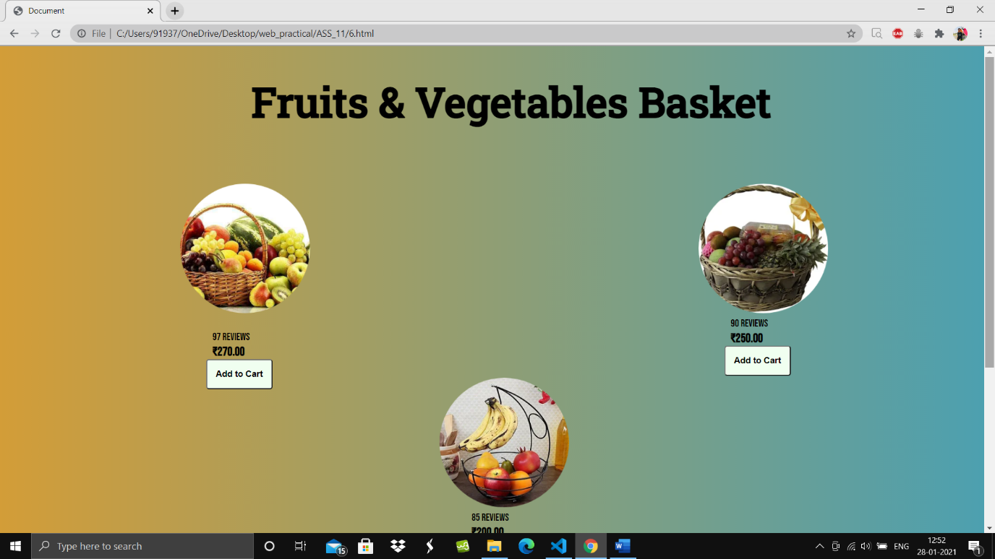

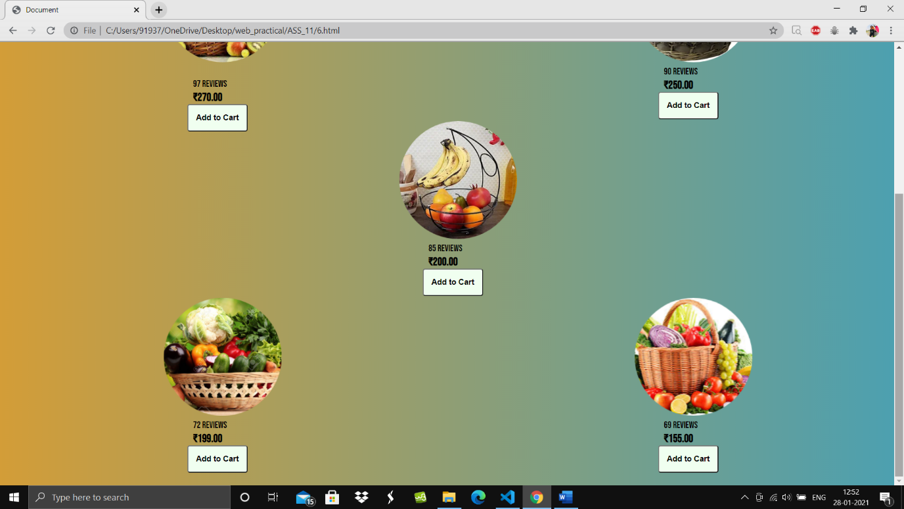

7) <!DOCTYPE html>

<html lang="en">

<head>

    <meta charset="UTF-8">

    <meta name="viewport" content="width=device-width, initial-scale=1.0">

    <title>Document</title>

    <link rel="preconnect" href="https://fonts.gstatic.com">

    <link href="https://fonts.googleapis.com/css2?family=Open+Sans:wght@300&display=swap" rel="stylesheet">

</head>

<style>

    div {

        /* outline: 2px solid red;  */

    }

    .container {

        position: relative;

        height: 1650px;

        width: 60%;

        margin: auto;

        border: 5px solid black;

        background-color: lightsteelblue;

        border-radius: 12px;

    }

    .box1 {

        position: absolute;

        height: 392px;

        width: 50%;

        margin: auto;

        margin-top: 50px;

        margin-left: 200px;

    }

    .box2 {

        position: absolute;

        height: 574px;

        width: 50%;

        margin: auto;

        margin-top: 410px;

        margin-left: 200px;

    }

    .box3 {

        position: absolute;

        height: 480px;

        width: 50%;

        margin: auto;

        margin-top: 960px;

        margin-left: 200px;

    }

    .input {

        padding: 5px;

        box-sizing: border-box;

        border: 2px solid black;

        border-radius: 4px;

        background-color: #3CBC8D;

        color: white;

        transition: width 0.4s ease-in-out;

    }

    .input:focus {

        background-color: lightblue;

        border: 3px solid #555;

    }

    .field3,

    .field2,

    .field1 {

        border: 3px solid black;

        padding: 50px;

    }

    body {

        background: linear-gradient(0.25turn, #3f87a6, #ebf8e1, #f69d3c);

        font-family: 'Open Sans', sans-serif;

    }

    .box1,

    .box2,

    .box3 {

        background-color: #e3d0b9;

    }

    .head {

        margin-left: 250px;

    }

    .btn

    {

        padding: 8px;

        margin-top: 1400px;

        margin-left: 730px;

        border-radius: 12px;

        cursor: pointer;

        background-color:powderblue;

        text-emphasis: weight;

        text-shadow: orangered;

        border: 2px solid black;

    }

</style>

<body>

    <div class="container">

        <h1 class="head"><u>Personal Details</u></h1>

        <form action="/action_page.php">

            <div class="box1">

                <fieldset class="field1">

                    <legend>Personal Information</legend>

                    <label>First name:</label><br>

                    <input type="text" size="40" class="input"><br><br>

                    <label>Last name:</label><br>

                    <input type="text" size="40" class="input"><br><br>

                    <label>Date of Birth:</label><br>

                    <input type="date" name="birthday" class="input"><br><br>

                    <label>Gender:</label><br>

                    <select>

                        <option>Choose a gender</option>

                        <option>Male</option>

                        <option>Female</option>

                        <option>Other</option>

                    </select>

                </fieldset>

            </div>

            <br><br>

            <div class="box2">

                <fieldset class="field2">

                    <legend>Account Information</legend>

                    <label>Email:</label><br>

                    <input type="email" size="40" class="input"><br><br>

                    <label for="">Re-type Email</label><br>

                    <input type="email" name="" id="" size="40" class="input"><br><br>

                    <label for="">Password</label><br>

                    <input type="password" name="" id="" size="40" class="input"><br>

                    <span>(Min 8 characters,1number,case sensitive)</span><br>

                    <br>

                    <label for="">Re-type password</label><br>

                    <input type="password" name="" id="" size="40" class="input"><br><br>

                    <label for="">Security Question</label><br>

                    <select name="" id="">

                        <option value="">Choose a security question</option>

                        <option value="">Your first pet's name?</option>

                        <option value="">Your first teacher?</option>

                        <option value="">Your first house number?</option>

                    </select>

                    <br><br>

                    <label for="">Security Answer</label><br>

                    <input type="text" name="" id="" size="40" class="input"><br>

                    <span>(Not case-sensitive)</span><br>

                </fieldset>

            </div>

            <br><br>

            <div class="box3">

                <fieldset class="field3">

                    <legend>Contact Information</legend>

                    <label for="fname">Address:</label><br>

                    <input type="text" id="fname" name="fname" size="40" class="input"><br><br>

                    <label for="lname">City:</label><br>

                    <input type="text" id="lname" name="lname" size="40" class="input"><br><br>

                    <label for="email">State:</label><br>

                    <select name="" id="">

                        <option value="">Choose a State</option>

                        <option value="">Bihar</option>

                        <option value="">Maharashtra</option>

                        <option value="">Goa</option>

                        <option value="">Tamil Nadu</option>

                        <option value="">Haryana</option>

                    </select>

                    <br><br>

                    <label for="">Zip Code</label><br>

                    <input type="text" name="" id="" size="10" class="input">

                    <span>(Optional)</span>

                    <br><br>

                    <label for="">Phone</label><br>

                    <input type="text" name="" id="" size="20" class="input">

                    <select name="" id="">

                        <option value="">Mobile</option>

                        <option value="">Lnadline</option>

                        <option value="">Telephone</option>

                        <option value="">R-sim</option>

                    </select>

                    <br>

                    <span>(No dashes or spaces)</span>

                </fieldset>

            </div>

        </form>

        <div>

            <button class="btn"><b>Submit</b></button>

        </div>

    </div>

</body>

</html>

