Approach

Greedy

# Explanation

* Created a dictionary where each key corresponds to an array. The key here corresponds to requirements and the array is used to store the index where that particular requirement is fulfilled i.e === true (refer the image below); 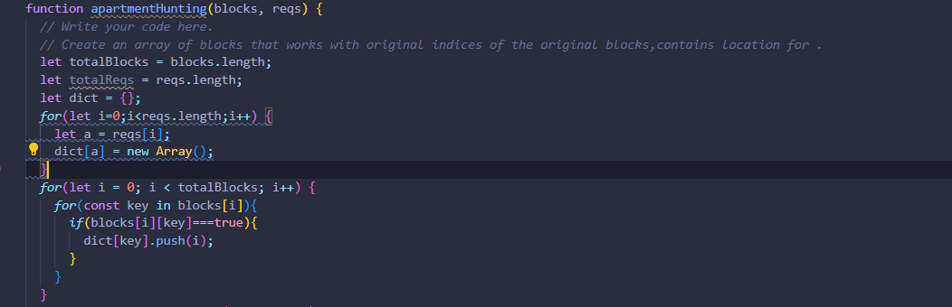
* After creating the dictionary ,we traverse the input blocks array to fill the dictionary with relevant data. (Refer above image)
* Afterwards , we create an array named maxToWalk which is used to store the maximum distance that someone living in that block has to travel to travel to any of the requirements. 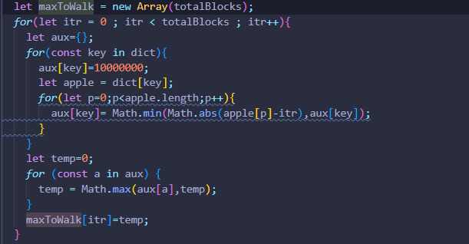
* Then we use two variables, one keeps track of the index and the other is used to track the optimal place such that the max distance one has to travel from that block is minimal of all the blocks (which is the answer). 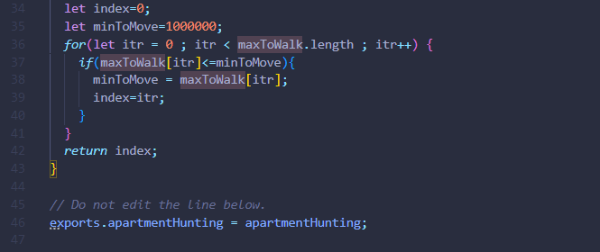
* The we simply return the answer.

The requirements and the blocks are passed from test.js where this function is imported and called .Answer’s put on the console as a log.