Transforms

The usual mathematical representation of an image is a function of two spatial variables: . The value of the function at a particular location represents the intensity of the image at that point. This is called the spatial domain. The term transform refers to an alternative mathematical representation of an image. For example, the Fourier transform is a representation of an image as a sum of complex exponentials of varying magnitudes, frequencies, and phases. This is called the frequency domain. Transforms are useful for a wide range of purposes, including convolution, enhancement, feature detection, and compression.
This chapter defines several important transforms and shows examples of their application to image processing.
Fourier Transform | Defines the Fourier transform and some of its applications in image processing
Discrete Cosine Transform | Describes the discrete cosine transform (DCT) of an image and its application, particularly in image compression
Radon Transform | Describes how the Image Processing Toolbox radon function computes projections of an image matrix along specified directions
Fan-Beam Projection Data | Describes how the Image Processing Toolbox radon function computes projections of an image matrix along specified directions

Fourier Transform
The Fourier transform is a representation of an image as a sum of complex exponentials of varying magnitudes, frequencies, and phases. The Fourier transform plays a critical role in a broad range of image processing applications, including enhancement, analysis, restoration, and compression.
This section includes the following subsections:
- Definition of Fourier Transform
- Discrete Fourier Transform, including a discussion of fast Fourier transform
- Applications of the Fourier Transform (sample applications using Fourier transforms)

Definition of Fourier Transform
If is a function of two discrete spatial variables m and n, then the two-dimensional Fourier transform of is defined by the relationship
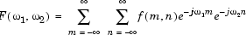
The variables ω₁ and ω₂ are frequency variables; their units are radians per sample. is often called the frequency-domain representation of . is a complex-valued function that is periodic both in and , with period . Because of the periodicity, usually only the range is displayed. Note that is the sum of all the values of . For this reason, is often called the constant component or DC component of the Fourier transform. (DC stands for direct current; it is an electrical engineering term that refers to a constant-voltage power source, as opposed to a power source whose voltage varies sinusoidally.)
The inverse of a transform is an operation that when performed on a transformed image produces the original image. The inverse two-dimensional Fourier transform is given by
Roughly speaking, this equation means that can be represented as a sum of an infinite number of complex exponentials (sinusoids) with different frequencies. The magnitude and phase of the contribution at the frequencies are given by .

Visualizing the Fourier Transform
To illustrate, consider a function that equals 1 within a rectangular region and 0 everywhere else. To simplify the diagram, is shown as a continuous function, even though the variables m and n are discrete.

Rectangular Function
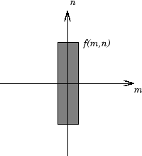
The following figure shows, as a mesh plot, the magnitude of the Fourier transform, , of the rectangular function shown in the preceding figure. The mesh plot of the magnitude is a common way to visualize the Fourier transform.

Magnitude Image of a Rectangular Function
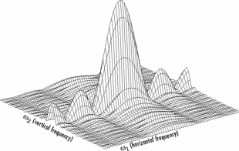
The peak at the center of the plot is , which is the sum of all the values in . The plot also shows that has more energy at high horizontal frequencies than at high vertical frequencies. This reflects the fact that horizontal cross sections of are narrow pulses, while vertical cross sections are broad pulses. Narrow pulses have more high-frequency content than broad pulses.
Another common way to visualize the Fourier transform is to display as an image, as shown.

Log of the Fourier Transform of a Rectangular Function
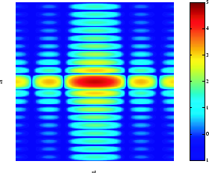
Using the logarithm helps to bring out details of the Fourier transform in regions where is very close to 0.
Examples of the Fourier transform for other simple shapes are shown below.

Fourier Transforms of Some Simple Shapes
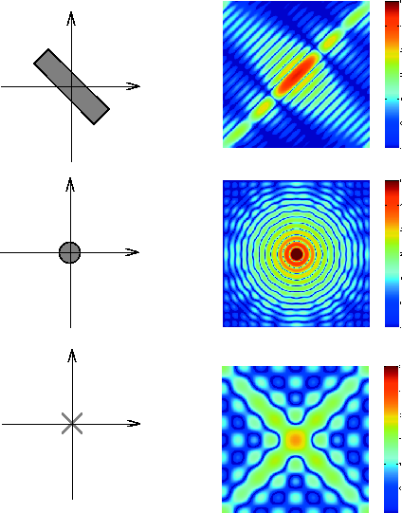

Discrete Fourier Transform
Working with the Fourier transform on a computer usually involves a form of the transform known as the discrete Fourier transform (DFT). A discrete transform is a transform whose input and output values are discrete samples, making it convenient for computer manipulation. There are two principal reasons for using this form of the transform:
- The input and output of the DFT are both discrete, which makes it convenient for computer manipulations.
- There is a fast algorithm for computing the DFT known as the fast Fourier transform (FFT).
The DFT is usually defined for a discrete function that is nonzero only over the finite region and . The two-dimensional M-by-N DFT and inverse M-by-N DFT relationships are given by
The values are the DFT coefficients of . The zero-frequency coefficient, , is often called the "DC component." DC is an electrical engineering term that stands for direct current. (Note that matrix indices in MATLAB always start at 1 rather than 0; therefore, the matrix elements f(1,1) and F(1,1) correspond to the mathematical quantities and , respectively.)
The MATLAB functions fft, fft2, and fftn implement the fast Fourier transform algorithm for computing the one-dimensional DFT, two-dimensional DFT, and N-dimensional DFT, respectively. The functions ifft, ifft2, and ifftn compute the inverse DFT.

Relationship to the Fourier Transform
The DFT coefficients are samples of the Fourier transform .
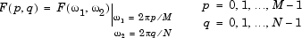

Example
- Construct a matrix f that is similar to the function f(m,n) in the example in Definition of Fourier Transform. Remember that f(m,n) is equal to 1 within the rectangular region and 0 elsewhere. Use a binary image to represent f(m,n).
- f = zeros(30,30);
- f(5:24,13:17) = 1;
imshow(f,'notruesize')

- Compute and visualize the 30-by-30 DFT of f with these commands.
- F = fft2(f);
- F2 = log(abs(F));
imshow(F2,[-1 5],'notruesize'); colormap(jet); colorbar
Discrete Fourier Transform Computed Without Padding
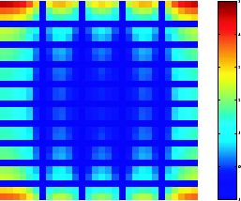
This plot differs from the Fourier transform displayed in Visualizing the Fourier Transform. First, the sampling of the Fourier transform is much coarser. Second, the zero-frequency coefficient is displayed in the upper left corner instead of the traditional location in the center.
- To obtain a finer sampling of the Fourier transform, add zero padding to f when computing its DFT. The zero padding and DFT computation can be performed in a single step with this command.
F = fft2(f,256,256);
This command zero-pads f to be 256-by-256 before computing the DFT.
imshow(log(abs(F)),[-1 5]); colormap(jet); colorbar
Discrete Fourier Transform Computed with Padding
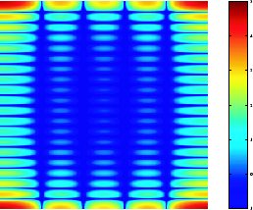
- The zero-frequency coefficient, however, is still displayed in the upper left corner rather than the center. You can fix this problem by using the function fftshift, which swaps the quadrants of F so that the zero-frequency coefficient is in the center.
- F = fft2(f,256,256);F2 = fftshift(F);
imshow(log(abs(F2)),[-1 5]); colormap(jet); colorbar
The resulting plot is identical to the one shown in Visualizing the Fourier Transform.

Applications of the Fourier Transform
This section presents a few of the many image processing-related applications of the Fourier transform.

Frequency Response of Linear Filters
The Fourier transform of the impulse response of a linear filter gives the frequency response of the filter. The function freqz2 computes and displays a filter's frequency response. The frequency response of the Gaussian convolution kernel shows that this filter passes low frequencies and attenuates high frequencies.
h = fspecial('gaussian');
freqz2(h)

Frequency Response of a Gaussian Filter
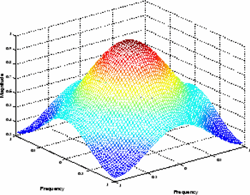
See Linear Filtering and Filter Design for more information about linear filtering, filter design, and frequency responses.

Fast Convolution
A key property of the Fourier transform is that the multiplication of two Fourier transforms corresponds to the convolution of the associated spatial functions. This property, together with the fast Fourier transform, forms the basis for a fast convolution algorithm.
Note The FFT-based convolution method is most often used for large inputs. For small inputs it is generally faster to use imfilter.
To illustrate, this example performs the convolution of A and B, where A is an M-by-N matrix and B is a P-by-Q matrix:
- Create two matrices.
- A = magic(3);
B = ones(3);
- Zero-pad A and B so that they are at least (M+P-1)-by-(N+Q-1). (Often A and B are zero-padded to a size that is a power of 2 because fft2 is fastest for these sizes.) The example pads the matrices to be 8-by-8.
- A(8,8) = 0;
B(8,8) = 0;
- Compute the two-dimensional DFT of A and B using fft2.
- Multiply the two DFTs together.
- Compute the inverse two-dimensional DFT of the result using ifft2.
The following code performs steps 3, 4, and 5 in the procedure.
C = ifft2(fft2(A).*fft2(B));
- Extract the nonzero portion of the result and remove the imaginary part caused by roundoff error.
- C = C(1:5,1:5);
- C = real(C)

- C =

- 8.0000 9.0000 15.0000 7.0000 6.0000
- 11.0000 17.0000 30.0000 19.0000 13.0000
- 15.0000 30.0000 45.0000 30.0000 15.0000
- 7.0000 21.0000 30.0000 23.0000 9.0000
4.0000 13.0000 15.0000 11.0000 2.0000

Locating Image Features
The Fourier transform can also be used to perform correlation, which is closely related to convolution. Correlation can be used to locate features within an image; in this context correlation is often called template matching.
This example illustrates how to use correlation to locate occurrences of the letter "a" in an image containing text:
- Read in the sample image.
bw = imread('text.png');
- Create a template for matching by extracting the letter "a" from the image.
a = bw(32:45,88:98);
You can also create the template image by using the interactive version of imcrop, using the pixval function to determine the coordinates of features in an image.
The following figure shows both the original image and the template.
imshow(bw);
figure, imshow(a);
Image (left) and the Template to Correlate (right)

- Compute the correlation of the template image with the original image by rotating the template image by 180º and then using the FFT-based convolution technique described in Fast Convolution.
(Convolution is equivalent to correlation if you rotate the convolution kernel by 180º.) To match the template to the image, use the fft2 and ifft2 functions.
C = real(ifft2(fft2(bw) .* fft2(rot90(a,2),256,256)));
The following image shows the result of the correlation. Bright peaks in the image correspond to occurrences of the letter.
figure, imshow(C,[]) % Scale image to appropriate display range.
Correlated Image

- To view the locations of the template in the image, find the maximum pixel value and then define a threshold value that is less than this maximum. The locations of these peaks are indicated by the white spots in the thresholded correlation image. (To make the locations easier to see in this figure, the thresholded image has been dilated to enlarge the size of the points.)
- max(C(:))
- ans =
- 68.0000
- thresh = 60; % Use a threshold that's a little less than max.
- figure, imshow(C > thresh)% Display showing pixels over
threshold.
Correlated, Thresholded Image Showing Template Locations


Discrete Cosine Transform
The discrete cosine transform (DCT) represents an image as a sum of sinusoids of varying magnitudes and frequencies. The dct2 function in the Image Processing Toolbox computes the two-dimensional discrete cosine transform (DCT) of an image. The DCT has the property that, for a typical image, most of the visually significant information about the image is concentrated in just a few coefficients of the DCT. For this reason, the DCT is often used in image compression applications. For example, the DCT is at the heart of the international standard lossy image compression algorithm known as JPEG. (The name comes from the working group that developed the standard: the Joint Photographic Experts Group.)
The two-dimensional DCT of an M-by-N matrix A is defined as follows.
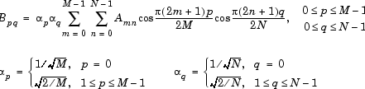
The values are called the DCT coefficients of A. (Note that matrix indices in MATLAB always start at 1 rather than 0; therefore, the MATLAB matrix elements A(1,1) and B(1,1) correspond to the mathematical quantities and , respectively.)
The DCT is an invertible transform, and its inverse is given by
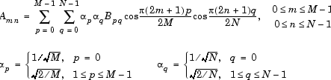
The inverse DCT equation can be interpreted as meaning that any M-by-N matrix A can be written as a sum of functions of the form
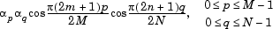
These functions are called the basis functions of the DCT. The DCT coefficients , then, can be regarded as the weights applied to each basis function. For 8-by-8 matrices, the 64 basis functions are illustrated by this image.

The 64 Basis Functions of an 8-by-8 Matrix
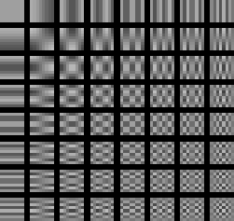
Horizontal frequencies increase from left to right, and vertical frequencies increase from top to bottom. The constant-valued basis function at the upper left is often called the DC basis function, and the corresponding DCT coefficient is often called the DC coefficient.

The DCT Transform Matrix
The Image Processing Toolbox offers two different ways to compute the DCT. The first method is to use the function dct2. dct2 uses an FFT-based algorithm for speedy computation with large inputs. The second method is to use the DCT transform matrix, which is returned by the function dctmtx and might be more efficient for small square inputs, such as 8-by-8 or 16-by-16. The M-by-M transform matrix T is given by
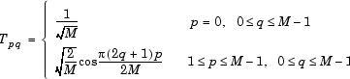
For an M-by-M matrix A, T*A is an M-by-M matrix whose columns contain the one-dimensional DCT of the columns of A. The two-dimensional DCT of A can be computed as B=T*A*T'. Since T is a real orthonormal matrix, its inverse is the same as its transpose. Therefore, the inverse two-dimensional DCT of B is given by T'*B*T.

DCT and Image Compression
In the JPEG image compression algorithm, the input image is divided into 8-by-8 or 16-by-16 blocks, and the two-dimensional DCT is computed for each block. The DCT coefficients are then quantized, coded, and transmitted. The JPEG receiver (or JPEG file reader) decodes the quantized DCT coefficients, computes the inverse two-dimensional DCT of each block, and then puts the blocks back together into a single image. For typical images, many of the DCT coefficients have values close to zero; these coefficients can be discarded without seriously affecting the quality of the reconstructed image.
The example code below computes the two-dimensional DCT of 8-by-8 blocks in the input image, discards (sets to zero) all but 10 of the 64 DCT coefficients in each block, and then reconstructs the image using the two-dimensional inverse DCT of each block. The transform matrix computation method is used.
I = imread('cameraman.tif');
I = im2double(I);
T = dctmtx(8);
B = blkproc(I,[8 8],'P1*x*P2',T,T');
mask = [1 1 1 1 0 0 0 0
1 1 1 0 0 0 0 0
1 1 0 0 0 0 0 0
1 0 0 0 0 0 0 0
0 0 0 0 0 0 0 0
0 0 0 0 0 0 0 0
0 0 0 0 0 0 0 0
0 0 0 0 0 0 0 0];
B2 = blkproc(B,[8 8],'P1.*x',mask);
I2 = blkproc(B2,[8 8],'P1*x*P2',T',T);
imshow(I), figure, imshow(I2)
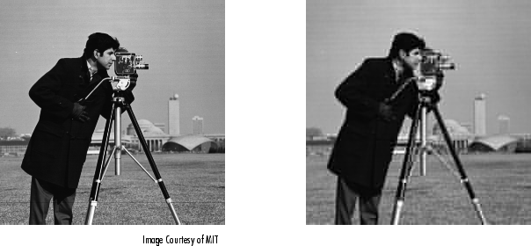
Although there is some loss of quality in the reconstructed image, it is clearly recognizable, even though almost 85% of the DCT coefficients were discarded. To experiment with discarding more or fewer coefficients, and to apply this technique to other images, try running the demo function dctdemo.

Radon Transform
The radon function in the Image Processing Toolbox computes projections of an image matrix along specified directions. A projection of a two-dimensional function f(x,y) is a set of line integrals. The radon function computes the line integrals from multiple sources along parallel paths, or beams, in a certain direction. The beams are spaced 1 pixel unit apart. To represent an image, the radon function takes multiple, parallel-beam projections of the image from different angles by rotating the source around the center of the image. The following figure shows a single projection at a specified rotation angle.

Parallel-Beam Projection at Rotation Angle Theta
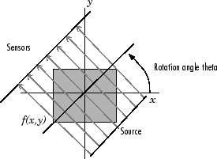
Note For information about creating projection data from line integrals along paths that radiate from a single source, called fan-beam projections, see Fan-Beam Projection Data. To convert parallel-beam projection data to fan-beam projection data, use the para2fan function.
For example, the line integral of f(x,y) in the vertical direction is the projection of f(x,y) onto the x-axis; the line integral in the horizontal direction is the projection of f(x,y) onto the y-axis. The following figure shows horizontal and vertical projections for a simple two-dimensional function.

Horizontal and Vertical Projections of a Simple Function
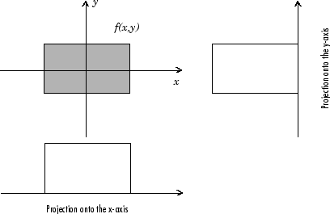
Projections can be computed along any angle [[THETA]]. In general, the Radon transform of f(x,y) is the line integral of f parallel to the y´-axis
where
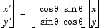
The following figure illustrates the geometry of the Radon transform.

Geometry of the Radon Transform
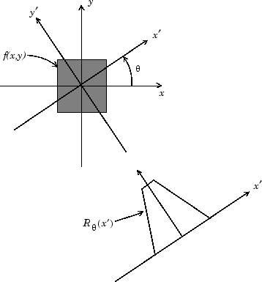

Plotting the Radon Transform
You can compute the Radon transform of an image I for the angles specified in the vector theta using the radon function with this syntax.
[R,xp] = radon(I,theta);
The columns of R contain the Radon transform for each angle in theta. The vector xp contains the corresponding coordinates along the x´-axis. The center pixel of I is defined to be floor((size(I)+1)/2); this is the pixel on the x´-axis corresponding to .
The commands below compute and plot the Radon transform at 0° and 45° of an image containing a single square object. xp is the same for all projection angles.
I = zeros(100,100);
I(25:75, 25:75) = 1;
imshow(I)
[R,xp] = radon(I,[0 45]);
figure; plot(xp,R(:,1)); title('R_{0^o} (x\prime)')


Radon Transform of a Square Function at 0 Degrees
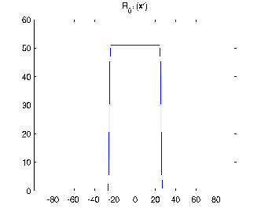
figure; plot(xp,R(:,2)); title('R_{45^o} (x\prime)')

Radon Transform of a Square Function at 45 Degrees
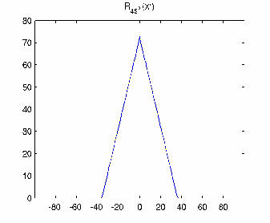

Viewing the Radon Transform as an Image
The Radon transform for a large number of angles is often displayed as an image. In this example, the Radon transform for the square image is computed at angles from 0° to 180°, in 1° increments.
theta = 0:180;
[R,xp] = radon(I,theta);
imagesc(theta,xp,R);
title('R_{\theta} (X\prime)');
xlabel('\theta (degrees)');
ylabel('X\prime');
set(gca,'XTick',0:20:180);
colormap(hot);
colorbar

Radon Transform Using 180 Projections
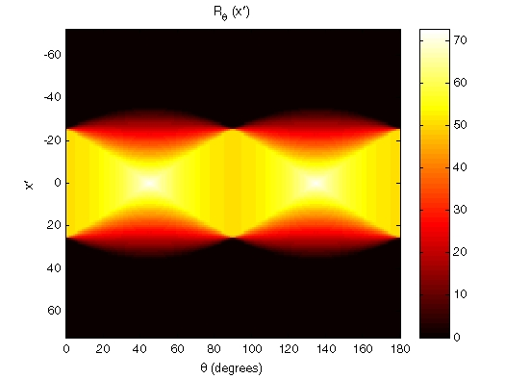

Using the Radon Transform to Detect Lines
The Radon transform is closely related to a common computer vision operation known as the Hough transform. You can use the radon function to implement a form of the Hough transform used to detect straight lines. The steps are
- Compute a binary edge image using the edge function.
- I = fitsread('solarspectra.fts');
- I = mat2gray(I);
- BW = edge(I);
imshow(I), figure, imshow(BW)
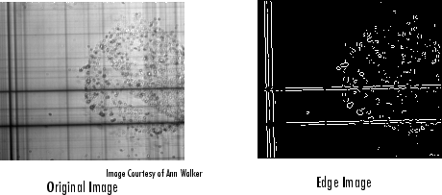
- Compute the Radon transform of the edge image.
- theta = 0:179;
- [R,xp] = radon(BW,theta);
- figure, imagesc(theta, xp, R); colormap(hot);
- xlabel('\theta (degrees)'); ylabel('x\prime');
- title('R_{\theta} (x\prime)');
colorbar
Radon Transform of an Edge Image
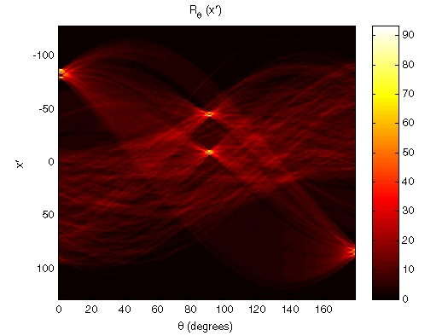
- Find the locations of strong peaks in the Radon transform matrix. The locations of these peaks correspond to the locations of straight lines in the original image.
In the following figure, the strongest peaks in R correspond to and . The line perpendicular to that angle and located at is shown below, superimposed in red on the original image. The Radon transform geometry is shown in black. Notice that the other strong lines parallel to the red line also appear as peaks at in the transform. Also, the lines perpendicular to this line appear as peaks at .

Radon Transform Geometry and the Strongest Peak (Red)
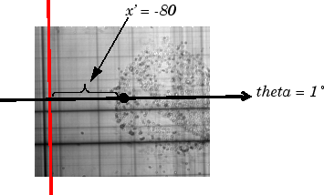

Inverse Radon Transform
The iradon function performs the inverse Radon transform, which is commonly used in tomography applications. This transform inverts the Radon transform (which was introduced in the previous section), and can therefore be used to reconstruct images from projection data.
As described in Radon Transform, given an image I and a set of angles theta, the radon function can be used to calculate the Radon transform.
R = radon(I,theta);
The function iradon can then be called to reconstruct the image I.
IR = iradon(R,theta);
In the example above, projections are calculated from the original image I. In most application areas, there is no original image from which projections are formed. For example, in X-ray absorption tomography, projections are formed by measuring the attenuation of radiation that passes through a physical specimen at different angles. The original image can be thought of as a cross section through the specimen, in which intensity values represent the density of the specimen. Projections are collected using special purpose hardware, and then an internal image of the specimen is reconstructed by iradon. This allows for noninvasive imaging of the inside of a living body or another opaque object.
iradon reconstructs an image from parallel-beam projections. In parallel-beam geometry, each projection is formed by combining a set of line integrals through an image at a specific angle.
The following figure illustrates how parallel-beam geometry is applied in X-ray absorption tomography. Note that there is an equal number of n emitters and n sensors. Each sensor measures the radiation emitted from its corresponding emitter, and the attenuation in the radiation gives a measure of the integrated density, or mass, of the object. This corresponds to the line integral that is calculated in the Radon transform.
The parallel-beam geometry used in the figure is the same as the geometry that was described in Radon Transform. f(x,y) denotes the brightness of the image and is the projection at angle theta.

Parallel-Beam Projections Through an Object
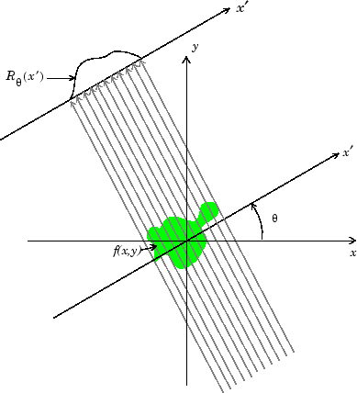
Another geometry that is commonly used is fan-beam geometry, in which there is one source and n sensors. For more information, see Fan-Beam Projection Data. To convert parallel-beam projection data into fan-beam projection data, use the para2fan function.

Improving the Results
iradon uses the filtered backprojection algorithm to compute the inverse Radon transform. This algorithm forms an approximation of the image I based on the projections in the columns of R. A more accurate result can be obtained by using more projections in the reconstruction. As the number of projections (the length of theta) increases, the reconstructed image IR more accurately approximates the original image I. The vector theta must contain monotonically increasing angular values with a constant incremental angle Δ[[THETA]]. When the scalar Δ[[THETA]] is known, it can be passed to iradon instead of the array of theta values. Here is an example.
IR = iradon(R,Dtheta);
The filtered backprojection algorithm filters the projections in R and then reconstructs the image using the filtered projections. In some cases, noise can be present in the projections. To remove high frequency noise, apply a window to the filter to attenuate the noise. Many such windowed filters are available in iradon. The example call to iradon below applies a Hamming window to the filter. See the iradon reference page for more information.
IR = iradon(R,theta,'Hamming');
iradon also enables you to specify a normalized frequency, D, above which the filter has zero response. D must be a scalar in the range [0,1]. With this option, the frequency axis is rescaled so that the whole filter is compressed to fit into the frequency range [0,D]. This can be useful in cases where the projections contain little high-frequency information but there is high-frequency noise. In this case, the noise can be completely suppressed without compromising the reconstruction. The following call to iradon sets a normalized frequency value of 0.85.
IR = iradon(R,theta,0.85);

Example: Reconstructing an Image from Parallel Projection Data
The commands below illustrate how to reconstruct an image from parallel projection data. The test image is the Shepp-Logan head phantom, which can be generated by the Image Processing Toolbox function phantom. The phantom image illustrates many of the qualities that are found in real-world tomographic imaging of human heads. The bright elliptical shell along the exterior is analogous to a skull, and the many ellipses inside are analogous to brain features.
- Create a Shepp-Logan head phantom image.
- P = phantom(256);
imshow(P)

- Compute the Radon transform of the phantom brain for three different sets of theta values. R1 has 18 projections, R2 has 36 projections, and R3 has 90 projections.
- theta1 = 0:10:170; [R1,xp] = radon(P,theta1);
- theta2 = 0:5:175; [R2,xp] = radon(P,theta2);
theta3 = 0:2:178; [R3,xp] = radon(P,theta3);
- Display a plot of one of the Radon transforms of the Shepp-Logan head phantom. The following figure shows R3, the transform with 90 projections.
- figure, imagesc(theta3,xp,R3); colormap(hot); colorbar
xlabel('\theta'); ylabel('x\prime');
Radon Transform of Head Phantom Using 90 Projections
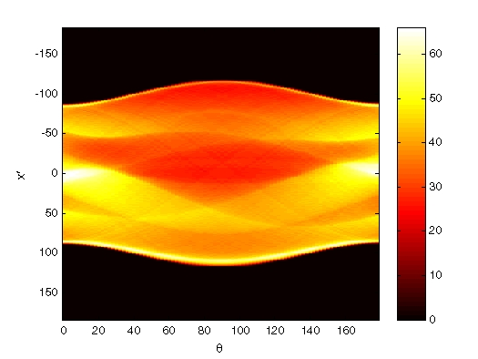
Note how some of the features of the input image appear in this image of the transform. The first column in the Radon transform corresponds to a projection at 0º that is integrating in the vertical direction. The centermost column corresponds to a projection at 90º, which is integrating in the horizontal direction. The projection at 90º has a wider profile than the projection at 0º due to the larger vertical semi-axis of the outermost ellipse of the phantom.
- Reconstruct the head phantom image from the projection data created in step 2 and display the results.
- I1 = iradon(R1,10);
- I2 = iradon(R2,5);
- I3 = iradon(R3,2);
- imshow(I1)
- figure, imshow(I2)
figure, imshow(I3)
The following figure shows the results of all three reconstructions. Notice how image I1, which was reconstructed from only 18 projections, is the least accurate reconstruction. Image I2, which was reconstructed from 36 projections, is better, but it is still not clear enough to discern clearly the small ellipses in the lower portion of the image. I3, reconstructed using 90 projections, most closely resembles the original image. Notice that when the number of projections is relatively small (as in I1 and I2), the reconstruction can include some artifacts from the back projection.
Inverse Radon Transforms of the Shepp-Logan Head Phantom
