

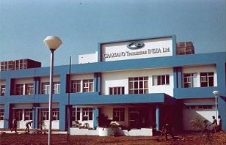

AT



Report Submitted By: -

MANISH SINGH

B.TECH (MECHANICAL & AUTOMATION ENGG.)

ROLLNO. 0481483603

(MAHARAJA AGRASEN INSTITUTE OF TECHNOLOGY)


GURU GOBIND SINGH INDRAPRASTHA UNIVERSITY
(NEW DELHI)

I am sincerely thankful to the (C.E.O.) Mr. L.K.CHAUDHARY, (H.R. MANAGER) L.K. GUPTA & to Mr. SURENDER METHA (production manager) of GRAZIANO TRASMISSIONI INDIA LTD., under whose able guidance I completed my summer training.


I must express my gratitude to other staff members who cooperated during my training period with valuable suggestions & also provided the prominent knowledge to complete this training report.

This training is such a memorable event which I cannot forget throughout my life & with so much of thanks I present this report to concerned authorities.

MANISH SINGH

