WHO IS GRAZIANO?
Graziano Trasmissioni SPA is a custom gear, transmission and related component manufacturer, based in Rivoli (Torino), Italy.

WHAT MARKETS DO THEY SERVE?
They serve the Agricultural Market with Transmission Components including Synchronizers, Clutch Cans, Helical and Spur Gears, and Straight and Spiral Bevel Gear Sets. We are also in the automotive industry with Transmissions for Hi-End European Performance Cars as well as sub components for Hi-Volume European and US vehicles. They have a diverse and capable design staff that accepts challenges in any Power Transmission application.

HISTORICAL BACKGROUND

GRAZIANO Trasmissioni is founded as a family company named “CGT - Carlo GRAZIANO Torino”, after his founder.


GRAZIANO Trasmissioni becomes the major Italian manufacturer of gears.
FIAT TRATTORI represents 70-80% of the turnover.

Export increases progressively up to 50%
R&D capability is formed; transmission components and complete drive-lines are developed (synchronizers - construction machine axles - forklift axles and transmissions)
Change in ownership (Rossi 1986 - Ghidella 1989)

GRAZIANO Trasmissioni becomes part of the Saurer Group.


Export becomes predominant (75%)
In house developed components and transmissions reach 50% of the sales City-Bus axles and utility vehicle axles are developed
Re-organization of the operations is carried out:
Certifications QS 9000, ISO 9001 and AVSQ
ISO 14001 Certification (achieved in the Cascine Vica, Bari and India plants)
Relevant growth in the automotive
GTG has reached a position of worldwide leader in the market

GROWTH, ACQUISITIONS, GLOBALIZATION

Acquisition of OTOTRASM Company
Acquisition of PIANELLI & TRAVERSA Plant and consequently enlargement of the Cascina Vica Plant to produce synchronizers
Enlargement of GARESSIO Plant

Enlargement of Sommariva Peron Plant for crown wheel & pinion production.


Foundation of GRAZIANO TRASMISSIONI India Ltd and building of the Plant to produce synchronizers and gears for agricultural sector.
GT India has been founded in the 1997; it is located in the Industrial Estate of Greater Noida, closed to New Delhi, the Indian capital.

The plant has a total area of 60000 sqm. of which 10000 sqm. Covered.
The synchronizer and gear production is mainly dedicated to the agricultural market, but its products are supplied to the commercial vehicles and construction equipments, too.

In only two years, GT India has reached the mass production and got the ISO 9002 and the ISO 14001 certifications.

GT India offers a full service to the domestic and international markets starting from the project development, to the production, to the complete heat treatments till to the shipment to the final Customers.
Today 70% of the capacity is being utilize for export

Acquisition of CNH Global's Carr Hill Facility (United Kingdom) now GRAZIANO TRASMISSIONI C.H. Limited
Acquisition of Magneto Group Gear Division (DEMM SpA and Aprilia Ingranaggi SpA)

GTG consolidation as worldwide leader in its sector.

MAJOR CUSTOMERS AND OPPORTUNITIES

All the major agriculture construction equipments & city buses manufacture: ESCORTS, EICHER VALTRA, ITL-RENAULT AGRICULTURE, M&M, NEW HOLLAND, and PTL.
Some other companies are: VOLTAS, HYUNDAI, HMT, TATA TELCO, FIAT AUTO

GLOBAL PRESENCE



SHARE OF THE 2003 TOTAL SALES



PRODUCT RANGE

Graziano Transmission INDIA Pvt. Ltd. has technological capability & capacity to manufacture the following type of products:

- GEARS
- SYNCHRONIZERS
- SHAFT

GEARS: - Gears are used extensively for transmission of power. The find application in: -
Automobile, gear boxes, oil engines, machine tools, industrial machinery, agriculture machinery, geared motors etc. the gear should be fatigue free from the high stress to avoid the frequent failures.

Gears are used to reverse rotational direction, increase or decrease speed of rotation, transfer rotation to a different axis, or to synchronize rotation across two or more axis in a machine or engine. A key benefit of gears is their ability to utilize the mechanical principles of ratios to turn speed into power, otherwise referred to as gear reduction. Gears are used in what is called a train, a group of two or more gears that work together to produce torque. The basic gear train is comprised of two gears, one large and one small. They rotate in opposite directions from one another, with their teeth interlocking and driving the rotation. A gear in a train is referred to as a driver (the gear that effects the rotation), a driven gear (the gear last in the train), or an idler (any gear between the first and last gear). The power output or torque produced by a gear train is determined by the gear ratios and the by output direction (which gear drives which).

Gear Design: - In order to maintain precise gear ratios and output speeds, gears have specially designed cogs. The most popular design used to achieve this is the involute profile. It uses the mathematical concept of the involute curve to space gear cogs in a manner that efficiently keeps gear rotation perpendicular to a flat plane.
GEAR TYPES

Here is a brief overview of the most popular gear types:

- Spur Gear: - Characterized by their straight cogs, these gears are mounted on parallel shafts. You'll find examples of spur gear trains in watches and clocks.
- Bevel Gear: - Characterized by cogs cut in a cone shape. The gear shafts are generally mounted at 90º angles to each other.

- Worm Gear and Wheel: - A gear comprised of a wheel gear with inclined cogs that is rotated by a screw thread (a single-cogged gear called a worm).

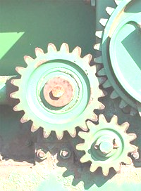
- Helical Gear: - Characterized by cogs that is cut at an angle to the face of the gear. The gears can be mounted perpendicularly or parallel. Automobile transmissions make use of these gears. Internal Gear: an inside out gear. A small gear is set within a larger gear that has its cogs on the inside. This setup protects the cogs of the gears from contaminants.

SYNCHRONIZERS: - A modern gearbox is of the constant mesh type, in which all gears are always in mesh but only one of these meshed pairs of gears is locked to the shaft on which it is mounted at any one time, the others being allowed to rotate freely; thus greatly reducing the skill required to shift gears.

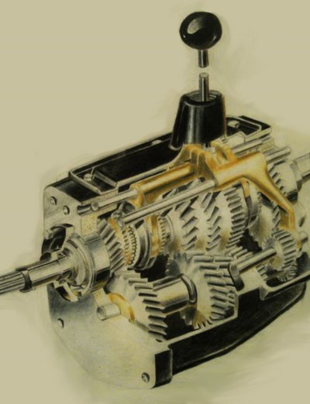
Most modern cars are fitted with a synchronized gear box, although it is entirely possible to construct a constant mesh gearbox without synchromesh, as found in motorcycle for example. In a constant mesh gearbox, the gears of the different transmission speeds are always in mesh and rotating, but the gears are not directly rotationally connected to the shafts on which they rotate. . In a synchromesh gearbox, to correctly match the speed of the gear to that of the shaft as the gear is engaged, so the selection and the engagement of the gear speed must take place through a further system that is to say the synchronizer.

Synchronized Generally Consists Of Following Parts:

- Fixed hub
- Sliding sleeve
- Clutch body ring
- Balls
- Poppets
- Springs
- Synchro ring

Fixed hub is mounted directly on the shaft and on it sliding sleeves moves to engage/disengage different gears with the help of which fits into the external groove on the sliding sleeves.

SHAFTS: - Shafts are essential parts of a transmission through which power is delivered in and out from the transmission and on which the various gears and synchronizers are mounted inside the gear box or the transmissions. It may have external splines or teeth depending upon the design and application of the transmission.

RAW MATERIAL
FORGING
INITIAL ROUGH TURNING
SOFT FACE TURNING
BROACHING
SLOT MILLING
WASHING
HOBBING
SHAPING
MULTI HOLE DRILLING
CLOSE TURNING
HEAT TREATMENT
CLOSE FACE TURNING
FACE GRINDING
CERAMIC DEBURRING
INSPECTION
OILING & PACKING
REJECT
ARE DIMENSIONS CORRECT
STOP
START
1
YES
NO
1
A PERFECT PROCESS FLOWCHART

FORGING: - Forging may be defined as a metal working process by which metals or alloys are plastically deformed to the desired shapes by compressive force. Depending upon the mode of application of this force, the forging equipment used may be grouped under two main categories.

- Hammers: - Hammers imparted stress on material and they operate in a vertical position.

- Forging Presses & Forging Machine: - In these equipment’s the compressive force is applied continuously and the material is gradually pressed or squeezed into shape. The forging press operates in a vertical position like hammer. The forging machines or up setters operate in horizontal position.

When all the operations complete, the forged part is generally ready for the further operation by the customers. However depending upon the application and the nature of next operation, it must be processed for the rough machining also as desired by the customer, before the actual machining at the customer’s end.

TURNING: - Generally turning is the process, which is used to remove excess material from the work piece to produce a shape as per drawing.
Turning is the machining operation that produces cylindrical parts. In its basic form, it can be defined as the machining of an external surface:
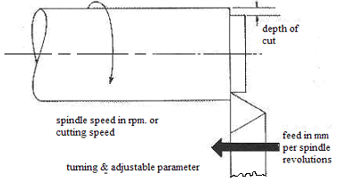
- With the workpiece rotating,
- With a single-point cutting tool, and
- With the cutting tool feeding parallel to the axis of the work piece and at a distance that will remove the outer surface of the work.

Adjustable Cutting Factors In Turning: -

The three primary factors in any basic turning operation are speed, feed, and depth of cut. Other factors such as kind of material and type of tool have a large influence, of course, but these three are the ones the operator can change by adjusting the controls, right at the machine.

Speed, always refers to the spindle and the work piece. When it is stated in revolutions per minute (rpm) it tells their rotating speed. But the important figure for a particular turning operation is the surface speed, or the speed at which the work piece material is moving past the cutting tool. It is simply the product of the rotating speed times the circumference (in feet) of the work piece before the cut is started. It is expressed in surface feet per minute (sfpm), and it refers only to the work piece. Every different diameter on a work piece will have a different cutting speed, even though the rotating speed remains the same.

Feed, always refers to the cutting tool, and it is the rate at which the tool advances along its cutting path. On most power-fed lathes, the feed rate is directly related to the spindle speed and is expressed in inches (of tool advance) per revolution (of the spindle), or imp. The figure, by the way, is usually much less than an inch and is shown as decimal amount.

Depth of Cut is practically self explanatory. It is the thickness of the layer being removed from the workpiece or the distance from the uncut surface of the work to the cut surface, expressed in inches. It is important to note, though, that the diameter of the workpiece is reduced by two times the depth of cut because this layer is being removed from both sides of the work.

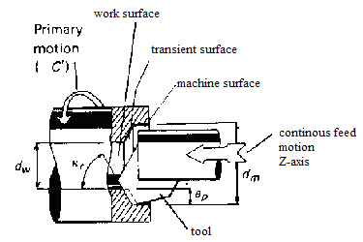
Following Operations We Can Do With the Help of Turing: -

- Rough Turning: - Heavy depth of the cut with high feed rate is employed and maximum stock is removed. Surface finish is not much important.

- Finish Turning: - Rough turning is followed by finish turning in which stock removal is less and feed rate is comparatively low because finish is important.

- Bore Turning: - Boring always involves the enlarging of an existing hole, which may have been made by a drill or may be the result of a core in a casting. Boring is essentially internal turning while feeding the tool parallel to the rotation axis of the work piece

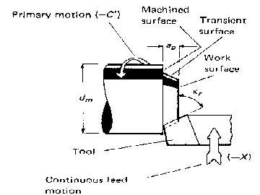
- Facing: - The method removes the stock from the face by turning and ensuring the face to be perpendicular to the axis of the job.

- OD-Grooving: - Grooving are made on the outside diameter of the work piece

- ID-Grooving: - Grooving is made on the internal diameter of the work piece.

These operations can be best performed on CNC (computer numerical control) Turing machine.

BROACHING: - Broaching is a method of removing metal by pushing or pulling a cutting tool called broach, which cuts in fixed path. And according to the method of cutting whether by pull or push the process is called pull or push type broaching. In this plant all the internal splines/teeth and keyways are cut by broaching process on three broaching machine of different capacities (35 tonnes and 16 tonnes respectively). Both the machine apply the same type of broaching method i.e. pull type broaching.

Broaching machine is of two types: -

- Vertical Broach
- Horizontal Broach

Both the above machines are vertical type.

The advantages of broaching are: -

- Short cycle time with high accuracy.
- Various contours and complicated irregular shape can be easily broached.
- Production of broaching is exceptionally high hence most suitable for mass production.
- Remarkable finished face.
- Extremely economical
- Expertise not needed.

Disadvantages are: -

- High cost of tool and machine
- The machine & tool are very specific & there is little or no scope for flexibility.

Cutting Tool: Broach

A broach is a multiple edges cutting tool that has successively higher cutting edges along the length of the tool. It is made of HSS (high speed steel) material. Design of the broach (length & pitch of the teeth) depending upon the width of the work piece to be cut &the depth of the cut.

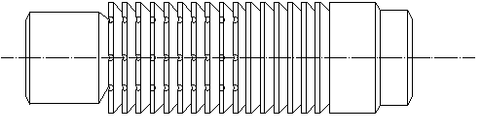
A PUSH BROACH

Study of a typical broaching application for the part no. 82ABC0001.
Splines data /broach data to be cut:

No. of teeth : 38
Module : 2
Pressure angle : 30 degrees
Major Dia : 80.07-0.03
Minor dia : 76.09-0.02
Pitch dia : 76.00
Dia over two pins : 72.81-0.02
Dia of the pins : 3.5
Broaching length : 17.6mm
Initial pilot dia : 75.85-0.02mm
Material : alloy steel (230mncr5)
Preheat treatment of the material : isothermal annealing

As per the spindle to be cut broaching tool (broach) is designed such as that when that the broaching tool (broach) is passed through a work piece the above characteristics are produce on the part. For example keeping in view the above splines details various parameters of the broach designed are such as:

Total length of the broach : 1360mm (depends on the broaching machine)
Pitch of the primary teeth : 11mm
Radius (at the root of the teeth):1.2mm
Total no. of teeth : 115
Primary teeth : from teeth # 8 to teeth # 7 (increment = 0.02mm)
Profile teeth : from teeth # 8 to teeth # 105
Calibration teeth : from teeth # 106 to teeth # 115 (no increment)

MILLING: - During milling operation metal is machined or removed as the work is fed against a rotating multipoint cutter.

Milling operation is of two types:

- Up Milling:- The up milling, which is also called conventional milling, is the process of removing metal by the cutter which is rotated against the direction of the feed of work piece.
The thickness of the chip in up milling is the least at the beginning of the cut & reaches maximum when the cut terminates. Cutting force is upward.

- Down Milling: - The down milling is also called climb milling i.e. is the processes of removing metals by the cutter which is rotated in the same direction as the feed of work piece.
The thickness of the chip is maximum when the tooth beings its cut and it reduces to the minimum when the cut terminates. Cutting force is downward.

Depending Upon The Application Of The Milling Machines Are Two Types: -

Vertical Milling Machine: - The machine has cutter spindle aligned vertical to the worktable. The spindle head which clamped to the vertical column may swivel at an angle, permitting the milling cutter mounted on the spindle to work on angular surfaces.

The machine can be used for machining grooves, and flat surfaces.
The vertical milling machine that is been used here is C.N.C based. It can accommodate twenty four tools at a time, whose usage is controlled by the computer. The table bed can move along two horizontal axis, while the spindle mover along the vertical axis.

Horizontal Milling Machine: - In this case axis of the cutter spindle is horizontal. The operations more or less are similar to the vertical milling machine but it less flexible than the previous one. The machine used here is hydraulically operated

GEAR CUTTING

It mainly consists of two methods:

- Gear Hobbing
- Gear Shaping

GEAR HOBBING

Gear hobbing is a highly utilized flexible manufacturing process for massive production of external gears. However, the complex geometry of cutting hobs is responsible for the almost exclusive utilization of high-speed steel (HSS) as cutting tool material. The hob & the gear blank are connected by means of the proper change gears (in mechanical type of machine & in CNC machine this relation is maintained through software & servomotors). The ratio of the hob & blank speed (r.p.m) of two are so synchronized that the blank rotates through one pitch distance for each complete revolution of the hob. The hob teeth are just like screw threads, i.e. having a definite helix angle. The hobs is, therefore titled to its own helix angle while cutting the gear so that its teeth are square with the blank & produce a true involutes shape.

In operation tooth of the hob can be conceived as a cylindrical body, around which the teeth of a long rake angle are wrapped along a helical path & provided with straight flutes at interval, parallel to the axis of the cylinder. The threads of the hob facing blank are directed along the tooth spaces for cutting spur gear. But while cutting the helical gear, the hob axis has to be set at an inclination equal to the sum of the helix angle of the hob and the helix of the gear.
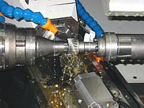

The operation of gear hobbing starts with in feed to the revolving hob till it reaches the required depth of the gear tooth. It is followed by feeding the hob in the direction parallel to the rotation gear blank. The result is the generation of teeth on the blank periphery.

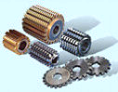

HOB CUTTER

TYPES OF HOBBING: -

The hobbing process is classified into different types according to the direction of the hob for gear cutting. This classification is as follow:-

- Hobbing With Axial Feed: -

This type of feed method is mainly used for cutting spur & helical gear. It involves moving the hob toward the gear blank in such a relative position that the required tooth depth is obtained. This followed by feeding the rotating hob (cutting motion) along the face of the blank parallel to the axis of the latter.

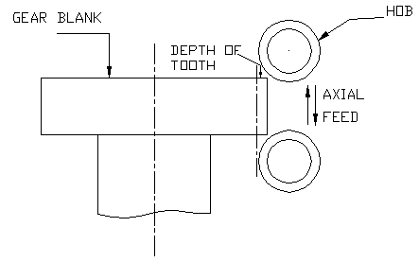

- Hobbing With Radial Feed: -

This method of the hob in feed is mainly used for cutting wheels. In this method the hob and gear blank are set with their axis normal to each other. The blank continues to rotate at a set speed about its vertical axis and the rotating hob is given in feed in radial direction i.e. towards the center of the blank rotation.

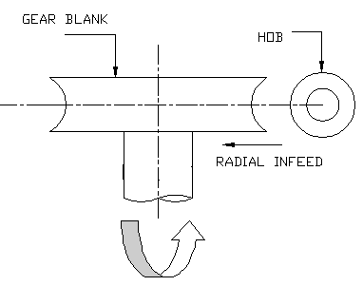

- Hobbing With Tangential Feed: -

In this method the worm wheel blank rotated in the vertical plane about a horizontal axis. The hob is held with its axis horizontal but at right angle to the axis of the blank.

Hobbing with tangential feed type are not use in this factory. The machine are used are CNC gear hobbing machines.

DETERMINATION OF HOBBING TIME
Straight toothed & helical gears:-

Axial method | T = (Z2/n1*Z1)* (E+b2+A)/Sa
Radial axial method | T = (Z2/n1*Z1)*(h2/Sa+ (E+b2+A)/Sa

Z2 : no. of teeth of the work piece
Z1 : no. of starts in hob
N1 : hob speed (rpm)
E : hob approach travel in mm
b2 : face with of work in mm
A : hob over run travel in mm
Sa : axial feed in mm

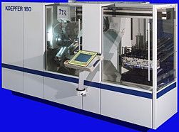

C.N.C GEAR HOBBING MACHINE

Advantages of Hobbing Process: -

- It is faster & continuous process. Hence quite economical as compared to the generating processes as compared to other processes.

- It enables a high rate of production.

- The gear teeth generated through this process are very accurate.

- The process can be adopted with equal advantages for both medium & large batch production.

- Hobbing machine there setting & operation is simple.

Disadvantages of Hobbing Process: -

- It does not suit the generation of internal gears.

GEAR SHAPING

It is second most commonly used method for the gear generation. In certain cases where gear hobbing is not possible (e.g. sholder gear where there is no space to provide the run in clearance & run out clearance for the hob cutter), gear shaping in the only alternative.

In gear shaping the cutter reciprocates rapidly & the teeth are cut by the reciprocating motion of the cutter & because of this (& simultaneously rotated also in the opposite direction), these machines are called gear shaper the cutter can either be a rack type or rotary pinion type cutter. All gear shaping machines are suitable for external and internal gears.

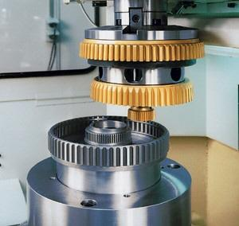

GEAR SHAPING MACHINE
Case study of the typical gear hobbing process of the part no. ABC 00002
GEAR DATA:

No. of teeth : 25
Module : 4
Pressure angle : 22 degrees 30 minutes
Major Dia : 107.3-0.3mm
Minor dia : 88.60-0.6mm
Pitch dia : 100mm
Base dia : 92.388
Circular thickness : 5.99+-0.2mm
Span (chordal thickness) over 4 no. of teeth : 42.35+-0.02mm
Helix angle : 0 (which means spur gear)

Depending upon the above requirement of the gear made, cutting tool (in our case hob cutter) is designed. In such a way that after the gear hobbing process on the gear machine the same characteristics (except chordal thickness & circular thickness, which are precisely during gear shaving operations) as mentioned above are obtained on the component.
For making the above pieces on the gear hobbing machine, one special fixture is required which locates & clamp the gear blank. Generally gear are located on bore & clamped on the face. Clamping is done on the face with the hydraulics pressure of the range 15-25 bar depending upon the size of the component must not rotate or move & must be firmly held at its position.

The Principal Motions Involved In Rotary Gear Shaper Cutter Are The Following

- Cutting Motion: - The downward liner motion of the cutter spindle together with the cutter.
- Return Stroke: - The upward linear travel of the spindle & cutter to withdraw the latter to its starting position
- Indexing Motion: - There is definite motion relationship between the table RPM & the hob rpm & this relation ship depends upon the no. of teeth to be cut & the no. of starts of the hob cutter & is established by the following formula:

Ratio of the table rpm & hob rpm = (K * Z1)/ (Z2)
Where,
K : Machine constant which is defined by the manufacturer
Z1 : No. of starts of hob cutter
Z2 : No. of teeth to be cut

The ratio is maintained through the set of indexing gear in the mechanical type of machine & through software & servomotors on CNC machines.

Advantages of Gear Shaper Process:-
- It is quite a fast process & suits well to the medium & large size batch production.
- The teeth can be easily cut up to quite closer to a sholder.
- The teeth cut on the gear carry a very accurate tooth profile.
- There is no need of change of cutter for cutting teeth of different spur gear so long as their module is same.

Limitations:-
- A special guide, called helical guide is required for the helical gears which, contains the required hand of helix angle.
- Worms & worm wheel cannot be produce on these machines.
- Since cuttings take place only during the cutting stroke, the time spends in the return stroke goes as a waste.

CHAMFERING: - Chamfering is the operation of the beveling the extreme end of the work piece. This is done to remove the burrs, to protect the end of the work piece from being damaged and to break the sharp edges. This operation is done on the machines made for the purpose called Gratomat. in this machine reinforced type of the grinding wheels of dimensions 68*10*2.5 mm are used which rotate at very high speed of the order of the 1000 rpm & while rotating along with the job it remove the burrs & break the sharp edge along the periphery of the teeth.

GEAR SHAVING: - It is the final operation before the heat treatment & it is finishing operation as far as gear cutting is concerned.

During the gear shaving hobbing the profile & the lead is not precise as required also it is not designed for the same also & it is called per shave hobbing (i.e. shaving to follow after hobbing). During hobbing process, some amount of the material is left on both side flank ( from 0.07 mm to 0.100 mm) which is removed during the gear shaving operation & all the gear characteristics such as Crowning, Taper in the lead etc. are down during this operation also. Gear shaving is done with the help of cutting tool called shaving cutter, which is special designed for operation.

Types of Gear Shaving: -

- Conventional Type: - In this type the table (on which the job is mounted) is moved along the axis of the job and during this transverse motion while the cutter & the job are rotating meshed together, feed is given to the table in upward direction & the serration inside the teeth of the shaving cutter removed the material production the desired surface finish.

- Diagonal Type: - In this type the table is moved at an angle that gives more cutting area to the cutter on the job in less travel thus saving the cutting time and hence the cycle time

- Under Pass Type: - In this type of the shaving method the table is moved at the 90 degrees. This is used in case of the shoulder gear where there is no space for the cutter for the transversal motion & also where high production is required because in this type of shaving the machining time is very less.

DIAGONAL TYPE of shaving is used in the factory

FUTURE PERFECT PRESENT OBSOLETE

The advancement of the human civilization during industrial revolution saw a surge in the demand & utilization of material to a new height. At that time all the emphasis was laid on making the automatic machines the idea started at that time has led to the complete automation of the plant in the present world and have paved the way for the more RELIABLE human intervention free CNC machines. The future of more advance machines is around the corner which will be capable enough to handle logical and analytical problem with the ARTIFICIAL INTELLIGENCE, but for the time being ordinary computer controlled CNC machinery are their to satisfy the ever growing human demands.

ROBOTICS: - The new promising field of robotics has shown terrific achievements, the things which were considered impossible are things of past now. In no time the industry will be advocating for the use of robots on a war scale. In fact the leaders of world technology have already started to adopt the new generation computers. Take for an e.g. the humanoid robot ASIMO form HONDA it can walk like human beings and can response to the emotional gestures and is capable of handling very basic analytical problems. The point of talking these things here is to present the power of human thoughts if left free and with ample supply of funds we can become unstoppable.

Considering The Cost Of The Futuristic Technology, Working With The Present One Looks A Viable Option To Survive In The Market.

THE GRAZIANO TRASMISSIONI HAS WISELY UTILISED THE CURRENT TECHNOLOGY IN A BEST POSSIBLE WAY TO DEVELOP A REPUTATION OF TRUST AND RELIABLITY.

The situation of current cut throat competition in the industry has led to a continuous development of the new ideas and adaptation of new technology without compromising the quality of the product. This is possible only by increasing the production rate, optimizing machining conditions, improving dimensional control, minimizing human involvement in actual processing, reducing non-machining times and similar other measures. These requirements have led to a very wide application of numeric control in various manufacturing process and equipment, special in metal machining.

ADVANTAGES: -

1. Increased productivity | 2. Reduced scrap | 3. Lesser requirements of jigs & fixtures
4. Reduced tooling cost | 5. Reduced inspection | 6. Higher accuracy
7. Fool proofing | 8. Reduced inventory | 9.. Better safety of man & the machine
10. Reduced space | 11. No need of skilled operators

DISADVANTAGES: -

- Heavy investment
- Costly & complicated maintenance
- Costly control systems.

CNC (Computer Numeric Control)

It is a software based system, in which the computer replaces the control unit of the conventional NC. It does not carry the hard-wired logic systems and all their functions for controlling the machine tool are performed by the software program of the computer. Moreover there is a separate computer controlling each machine tool, with stored program logic, it is known as a self contained NC system. The computer used is known as dedicated mini-computer.

The main objective of using this system is to simplify the hardware of conventional NC and replace it with software to maximum possible extent.

Data Structure of CNC Control

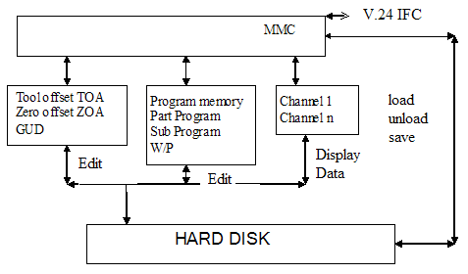

Digital Computer Control: - In these control systems signals in certain parts of the plant are in analog form i.e. continuous handles data only in digital; this requires signal discretization and analog-to-digital interfacing in form of A/D and D/A converters.

A simple form the digital control system knows as sampled-data control system. The sampler is an electronic switch whose output is the discritized versions of the

analog error signal and is a train of pulses of the sampling frequency with the strength of each pulse being that the error signal at the beginning of the sampling period. The sampled signal is passed through a data hold and is then filtered by a digital filter in accordance with the control algorithm the smoothed out control signal u(t) is then used to manipulate the plant.
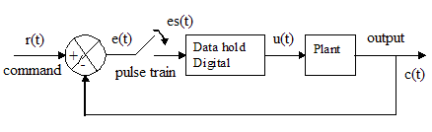
Computer control is needed in large and complex control schemes dealing with a number of input, output variables and feedback channels.

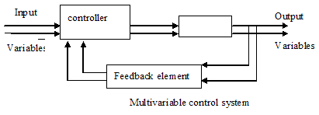

Analog Computer Control: - The signal that are varying continuously are the analog signals take for e.g. temperature & voltage and they are difficult to control.

Controller Components: -

- Sensors: - These are low power transducers which produce output signal as a measure of the controlled variable.

- Differencing & Amplification: - Differencing is to get the error signal & amplification is to amplify it to a suitable level in magnitude & power are most conveniently carried out electronically for e.g. by OPAMPs

- Actuators: - These are the devices whose output is mechanical motion (translatory/rotary: though rotary motion is preferred). The actuators are characterized by the power output and speed-torque relationship to match the load.

- Servomotors: - They are chiefly used in controlled drives because they are made to have a low inertia and are very susceptible to electrical variations. The main advantage of its design is its speed-torque characteristics at a given voltage are more flat than the conventional motors.

- Stepper Motors: - the stepper motor is a special type as synchronous motor which is designed to rotate through a specific angle (say 7.5⁰, 15⁰) for each electrical pulse received from its control unit. The stepper motor is used in digitally controlled position control system in open-loop mode.

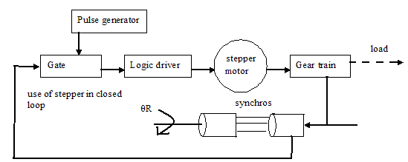

No sensors are needed for position and speed sensing as these are directly obtained by counting input pulses and periodic counting if speed information is needed.
Positioning of work table & tools in numerically controlled machining equipment are handled by the stepper motors.

The Commercially Available Common CNC Machines Generally Have 4 Drives

1. Spin 2. Spindle 3. Axes drive*2 4. Main drive

All the drives are controlled by the main drive while the main drive is computer controlled which is also responsible for controlling the other drives.

Types Of Axes Required Being Computer Controlled: -

1. Machining axes | 2. Channel axes | 3. Geometry axes
4. Special axes | 5. Path axes | 6. Synchronized axes
7. Positioning axes | 8. Command axes (motion synchronized axes) | 9. PLC axes
10. Link axes | 11. Leading link axes

Procedure for Manufacturing Through CNC: -

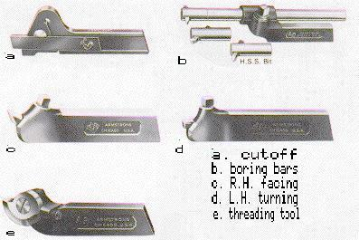
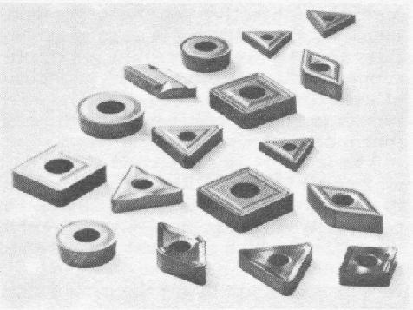
- Tool Design: - All types of tools take for e.g., milling cutters, drills, single point cutting tools, hobbing tool, shaping tool are available for machining. Lathes have some specially designed tools (cutting edges of tool are mechanically clamped to the shank) are used which are capable of performing a number of operations like milling drilling and can also act as single point cutting tool while performing a number of operations on lathe ranging from groove cutting, to face turning, ordinary turning, to screw cutting and can even act as a boring tool.

- Fixture Design: - With the automation level GRAZIANO is having they do not require any special type of jigs or fixture. On ordinary use bases they have diamond locators, vee locators, quick acting nuts or heel clamps.

For turning purpose with CNC machines pneumatically operated chucks can handle major part of workpiece while some special jobs can be easily held with the collets, dog clutch and face plates.

For milling ordinary collapsible mandrel are used. While hobbing machines have a moveable central clamps (also refereed as dead centre), which are capable to hold the object between its tapped centre.

- Deciding Tool Details: - As they are having more or less standardized tool for their machines hence the requirements for specially customized tools are never required.

- Workpiece Design: - More or less the final products complete with all the specifications in detail of the gear drawing is supplied to the GRAZIANO by their customers.

The details are then transferred to the design centre of the GRAZIANO to get the minimum dimensions required for the raw material that can be satisfactorily formed in a gear.
The company has specially designed software to calculate the practical details of the gear based on the theoretical design supplied to them by their customers (the programmed is originally kept by the parent company in ITALY while in INDIA they have the 24 hours of internet access to their program). The software calculates all the requisite dimensions of the raw uncut workpiece i.e. dimensions after forging. The drawing based on these dimensions are then prepared on the AUTO CAD. All the drawings are in the 2-D for easy understanding to the programmers and for the operators.

Sometimes on special request or as per demand they also design the gears based on the power and torque requirement for a particular product. Special software connected via internet is used for calculating the final gear details. The information obtained is then transferred to the software mentioned above for initial preparation.

- Part Programming: - GRAZIANO has a dedicated department for the part programming. The programmers are talented enough to handle any type of part itself in the factory and the outsourcing of the job is not required.

Engineering drawing
Process planning
Manual programming
Computer programming
Program transfer to machine hard disk
CNC machine tool
Finished product

GENERAL POWER RATINGS OF THE CNC: -

Generally all the machines were having the same ratings with the exceptions of one or two.

- Input voltage : 415 V A.C.
- Phase : 3
- Control volt : 24V D.C.
- Rated current : 36 A
- KVA Rating : 25 KVA

Classifications of CNC Systems: -

- According to tool positioning or programming modes: -
- Fixed zero system
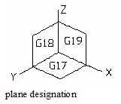
- Floating zero system
- Absolute system
- Incremental system

- According to motion control systems
- Point to point system
- Straight line or straight cut system
- Contouring or continuous path system

- According to types of feedback
- Analog
- Digital

- According to servo control systems
- Open-loop system
- Closed-loop system

Specifying The Origin Of Coordinate System: -

- Fixed Zero Method: - In this method, the zero point is always situated at a fixed location on the machine table.
- Floating Zero Method: - The part programmer decides the location of zero point anywhere according to the convenience, and the machine operator is duly informed about the same.

Tool Positioning System: -

- Absolute System: - The positions are indicated form a fixed zero point or reference point.
- Incremental System: - The tool position or locations are indicated with reference to a previously known location.
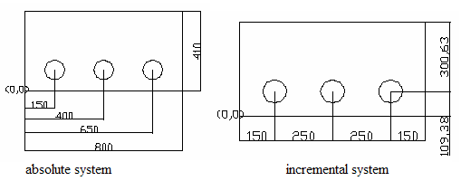

Motion Control Systems: -

- Point To Point System: - This system is commonly used in many operations like drilling, boring tapping, reaming etc., where the primary requirement is of accurately locating the tool or the workpiece at some specified location to perform the desired operation.

- Straight Line Or Straight Cut System: - This system is considered an extension of the point to point system. This system describes that the cutting tool can move along straight lines only which are parallel to the principle axis of motion, i.e., X-axis, Y-axis, Z-axis. This renders the CNC machine tool capable of performing milling operations, like groove cutting, slot cutting, milling rectangular shapes etc. feed to the tool or the workpiece is normally controlled through programmed commands. However the motion of different axis can not be combined.

- Contouring Or Continuous Path System: - It implies controlled and coordinated simultaneous movements of different slides of the machine tool to enable predetermined relative motions of the tool and workpiece during the entire machining operation. That means the motion of the tool & that of the workpiece are controlled along many axis simultaneously in this systems and this facilitates machining of different types of curved surfaces and profiles, contours and combinations of straight and curved profiles.

INTERPOLATIONS: -

Interpolation is the term used to denote the method or technique employed to facilitate the movement of the tool of a CNC machine form one programmed point to the next programmed point along a predicated path.

- Linear interpolation: - a straight line path.
- Circular interpolation: - along an arc or a circular path.
- Helical interpolation: - along a helical path.
- Parabolic interpolation
- Cubic interpolation: - involving complex tool paths maintaining continuity of the boundary profile.

Feedback Devices: -

- Analog transducers: - produces a variable electric voltage.
- Digital transducers: - produces countable electric pulses.

Servo Control Systems: -

Servomechanism: - Servomechanism or servo is restricted to feedback control systems in which the controlled variable is mechanical position of time derivatives of position, e.g. velocity and acceleration.

- Open Loop Control: - Any physical system which does not automatically correct for variation in its output, is called an open-loop systems.

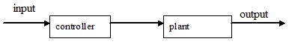

The open loop control is therefore satisfactory only if such fluctuations can be tolerated or system components are designed and constructed so as to limit parameter variations and environmental conditions are well controlled.

- Closed Loop System: - Any physical system which can automatically correct for variation in its output is called Close-loop systems. The sole difference between open & close loop is that of the feedback mechanism used specifically to correct the output variations in a close-loop system. Any physical system which does not automatically correct for variation in its output, is called an open-loop systems.

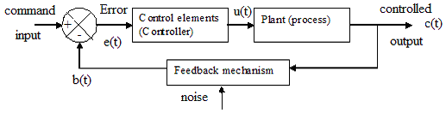

PROGRAM DEVELOPMENT FOR CNC MACHINE

Machine Axes: - Machine axes are the axes that actually exist on machine & have been parameterized during installation.

Geometry Axes (Special Axes): - These are the axes programmed in the part program.
Geometry axes & the special axes are offset by the selected zero offset relative to the machine axes. 3 are the maximum number of Cartesian geometry axes.

MCS: - Machine Co-ordinate System refers to the co-ordinates of the machine. (X, Y, Z).

WCS: - Work Co-ordinate System can be used to create a relationship. This relationship defines the position of the W/P co-ordinate system in relation to the MCS. (X1, Y1 Z1).

Program Types:-

- Part Program: - A part program consists of a sequence of instructions to the NC control. in its entirety this sequence effects the production of a specific W/P

- Sub Program: - Sequence of instructions in a part program which can be called repeatedly.

- Cycles: - Sequence of instructions in apart program which can be called repeatedly.

File Types:-

.mpf | Main Program | .ufr | Zero Offsets/ Frame
.spf | Sub Program | .ini | Initialization File
.tea | Machine Data | .com | Comment
.sea | Setting Data | .def | Definition Of Global User Data & Macros
.toa | Tool Offsets | .gud | User Data Global
.lud | Local User Data | .wmf | Windows Meta File (Exchange Format For Tool Management)
.top | Tool Plan

In GRAZIANO TRANSMISSIONI all the CNC machinery are DOS based i.e. they uses DOS as the programming language.

NC Words:

The whole programming of the CNC machines is based on achieving a single goal; just get the coordinates of the machining points or that of the contours.
The perfect co-ordinates facilitates the machine tool either the movements of the tool to a specified location or helps in the movement of the workpiece bed. Collectively in short the whole game of CNC lies in locating the co-ordinates of the machining points
To get that particular points NC words are used on the large scale.

- N-Words: - Denotes the sequence number to identify the block
- G-Words: - They are called as preparatory words, i.e., the word is used to prepare the controlling unit for the operating instructions, which are to follow for example.

G0: rapid traverse | G1: linear interpolation | G2: circular interpolation cw
G3: circular interpolation ccw | G2/g3 turn: helical interpolation | G04: dual time
G12: 3-d interpolation | G17: z in feed | G18: y in feed
G19: x in feed | G33: thread cutting | G53-g57: modal/non-modal, settable/programmable zero offset
G64: continuous path mode | G90: absolute dimensions | G91: incremental dimensions

- X, Y, Z (or U, V, W): - They are known as coordinate words or dimension data words.
- A, B: - They denote the angular position, they are mainly used by the 4 or 5 axis machines
- F-Words: - They specify the feed rate in mm/minute.
- S-Words: - Specifies the cutting speed or in other words mentions the spindle speed in rev./minute.
- T-Words: - Tool selection words are required only by those machines, which carry a tool turret or an automatic tool changer.
- D-Words: - D1-D9 cutting edge selection.
- M-Words: - Miscellaneous function words basically define some awkward or auxiliary functions for example.

M00: progressive stop | M02: end of program | M03: cw revolution
M04: ccw revolution | M06: tool change | M07: coolant on
M09: coolant off | M10: chuck decamp | M11: chuck clamp
M30: rewind/end of program

- R-Words: - Arithmetic functions.
- L-Words: - Sub-program call
- RP: - Radial path
- AP: - Angular path

- I, J, K: - Circle centre points in Cartesian co-ordinates
- TRANS (TRANSFER OR TRANSLATE): - It easier to make a design of the pattern on a convenient position lets say on the origin (0, 0). Then the whole pattern can be conveniently transferred to the required (X, Y) position using the TRANS command. The point of talking about these commands is that when we are having the computers than why not to use it to its maximum capacity.
- ROT (ROTATE): - in the same upper way if a pattern is inclined to an angle with a particular plane, it will become highly difficult to fid the co-ordinates of the inclined pattern, hence the best way develop the design at the origin and then rotate it to the required design by the ROT command.
- MIRROR: - Works as the same as the above a pattern having similarity along a axis can be mirrored by the MIRROR command the computer will itself calculate the co-ordinates of the rest of the pattern for the machining.

SOME SAMPLE PROGRAMMING

MAKING HOLES IN A PATTERN
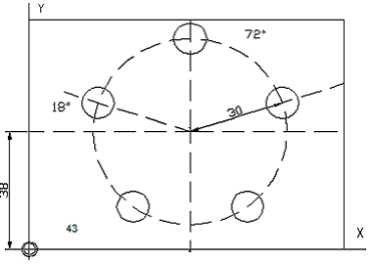

N10 G17 G54
N20 G111 X43 Y38
N30 G0 RP=30 AP=18 Z5 approach starting pt. in cylindrical coords
N40 L10 sub-program call
N50 G91 AP=72 polar angle in incremental direction
N60 L10
N70 AP=IC(72)
N80 L10
N90 AP=IC(72)
N100 L10
N110 G0 X300 Y200 Z100 M30 retract tool, end of program

PROGRAM FOR TOOL CHANGE LOCATION

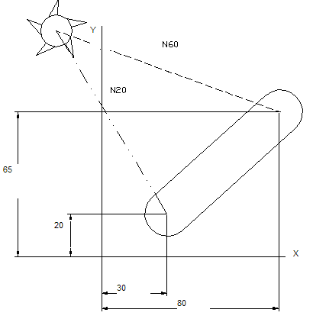

N10 G90 S400 M3 abs. dimension, spindle ccw
N20 G0 X30 Y20 Z2
N30 G1 Z-5 F1000
N40 X80 Y65 travel on a straight line
N50 G0 Z2
N60 X-20 Y100 Z100 M30 retract tool, end of prog.

ORIGINAL PROGRAM FOR SIEMENS MILLING MACHINE

MILLING ON INTERNAL GEARS

% START OF PROGRAM %

%_N_21257_MPF
; $ PATH=/ _N_MPF_DIR
; SLEAVE 21257/11387 UN CUT TEETH MILLING]
N5 G17 ; plane selection
N10 R01=1 ; initializing arithmetic operator
N15 G56 ; settable zero offset
N20 T3 ; tool select no. 3
N25 M6 ; tool change
N30 M3 S210 ; cw. Rev. , spindle speed
N35 G0 Z150 ; rapid traverse
N40 M08 G0 X0 Y0 ; coolant ON
N45 G0 Z10
N50 G1 Z-0.59 F1000 ; linear interpolation, feed
N55 G111 X0 Y0
N60 G01 RP=27.0 AP=90.20 F1500
N65 G01 RP= 32.00 AP=90.20 F32
N70 G01 RP=32.48 AP=90.20 F10
N75 G04 F3 ; dual time, 3 sec. wait
N80 G0 X0 Y0
N85 G1 Z-0.65 F200
N90 G01 RP=27 AP=210.28 F1500
N95 RP=32.10 AP=210.28 F32
N100 RP=32.63 AP=210.28 F10
N105 G04 F3
N110 G0 X0 Y0 ; move to 0, 0, 0
N115 G1Z-0.65 F200
N120 G01 RP=27.0 AP=330.18 F1500
N125 G01 RP=32.20 AP=330.18 F32
N130 G01 RP=32.70 AP=330.18 F10
N135 G04 F3
N140 G0 X0 Y0
N145 Z150
N150 X-150 Y250 ; table move
N155 R2=R1+R2 ; part counter
N160 R100=R1+R100 ; 100 part counter
N165 M09
N170 M30 ; rewind or end of process

% END OF PROGRAM %

ORIGINAL PROGRAM FOR HOBBING

N2 M11 ; (W/P DECLAMP)
N3 M15 ; (TAIL STOCK DOWN)
N4 M10 ; (W/P CLAMP)
N5 G04F0.54
N6 G90G00G54X50
N7G90G00G54Z0
N8 IF R25>80 GOTOF
N9 G90G00G54 Y=R25 M08
N10 M03 S350
N11 G90G00G54X0Z0
N12 G90G01G54 X-4.5G94F10
N13 G04 F0.5
N14 G91 G54 G01 Z=11.241 X=2.790 G94 F30
N15 G4 F0.3
N16 G90G00G55X0Z04
N17 G90G01G55 X-4.15G94 F50
N18 G91 G55 G01 Z=25 X-6.3 G94 F30
N19 G4 F.54
N20 G90G00G54 X1 M09
N21 G90G00G54 X50 Z0 M05
N22 R25=R25+R26
N23 M16 G04F2;
N24 M11;
N25 END ; (HOB LIFE OVER)
N26 R99=R99+1
N27 M30 (END OF PROGRAM)

ORIGINAL PROGRAM FOR GUN DRILLING MACHINE

N10 G90 G71 G94
N20 G0 G55 D0 X0 Z5.0
N30 G04 F1
N40 M03 S2700
N50 M07 G0 Z2.0
N60 G01 Z-10.0 F40
N70 G01 Z-165 F80
N80 G04 F2
N90 M08
N100 M05
N120 Z5.0

DIFFICULTY LEVELS OF PROGRAMMING

If considered the programming difficulty the most difficult program is that of the grinding wheel because it requires dressing after every few cycles of the grinding. Micro programmes are required that to calculate the grinding wheel wear during the grinding and also due to the dressing of the wheel, the programming is complicated and requires practical approach for calculating the wheel wear. The programming can be so complex that it can take up to a whole week before actual cutting process starts.

But on the contrary the programmers considers the toughest part of the programming is the initial phase i.e. form the scratch or lets say of the uncut blank because it’s the first machining process which will govern all the other process & it will also declare the accuracy and the quality of the sequential processes along with the quality of the gear as a whole.

TOOL ROOM ACTIVITYS: -

- Shaving cutter sharpening machine. For the resharpening of the shaving cutter
- Universal surface grinding used for the external surface grinding
- Universal milling machine
- Universal grinding machine
- Broach resharpening machine.
This is special machine for the resharpening of the broaches. Resharpening is of the dry type and no cutting oil or coolant is used for the purpose. The resharpening is done with the help of special type CBN (carbon boron nitride) wheel with resin bond.
- Universal tool & cutter grinder.
For resharpening of the all type of milling cutter, drills etc
- Shaper cutter resharpening machine.
As the name suggest it is used for resharpening of the shaper cutters.
- Hob cutter resharpening machine.
Special machine for the resharpening of the hob cutters. Neat cutting oil is used during resharpening.

HEAT TREATMENTS

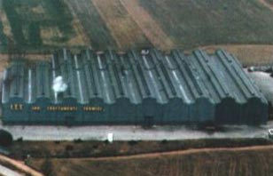
Heat treatment is an extremely important aspect of gear production. Normally transmission parts are treated in such a way that the case (up to the depth of about 1-mm max) is hardened to 60-62 HRC & the core remains tough so that it is not brittle. This is achieved by first increasing the percentage of the carbon in the iron (called case carburizing) & then quenching it at about 930 ºC in the oil so that hard marten site structure is obtained in the case with high hardness up to 62 HRC.

For this reason, GRAZIANO Trasmissioni founded I.T.T. SRL, INDUSTRIA TRATTAMENTI TERMICI (Industrial Heat Treatment srl) in 1977. GRAZIANO Trasmissioni uses this plant to carry out the heat treatment operations both for the needs of its INDIAN Plants and for third-party customers. Its highly reliable modern machines, which are technologically advanced, offer a variety of treatment processes.

TYPES OF FURNACES IN GRAZIANO: -

2 rotary furnaces
6 SQF (sealed quenching furnace)4 electric + 2 gas fired

Case Carburizing

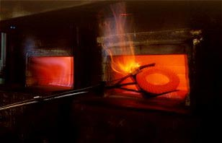
First step is carried out by furnaces with single or double chambers and by continuous furnaces. The carburization is done at 9300 C. The heating is done for a period of 4-10 hrs. The carbon potential can be maintained up to 0.95 as per the requirement. Atmosphere regulation is obtained with anologes, azote & methanol and air-methane is carried out by oxygen and lambda probes and by CO/CO₂ analizers. The gases used are methanol, nitrogen & propane.
The automation system and the microprocessor regulation unit allow the carburizing process to be kept constantly under control.
Daily production: 40 tons
Hourly capacity: 360 components

Quenching: - For obtaining the hardness of the order of 60-62 HRC, quenching is required from a temperature of about 800-840 0C with a carbon potential of 0.69 for 30 minute in pool of oil. The quenching oil used is CASTROL T-401. Case structure obtained by quenching is untempered marten site. The stresses are obtained after quenching which is required to be removed by the tempering.

Washing is required after the quenching to remove the oil stains.
The whole process is done in a controlled environment to minimize the distortion of the material.

Tempering: - Stresses developed during quenching of the material are removed by tempering the material. The temperature is maintained at 150-170 0C. The charge is maintained at this temperature for about 2- hours.

Rotary Furnace: - The main advantages of the rotary furnace are observed in the heat treatment of the thin cross section or the hollow parts that can not be done by the method mentioned above. The idea behind the change of the furnace for some particular materials is to maintain the dimensional and geometrical accuracies.

Rotary furnaces are specifically used for thin hollow sleeves at a temperature of about 820-850 ⁰C.

The quenching oil temperature is kept around 30-40 ºC. In this press quenching a solid mandrel is used on which component is kept and quenched at pressure.

SHOT BLASTING: - The shot blasting system is equipped with a turbine and an 8-station rotating table for shafts & gears, 6 bar pneumatic system and a 4-station rotating table for pinions. Shot blasting is basically done to remove the scales formation & for cleaning of the gears.

The grinding internal or external is carried out as per requirement.

SURFACE COATING: - The transmission components are treated with the certain types of the surface coating depending upon the type and nature of application. This plant has a facility of doing surface treatment of Mn Phospating.

Mn Phospating serves the purpose of initial lubrication and the rust prevention.
Phospating is of generally two types: -

- Zn Phospating
- Mn Phospating

LABORATORY: -
ITT is equipped with a metallurgical laboratory in which it is possible to carry out the following: -
- Analysis of steel by means of mass spectrometer
- Testing of hardness and micro-hardness
- Structural analyses
- Inclusion rate defining
- Analyses of the oils (Castrol SF6) for hardening by means of Quench-O-Meter
- Examination to the Magnetic Flux Tester
- Examination with Eddy current.
- Rockwell, Brinell, Vickers hardness tester.

INSPECTION METHODS: -

Gears are highly precise components; hence they require a very strict inspection before and after the manufacturing. Gears are designed to work in very hard conditions and they are made to bear any type of working conditions through out their life cycles.

Graziano follow very high quality control standards: -

To maintain the standard & the reputation following inspections are carried out: -

- Involute Tester: - Checks the lead & the involute profile of the gear; before & after the shaving operation.

- CMM (Coordinate Measuring Machine): - The machine is capable of determining the 3-D dimensions of the object.

- Contracer Testing Machine: - the device is capable of tracing the contours of the object and facilitates in calculating the dimensions.

- Profile Projector: - They dimensions small enough for any instrument to detect can easily be projected on a screen for calculating the dimensions.

- ULM (Universal Linear Measuring Machine): - The purpose solved by the machine is the calibration gauges and the instruments.

- Bench Centre: - For checking face runout.

