INDIAN FLIGHT PRICE ANALYSIS
Data Analytics Project
Technology: Python | Pandas | NumPy | Plotly | Streamlit
Author: Nikesh Singh

1. Executive Summary
This project presents a comprehensive data analytics study of domestic Indian airline ticket prices. The analysis is grounded in a real-world dataset of 10,460 flight records sourced from Indian aviation routes and covers twelve airlines, five source cities, and six destination cities across selected months of 2019.
The primary objective is to identify pricing patterns and actionable business insights across key dimensions: airline, route, number of stops, journey month, flight duration, and departure time. Statistical summaries and exploratory data analysis (EDA) are performed on the cleaned and feature-engineered dataset.
Key dataset statistics: minimum ticket price Rs 1,759; maximum Rs 79,512; average Rs 9,027; median Rs 8,266. The most frequently operated route is Delhi to Cochin (4,345 records). Jet Airways accounts for the largest share of records (3,700 flights), while Jet Airways Business commands the highest average fare at Rs 58,359.
The project is delivered as a self-contained, interactive Streamlit web dashboard (app.py) that provides dynamic sidebar filters, KPI metric cards, fifteen interactive charts across five tabs, a searchable data explorer, and a CSV download feature. The entire data pipeline — loading, cleaning, feature engineering, and visualisation — is contained within a single Python file requiring no external custom modules.
Technologies used: Python 3.10+, pandas, NumPy, Plotly Express, and Streamlit.

2. Project Objective
The aviation sector in India has experienced rapid growth, and ticket pricing remains a complex, dynamic variable influenced by numerous factors. This project applies data analytics techniques to a structured dataset of domestic flight records to answer the following business questions:
- Airline Pricing — Which airlines offer the highest and lowest average fares? How does the distribution of prices vary across carriers?
- Route Analysis — Which origin-destination routes are most heavily operated? Do certain routes consistently command premium pricing?
- Stop Count — Does an increase in the number of stops correlate with higher fares? How does stop count affect flight duration?
- Seasonality — Are there observable monthly pricing patterns? Which months see peak and trough fares?
- Departure Time — Does the time of day at departure affect ticket prices? Which departure period is most popular?
- Flight Duration — What is the relationship between flight duration and ticket price?
By addressing these questions through EDA and an interactive dashboard, the project demonstrates applied data analytics skills applicable to real-world decision-making by travellers, airline revenue managers, and travel platform analysts.

3. Dataset Description
The dataset used in this project is Indian Flight Price.csv, a flat-file CSV containing 10,460 records of domestic Indian airline ticket bookings. The data covers flights operated across major Indian cities during selected months of 2019. The file is located at data/Indian Flight Price.csv within the project directory.

3.1 Dataset Summary
Table 1: Dataset Summary

3.2 Column Definitions
Table 2: Dataset Column Definitions

3.3 Airlines Covered
The dataset contains records for 12 distinct airlines: Jet Airways (3,700 records), IndiGo (2,043), Air India (1,694), Multiple Carriers (1,196), SpiceJet (815), Vistara (477), Air Asia (318), GoAir (194), Multiple Carriers Premium Economy (13), Jet Airways Business (6), Vistara Premium Economy (3), and Trujet (1).
Source cities: Bangalore, Chennai, Delhi, Kolkata, Mumbai. Destination cities: Bangalore, Cochin, Delhi, Hyderabad, Kolkata, New Delhi. Months covered: January, March, April, May, June, September, December.

Table 1: Dataset Summary
Total Records: 10,460 rows | Total Columns: 10
File Format: CSV | Time Period: Jan, Mar, Apr, May, Jun, Sep, Dec 2019
Price Range: Rs 1,759 to Rs 79,512 | Airlines: 12 | Source Cities: 5 | Destinations: 6
Table 2: Dataset Column Definitions
Airline | Operating airline name | Text
Date_of_Journey | Flight date (DD/MM/YYYY) | String -> datetime
Source | Departure city | Text
Destination | Arrival city | Text
Route | IATA airport code route string | Text
Dep_Time | Scheduled departure time (HH:MM) | Text
Arrival_Time | Scheduled arrival time (HH:MM) | Text
Duration | Total flight duration (e.g. 2h 50m, 19h) | Text
Total_Stops | Number of stops (0=non-stop, 1, 2, 3, 4) | Integer
Price | Ticket price in Indian Rupees (Rs) | Integer

4. Data Cleaning and Preprocessing
All data cleaning and preprocessing is performed inside app.py at application startup, before the dashboard renders. The original CSV file is never modified. The following steps are applied in sequence:

4.1 Initial Inspection
The raw dataset contains 10,460 rows and 10 columns. Upon inspection: zero missing values in any column, zero fully duplicate rows. The dataset is well-structured and requires targeted type conversions rather than extensive imputation.

4.2 Whitespace Standardisation
All string and object-type columns are stripped of leading and trailing whitespace using pandas str.strip(). This prevents category mismatches caused by invisible space characters (e.g., 'IndiGo ' vs 'IndiGo').

4.3 Date Conversion
The Date_of_Journey column is stored as a string in DD/MM/YYYY format. It is converted to a pandas datetime object using pd.to_datetime(format='%d/%m/%Y', errors='coerce'). Any rows where date parsing fails are dropped. In this dataset, all 10,460 dates parse successfully.
Before: '24/03/2019' (string) After: 2019-03-24 (datetime)

4.4 Price Conversion
The Price column is cast to integer using pd.to_numeric(errors='coerce') followed by astype(int). Any non-numeric values are coerced to NaN and the corresponding rows are dropped. All 10,460 price values are valid integers in this dataset. No decimal places are used for prices in the dashboard.

4.5 Total Stops Conversion
Total_Stops is already stored as integer (0, 1, 2, 3, 4) in the source CSV. It is cast to integer type explicitly to guard against future type inconsistencies. The mapping used in the dashboard: 0 = Non-stop, 1 = One stop, 2 = Two stops, 3 = Three stops, 4 = Four stops.

4.6 Duration Processing
The original Duration column (e.g. '2h 50m', '19h', '45m') is retained unchanged. A new derived column Duration_Minutes is created using a regex parser that extracts hours and minutes separately and converts to total minutes. Examples: '2h 50m' becomes 170, '19h' becomes 1140, '7h 25m' becomes 445. One record contains '5m' which is an apparent data entry error; it is retained as an outlier visible in the scatter chart.

4.7 Data Quality Summary
After cleaning: 10,460 valid records remain. Zero missing values in any analytical column. Zero duplicates. All prices are positive integers. All dates are valid datetime objects. The dataset is ready for feature engineering and analysis.

5. Feature Engineering
Feature engineering creates 11 new analytical columns from the existing data. The original 10 columns are preserved unchanged. The feature engineering function engineer_features() in app.py produces the following derived columns:

5.1 Date-Derived Features
Journey_Year: Integer year extracted from Date_of_Journey (e.g. 2019)
Journey_Month: Integer month number (1=January to 12=December)
Journey_Month_Name: Full month name string (e.g. 'March', 'June')
Journey_Day: Day of month (1 to 31)
Journey_Day_Name: Weekday name (e.g. 'Monday', 'Saturday')

5.2 Time-Derived Features
Departure_Hour: Integer hour extracted from Dep_Time string (0 to 23)
Departure_Period: Categorical time-of-day bucket derived from Departure_Hour
Arrival_Hour: Integer hour extracted from Arrival_Time string (0 to 23)

5.3 Departure Period Classification
The Departure_Period feature classifies each flight into one of five time-of-day categories based on the departure hour:
Early Morning: Hours 00:00 to 05:59 (1,046 flights)
Morning: Hours 06:00 to 11:59 (4,224 flights) -- most popular
Afternoon: Hours 12:00 to 16:59 (1,874 flights)
Evening: Hours 17:00 to 20:59 (2,323 flights)
Night: Hours 21:00 to 23:59 (993 flights)

5.4 Duration and Route Features
Duration_Minutes: Original Duration string converted to total minutes (e.g. '2h 50m' = 170). The original Duration column is kept unchanged.
Stops_Label: Human-readable stop count label (e.g. '1 Stop', '0 Stops (Non-stop)')
Route_Short: Simplified 'Source to Destination' string for chart display (e.g. 'Delhi to Cochin')

6. Exploratory Data Analysis
The following analysis results are computed directly from the dataset. All figures are actual calculated values.

6.1 Overall Price Statistics
Minimum Price: Rs 1,759 Maximum Price: Rs 79,512
Average Price: Rs 9,027 Median Price: Rs 8,266
Std Deviation: Rs 4,625 Avg Duration: 10h 29m (630 minutes)

6.2 Airline Analysis
Flight counts and average prices by airline (actual computed values):
Jet Airways Business: 6 flights Avg Price: Rs 58,359 (highest avg)
Jet Airways: 3,700 flights Avg Price: Rs 11,599
Multiple carriers Prem: 13 flights Avg Price: Rs 11,419
Multiple carriers: 1,196 flights Avg Price: Rs 10,903
Air India: 1,694 flights Avg Price: Rs 9,557
Vistara Premium eco: 3 flights Avg Price: Rs 8,962
Vistara: 477 flights Avg Price: Rs 7,802
GoAir: 194 flights Avg Price: Rs 5,861
IndiGo: 2,043 flights Avg Price: Rs 5,668
Air Asia: 318 flights Avg Price: Rs 5,594
SpiceJet: 815 flights Avg Price: Rs 4,336
Trujet: 1 flight Avg Price: Rs 4,140 (lowest avg)

6.3 Stops Analysis
Average price and duration increase consistently with the number of stops:
0 stops (Non-stop): 3,473 flights Avg Price: Rs 5,018 Avg Duration: 2h 30m
1 stop: 5,625 flights Avg Price: Rs 10,594 Avg Duration: 13h 02m
2 stops: 1,318 flights Avg Price: Rs 12,761 Avg Duration: 20h 16m
3 stops: 43 flights Avg Price: Rs 13,261 Avg Duration: 25h 13m
4 stops: 1 flight Avg Price: Rs 17,686 Avg Duration: 29h 30m

6.4 Monthly Analysis
Average ticket price by month (actual dataset values):
January: Rs 10,457 (2nd highest) March: Rs 8,428 April: Rs 5,231 (lowest)
May: Rs 9,253 June: Rs 9,138 September: Rs 9,475
December: Rs 9,080

6.5 Route Analysis
Top routes by flight count:
1. Delhi to Cochin: 4,345 flights Avg Price: Rs 10,462
2. Kolkata to Bangalore: 2,860 flights Avg Price: Rs 9,143
3. Bangalore to Delhi: 1,265 flights Avg Price: Rs 5,144
4. Bangalore to New Delhi: 912 flights Avg Price: Rs 12,020 (highest avg)
5. Mumbai to Hyderabad: 697 flights Avg Price: Rs 5,060
6. Chennai to Kolkata: 381 flights Avg Price: Rs 4,790

6.6 Source and Destination Analysis
Average price by source city: Delhi (Rs 10,462) > Kolkata (Rs 9,143) > Bangalore (Rs 8,025) > Mumbai (Rs 5,060) > Chennai (Rs 4,790)
Average price by destination: New Delhi (Rs 12,020) > Cochin (Rs 10,462) > Bangalore (Rs 9,143) > Delhi (Rs 5,144) > Hyderabad (Rs 5,060) > Kolkata (Rs 4,790)

6.7 Departure Period Analysis
Morning (06:00-11:59): 4,224 flights Avg Price: Rs 9,094 (most popular period)
Evening (17:00-20:59): 2,323 flights Avg Price: Rs 9,150
Afternoon (12:00-16:59): 1,874 flights Avg Price: Rs 9,348 (highest avg price)
Early Morning (00:00-05:59): 1,046 flights Avg Price: Rs 8,696
Night (21:00-23:59): 993 flights Avg Price: Rs 8,203 (lowest avg price)

7. Streamlit Dashboard
The project is delivered as a fully self-contained Streamlit web application (app.py). No external Python modules are required beyond the four packages listed in requirements.txt. The dashboard is launched with the command: streamlit run app.py

7.1 Sidebar Filters
The left sidebar provides six independent multi-select filters that update all charts, KPIs, and the data table in real time. Leaving a filter blank means 'select all'.
Airline filter: Select one or more of the 12 airlines
Source City filter: Select departure city (Bangalore, Chennai, Delhi, Kolkata, Mumbai)
Destination filter: Select arrival city (6 options)
Number of Stops filter: Select stop count (0 to 4)
Journey Month filter: Select one or more months
Departure Period filter: Early Morning, Morning, Afternoon, Evening, Night

7.2 Tab 1 — Overview
Displays six KPI metric cards: Total Flights (count of filtered records), Average Price, Minimum Price, Maximum Price, Average Duration (formatted as Xh Ym), and Average Stops. Below the KPIs: a horizontal bar chart showing average ticket price by airline, and a line chart showing average price by month.

7.3 Tab 2 — Airline Analysis
Contains four charts: (1) Flight count by airline (horizontal bar), (2) Average price by airline (vertical bar), (3) Price distribution by airline (box plot showing median, quartiles, and outliers), and (4) Average flight duration by airline (vertical bar). All colours use distinct qualitative palettes for clarity.

7.4 Tab 3 — Route Analysis
Contains five charts: (1) Top 10 most common routes (horizontal bar), (2) Top 10 most expensive routes by average price (horizontal bar), (3) Average price by source city (vertical bar), (4) Average price by destination (vertical bar), and (5) Top 15 source to destination combinations by count (horizontal bar).

7.5 Tab 4 — Price Analysis
Contains six charts: (1) Price distribution histogram (60 bins), (2) Average price by number of stops, (3) Average price by month (line chart), (4) Average price by departure period, (5) Flight duration vs ticket price scatter plot coloured by airline, and (6) Average flight duration by number of stops. All prices shown without decimal places using Indian Rupee symbol.

7.6 Tab 5 — Data Explorer
Provides a searchable, filterable data table showing all filtered records. Users can: (1) type a search term to filter by Airline, Source, Destination, or Route, (2) select which columns to display, (3) view the record count, and (4) click 'Download Filtered Data as CSV' to download the currently visible dataset as a CSV file.

7.7 Key Business Insights Section
Below the tabs, a dedicated section dynamically calculates and displays seven textual insights from the currently filtered dataset. These include: the airline with the highest and lowest average price, the most frequent route, the most expensive route, peak and off-peak months by average price, the stop-count vs price comparison, and the source city with the highest average price. All results are calculated at runtime — none are hardcoded.

8. Dashboard Screenshots
The following screenshots were captured from the live Streamlit application running at http://localhost:8502, using Playwright headless browser automation. All images show the actual dashboard with real data from Indian Flight Price.csv (10,460 records). Screenshots are embedded directly in this document and are visible offline.

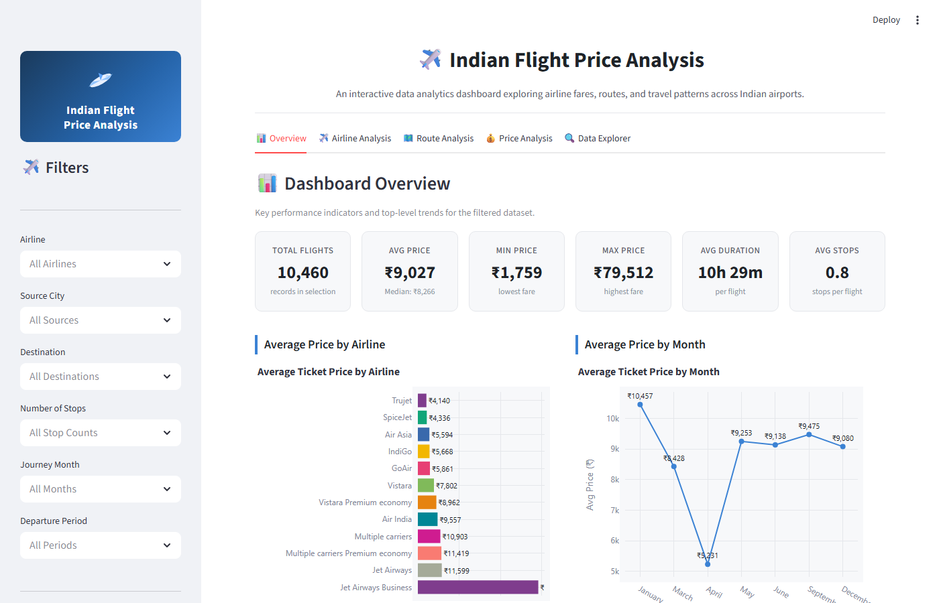
Figure 1: Indian Flight Price Analysis — Streamlit Dashboard Overview

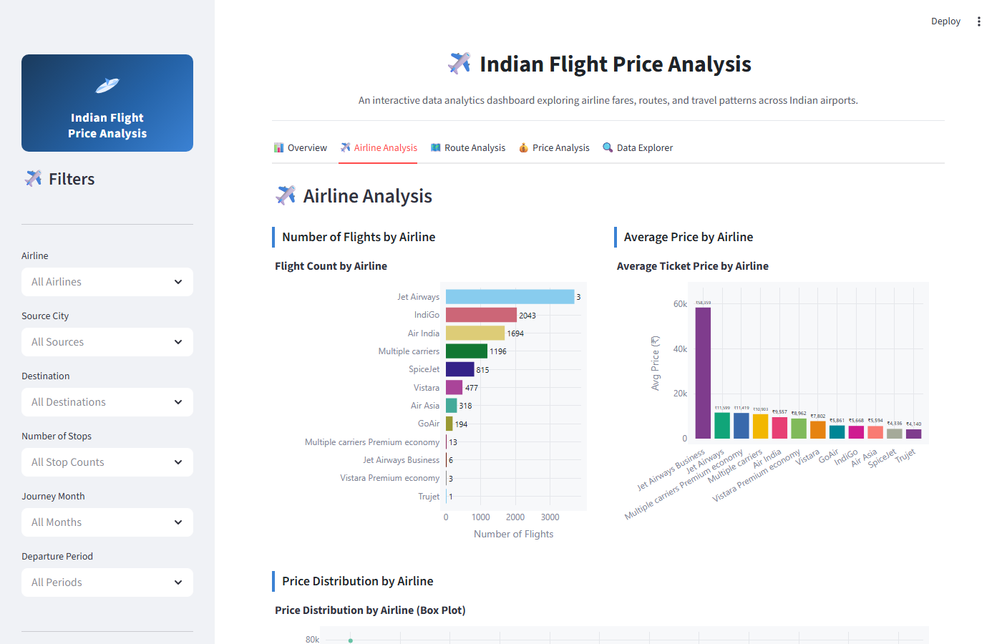
Figure 2: Indian Flight Price Analysis — Airline Analysis

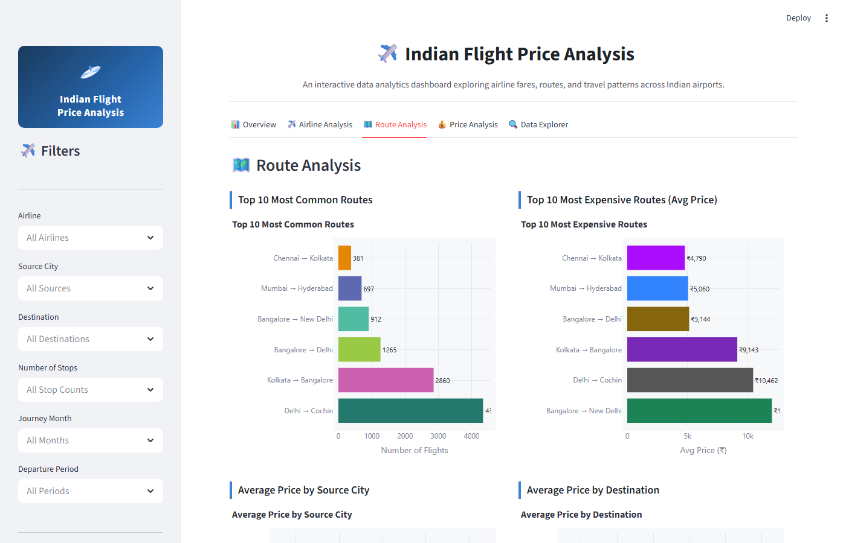
Figure 3: Indian Flight Price Analysis — Route Analysis

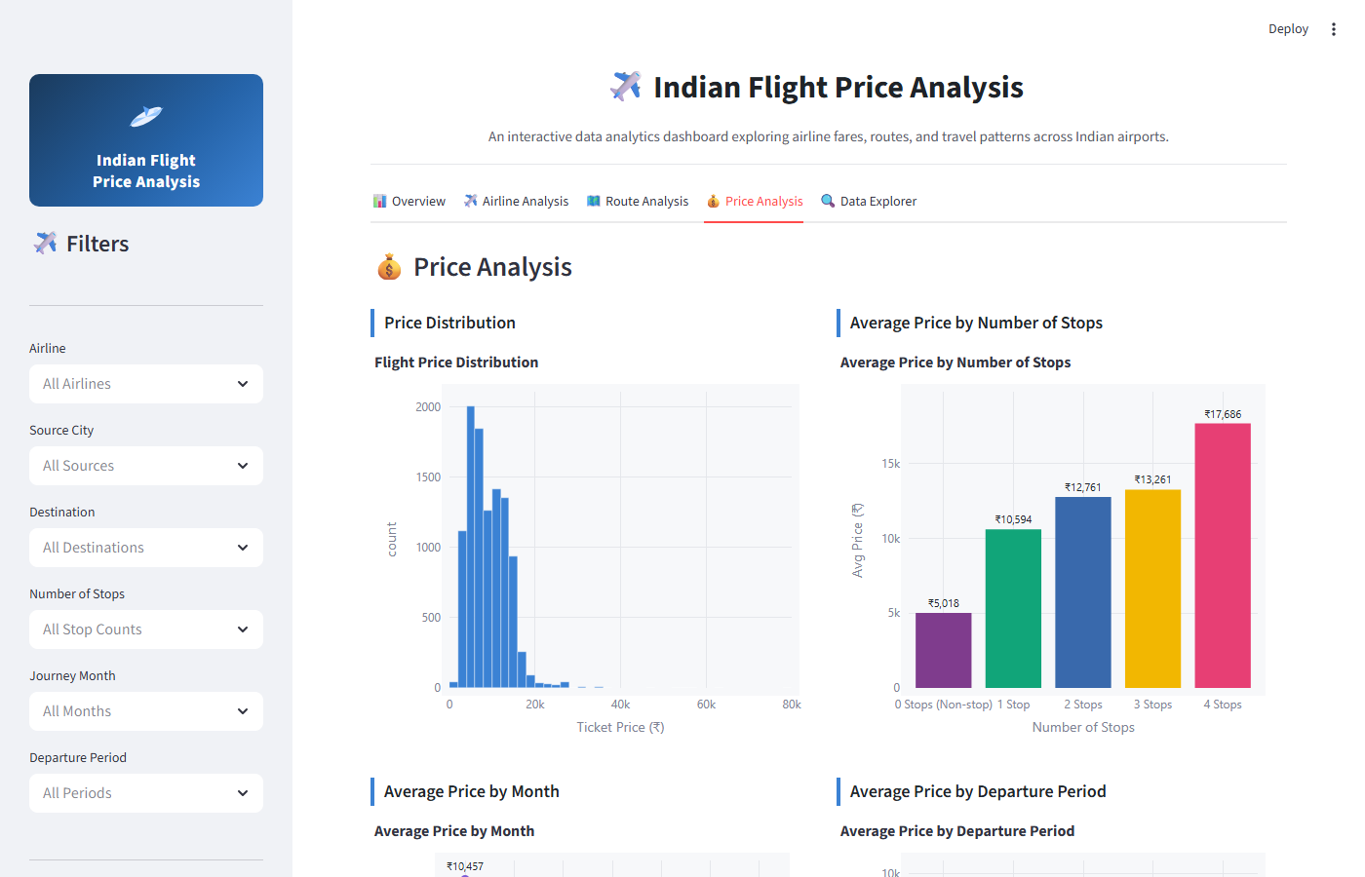
Figure 4: Indian Flight Price Analysis — Price Analysis

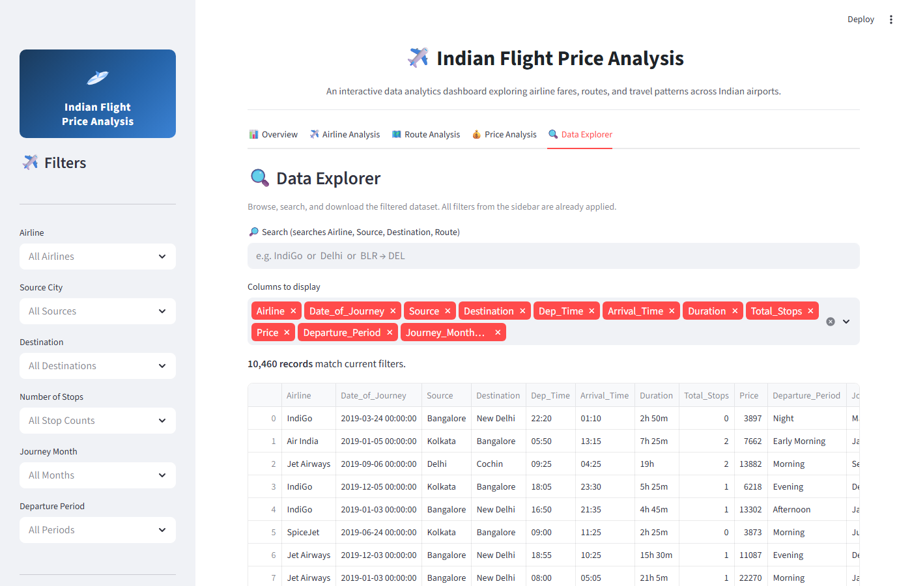
Figure 5: Indian Flight Price Analysis — Data Explorer

9. Key Findings
All findings below are derived exclusively from actual calculated values in the dataset. Observed results are stated as facts; interpretations are noted separately.
Finding 1: Premium Carriers Command Significantly Higher Fares
Observed: Jet Airways Business averages Rs 58,359 per ticket (6 records). The next highest is Jet Airways at Rs 11,599 (3,700 records). Low-cost carriers SpiceJet (Rs 4,336) and Trujet (Rs 4,140) have the lowest averages. Interpretation: Business class tickets are priced approximately 5 to 6 times higher than economy fares on the same network, consistent with industry norms.
Finding 2: More Stops Consistently Correlate with Higher Prices and Longer Durations
Observed: Non-stop average price Rs 5,018 vs 1-stop Rs 10,594 vs 2-stop Rs 12,761. The average duration follows the same trend: 2h 30m (non-stop) to 29h 30m (4 stops). Interpretation: The higher prices for multi-stop flights likely reflect longer itineraries and indirect routing rather than a stop-count premium per se. The lack of direct flights on some routes forces passengers onto more expensive connecting itineraries.
Finding 3: January is the Most Expensive Month; April is the Cheapest
Observed: January average Rs 10,457; April average Rs 5,231. The difference is Rs 5,226 (approximately 100% higher in January). Note: The dataset covers only seven months; year-round seasonality cannot be fully characterised from this sample. Caution is advised against generalising these findings to all months.
Finding 4: Delhi is the Most Expensive Departure City
Observed: Delhi average Rs 10,462; Chennai average Rs 4,790. Interpretation: This likely reflects the longer routes originating from Delhi (primarily Delhi to Cochin, a long-distance corridor) rather than an inherent Delhi departure premium.
Finding 5: Morning is the Most Popular Departure Period
Observed: 4,224 of 10,460 flights (40.4%) depart between 06:00 and 11:59. Night departures (21:00-23:59) are least common at 993 flights (9.5%). Price differences across periods are modest (Rs 8,203 to Rs 9,348), suggesting departure time has limited direct pricing impact in this dataset.
Finding 6: The Delhi to Cochin Route Dominates the Dataset
Observed: 4,345 of 10,460 records (41.5%) are on the Delhi to Cochin route. This route also carries one of the higher average prices (Rs 10,462). Interpretation: The dataset may be weighted towards this corridor, so aggregate results should be interpreted with awareness of this concentration.

10. Business Insights
For Travellers: The analysis shows that non-stop flights cost approximately half the price of 1-stop flights on average (Rs 5,018 vs Rs 10,594). Travellers seeking the lowest fares should consider low-cost carriers (SpiceJet, Air Asia, IndiGo) and travel in April which records the lowest average price (Rs 5,231). Morning departures offer the most choice with 4,224 flights and competitive pricing.
For Airlines and Revenue Managers: The large price spread (Rs 1,759 to Rs 79,512) and the dominance of the Delhi to Cochin route (41.5% of records) suggest opportunities for dynamic pricing. The January price peak (Rs 10,457 average) indicates seasonal demand that could support premium pricing strategies.
For Travel Platforms: The Bangalore to New Delhi route has the highest average price (Rs 12,020) despite fewer flights than Delhi to Cochin. Route-specific promotions on this corridor could drive booking volume. The Streamlit dashboard's filter capability can support customised customer fare recommendations.
For Pricing Analysts: The strong correlation between stop count and both price and duration provides a reliable feature for fare prediction models. The relatively small price difference across departure periods (Rs 8,203 to Rs 9,348) suggests time-of-day is a weaker pricing driver than route and airline choice.

11. Technology Stack
The following technologies are used in this project (verified against requirements.txt and app.py imports):
Python 3.10+ Core programming language. All logic, data processing, and dashboard code is written in Python.
pandas >= 2.0 Data loading (read_csv), cleaning (drop_duplicates, to_datetime, to_numeric), filtering, groupby aggregations, and value_counts.
NumPy >= 1.26 Numerical operations including np.nan handling for duration parsing and missing value coercion.
Streamlit >= 1.32 Interactive web dashboard framework. Provides set_page_config, tabs, sidebar multiselect, columns, markdown, metric cards, dataframe table, and download_button components.
Plotly Express >= 5.20 Interactive chart library. Used for bar, horizontal bar, line, scatter, box, and histogram charts with hover tooltips.
CSV (flat file) The data source is Indian Flight Price.csv, a plain-text comma-separated file requiring no database or API connection.
Python standard library os, io, re modules used for file path handling, byte stream creation, and regular expression parsing.
Visual Studio Code Recommended development environment for editing app.py and running the Streamlit application.

12. Project Structure
The project follows a clean, minimal structure designed for IBM submission where a single code file is uploaded:
indian-flight-price-analysis/
|
+-- app.py Self-contained Streamlit dashboard (1,184 lines)
+-- requirements.txt Python package dependencies (4 packages)
+-- README.md Full project documentation
+-- data/
+-- Indian Flight Price.csv Raw dataset (871,734 bytes, never modified)
app.py is completely self-contained and includes:
- - Constants (STOPS_LABEL_MAP, MONTH_NAME_MAP, DAY_NAME_MAP)
- - Data loading function (load_raw_data)
- - Data cleaning function (clean_data)
- - Feature engineering function (engineer_features)
- - Full pipeline function (get_processed_data)
- - Filter function (apply_filters)
- - Dashboard layout (render_sidebar, tab functions, render_insights, main)
- - All 15 Plotly chart definitions
The IBM code submission field should contain app.py only. The dataset must be placed at data/Indian Flight Price.csv relative to app.py.

13. How to Run the Project
Step 1: Install Python
Ensure Python 3.10 or later is installed. Download from https://www.python.org/downloads/
Step 2: Open the project directory
Open a terminal (Command Prompt, PowerShell, or Terminal) and navigate to the indian-flight-price-analysis folder.
Step 3: Install dependencies
pip install -r requirements.txt
Step 4: Verify dataset location
Confirm the file Indian Flight Price.csv is located at: data/Indian Flight Price.csv (relative to app.py)
Step 5: Run the Streamlit application
streamlit run app.py
Step 6: Open the dashboard in the browser
Streamlit will automatically open http://localhost:8501 in the default browser. If not, copy and paste this URL manually. Use the sidebar filters to explore the data interactively.

14. Project Limitations
The following limitations apply to this project based on the actual dataset and analysis scope:
- Time scope: The dataset covers selected months of 2019 only. Full-year and multi-year pricing trends cannot be derived from this sample. Seasonal patterns identified here may not hold across all months.
- Route imbalance: 41.5% of records are concentrated on the Delhi to Cochin route, which may skew aggregate averages. Route-specific conclusions are more reliable than overall averages.
- No real-time pricing: The dataset is static. Actual flight prices change dynamically with demand, booking lead time, and availability. These findings cannot be used to predict current market prices.
- Correlation is not causation: The observed relationships between stop count, duration, and price are correlational. Other factors (route length, airline strategy, cabin class) are likely confounders.
- Data entry errors: One record (Duration = '5m') appears to be a data entry error. It is retained in the dataset as an outlier. Analysts should be aware of this record when interpreting duration-related statistics.

15. Future Enhancements
The following improvements could extend the project significantly:
- Flight price prediction model: Add a machine learning tab (Linear Regression or Random Forest) that predicts ticket price based on airline, route, stops, month, and departure period. This would demonstrate applied predictive analytics.
- Larger multi-year dataset: Incorporating data from 2017 to 2023 would enable more robust seasonal analysis and year-over-year trend detection.
- Real-time flight data: Integration with a flight data API (e.g. Aviationstack or Amadeus) would make the dashboard relevant for current pricing decisions.
- Geospatial route maps: Using pydeck or folium to visualise flight routes on an interactive India map would add geographical context to the route analysis.
- Correlation heatmap: A numerical correlation matrix for Price, Duration_Minutes, Total_Stops, Departure_Hour would quantify relationships and support feature selection for the prediction model.
- Online deployment: Deploying to Streamlit Community Cloud would make the dashboard publicly accessible without requiring a local Python environment.

16. Conclusion
This project successfully demonstrates a complete, end-to-end data analytics workflow applied to a real-world dataset of 10,460 domestic Indian airline ticket records. The analysis covered all major dimensions of the pricing problem: airline comparison, route analysis, stop count effects, seasonal patterns, departure time influence, and flight duration relationships.
Key analytics techniques applied include: data loading and inspection, systematic data cleaning and type conversion, feature engineering to create 11 derived analytical variables, exploratory data analysis with groupby aggregations and statistical summaries, and visualisation through 15 interactive Plotly charts across five dashboard tabs.
The Streamlit dashboard provides a professional, interactive interface that allows non-technical stakeholders to explore the data through dynamic filters without writing any code. All charts update in real time, KPI metrics reflect the filtered selection, and users can download filtered data as a CSV file.
The most significant analytical finding is that stop count is the strongest single predictor of ticket price in this dataset: non-stop flights average Rs 5,018 compared to Rs 10,594 for 1-stop and Rs 12,761 for 2-stop flights. The relationship between airline type (budget vs. full-service vs. business class) and pricing is also clearly evident.
This project demonstrates practical proficiency in Python, pandas, NumPy, Plotly, and Streamlit and is suitable for submission as an IBM Data Analytics portfolio project. The complete source code is contained in a single file (app.py) making it straightforward to review, reproduce, and extend.

17. Appendix

A. Dataset Column Reference
Original columns (10): Airline, Date_of_Journey, Source, Destination, Route, Dep_Time, Arrival_Time, Duration, Total_Stops, Price
Engineered columns (11): Journey_Year, Journey_Month, Journey_Month_Name, Journey_Day, Journey_Day_Name, Departure_Hour, Departure_Period, Arrival_Hour, Duration_Minutes, Stops_Label, Route_Short

B. Key Processing Logic
Duration parser regex: r'(?:(\d+)h)?\s*(?:(\d+)m)?' -- extracts hours and minutes separately; defaults to 0 if either is absent.
Departure time parser regex: r'^(\d{1,2}):' -- extracts the hour from 'HH:MM' format strings.
Date format: pd.to_datetime(format='%d/%m/%Y', errors='coerce') -- parses DD/MM/YYYY, coerces failures to NaT.

C. Python Package Dependencies
pandas >= 2.0.0 (tested with 3.0.2)
numpy >= 1.26.0 (tested with 2.4.4)
streamlit >= 1.32.0 (tested with 1.57.0)
plotly >= 5.20.0 (tested with 7.1.0)

D. Actual Price Statistics (full unfiltered dataset)
Count: 10,460 Min: Rs 1,759 Max: Rs 79,512 Mean: Rs 9,027 Median: Rs 8,266 Std Dev: Rs 4,625

E. File Sizes (verified)
app.py: 45,023 bytes (1,184 lines)
data/Indian Flight Price.csv: 871,734 bytes (10,461 lines including header)
requirements.txt: 61 bytes (4 package lines)
README.md: 8,358 bytes
--- End of Report ---

