CSS

What is CSS?
- CSS stands for Cascading Style Sheets
- CSS describes how HTML elements are to be displayed on screen, paper, or in other media
- CSS saves a lot of work. It can control the layout of multiple web pages all at once
- External stylesheets are stored in CSS files

CSS Selectors

The element Selector
The element selector selects elements based on the element name.
You can select all <p> elements on a page like this (in this case, all <p> elements will be center-aligned, with a red text color):

Example
p {
text-align: center;
color: red;
}

The id Selector
The id selector uses the id attribute of an HTML element to select a specific element.
The id of an element should be unique within a page, so the id selector is used to select one unique element!

Example
#para1 {
text-align: center;
color: red;
}

The class Selector
The class selector selects elements with a specific class attribute.
To select elements with a specific class, write a period (.) character, followed by the name of the class.
In the example below, all HTML elements with class="center" will be red and center-aligned:

Example
.center {
text-align: center;
color: red;
}
You can also specify that only specific HTML elements should be affected by a class.
In the example below, only <p> elements with class="center" will be center-aligned:

Example
p.center {
text-align: center;
color: red;
}

HTML elements can also refer to more than one class.
In the example below, the <p> element will be styled according to class="center" and to class="large":

Example
<p class="center large">This paragraph refers to two classes.</p>

Grouping Selectors
It will be better to group the selectors, to minimize the code.
To group selectors, separate each selector with a comma.
In the example below we have grouped the selectors from the code above:

Example
h1, h2, p {
text-align: center;
color: red;
}

Three Ways to Insert CSS
There are three ways of inserting a style sheet:
- External style sheet
- Internal style sheet
- Inline style

External Style Sheet
With an external style sheet, you can change the look of an entire website by changing just one file!
Each page must include a reference to the external style sheet file inside the <link> element. The <link> element goes inside the <head> section:

Example
<head>
<link rel="stylesheet" type="text/css" href="mystyle.css">
</head>

Internal Style Sheet
An internal style sheet may be used if one single page has a unique style.
Internal styles are defined within the <style> element, inside the <head> section of an HTML page:

Example
<head>
<style>
body {
background-color: linen;
}
h1 {
color: maroon;
margin-left: 40px;
}
</style>
</head>

Inline Styles
An inline style may be used to apply a unique style for a single element.
To use inline styles, add the style attribute to the relevant element. The style attribute can contain any CSS property.
The example below shows how to change the color and the left margin of a <h1> element:

Example
<h1 style="color:blue;margin-left:30px;">This is a heading.</h1>

Cascading Order
What style will be used when there is more than one style specified for an HTML element?
Generally speaking we can say that all the styles will "cascade" into a new "virtual" style sheet by the following rules, where number one has the highest priority:
- Inline style (inside an HTML element)
- External and internal style sheets (in the head section)
- Browser default
So, an inline style (inside a specific HTML element) has the highest priority, which means that it will override a style defined inside the <head> tag, or in an external style sheet, or a browser default value.

CSS Colors
Colors are displayed combining RED, GREEN, and BLUE light.
Colors in CSS are most often specified by:
- a valid color name - like "red"
- an RGB value - like "rgb(255, 0, 0)"
- a HEX value - like "#ff0000"

CSS Backgrounds
The CSS background properties are used to define the background effects for elements.
CSS background properties:
- background-color
- background-image
- background-repeat
- background-attachment
- background-position

CSS Border Properties
The CSS border properties allow you to specify the style, width, and color of an element's border.

CSS Margin Properties
The CSS margin properties are used to generate space around elements.
The margin properties set the size of the white space OUTSIDE the border.

CSS Padding Properties
The CSS padding properties are used to generate space around content.
The padding properties set the size of the white space between the element content and the element border.

CSS Dimension Properties
The CSS dimension properties allow you to control the height and width of an element.
Property | Description
height | Sets the height of an element
max-height | Sets the maximum height of an element
max-width | Sets the maximum width of an element
min-height | Sets the minimum height of an element
min-width | Sets the minimum width of an element
width | Sets the width of an element

Definition and Usage
The max-height property is used to set the maximum height of an element.
This prevents the value of the height property from becoming larger than max-height.
The min-height property is used to set the minimum height of an element.
This prevents the value of the height property from becoming smaller than min-height.

CSS Text
Property | Description
color | Sets the color of text
direction | Specifies the text direction/writing direction
letter-spacing | Increases or decreases the space between characters in a text
line-height | Sets the line height
text-align | Specifies the horizontal alignment of text
text-decoration | Specifies the decoration added to text
text-indent | Specifies the indentation of the first line in a text-block
text-shadow | Specifies the shadow effect added to text
text-transform | Controls the capitalization of text
unicode-bidi | Used together with the direction property to set or return  whether the text should be overridden to support multiple  languages in the same document
vertical-align | Sets the vertical alignment of an element
white-space | Specifies how white-space inside an element is handled
word-spacing | Increases or decreases the space between words in a text

Styling Links
Links can be styled with any CSS property (e.g. color, font-family, background, etc.).

Example
a {
color: hotpink;
}
In addition, links can be styled differently depending on what state they are in.
The four links states are:
- a:link - a normal, unvisited link
- a:visited - a link the user has visited
- a:hover - a link when the user mouses over it
- a:active - a link the moment it is clicked
When setting the style for several link states, there are some order rules:
- a:hover MUST come after a:link and a:visited
- a:active MUST come after a:hover

CSS Lists

HTML Lists and CSS List Properties
In HTML, there are two main types of lists:
- unordered lists (<ul>) - the list items are marked with bullets
- ordered lists (<ol>) - the list items are marked with numbers or letters
The CSS list properties allow you to:
- Set different list item markers for ordered lists
- Set different list item markers for unordered lists
- Set an image as the list item marker
- Add background colors to lists and list items

Different List Item Markers
The list-style-type property specifies the type of list item marker.
The following example shows some of the available list item markers:

Example
ul.a {
list-style-type: circle;
}
ul.b {
list-style-type: square;
}
ol.c {
list-style-type: upper-roman;
}
ol.d {
list-style-type: lower-alpha;
}
Property | Description
list-style | Sets all the properties for a list in one declaration
list-style-image | Specifies an image as the list-item marker
list-style-position | Specifies if the list-item markers should appear inside or  outside the content flow
list-style-type | Specifies the type of list-item marker

The CSS Box Model
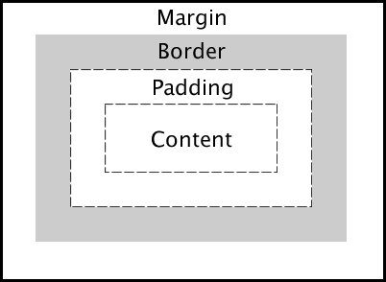
Explanation of the different parts:
- Content - The content of the box, where text and images appear
- Padding - Clears an area around the content. The padding is transparent
- Border - A border that goes around the padding and content
- Margin - Clears an area outside the border. The margin is transparent

CSS Outline
An outline is a line that is drawn around elements (outside the borders) to make the element "stand out".
However, the outline property is different from the border property - The outline is NOT a part of an element's dimensions; the element's total width and height is not affected by the width of the outline.

The display Property
The display property specifies if/how an element is displayed.
Every HTML element has a default display value depending on what type of element it is. The default display value for most elements is block or inline.

Block-level Elements
A block-level element always starts on a new line and takes up the full width available (stretches out to the left and right as far as it can).
The <div> element is a block-level element.
Examples of block-level elements:
- <div>
- <h1> - <h6>
- <p>
- <form>
- <header>
- <footer>
- <section>

Inline Elements
An inline element does not start on a new line and only takes up as much width as necessary.
This is an inline <span> element inside a paragraph.
Examples of inline elements:
- <span>
- <a>
- <img>

Display: none;
display: none; is commonly used with JavaScript to hide and show elements without deleting and recreating them. Take a look at our last example on this page if you want to know how this can be achieved.
The <script> element use display: none; as its default.

Hide an Element - display:none or visibility:hidden?
Hiding an element can be done by setting the display property to none. The element will be hidden, and the page will be displayed as if the element is not there:

Example
h1.hidden {
display: none;
}

visibility:hidden; also hides an element.
However, the element will still take up the same space as before. The element will be hidden, but still affect the layout:

Example
h1.hidden {
visibility: hidden;
}

Property | Description
display | Specifies how an element should be displayed
visibility | Specifies whether or not an element  should be visible

CSS Layout - width and max-width
Setting the width of a block-level element will prevent it from stretching out to the edges of its container. Then, you can set the margins to auto, to horizontally center the element within its container. The element will take up the specified width, and the remaining space will be split equally between the two margins.
Note: The problem with the <div> above occurs when the browser window is smaller than the width of the element. The browser then adds a horizontal scrollbar to the page.
Using max-width instead, in this situation, will improve the browser's handling of small windows. This is important when making a site usable on small devices:

CSS Layout - The position Property
The position property specifies the type of positioning method used for an element (static, relative, fixed or absolute).

position: static;
HTML elements are positioned static by default.
Static positioned elements are not affected by the top, bottom, left, and right properties.
An element with position: static; is not positioned in any special way; it is always positioned according to the normal flow of the page.

position: relative;
An element with position: relative; is positioned relative to its normal position.
Setting the top, right, bottom, and left properties of a relatively-positioned element will cause it to be adjusted away from its normal position. Other content will not be adjusted to fit into any gap left by the element.

position: fixed;
An element with position: fixed; is positioned relative to the viewport, which means it always stays in the same place even if the page is scrolled. The top, right, bottom, and left properties are used to position the element.
A fixed element does not leave a gap in the page where it would normally have been located.

position: absolute;
An element with position: absolute; is positioned relative to the nearest positioned ancestor (instead of positioned relative to the viewport, like fixed).
However; if an absolute positioned element has no positioned ancestors, it uses the document body, and moves along with page scrolling.
Note: A "positioned" element is one whose position is anything except static.

CSS Layout - float and clear
The float property specifies whether or not an element should float.
The clear property is used to control the behavior of floating elements.

The float Property
In its simplest use, the float property can be used to wrap text around images.
The following example specifies that an image should float to the right in a text:

Example
img {
float: right;
margin: 0 0 10px 10px;
}

The clear Property
The clear property is used to control the behavior of floating elements.
Elements after a floating element will flow around it. To avoid this, use the clear property.
The clear property specifies on which sides of an element floating elements are not allowed to float:

Example
div {
clear: left;
}

The inline-block Value
It has been possible for a long time to create a grid of boxes that fills the browser width and wraps nicely (when the browser is resized), by using the float property.
However, the inline-block value of the display property makes this even easier.
inline-block elements are like inline elements but they can have a width and a height.

CSS Combinators
 | A combinator is something that explains the relationship between the selectors.
A CSS selector can contain more than one simple selector. Between the simple selectors, we can include a combinator.
There are four different combinators in CSS3:
- descendant selector (space)
- child selector (>)
- adjacent sibling selector (+)
- general sibling selector (~)

Descendant Selector
The descendant selector matches all elements that are descendants of a specified element.

Child Selector
The child selector selects all elements that are the immediate children of a specified element.

Adjacent Sibling Selector
The adjacent sibling selector selects all elements that are the adjacent siblings of a specified element.
Sibling elements must have the same parent element, and "adjacent" means "immediately following".

General Sibling Selector
The general sibling selector selects all elements that are siblings of a specified element.

What are Pseudo-classes?
A pseudo-class is used to define a special state of an element.
For example, it can be used to:
- Style an element when a user mouses over it
- Style visited and unvisited links differently
- Style an element when it gets focus

Anchor Pseudo-classes
Links can be displayed in different ways:

Example
/* unvisited link */
a:link {
color: #FF0000;
}
/* visited link */
a:visited {
color: #00FF00;
}
/* mouse over link */
a:hover {
color: #FF00FF;
}
/* selected link */
a:active {
color: #0000FF;
}

What are Pseudo-Elements?
A CSS pseudo-element is used to style specified parts of an element.
For example, it can be used to:
- Style the first letter, or line, of an element
- Insert content before, or after, the content of an element

Syntax
The syntax of pseudo-elements:
selector::pseudo-element {
property:value;
}

All CSS Pseudo Elements
Selector | Example | Example description
::after | p::after | Insert something after the content of each <p> element
::before | p::before | Insert something before the content of each <p> element
::first-letter | p::first-letter | Selects the first letter of each <p> element
::first-line | p::first-line | Selects the first line of each <p> element
::selection | p::selection | Selects the portion of an element that is selected by a user
What are the components of a CSS Style?
A style rule is made of three parts −
- Selector − A selector is an HTML tag at which a style will be applied. This could be any tag like <h1> or <table> etc.
- Property − A property is a type of attribute of HTML tag. Put simply, all the HTML attributes are converted into CSS properties. They could be color, border etc.
- Value − Values are assigned to properties. For example, color property can have value either red or #F1F1F1 etc.

What is universal selector?
Rather than selecting elements of a specific type, the universal selector quite simply matches the name of any element type −
* {
color: #000000;
}

What is an attribute selector?
You can also apply styles to HTML elements with particular attributes. The style rule below will match all the input elements having a type attribute with a value of text −
input[type = "text"]{
color: #000000;
}

How CSS style overriding works?
Following is the rule to override any Style Sheet Rule −
- Any inline style sheet takes highest priority. So, it will override any rule defined in <style>...</style> tags or rules defined in any external style sheet file.
- Any rule defined in <style>...</style> tags will override rules defined in any external style sheet file.
- Any rule defined in external style sheet file takes lowest priority, and rules defined in this file will be applied only when above two rules are not applicable.

What is grouping and what is it used for?
  - Grouping allows you to apply the same style to multiple elements with a single declaration. This is done by grouping the selectors into a list, separated by commas.
e.g.) h1, h2 { font-family: Helvetica; font-size: 20; }
  - Grouping helps memory usage and enhances readability.

Explain what a class selector is and how it’s used:
  - A class can be thought of as a grouped collection of CSS attributes applied to HTML elements. This allows you to apply the same styling to multiple HTML elements by placing them in the same CSS class.
  - Class methods can be called by inserting a ‘class’ property and name within an HTML element, then calling the class name with a ‘.’ in the CSS doc.
  - Class syntax:
Within an HTML doc:
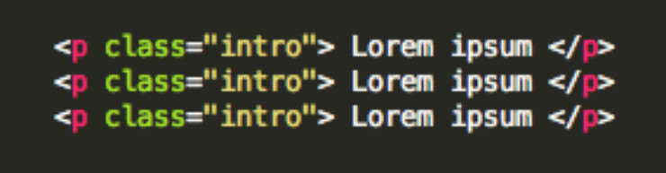
Within a CSS doc:
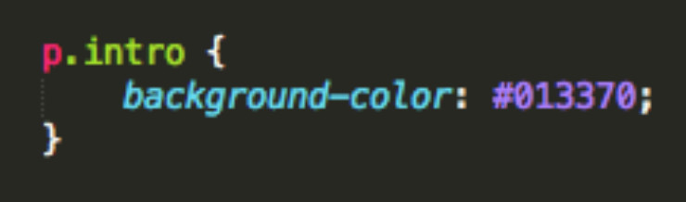
  - The code listed here identifies the class ‘intro’ in the HTML doc, then applies the same background-color styling to all paragraphs within that class.

What are pseudo classes and what are they used for?
  - Pseudo classes are similar to classes, but are not explicitly defined in the markup, and are used to add additional effects to selected HTML elements such as link colors, hover actions, etc.
  - Pseudo classes are defined by first listing the selector, followed by a colon and then pseudo-class element. E.g., a:link{ color: blue }, or a:visited { color: red }
    - Pseudo-class syntax:
selector:pseudo-class {
property:value;}
    - Syntax for using a pseudo class within a CSS class:
selector.class:pseudo-class {
property:value;}
  - :link, :visited, :hover, :active, :first_line are all examples of pseudo classes, used to call a specific action on an element, such as the changing of a link color after it has been visited.

Explain the three main ways to apply CSS styles to a Web page:
  - Inline: Though this method often goes against best practices, it’s easily done by inserting a ‘style’ attribute inside an HTML element:
    - e.g.) <p style=”color:blue”>Lorem Ipsum</p>
  - Embedded/Internal: Done by defining the head of an HTML document by wrapping characteristics in a <style> tag.
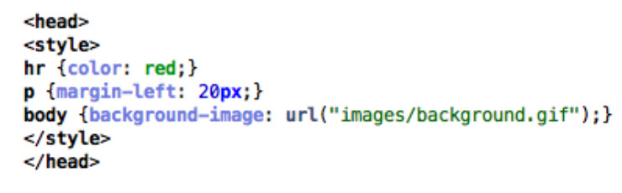
  - Linked/External: CSS is placed in an external .css file, and linked to the HTML document with a <link> tag. This can also be accomplished using the ‘@import’, however, this can slow page load time and is generally not advised.
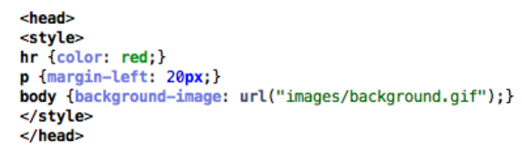

What is grouping and what is it used for?
  - Grouping allows you to apply the same style to multiple elements with a single declaration. This is done by grouping the selectors into a list, separated by commas.
e.g.) h1, h2 { font-family: Helvetica; font-size: 20; }
  - Grouping helps memory usage and enhances readability.

What is an ID selector and how is it used?
  - IDs are used to identify and apply styling to a single specific HTML element. IDs are defined within the HTML page by inserting an ID selector in the HTML element:
    - eg)
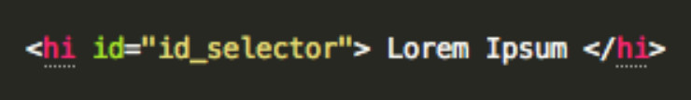
  - ID selectors are defined within the CSS page by calling a ‘#’ followed by the name of the ID:
    - eg)
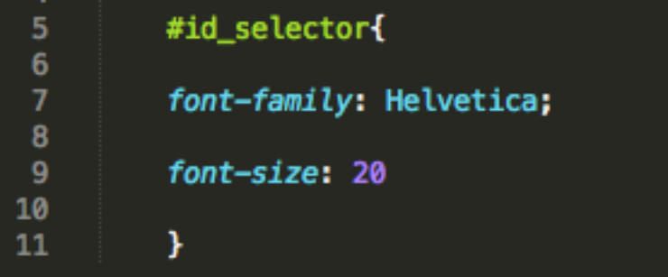
  - ID selectors are unique and can only be applied to a single element.

What is a Class selector and how does it differ from an ID selector?
  - Class selectors are used to apply style to multiple HTML identified with the same class.
    - Within the HTML doc:
      - e.g.)
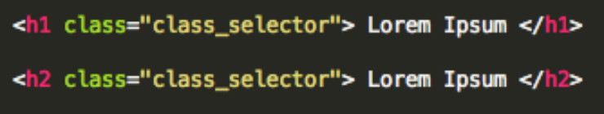
  - Class selectors are called within the CSS document by a ‘.’, followed by the class name:
    - Within the CSS doc:
      - e.g.)
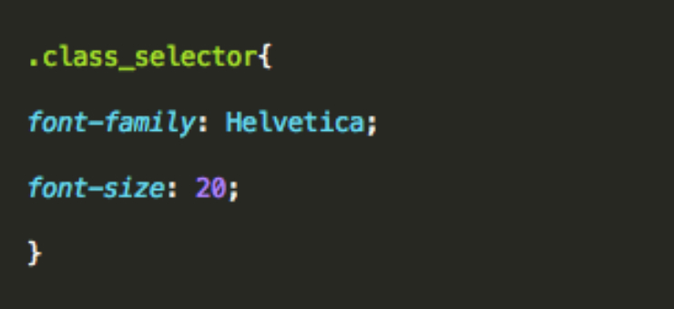
  - The main difference is that the same class selector can be applied to multiple HTML elements, whereas ID selectors are unique..

What are child selectors?
  - Child selectors are another way to group and style a set of elements that descend from a parent element.
  - A child selector is matched by calling two or more elements, separated by a ‘>’ sign to indicate inheritance.
e.g.)
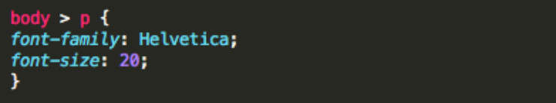
  - In this example, the same styling would be applied to all paragraphs within the body.

What are the different CSS properties used to change dimensions and what values can they accept?
  - height: Sets a specific height
    - auto
    - length
    - %
    - inherit
  - width: Sets a specific width
    - auto
    - length
    - %
    - inherit
  - max-height: Sets a maximum height
    - auto
    - length
    - %
    - inherit
  - max-width: Sets a maximum width
    - auto
    - length
    - %
    - inherit
  - min-height: Sets a minimum height
    - auto
    - length
    - %
    - inherit
  - min-width: Sets a minimum width
    - auto
    - length
    - %
    - inherit

How is the float property implemented in CSS?
  - Floats allow an element to be positioned horizontally, allowing elements below the floated element to flow around it. Several floating elements can be placed together to make a gallery type layout.
  - Floats can only accept a left or right value.
    - e.g.)
img {
float: right;
width: 50px;
margin: 5px;
}
  - To prevent subsequent elements from flowing around the floated element, pass in the clear property, followed by the side you wish to disable (i.e., ‘left’, ‘right’, ‘both’).

What is the CSS Box Model used for? What are the elements that it includes?
  - CSS box model is made up of margins, borders, padding, and content.
  - Box model provides a structured way to space elements in relationship to each other.
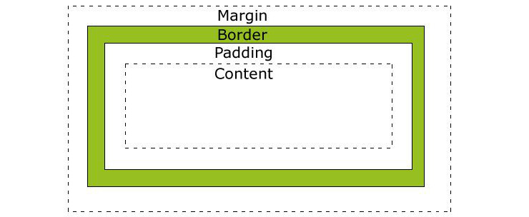
W3schools

How to restore the default property value using CSS?
  - In short, there’s no easy way to restore to default values to whatever a browser uses . The closest option is to use the ‘initial’ property value, which will restore it to the default CSS values, rather than the browser’s default styles.

What is the purpose of pseudo-elements and how are they made?
  - Pseudo elements are made using a double colon (::) followed by the name of the pseudo element.
  - Pseudo-elements are used to add special effects to some selectors, and can only be applied to block-level elements.
  - Most commonly used pseudo-elements are ::first_line, ::first_letter, ::before, ::after

How are inline and block elements different from each other?
  - A block element is an element that takes up the full width available, and has a line break before and after it. <h1>, <p>, <li>, and <div> are all examples of block elements.
  - An inline element only takes up as much width as necessary, cannot accept width and height values, and does not force line breaks. <a> and <span> are examples of inline elements.

What is the purpose of the z-index and how is it used?
  - The z-index helps specify the stack order of positioned elements that may overlap one another. The z-index default value is zero, and can take on either a positive or negative number.
  - An element with a higher z-index is always stacked above one with a lower index.
  - Z-Index can take the following values:
Auto: Sets the stack order equal to its parents.
Number: Orders the stack order.
Initial: Sets this property to its default value (0).
Inherit: Inherits this property from its parent element.

What are the advantages and disadvantages of External Style Sheets?
  - The biggest advantages of external style sheets are that they can be applied to multiple documents while being managed from a single style sheet. This keeps code DRY and improves efficiency and convenience.
  - The disadvantages are that it may decrease loading time in some situations. It may also not be practical if there are not enough styling conditions to justify an external sheet.

List the main CSS style sheet properties:
  - Background
  - Text
  - Font
  - Border
  - Outline
  - Margin
  - Padding
  - List
  - Table

Which online resources do you refer to when having issues with CSS?
  - No real correct answer here, save for being able to discuss your favorite online CSS community forums and resources. e.g. Mozilla Developer Network, StackOverflow, etc.
  - This is just your opportunity to discuss larger CSS issues and show how plugged-in you are to the community.

What are the various techniques for clearing floats?
  - At some point or another, you will likely experience a collapsed float, which you will need to address.
  - This can be accomplished several ways, including using a clearfix², by floating the parent element of the collapsed element, or by using an overflow property³.

Explain the difference between visibility:hidden and display:none
  - visibility:hidden simply hides the element, while it will still take up space and affect the layout of the document.
  - display:none also hides the element, but will not take up space and the page will appear as if the element is not present.

What are some of the new features and properties in CSS3?
  - Box model
  - New Web fonts
  - Rounded corners
  - Border Images
  - Box Shadows, Text Shadows
  - New Color schemes (RGBA)
  - Transform property
  - New Pseudo-classes
  - Multi-column layout
  - New Gradients

Why shouldn’t I use fixed sized fonts ?
  - Often times, fixed font sizes will show up incorrectly on the user end and will prohibit responsiveness. Using relative sizing will keep fonts proportionate in their relationships to each other and will allow for greater end user flexibility.

Which font names are available on all platforms ?
  - Only five basic font families( serif, sans-serif, cursive, fantasy, and monsospace) are recognized across platforms, rather than specific fonts.
  - Specific font name recognitions will vary by browser.

Do you use grid systems, and if so, what do you prefer?
  - Again, no correct answer here. Just be able to discuss the pros and cons of different grid systems, mobile-first, fluid and responsive web design issues.

What are the advantages/disadvantages of using CSS preprocessors? (SASS, Compass, Stylus, LESS)
  - Here is another opportunity to discuss your personal preferences on use of CSS preprocessors and why.
  - While there’s no right or wrong answer here, below are some commonly cited pros and cons of using preprocessors:
Benefits: Ability to use nested sytax, define variables and mixins, use of mathematical and operational functions, and the ability to join multiple files into a single one.
Disadvantages: Difficulties tracking file size, maintenance and updating issues, difficulties debugging.

Why and how are shorthand properties used? Give examples.
  - Using shorthand properties can improve page load times and reduce file size.
  - Can be done with background, font, border, padding, outline, and list-style properties.
  - Short handing is accomplished by listing the property values on a single line, in a specific order.
e.g.) Code snippet ‘a’ gets shorthanded into code snippet ‘b’ by condensing the property values (in order) onto a single line:
a)
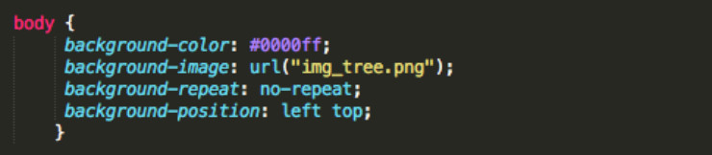
b)
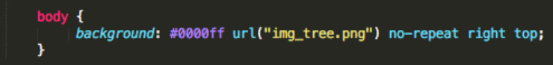

What is graceful degradation?
In case the component fails, it will continue to work properly in the presence of a graceful degradation. The latest browser application is used when a webpage is designed. As it is not available to everyone, there is a basic functionality, which enables its use to a wider audience. In case the image is unavailable for viewing, text is shown with the alt tag.
THE GRACEFUL DEGRADATION PERSPECTIVE:
Graceful degradation focuses on building the website for the most advanced/capable browsers. Testing in browsers deemed “older” or less capable usually takes place during the last quarter of the development cycle and is often restricted to the previous release of the major browsers (IE, Mozilla, etc.).

Under this paradigm, older browsers are expected to have a poor, but passable experience. Small fixes may be made to accommodate a particular browser. Because they are not the focus, little attention is paid beyond fixing the most egregious errors.

Progressive Enhancement
Progressive enhancement enables us to establish a solid baseline of cross-browser support and then enhance the design with advanced CSS features for supportive browsers.
The key thing of course is to begin with a solid baseline design that works well in as many browsers as possible. Once this is done, there is no reason to worry about which browsers support which CSS 3 properties because your site is going to work fine regardless of support. Then, in those situations where some sort of advanced support is desired, you can always go in and fix things up as needed. There are a wide variety of solutions for supporting the latest and greatest CSS3 tricks, including browser detection, proprietary expressions, conditional comments, CSS hacks and other workarounds. Indeed, you can go as crazy as you want to, but the whole point of this article is to explain that you can avoid the fuss by progressively enhancing your site instead.

How can the gap under the image be removed?
As images being inline elements are treated same as texts, so there is a gap left, which can be removed by:
img { display: block ; }

98. Why can @import be at the top only?
A style sheet that is imported into another one has a lower ranking in the cascading order: the importing style sheet overrides the imported one. Programmers may recognize this as the same model as in Java, Modula, Object-Pascal, Oberon and other modular programming languages.

Which among the following is more precedent(an earlier event or action): CSS properties or HTML procedures?
CSS is more precedent over HTML procedures. Browsers, which do not have CSS support, display HTML attributes.

Alternate Style
Specifying alternative style sheets in a web page provides a way for users to see multiple versions of a page, based on their needs or preferences.

Firefox lets the user select the stylesheet using the View > Page Style submenu, Internet Explorer also supports this feature (beginning with IE 8), also accessed from View > Page Style (at least as of IE 11), but Chrome requires an extension to use the feature (as of version 48). The web page can also provide its own user interface to let the user switch styles.

