JAVA

Features of Java
- Simple
- Object-Oriented
- Platform independent
- Secured
- Robust
- Architecture neutral
- Portable
- Dynamic
- Interpreted
- High Performance
- Multithreaded
- Distributed

What happens at compile time?
At compile time, java file is compiled by Java Compiler (It does not interact with OS) and converts the java code into bytecode.
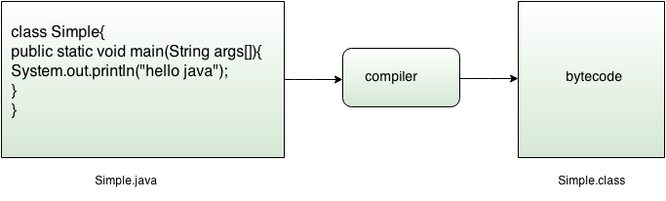
What happens at runtime?
At runtime, following steps are performed:
Classloader: is the subsystem of JVM that is used to load class files.
Bytecode Verifier: checks the code fragments for illegal code that can violate access right to objects.
Interpreter: read bytecode stream then execute the instructions.

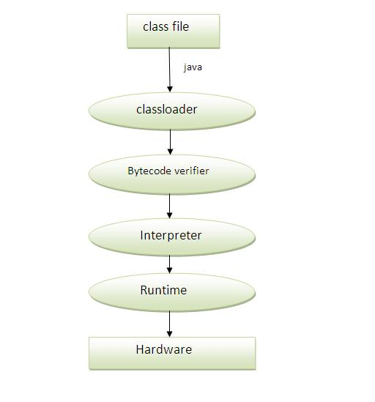

Q)Can you save a java source file by other name than the class name?
Yes, if the class is not public. It is explained in the figure given below:
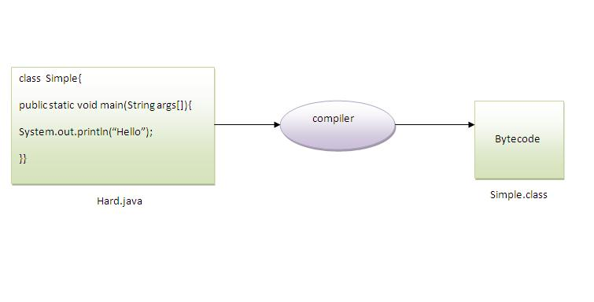
To compile: | javac Hard.java
To execute: | java Simple

Q)Can you have multiple classes in a java source file?
Yes, like the figure given below illustrates:
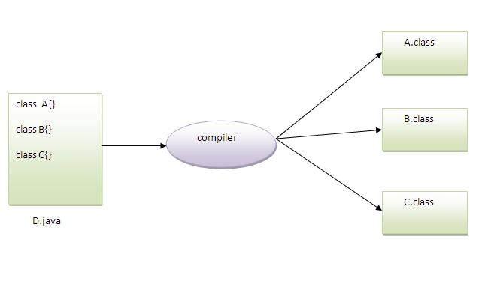

Difference between JDK, JRE and JVM
JVM
JVM (Java Virtual Machine) is an abstract machine. It is a specification that provides runtime environment in which java bytecode can be executed.
JVMs are available for many hardware and software platforms. JVM, JRE and JDK are platform dependent because configuration of each OS differs. But, Java is platform independent.
The JVM performs following main tasks:
- Loads code
- Verifies code
- Executes code
- Provides runtime environment
JRE
JRE is an acronym for Java Runtime Environment. It is used to provide runtime environment. It is the implementation of JVM. It physically exists. It contains set of libraries + other files that JVM uses at runtime.
Implementation of JVMs is also actively released by other companies besides Sun Micro Systems.
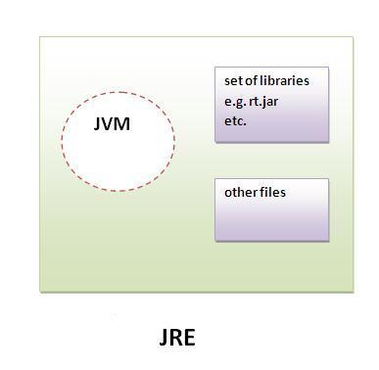
JDK
JDK is an acronym for Java Development Kit.It physically exists.It contains JRE + development tools.
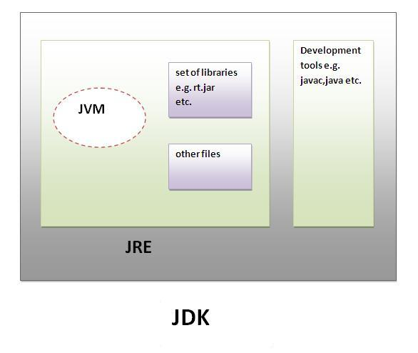

JVM (Java Virtual Machine)
JVM (Java Virtual Machine) is an abstract machine. It is a specification that provides runtime environment in which java bytecode can be executed.
JVMs are available for many hardware and software platforms (i.e. JVM is platform dependent).
The JVM performs following operation:
- Loads code
- Verifies code
- Executes code
- Provides runtime environment

JVM provides definitions for the:
- Memory area
- Class file format
- Register set
- Garbage-collected heap
- Fatal error reporting etc.

Internal Architecture of JVM
Let's understand the internal architecture of JVM. It contains classloader, memory area, execution engine etc.
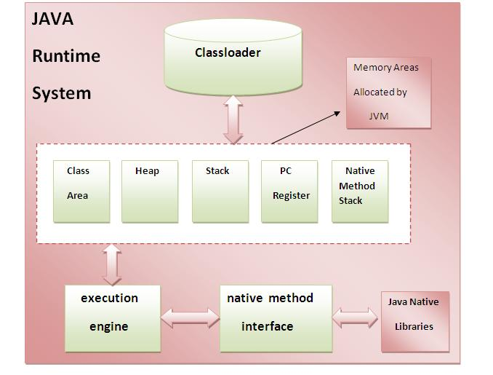

1) Classloader:
Classloader is a subsystem of JVM that is used to load class files.
2) Class(Method) Area:
Class(Method) Area stores per-class structures such as the runtime constant pool, field and method data, the code for methods.
3) Heap:
It is the runtime data area in which objects are allocated.
4) Stack:
Java Stack stores frames. It holds local variables and partial results, and plays a part in method invocation and return.
Each thread has a private JVM stack, created at the same time as thread.
A new frame is created each time a method is invoked. A frame is destroyed when its method invocation completes.
5) Program Counter Register:
PC (program counter) register. It contains the address of the Java virtual machine instruction currently being executed.
6) Native Method Stack:
It contains all the native methods used in the application.
7) Execution Engine:
It contains:
1) A virtual processor
2) Interpreter: Read bytecode stream then execute the instructions.
3) Just-In-Time(JIT) compiler: It is used to improve the performance. JIT compiles parts of the byte code that have similar functionality at the same time, and hence reduces the amount of time needed for compilation. Here the term? compiler? Refers to a translator from the instruction set of a Java virtual machine (JVM) to the instruction set of a specific CPU.

Types of Variable
There are three types of variables in java
- local variable
- instance variable
- static variable
Local Variable
A variable that is declared inside the method is called local variable.
Instance Variable
A variable that is declared inside the class but outside the method is called instance variable. It is not declared as static.
Static variable
A variable that is declared as static is called static variable. It cannot be local.

Data Types in Java
In java, there are two types of data types
- primitive data types
- non-primitive data types
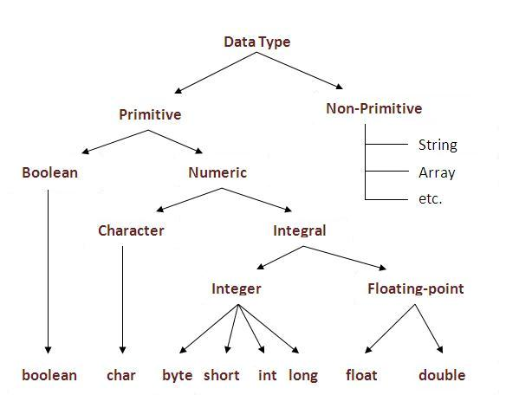
Advantage of OOPs over Procedure-oriented programming language
  - OOPs makes development and maintenance easier where as in Procedure-oriented programming language it is not easy to manage if code grows as project size grows.
  - OOPs provide data hiding whereas in Procedure-oriented programming language a global data can be accessed from anywhere.
  - OOPs provide ability to simulate real-world event much more effectively. We can provide the solution of real word problem if we are using the Object-Oriented Programming language.
What is difference between object-oriented programming language and object-based programming language?
Object based programming language follows all the features of OOPs except Inheritance. JavaScript and VBScript are examples of object based programming languages.

Overloading:
Advantage of method overloading?
Method overloading increases the readability of the program.
Different ways to overload the method
There are two ways to overload the method in java

- By changing number of arguments
- By changing the data type of arguments

Que) Why Method Overloading is not possible by changing the return type of method?
In java, method overloading is not possible by changing the return type of the method because there may occur ambiguity. Let's see how ambiguity may occur:
class Calculation3{
int sum(int a,int b){System.out.println(a+b);}
double sum(int a,int b){System.out.println(a+b);}

public static void main(String args[]){
Calculation3 obj=new Calculation3();
int result=obj.sum(20,20); //Compile Time Error
}
}
int result=obj.sum(20,20); //Here how can java determine which sum() method should be called

Java static keyword
The static can be:
- variable (also known as class variable)
- method (also known as class method)
- block
- nested class

Java static variable
If you declare any variable as static, it is known static variable.
- The static variable can be used to refer the common property of all objects (that is not unique for each object) e.g. company name of employees, college name of students etc.
- The static variable gets memory only once in class area at the time of class loading.

Advantage of static variable
It makes your program memory efficient (i.e. it saves memory).

Understanding problem without static variable
- class Student{
- int rollno;
- String name;
- String college="ITS";
- }
Suppose there are 500 students in my college, now all instance data members will get memory each time when object is created. All student have its unique rollno and name so instance data member is good. Here, college refers to the common property of all objects. If we make it static, this field will get memory only once

Java static method
If you apply static keyword with any method, it is known as static method.
- A static method belongs to the class rather than object of a class.
- A static method can be invoked without the need for creating an instance of a class.
- static method can access static data member and can change the value of it.

Q) why java main method is static?
Ans) because object is not required to call static method if it were non-static method, jvm create object first then call main() method that will lead the problem of extra memory allocation.

Java static block
- Is used to initialize the static data member.
- It is executed before main method at the time of classloading.

Q) Can we execute a program without main() method?
Ans) Yes, one of the way is static block but in previous version of JDK not in JDK 1.7.

Usage of java this keyword
Here is given the 6 usage of java this keyword.
- this keyword can be used to refer current class instance variable.
- this() can be used to invoke current class constructor.
- this keyword can be used to invoke current class method (implicitly)
- this can be passed as an argument in the method call.
- this can be passed as argument in the constructor call.
- this keyword can also be used to return the current class instance.

2) this() can be used to invoked current class constructor.
The this() constructor call can be used to invoke the current class constructor (constructor chaining). This approach is better if you have many constructors in the class and want to reuse that constructor.

Why use inheritance in java
- For Method Overriding (so runtime polymorphism can be achieved).
- For Code Reusability.

Note: Multiple inheritance is not supported in java through class.

Q) Why multiple inheritance is not supported in java?
To reduce the complexity and simplify the language, multiple inheritance is not supported in java.
Consider a scenario where A, B and C are three classes. The C class inherits A and B classes. If A and B classes have same method and you call it from child class object, there will be ambiguity to call method of A or B class.
Since compile time errors are better than runtime errors, java renders compile time error if you inherit 2 classes. So whether you have same method or different, there will be compile time error now.

Usage of Java Method Overriding
- Method overriding is used to provide specific implementation of a method that is already provided by its super class.
- Method overriding is used for runtime polymorphism

Can we override static method?
No, static method cannot be overridden. It can be proved by runtime polymorphism, so we will learn it later.

Why we cannot override static method?
because static method is bound with class whereas instance method is bound with object. Static belongs to class area and instance belongs to heap area.

Final Keyword in Java
The final keyword in java is used to restrict the user. The java final keyword can be used in many context. Final can be:
- variable
- method
- class

Java final variable
If you make any variable as final, you cannot change the value of final variable (It will be constant).

Java final method
If you make any method as final, you cannot override it.

Java final class
If you make any class as final, you cannot extend it.

Is final method inherited?
Ans) Yes, final method is inherited but you cannot override it.
What is blank or uninitialized final variable?
A final variable that is not initialized at the time of declaration is known as blank final variable.
If you want to create a variable that is initialized at the time of creating object and once initialized may not be changed, it is useful. For example PAN CARD number of an employee.
It can be initialized only in constructor.

static blank final variable
A static final variable that is not initialized at the time of declaration is known as static blank final variable. It can be initialized only in static block.

What is final parameter?
If you declare any parameter as final, you cannot change the value of it.

Can we declare a constructor final?
No, because constructor is never inherited.

Polymorphism in Java
Polymorphism in java is a concept by which we can perform a single action by different ways.
There are two types of polymorphism in java: compile time polymorphism and runtime polymorphism. We can perform polymorphism in java by method overloading and method overriding.

Runtime Polymorphism in Java
Runtime polymorphism or Dynamic Method Dispatch is a process in which a call to an overridden method is resolved at runtime rather than compile-time.
In this process, an overridden method is called through the reference variable of a superclass. The determination of the method to be called is based on the object being referred to by the reference variable.
Let's first understand the upcasting before Runtime Polymorphism.

Upcasting
When reference variable of Parent class refers to the object of Child class, it is known as upcasting. For example:
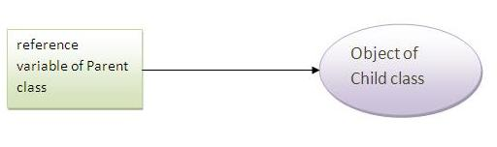
- class A{}
- class B extends A{}
- A a=new B();//upcasting

Real example of Java Runtime Polymorphism
Consider a scenario, Bank is a class that provides method to get the rate of interest. But, rate of interest may differ according to banks. For example, SBI, ICICI and AXIS banks could provide 8%, 7% and 9% rate of interest.
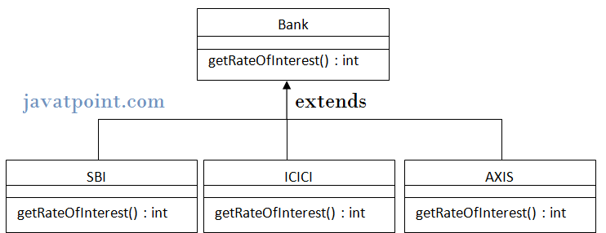
Note: It is also given in method overriding but there was no upcasting.
class Bank{
int getRateOfInterest(){return 0;}
}

class SBI extends Bank{
int getRateOfInterest(){return 8;}
}
class ICICI extends Bank{
int getRateOfInterest(){return 7;}
}
class AXIS extends Bank{
int getRateOfInterest(){return 9;}
}

class Test3{
public static void main(String args[]){
Bank b1=new SBI();
Bank b2=new ICICI();
Bank b3=new AXIS();
System.out.println("SBI Rate of Interest: "+b1.getRateOfInterest());
System.out.println("ICICI Rate of Interest: "+b2.getRateOfInterest());
System.out.println("AXIS Rate of Interest: "+b3.getRateOfInterest());
}
}
Output:
SBI Rate of Interest: 8
ICICI Rate of Interest: 7
AXIS Rate of Interest: 9

Static Binding and Dynamic Binding
Connecting a method call to the method body is known as binding.
There are two types of binding
- static binding (also known as early binding).
- dynamic binding (also known as late binding).

static binding
When type of the object is determined at compiled time(by the compiler), it is known as static binding.
If there is any private, final or static method in a class, there is static binding.

Dynamic binding
When type of the object is determined at run-time, it is known as dynamic binding.

Example of dynamic binding
- class Animal{
- void eat(){System.out.println("animal is eating...");}
- }

- class Dog extends Animal{
- void eat(){System.out.println("dog is eating...");}

- public static void main(String args[]){
- Animal a=new Dog();
- a.eat();
- }
- }
Output:dog is eating...
In the above example object type cannot be determined by the compiler, because the instance of Dog is also an instance of Animal. So compiler doesn't know its type, only its base type.

Java instanceof
The java instanceof operator is used to test whether the object is an instance of the specified type (class or subclass or interface).
- class Animal{}
- class Dog1 extends Animal{//Dog inherits Animal

- public static void main(String args[]){
- Dog1 d=new Dog1();
- System.out.println(d instanceof Animal);//true
- }
- }

- class Dog2{
- public static void main(String args[]){
- Dog2 d=null;
- System.out.println(d instanceof Dog2);//false
- }
- }

Understanding Real use of instanceof in java
Let's see the real use of instanceof keyword by the example given below.
- interface Printable{}
- class A implements Printable{
- public void a(){System.out.println("a method");}
- }
- class B implements Printable{
- public void b(){System.out.println("b method");}
- }

- class Call{
- void invoke(Printable p){//upcasting
- if(p instanceof A){
- A a=(A)p;//Downcasting
- a.a();
- }
- if(p instanceof B){
- B b=(B)p;//Downcasting
- b.b();
- }

- }
- }//end of Call class

- class Test4{
- public static void main(String args[]){
- Printable p=new B();
- Call c=new Call();
- c.invoke(p);
- }
- }
Output: b method

Abstract class in Java
A class that is declared with abstract keyword is known as abstract class in java. It can have abstract and non-abstract methods (method with body).

Abstraction in Java
Abstraction is a process of hiding the implementation details and showing only functionality to the user.
Another way, it shows only important things to the user and hides the internal details for example sending sms, you just type the text and send the message. You don't know the internal processing about the message delivery.
Abstraction lets you focus on what the object does instead of how it does it.

Ways to achieve Abstaction
There are two ways to achieve abstraction in java
- Abstract class (0 to 100%)
- Interface (100%)

Understanding the real scenario of abstract class
In this example, Shape is the abstract class, its implementation is provided by the Rectangle and Circle classes. Mostly, we don't know about the implementation class (i.e. hidden to the end user) and object of the implementation class is provided by the factory method.
A factory method is the method that returns the instance of the class. In this example, if you create the instance of Rectangle class, draw() method of Rectangle class will be invoked.
File: TestAbstraction1.java
- abstract class Shape{
- abstract void draw();
- }
- //In real scenario, implementation is provided by others i.e. unknown by end user
- class Rectangle extends Shape{
- void draw(){System.out.println("drawing rectangle");}
- }

- class Circle1 extends Shape{
- void draw(){System.out.println("drawing circle");}
- }

- //In real scenario, method is called by programmer or user
- class TestAbstraction1{
- public static void main(String args[]){
- Shape s=new Circle1();//In real scenario, object is provided through method e.g. getShape() method
- s.draw();
- }
- }
drawing circle

Rule: If there is any abstract method in a class, that class must be abstract.

Rule: If you are extending any abstract class that have abstract method, you must either provide the implementation of the method or make this class abstract.

Interface in Java
An interface in java is a blueprint of a class. It has static constants and abstract methods only.

Why use Java interface?
There are mainly three reasons to use interface. They are given below.
- It is used to achieve fully abstraction.
- By interface, we can support the functionality of multiple inheritance.
- It can be used to achieve loose coupling.

The java compiler adds public and abstract keywords before the interface method and public, static and final keywords before data members.

Understanding relationship between classes and interfaces
As shown in the figure given below, a class extends another class, an interface extends another interface but a class implements an interface.
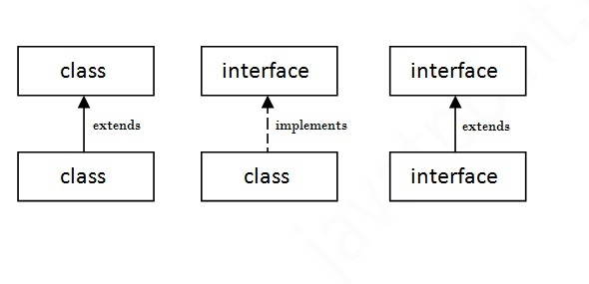

Multiple inheritance in Java by interface
If a class implements multiple interfaces, or an interface extends multiple interfaces i.e. known as multiple inheritance.
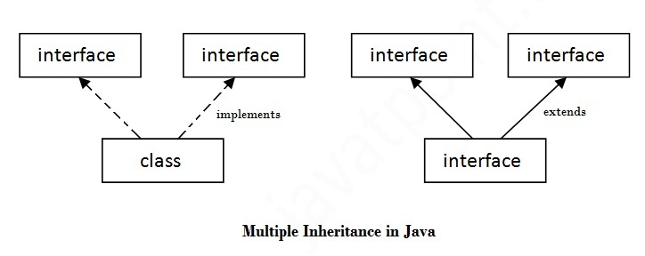

Q) Multiple inheritance is not supported through class in java but it is possible by interface, why?
As we have explained in the inheritance chapter, multiple inheritance is not supported in case of class. But it is supported in case of interface because there is no ambiguity as implementation is provided by the implementation class. For example:
- interface Printable{
- void print();
- }
- interface Showable{
- void print();
- }

- class TestTnterface1 implements Printable,Showable{
- public void print(){System.out.println("Hello");}
- public static void main(String args[]){
- TestTnterface1 obj = new TestTnterface1();
- obj.print();
- }
- }
Hello
As you can see in the above example, Printable and Showable interface have same methods but its implementation is provided by class TestTnterface1, so there is no ambiguity.
Q) What is marker or tagged interface?
An interface that have no member is known as marker or tagged interface. For example: Serializable, Cloneable, Remote etc. They are used to provide some essential information to the JVM so that JVM may perform some useful operation.
- //How Serializable interface is written?
- public interface Serializable{
- }

Difference between abstract class and interface
Abstract class and interface both are used to achieve abstraction where we can declare the abstract methods. Abstract class and interface both can't be instantiated.
But there are many differences between abstract class and interface that are given below.
Abstract class | Interface
1) Abstract class can have abstract and non-abstract methods. | Interface can have only abstract methods.
2) Abstract class doesn't support multiple inheritance. | Interface supports multiple inheritance.
3) Abstract class can have final, non-final, static and non-static variables. | Interface has only static and final variables.
4) Abstract class can have static methods, main method and constructor. | Interface can't have static methods, main method or constructor.
5) Abstract class can provide the implementation of interface. | Interface can't provide the implementation of abstract class.
6) The abstract keyword is used to declare abstract class. | The interface keyword is used to declare interface.
7) Example:  public abstract class Shape{  public abstract void draw();  } | Example:  public interface Drawable{  void draw();  }

Simply, abstract class achieves partial abstraction (0 to 100%) whereas interface achieves fully abstraction (100%).

Access Modifiers in java
There are two types of modifiers in java: access modifiers and non-access modifiers.
The access modifier in java specifies accessibility (scope) of a data member, method, constructor or class.
There are 4 types of java access modifiers:
- private
- default
- protected
- public

private access modifier
The private access modifier is accessible only within class.

Note: A class cannot be private or protected except nested class.

default access modifier
If you don't use any modifier, it is treated as default bydefault. The default modifier is accessible only within package.

protected access modifier
The protected access modifier is accessible within package and outside the package but through inheritance only.
The protected access modifier can be applied on the data member, method and constructor. It can't be applied on the class.

public access modifier
The public access modifier is accessible everywhere. It has the widest scope among all other modifiers.

Encapsulation in Java
Encapsulation in java is a process of wrapping code and data together into a single unit, for example capsule i.e. mixed of several medicines.

We can create a fully encapsulated class in java by making all the data members of the class private. Now we can use setter and getter methods to set and get the data in it.
The Java Bean class is the example of fully encapsulated class.

Advantage of Encapsulation in java
By providing only setter or getter method, you can make the class read-only or write-only. It provides you the control over the data. Suppose you want to set the value of id i.e. greater than 100 only, you can write the logic inside the setter method.

Object class in Java
The Object class is the parent class of all the classes in java by default. In other words, it is the topmost class of java.
The Object class is beneficial if you want to refer any object whose type you don't know. Notice that parent class reference variable can refer the child class object, know as upcasting.
Let's take an example, there is getObject() method that returns an object but it can be of any type like Employee,Student etc, we can use Object class reference to refer that object. For example:
- Object obj=getObject();//we don't what object would be returned from this method
The Object class provides some common behaviours to all the objects such as object can be compared, object can be cloned, object can be notified etc.
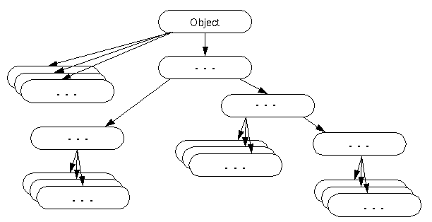

Method | Description
public final Class getClass() | returns the Class class object of this object. The Class class can further be used to get the metadata of this class.
public int hashCode() | returns the hashcode number for this object.
public boolean equals(Object obj) | compares the given object to this object.
protected Object clone() throws CloneNotSupportedException | creates and returns the exact copy (clone) of this object.
public String toString() | returns the string representation of this object.
public final void notify() | wakes up single thread, waiting on this object's monitor.
public final void notifyAll() | wakes up all the threads, waiting on this object's monitor.
public final void wait(long timeout)throws InterruptedException | causes the current thread to wait for the specified milliseconds, until another thread notifies (invokes notify() or notifyAll() method).
public final void wait(long timeout,int nanos)throws InterruptedException | causes the current thread to wait for the specified miliseconds and nanoseconds, until another thread notifies (invokes notify() or notifyAll() method).
public final void wait()throws InterruptedException | causes the current thread to wait, until another thread notifies (invokes notify() or notifyAll() method).
protected void finalize()throws Throwable | is invoked by the garbage collector before object is being garbage collected.

Object Cloning in Java
The object cloning is a way to create exact copy of an object. For this purpose, clone() method of Object class is used to clone an object.
The java.lang.Cloneable interface must be implemented by the class whose object clone we want to create. If we don't implement Cloneable interface, clone() method generates CloneNotSupportedException.
The clone() method is defined in the Object class. Syntax of the clone() method is as follows:
- protected Object clone() throws CloneNotSupportedException

Why use clone() method ?
The clone() method saves the extra processing task for creating the exact copy of an object. If we perform it by using the new keyword, it will take a lot of processing to be performed that is why we use object cloning.
Advantage of Object cloning
Less processing task.

Example of clone() method (Object cloning)
Let's see the simple example of object cloning
- class Student18 implements Cloneable{
- int rollno;
- String name;

- Student18(int rollno,String name){
- this.rollno=rollno;
- this.name=name;
- }

- public Object clone()throws CloneNotSupportedException{
- return super.clone();
- }

- public static void main(String args[]){
- try{
- Student18 s1=new Student18(101,"amit");

- Student18 s2=(Student18)s1.clone();

- System.out.println(s1.rollno+" "+s1.name);
- System.out.println(s2.rollno+" "+s2.name);

- }catch(CloneNotSupportedException c){}

- }
- }
Output:101 amit
101 amit
As you can see in the above example, both reference variables have the same value. Thus, the clone() copies the values of an object to another. So we don't need to write explicit code to copy the value of an object to another.
If we create another object by new keyword and assign the values of another object to this one, it will require a lot of processing on this object. So to save the extra processing task we use clone() method.

Java Array
Normally, array is a collection of similar type of elements that have contiguous memory location.
Java array is an object the contains elements of similar data type. It is a data structure where we store similar elements. We can store only fixed set of elements in a java array.
Array in java is index based, first element of the array is stored at 0 index.
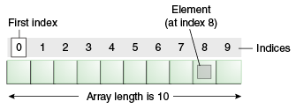

Advantage of Java Array
- Code Optimization: It makes the code optimized, we can retrieve or sort the data easily.
- Random access: We can get any data located at any index position.

Disadvantage of Java Array
- Size Limit: We can store only fixed size of elements in the array. It doesn't grow its size at runtime. To solve this problem, collection framework is used in java.

Types of Array in java
There are two types of array.
- Single Dimensional Array
- Multidimensional Array

Wrapper class in Java
Wrapper class in java provides the mechanism to convert primitive into object and object into primitive.
Since J2SE 5.0, autoboxing and unboxing feature converts primitive into object and object into primitive automatically. The automatic conversion of primitive into object is known and autoboxing and vice-versa unboxing.
One of the eight classes of java.lang package are known as wrapper class in java. The list of eight wrapper classes are given below:
Primitive Type | Wrapper class
boolean | Boolean
char | Character
byte | Byte
short | Short
int | Integer
long | Long
float | Float
double | Double

Wrapper class Example: Primitive to Wrapper
- public class WrapperExample1{
- public static void main(String args[]){
- //Converting int into Integer
- int a=20;
- Integer i=Integer.valueOf(a);//converting int into Integer
- Integer j=a;//autoboxing, now compiler will write Integer.valueOf(a) internally

- System.out.println(a+" "+i+" "+j);
- }}
Output:
20 20 20

Wrapper class Example: Wrapper to Primitive
- public class WrapperExample2{
- public static void main(String args[]){
- //Converting Integer to int
- Integer a=new Integer(3);
- int i=a.intValue();//converting Integer to int
- int j=a;//unboxing, now compiler will write a.intValue() internally

- System.out.println(a+" "+i+" "+j);
- }}
Output:
3 3 3

Call by Value and Call by Reference in Java
There is only call by value in java, not call by reference. If we call a method passing a value, it is known as call by value. The changes being done in the called method, is not affected in the calling method.

Q: If Java uses the pass-by reference, why won't a swap function work?
A: Java does manipulate objects by reference, and all object variables are references. However, Java doesn't pass method arguments by reference; it passes them by value.
Take the badSwap() method for example:
public void badSwap(int var1, int var2)
{
int temp = var1;
var1 = var2;
var2 = temp;
}
When badSwap() returns, the variables passed as arguments will still hold their original values. The method will also fail if we change the arguments type from int to Object, since Java passes object references by value as well. Now, here is where it gets tricky:
public void tricky(Point arg1, Point arg2)
{
arg1.x = 100;
arg1.y = 100;
Point temp = arg1;
arg1 = arg2;
arg2 = temp;
}
public static void main(String [] args)
{
Point pnt1 = new Point(0,0);
Point pnt2 = new Point(0,0);
System.out.println("X: " + pnt1.x + " Y: " +pnt1.y);
System.out.println("X: " + pnt2.x + " Y: " +pnt2.y);
System.out.println(" ");
tricky(pnt1,pnt2);
System.out.println("X: " + pnt1.x + " Y:" + pnt1.y);
System.out.println("X: " + pnt2.x + " Y: " +pnt2.y);
}
If we execute this main() method, we see the following output:
X: 0 Y: 0
X: 0 Y: 0
X: 100 Y: 100
X: 0 Y: 0
The method successfully alters the value of pnt1, even though it is passed by value; however, a swap of pnt1 and pnt2 fails! This is the major source of confusion. In themain() method, pnt1 and pnt2 are nothing more than object references. When you pass pnt1 and pnt2 to the tricky() method, Java passes the references by value just like any other parameter. This means the references passed to the method are actually copies of the original references. Figure 1 below shows two references pointing to the same object after Java passes an object to a method.
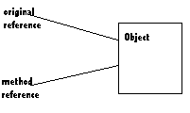Figure 1. After being passed to a method, an object will have at least two references
Java copies and passes thereference by value, not the object. Thus, method manipulation will alter the objects, since the references point to the original objects. But since the references are copies, swaps will fail. As Figure 2 illustrates, the method references swap, but not the original references. Unfortunately, after a method call, you are left with only the unswapped original references. For a swap to succeed outside of the method call, we need to swap the original references, not the copies.

Java Strictfp Keyword
Java strictfp keyword ensures that you will get the same result on every platform if you perform operations in the floating-point variable. The precision may differ from platform to platform that is why java programming language has provided the strictfp keyword, so that you get same result on every platform. So, now you have better control over the floating-point arithmetic.

Creating API Document | javadoc tool
We can create document api in java by the help of javadoc tool. In the java file, we must use the documentation comment /**... */ to post information for the class, method, constructor, fields etc.
Let's see the simple class that contains documentation comment.
- package com.abc;
- /** This class is a user-defined class that contains one methods cube.*/
- public class M{

- /** The cube method prints cube of the given number */
- public static void cube(int n){System.out.println(n*n*n);}
- }
To create the document API, you need to use the javadoc tool followed by java file name. There is no need to compile the javafile.
On the command prompt, you need to write:
javadoc M.java
to generate the document api. Now, there will be created a lot of html files. Open the index.html file to get the information about the classes.
What is String in java
Generally, string is a sequence of characters. But in java, string is an object that represents a sequence of characters. String class is used to create string object.

How to create String object?
There are two ways to create String object:
- By string literal
- By new keyword

1) String Literal
Java String literal is created by using double quotes. For Example:
- String s="welcome";
Each time you create a string literal, the JVM checks the string constant pool first. If the string already exists in the pool, a reference to the pooled instance is returned. If string doesn't exist in the pool, a new string instance is created and placed in the pool. For example:
- String s1="Welcome";
- String s2="Welcome";//will not create new instance 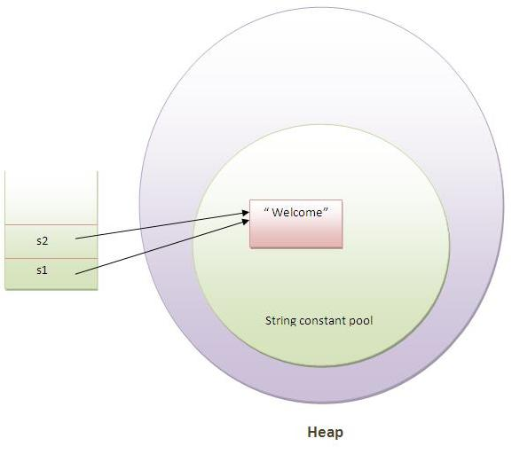
In the above example only one object will be created. Firstly JVM will not find any string object with the value "Welcome" in string constant pool, so it will create a new object. After that it will find the string with the value "Welcome" in the pool, it will not create new object but will return the reference to the same instance.

Note: String objects are stored in a special memory area known as string constant pool.

2) By new keyword

- String s=new String("Welcome");//creates two objects and one reference variable
In such case, JVM will create a new string object in normal(non pool) heap memory and the literal "Welcome" will be placed in the string constant pool. The variable s will refer to the object in heap(non pool).

Immutable String in Java
In java, string objects are immutable. Immutable simply means unmodifiable or unchangeable.
Once string object is created its data or state can't be changed but a new string object is created.
- class Testimmutablestring{
- public static void main(String args[]){
- String s="Sachin";
- s.concat(" Tendulkar");//concat() method appends the string at the end
- System.out.println(s);//will print Sachin because strings are immutable objects
- }
- }
But if we explicitely assign it to the reference variable, it will refer to "Sachin Tendulkar" object.For example:
- class Testimmutablestring1{
- public static void main(String args[]){
- String s="Sachin";
- s=s.concat(" Tendulkar");
- System.out.println(s);
- }
- }

Output:Sachin Tendulkar

Why string objects are immutable in java?
Because java uses the concept of string literal. Suppose there are 5 reference variables, all refers to one object "sachin".If one reference variable changes the value of the object, it will be affected to all the reference variables. That is why string objects are immutable in java.

Java String compare
We can compare string in java on the basis of content and reference.
It is used in authentication (by equals() method), sorting (by compareTo() method), reference matching (by == operator) etc.
There are three ways to compare string in java:
- By equals() method
- By = = operator
- By compareTo() method

1) String compare by equals() method
The String equals() method compares the original content of the string. It compares values of string for equality. String class provides two methods:
- public boolean equals(Object another) compares this string to the specified object.
- public boolean equalsIgnoreCase(String another) compares this String to another string, ignoring case.

2) String compare by == operator
The = = operator compares references not values.
- class Teststringcomparison3{
- public static void main(String args[]){
- String s1="Sachin";
- String s2="Sachin";
- String s3=new String("Sachin");
- System.out.println(s1==s2);//true (because both refer to same instance)
- System.out.println(s1==s3);//false(because s3 refers to instance created in nonpool)
- }
- }

3) String compare by compareTo() method
The String compareTo() method compares values lexicographically and returns an integer value that describes if first string is less than, equal to or greater than second string.
Suppose s1 and s2 are two string variables. If:
- s1 == s2 :0
- s1 > s2 :positive value
- s1 < s2 :negative value
- class Teststringcomparison4{
- public static void main(String args[]){
- String s1="Sachin";
- String s2="Sachin";
- String s3="Ratan";
- System.out.println(s1.compareTo(s2));//0
- System.out.println(s1.compareTo(s3));//1(because s1>s3)
- System.out.println(s3.compareTo(s1));//-1(because s3 < s1 )
- }
- }

String Concatenation in Java
In java, string concatenation forms a new string that is the combination of multiple strings. There are two ways to concat string in java:
- By + (string concatenation) operator
- By concat() method

1) String Concatenation by + (string concatenation) operator
Java string concatenation operator (+) is used to add strings. For Example:
- class TestStringConcatenation1{
- public static void main(String args[]){
- String s="Sachin"+" Tendulkar";
- System.out.println(s);//Sachin Tendulkar
- }
- }
The Java compiler transforms above code to this:
- String s=(new StringBuilder()).append("Sachin").append(" Tendulkar).toString();
In java, String concatenation is implemented through the StringBuilder (or StringBuffer) class and its append method. String concatenation operator produces a new string by appending the second operand onto the end of the first operand. The string concatenation operator can concat not only string but primitive values also. For Example:
- class TestStringConcatenation2{
- public static void main(String args[]){
- String s=50+30+"Sachin"+40+40;
- System.out.println(s);//80Sachin4040
- }
- }

Note: After a string literal, all the + will be treated as string concatenation operator.

2) String Concatenation by concat() method
The String concat() method concatenates the specified string to the end of current string.

- class TestStringConcatenation3{
- public static void main(String args[]){
- String s1="Sachin ";
- String s2="Tendulkar";
- String s3=s1.concat(s2);
- System.out.println(s3);//Sachin Tendulkar
- }
- }

Substring in Java
A part of string is called substring. In other words, substring is a subset of another string. In case of substring startIndex is inclusive and endIndex is exclusive.
You can get substring from the given string object by one of the two methods:
- public String substring(int startIndex): This method returns new String object containing the substring of the given string from specified startIndex (inclusive).
- public String substring(int startIndex, int endIndex): This method returns new String object containing the substring of the given string from specified startIndex to endIndex.
In case of string:
- startIndex: inclusive
- endIndex: exclusive
Let's understand the startIndex and endIndex by the code given below.
- String s="hello";
- System.out.println(s.substring(0,2));//he

Java String intern() method
A pool of strings, initially empty, is maintained privately by the class String.
When the intern method is invoked, if the pool already contains a string equal to this String object as determined by the equals(Object) method, then the string from the pool is returned. Otherwise, this String object is added to the pool and a reference to this String object is returned.
- String s=new String("Sachin");
- String s2=s.intern();
- System.out.println(s2);//Sachin

Java StringBuffer class
Java StringBuffer class is used to created mutable (modifiable) string. The StringBuffer class in java is same as String class except it is mutable i.e. it can be changed.

Note: Java StringBuffer class is thread-safe i.e. multiple threads cannot access it simultaneously. So it is safe and will result in an order.

Java StringBuilder class
Java StringBuilder class is used to create mutable (modifiable) string. The Java StringBuilder class is same as StringBuffer class except that it is non-synchronized. It is available since JDK 1.5.

Difference between String and StringBuffer
There are many differences between String and StringBuffer. A list of differences between String and StringBuffer are given below:
 | String | StringBuffer
1) | String class is immutable. | StringBuffer class is mutable.
2) | String is slow and consumes more memory when you concat too many strings because every time it creates new instance. | StringBuffer is fast and consumes less memory when you cancat strings.
3) | String class overrides the equals() method of Object class. So you can compare the contents of two strings by equals() method. | StringBuffer class doesn't override the equals() method of Object class.

Difference between StringBuffer and StringBuilder
There are many differences between StringBuffer and StringBuilder. A list of differences between StringBuffer and StringBuilder are given below:
No. | StringBuffer | StringBuilder
1) | StringBuffer is synchronized i.e. thread safe. It means two threads can't call the methods of StringBuffer simultaneously. | StringBuilder is non-synchronized i.e. not thread safe. It means two threads can call the methods of StringBuilder simultaneously.
2) | StringBuffer is less efficient than StringBuilder. | StringBuilder is more efficient than StringBuffer.

How to create Immutable class?
There are many immutable classes like String, Boolean, Byte, Short, Integer, Long, Float, Double etc. In short, all the wrapper classes and String class is immutable. We can also create immutable class by creating final class that have final data members as the example given below:

Example to create Immutable class
In this example, we have created a final class named Employee. It have one final datamember, a parameterized constructor and getter method.
- public final class Employee{
- final String pancardNumber;

- public Employee(String pancardNumber){
- this.pancardNumber=pancardNumber;
- }

- public String getPancardNumber(){
- return pancardNumber;
- }

- }

The above class is immutable because:
- The instance variable of the class is final i.e. we cannot change the value of it after creating an object.
- The class is final so we cannot create the subclass.
- There is no setter method i.e. we have no option to change the value of the instance variable.
These points make this class as immutable.

Java toString() method
If you want to represent any object as a string, toString() method comes into existence.

Java Regex
The Java Regex or Regular Expression is an API to define pattern for searching or manipulating strings.

Exception Handling in Java
The exception handling in java is one of the powerful mechanism to handle the runtime errors so that normal flow of the application can be maintained.

Types of Exception
There are mainly two types of exceptions: checked and unchecked where error is considered as unchecked exception. The sun microsystem says there are three types of exceptions:
- Checked Exception
- Unchecked Exception
- Error

Difference between checked and unchecked exceptions

1) Checked Exception
The classes that extend Throwable class except RuntimeException and Error are known as checked exceptions e.g. IOException, SQLException etc. Checked exceptions are checked at compile-time.

2) Unchecked Exception
The classes that extend RuntimeException are known as unchecked exceptions e.g. ArithmeticException, NullPointerException, ArrayIndexOutOfBoundsException etc. Unchecked exceptions are not checked at compile-time rather they are checked at runtime.

3) Error
Error is irrecoverable e.g. OutOfMemoryError, VirtualMachineError, AssertionError etc.

Java Exception Handling Keywords
There are 5 keywords used in java exception handling.
- try
- catch
- finally
- throw
- throws

Java try block
Java try block is used to enclose the code that might throw an exception. It must be used within the method.
Java try block must be followed by either catch or finally block.

Java catch block
Java catch block is used to handle the Exception. It must be used after the try block only.
You can use multiple catch block with a single try.
Internal working of java try-catch block
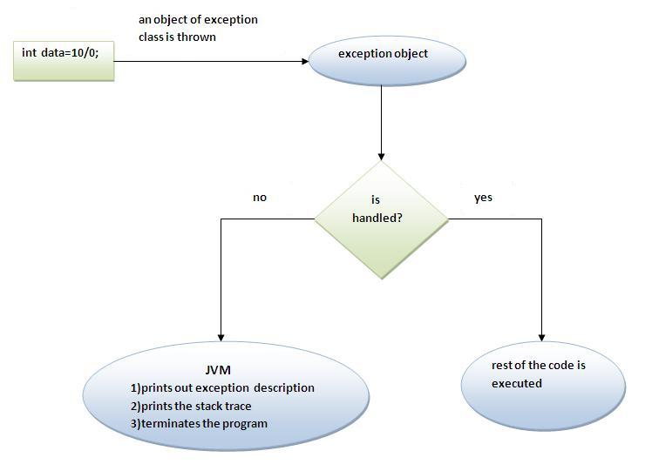
The JVM firstly checks whether the exception is handled or not. If exception is not handled, JVM provides a default exception handler that performs the following tasks:
- Prints out exception description.
- Prints the stack trace (Hierarchy of methods where the exception occurred).
- Causes the program to terminate.
But if exception is handled by the application programmer, normal flow of the application is maintained i.e. rest of the code is executed.
Java Multi catch block
If you have to perform different tasks at the occurrence of different Exceptions, use java multi catch block.
Let's see a simple example of java multi-catch block.
- public class TestMultipleCatchBlock{
- public static void main(String args[]){
- try{
- int a[]=new int[5];
- a[5]=30/0;
- }
- catch(ArithmeticException e){System.out.println("task1 is completed");}
- catch(ArrayIndexOutOfBoundsException e){System.out.println("task 2 completed");}
- catch(Exception e){System.out.println("common task completed");}

- System.out.println("rest of the code...");
- }
- }

Output:task1 completed
rest of the code...

Rule: At a time only one Exception is occured and at a time only one catch block is executed.

Rule: All catch blocks must be ordered from most specific to most general i.e. catch for ArithmeticException must come before catch for Exception.

Java Nested try block
The try block within a try block is known as nested try block in java.

Java finally block
Java finally block is a block that is used to execute important code such as closing connection, stream etc.
Java finally block is always executed whether exception is handled or not.
Java finally block must be followed by try or catch block.

Note: If you don't handle exception, before terminating the program, JVM executes finally block(if any).

Why use java finally
- Finally block in java can be used to put "cleanup" code such as closing a file, closing connection etc.

Rule: For each try block there can be zero or more catch blocks, but only one finally block.

Note: The finally block will not be executed if program exits (either by calling System.exit() or by causing a fatal error that causes the process to abort).

Java throw keyword
The Java throw keyword is used to explicitly throw an exception.
We can throw either checked or uncheked exceptions in java by throw keyword. The throw keyword is mainly used to throw custom exception. We will see custom exceptions later.
The syntax of java throw keyword is given below.
- throw exception;
Let's see the example of throw IOException.
- throw new IOException("sorry device error);

Java Exception propagation
An exception is first thrown from the top of the stack and if it is not caught, it drops down the call stack to the previous method, If not caught there, the exception again drops down to the previous method, and so on until they are caught or until they reach the very bottom of the call stack. This is called exception propagation.

Rule: By default Unchecked Exceptions are forwarded in calling chain (propagated).

Rule: By default, Checked Exceptions are not forwarded in calling chain (propagated).

ExceptionHandling with MethodOverriding in Java

1) Rule: If the superclass method does not declare an exception, subclass overridden method cannot declare the checked exception.
- import java.io.*;
- class Parent{
- void msg(){System.out.println("parent");}
- }

- class TestExceptionChild extends Parent{
- void msg()throws IOException{
- System.out.println("TestExceptionChild");
- }
- public static void main(String args[]){
- Parent p=new TestExceptionChild();
- p.msg();
- }
- }
Output: Compile Time Error

2) Rule: If the superclass method does not declare an exception, subclass overridden method cannot declare the checked exception but can declare unchecked exception.
- import java.io.*;
- class Parent{
- void msg(){System.out.println("parent");}
- }

- class TestExceptionChild1 extends Parent{
- void msg() throws ArithmeticException{
- System.out.println("child");
- }
- public static void main(String args[]){
- Parent p=new TestExceptionChild1();
- p.msg();
- }
- }
Output:child

3) Rule: If the superclass method declares an exception, subclass overridden method can declare same, subclass exception or no exception but cannot declare parent exception.
- import java.io.*;
- class Parent{
- void msg()throws ArithmeticException{System.out.println("parent");}
- }

- class TestExceptionChild2 extends Parent{
- void msg()throws Exception{System.out.println("child");}

- public static void main(String args[]){
- Parent p=new TestExceptionChild2();
- try{
- p.msg();
- }catch(Exception e){}
- }
- }
Output:Compile Time Error

- import java.io.*;
- class Parent{
- void msg()throws Exception{System.out.println("parent");}
- }

- class TestExceptionChild3 extends Parent{
- void msg()throws Exception{System.out.println("child");}

- public static void main(String args[]){
- Parent p=new TestExceptionChild3();
- try{
- p.msg();
- }catch(Exception e){}
- }
- }
Output:child

Java Custom Exception
If you are creating your own Exception that is known as custom exception or user-defined exception. Java custom exceptions are used to customize the exception according to user need.
By the help of custom exception, you can have your own exception and message.
Let's see a simple example of java custom exception.
- class InvalidAgeException extends Exception{
- InvalidAgeException(String s){
- super(s);
- }
- }
- class TestCustomException1{

- static void validate(int age)throws InvalidAgeException{
- if(age<18)
- throw new InvalidAgeException("not valid");
- else
- System.out.println("welcome to vote");
- }

- public static void main(String args[]){
- try{
- validate(13);
- }catch(Exception m){System.out.println("Exception occured: "+m);}
- System.out.println("rest of the code...");
- }
- }
Output:Exception occured: InvalidAgeException:not valid
rest of the code...

Java Inner Class
Java inner class or nested class is a class i.e. declared inside the class or interface.
We use inner classes to logically group classes and interfaces in one place so that it can be more readable and maintainable.
Additionally, it can access all the members of outer class including private data members and methods.

Syntax of Inner class
- class Java_Outer_class{
- //code
- class Java_Inner_class{
- //code
- }
- }

Advantage of java inner classes
There are basically three advantages of inner classes in java. They are as follows:
1) Nested classes represent a special type of relationship that is it can access all the members (data members and methods) of outer class including private.
2) Nested classes are used to develop more readable and maintainable code because it logically group classes and interfaces in one place only.
3) Code Optimization: It requires less code to write.

Java Member inner class
A non-static class that is created inside a class but outside a method is called member inner class.
Syntax:
- class Outer{
- //code
- class Inner{
- //code
- }
- }

Internal working of Java member inner class
The java compiler creates two class files in case of inner class. The class file name of inner class is "Outer$Inner". If you want to instantiate inner class, you must have to create the instance of outer class. In such case, instance of inner class is created inside the instance of outer class.

Java Anonymous inner class
A class that have no name is known as anonymous inner class in java. It should be used if you have to override method of class or interface. Java Anonymous inner class can be created by two ways:
- Class (may be abstract or concrete).
- Interface

Java anonymous inner class example using class
- abstract class Person{
- abstract void eat();
- }
- class TestAnonymousInner{
- public static void main(String args[]){
- Person p=new Person(){
- void eat(){System.out.println("nice fruits");}
- };
- p.eat();
- }
- }

Internal working of given code
- Person p=new Person(){
- void eat(){System.out.println("nice fruits");}
- };
- A class is created but its name is decided by the compiler which extends the Person class and provides the implementation of the eat() method.
- An object of Anonymous class is created that is referred by p reference variable of Person type.

Java anonymous inner class example using interface
- interface Eatable{
- void eat();
- }
- class TestAnnonymousInner1{
- public static void main(String args[]){
- Eatable e=new Eatable(){
- public void eat(){System.out.println("nice fruits");}
- };
- e.eat();
- }
- }

Internal working of given code
It performs two main tasks behind this code:
- Eatable p=new Eatable(){
- void eat(){System.out.println("nice fruits");}
- };
- A class is created but its name is decided by the compiler which implements the Eatable interface and provides the implementation of the eat() method.
- An object of Anonymous class is created that is referred by p reference variable of Eatable type.

Java Local inner class
A class i.e. created inside a method is called local inner class in java. If you want to invoke the methods of local inner class, you must instantiate this class inside the method.

Java local inner class example
- public class localInner1{
- private int data=30;//instance variable
- void display(){
- class Local{
- void msg(){System.out.println(data);}
- }
- Local l=new Local();
- l.msg();
- }
- public static void main(String args[]){
- localInner1 obj=new localInner1();
- obj.display();
- }
- }

Rule: Local variable can't be private, public or protected.

1) Local inner class cannot be invoked from outside the method.

2) Local inner class cannot access non-final local variable till JDK 1.7. Since JDK 1.8, it is possible to access the non-final local variable in local inner class.

Java static nested class
A static class i.e. created inside a class is called static nested class in java. It cannot access non-static data members and methods. It can be accessed by outer class name.
- It can access static data members of outer class including private.
- Static nested class cannot access non-static (instance) data member or method.
- class TestOuter1{
- static int data=30;
- static class Inner{
- void msg(){System.out.println("data is "+data);}
- }
- public static void main(String args[]){
- TestOuter1.Inner obj=new TestOuter1.Inner();
- obj.msg();
- }
- }
Output: data is 30

Java Nested Interface
An interface i.e. declared within another interface or class is known as nested interface. The nested interfaces are used to group related interfaces so that they can be easy to maintain. The nested interface must be referred by the outer interface or class. It can't be accessed directly.

Points to remember for nested interfaces
There are given some points that should be remembered by the java programmer.
- Nested interface must be public if it is declared inside the interface but it can have any access modifier if declared within the class.
- Nested interfaces are declared static implicitely.
Multithreading in Java
Multithreading in java is a process of executing multiple threads simultaneously.

Advantage of Java Multithreading
1) doesn't block the user
2) can perform many operations together so it saves time.
3) Threads are independent so it doesn't affect other threads if exception occur in a single thread.

What is Thread in java
A thread is a lightweight sub process, a smallest unit of processing. It is a separate path of execution.
Threads are independent, if there occurs exception in one thread, it doesn't affect other threads. It shares a common memory area.
As shown in the above figure, thread is executed inside the process. There is context-switching between the threads. There can be multiple processes inside the OS and one process can have multiple threads.

Note: At a time one thread is executed only.

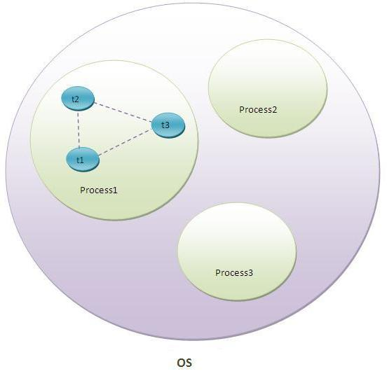

Life cycle of a Thread (Thread States)
- New
- Runnable
- Running
- Non-Runnable (Blocked)
- Terminated
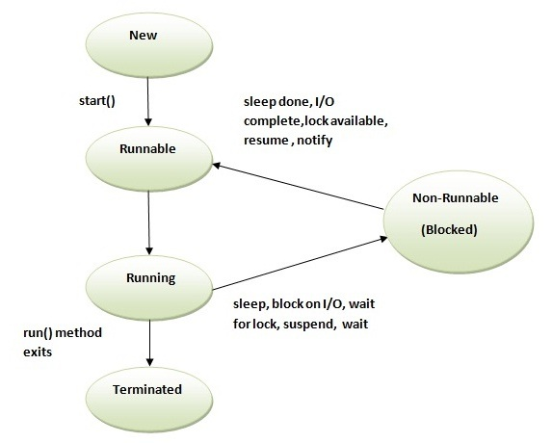

1) New
The thread is in new state if you create an instance of Thread class but before the invocation of start() method.

2) Runnable
The thread is in runnable state after invocation of start() method, but the thread scheduler has not selected it to be the running thread.

3) Running
The thread is in running state if the thread scheduler has selected it.

4) Non-Runnable (Blocked)
This is the state when the thread is still alive, but is currently not eligible to run.

5) Terminated
A thread is in terminated or dead state when its run() method exits.

How to create thread
There are two ways to create a thread:
- By extending Thread class
- By implementing Runnable interface.
TO BE Continued ……
Reflection:
Java Reflection makes it possible to inspect classes, interfaces, fields and methods at runtime, without knowing the names of the classes, methods etc. at compile time. It is also possible to instantiate new objects, invoke methods and get/set field values using reflection.

Where it is used
The Reflection API is mainly used in:
- IDE (Integrated Development Environment) e.g. Eclipse, MyEclipse, NetBeans etc.
- Debugger
- Test Tools etc.

Determining the class object
Following methods of Class class is used to determine the class object:
1) public boolean isInterface(): determines if the specified Class object represents an interface type.
2) public boolean isArray(): determines if this Class object represents an array class.
3) public boolean isPrimitive(): determines if the specified Class object represents a primitive type.
Let's see the simple example of reflection api to determine the object type.
class Simple{}
interface My{}
class Test{
public static void main(String args[]){
try{
Class c=Class.forName("Simple");
System.out.println(c.isInterface());
Class c2=Class.forName("My");
System.out.println(c2.isInterface());
}catch(Exception e){System.out.println(e);}
}
}
Output:
false
true

Java String to int
We can convert String to int in java using Integer.parseInt() method.
int i=Integer.parseInt("200");

Java int to String
We can convert int to String in java using String.valueOf() and Integer.toString() methods.
- int i=10;
- String s=String.valueOf(i);//Now it will return "10"

- int i=10;
- String s=Integer.toString(i);//Now it will return "10"

Same is for long, double and float
What is Collection in java
Collection represents a single unit of objects i.e. a group.

Hierarchy of Collection Framework
Let us see the hierarchy of collection framework. The java.util package contains all the classes and interfaces for Collection framework.
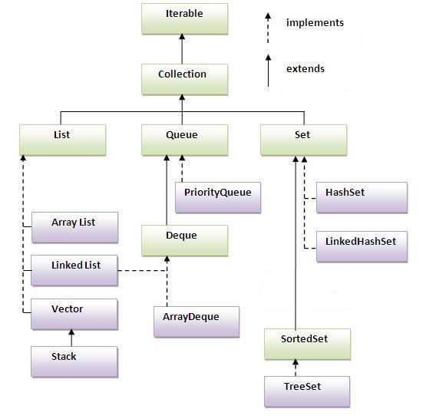

Two ways to iterate the elements of collection in java
- By Iterator interface.
- By for-each loop.
ArrayList<String> al=new ArrayList<String>();//creating arraylist
al.add("Ravi");//adding object in arraylist
al.add("Vijay");
al.add("Ravi");
al.add("Ajay");
for(String obj:al)
System.out.println(obj);
}

Iterator itr=al.iterator();//getting Iterator from arraylist to traverse elements
while(itr.hasNext()){
System.out.println(itr.next());
}
}

Difference between ArrayList and LinkedList
ArrayList | LinkedList
1) ArrayList internally uses dynamic array to store the elements. | LinkedList internally uses doubly linked list to store the elements.
2) Manipulation with ArrayList is slow because it internally uses array. If any element is removed from the array, all the bits are shifted in memory. | Manipulation with LinkedList is faster than ArrayList because it uses doubly linked list so no bit shifting is required in memory.
3) ArrayList class can act as a list only because it implements List only. | LinkedList class can act as a list and queue both because it implements List and Deque interfaces.
4) ArrayList is better for storing and accessing data. | LinkedList is better for manipulating data.

Java HashSet class
- Uses hashtable to store the elements. It extends AbstractSet class and implements Set interface.
- Contains unique elements only.

Difference between List and Set:
List can contain duplicate elements whereas Set contains unique elements only.

Java LinkedHashSet class:
- contains unique elements only like HashSet. It extends HashSet class and implements Set interface.
- maintains insertion order.

Java TreeSet class
- contains unique elements only like HashSet. The TreeSet class implements NavigableSet interface that extends the SortedSet interface.
- maintains ascending order.

Java Queue Interface
The Queue interface basically orders the element in FIFO(First In First Out)manner.

Java Map Interface
A map contains values based on the key i.e. key and value pair. Each pair is known as an entry. Map contains only unique elements.

Java HashMap class
- A HashMap contains values based on the key. It implements the Map interface and extends AbstractMap class.
- It contains only unique elements.
- It may have one null key and multiple null values.
- It maintains no order.

What is difference between HashSet and HashMap?
HashSet contains only values whereas HashMap contains entry(key and value).

Java LinkedHashMap class
- A LinkedHashMap contains values based on the key. It implements the Map interface and extends HashMap class.
- It contains only unique elements.
- It may have one null key and multiple null values.
- It is same as HashMap instead maintains insertion order.

Java TreeMap class
- A TreeMap contains values based on the key. It implements the NavigableMap interface and extends AbstractMap class.
- It contains only unique elements.
- It cannot have null key but can have multiple null values.
- It is same as HashMap instead maintains ascending order.

What is difference between HashMap and TreeMap?
1) HashMap is can contain one null key. | TreeMap can not contain any null key.
2) HashMap maintains no order. | TreeMap maintains ascending order.

Java Hashtable class
- A Hashtable is an array of list. Each list is known as a bucket. The position of bucket is identified by calling the hashcode() method. A Hashtable contains values based on the key. It implements the Map interface and extends Dictionary class.
- It contains only unique elements.
- It may have not have any null key or value.
- It is synchronized.

Difference between HashMap and Hashtable
HashMap | Hashtable
1) HashMap is non synchronized. It is not-thread safe and can't be shared between many threads without proper synchronization code. | Hashtable is synchronized. It is thread-safe and can be shared with many threads.
2) HashMap allows one null key and multiple null values. | Hashtable doesn't allow any null key or value.
3) HashMap is a new class introduced in JDK 1.2. | Hashtable is a legacy class.
4) HashMap is fast. | Hashtable is slow.
5) We can make the HashMap as synchronized by calling this code  Map m = Collections.synchronizedMap(hashMap); | Hashtable is internally synchronized and can't be unsynchronized.
6) HashMap is traversed by Iterator. | Hashtable is traversed by Enumerator and Iterator.
7) Iterator in HashMap is fail-fast. | Enumerator in Hashtable is not fail-fast.
8) HashMap inherits AbstractMap class. | Hashtable inherits Dictionary class.

Sorting
We can sort the elements of:
- String objects
- Wrapper class objects
- User-defined class objects
Collections class provides static methods for sorting the elements of collection. If collection elements are of Set type, we can use TreeSet. But We cannot sort the elements of List. Collections class provides methods for sorting the elements of List type elements.

Example of Sorting the elements of List that contains string objects
- ArrayList<String> al=new ArrayList<String>();
- al.add("Viru");
- al.add("Saurav");
- al.add("Mukesh");
- al.add("Tahir");
- Collections.sort(al);

Example of Sorting the elements of List that contains Wrapper class objects
- ArrayList al=new ArrayList();
- al.add(Integer.valueOf(201));
- al.add(Integer.valueOf(101));
- al.add(230);//internally will be converted into objects as Integer.valueOf(230)
- Collections.sort(al);

Comparable interface
Comparable interface is used to order the objects of user-defined class. This interface is found in java.lang package and contains only one method named compareTo(Object).It provide only single sorting sequence i.e. you can sort the elements on based on single datamember only. For instance it may be either rollno,name,age or anything else.

Note: String class and Wrapper classes implements the Comparable interface. So if you store the objects of string or wrapper classes, it will be Comparable.

Example of Sorting the elements of List that contains user-defined class objects on age basis

Student.java
- class Student implements Comparable{
- int rollno;
- String name;
- int age;
- Student(int rollno,String name,int age){
- this.rollno=rollno;
- this.name=name;
- this.age=age;
- }

- public int compareTo(Object obj){
- Student st=(Student)obj;
- if(age==st.age)
- return 0;
- else if(age>st.age)
- return 1;
- else
- return -1;
- }

- }

Simple.java
- import java.util.*;
- import java.io.*;

- class TestSort3{
- public static void main(String args[]){

- ArrayList al=new ArrayList();
- al.add(new Student(101,"Vijay",23));
- al.add(new Student(106,"Ajay",27));
- al.add(new Student(105,"Jai",21));

- Collections.sort(al);
- Iterator itr=al.iterator();
- while(itr.hasNext()){
- Student st=(Student)itr.next();
- System.out.println(st.rollno+""+st.name+""+st.age);
- }
- }
- }
Output: 105 Jai 21
101 Vijay 23
106 Ajay 27

Comparator interface
Comparator interface is used to order the objects of user-defined class.
This interface is found in java.util package and contains 2 methods compare(Object obj1,Object obj2) and equals(Object element).
It provides multiple sorting sequence i.e. you can sort the elements based on any data member. For instance it may be on rollno, name, age or anything else.

Syntax of compare method
public int compare(Object obj1,Object obj2): compares the first object with second object.

Example of sorting the elements of List that contains user-defined class objects on the basis of age and name
In this example, we have created 4 java classes:
- Student.java
- AgeComparator.java
- NameComparator.java
- Simple.java
Student.java
This class contains three fields rollno, name and age and a parameterized constructor.
- class Student{
- int rollno;
- String name;
- int age;
- Student(int rollno,String name,int age){
- this.rollno=rollno;
- this.name=name;
- this.age=age;
- }
- }

AgeComparator.java
- import java.util.*;
- class AgeComparator implements Comparator{
- public int Compare(Object o1,Object o2){
- Student s1=(Student)o1;
- Student s2=(Student)o2;

- if(s1.age==s2.age)
- return 0;
- else if(s1.age>s2.age)
- return 1;
- else
- return -1;
- }
- }

NameComparator.java
- import java.util.*;
- class NameComparator implements Comparator{
- public int Compare(Object o1,Object o2){
- Student s1=(Student)o1;
- Student s2=(Student)o2;

- return s1.name.compareTo(s2.name);
- }
- }

Simple.java
- ArrayList al=new ArrayList();
- al.add(new Student(101,"Vijay",23));
- al.add(new Student(106,"Ajay",27));
- al.add(new Student(105,"Jai",21));

- System.out.println("Sorting by Name...");

- Collections.sort(al,new NameComparator());

Difference between Comparable and Comparator
Comparable | Comparator
1) Comparable provides single sorting sequence. In other words, we can sort the collection on the basis of single element such as id or name or price etc. | Comparator provides multiple sorting sequence. In other words, we can sort the collection on the basis of multiple elements such as id, name and price etc.
2) Comparable affects the original class i.e. actual class is modified. | Comparator doesn't affect the original class i.e. actual class is not modified.
3) Comparable provides compareTo() method to sort elements. | Comparator provides compare() method to sort elements.
4) Comparable is found in java.lang package. | Comparator is found in java.util package.
5) We can sort the list elements of Comparable type by Collections.sort(List) method. | We can sort the list elements of Comparator type by Collections.sort(List,Comparator) method.

Properties class in Java
The properties object contains key and value pair both as a string. It is the subclass of Hashtable.
It can be used to get property value based on the property key. The Properties class provides methods to get data from properties file and store data into properties file. Moreover, it can be used to get properties of system.

Advantage of properties file
Easy Maintenance: If any information is changed from the properties file, you don't need to recompile the java class. It is mainly used to contain variable information i.e. to be changed.

Difference between ArrayList and Vector
ArrayList | Vector
1) ArrayList is not synchronized. | Vector is synchronized.
2) ArrayList increments 50% of current array size if number of element exceeds from its capacity. | Vector increments 100% means doubles the array size if total number of element exceeds than its capacity.
3) ArrayList is not a legacy class, it is introduced in JDK 1.2. | Vector is a legacy class.
4) ArrayList is fast because it is non-synchronized. | Vector is slow because it is synchronized i.e. in multithreading environment, it will hold the other threads in runnable or non-runnable state until current thread releases the lock of object.
5) ArrayList uses Iterator interface to traverse the elements. | Vector uses Enumeration interface to traverse the elements. But it can use Iterator also.

Data Structure Set uses to store its element is map
Set can store one null value.

5 Steps to connect to the database in java
- Register the driver class
- Creating connection
- Creating statement
- Executing queries
- Closing connection

PreparedStatement interface
The PreparedStatement interface is a subinterface of Statement. It is used to execute parameterized query.
Let's see the example of parameterized query:
- String sql="insert into emp values(?,?,?)";
As you can see, we are passing parameter (?) for the values. Its value will be set by calling the setter methods of PreparedStatement.

Why use PreparedStatement?
Improves performance: The performance of the application will be faster if you use PreparedStatement interface because query is compiled only once.

Example of PreparedStatement interface that updates the record
PreparedStatement stmt=con.prepareStatement("update emp set name=? where id=?");
stmt.setString(1,"Sonoo");//1 specifies the first parameter in the query i.e. name
stmt.setInt(2,101);

int i=stmt.executeUpdate();
System.out.println(i+" records updated");

ResultSetMetaData Interface
The metadata means data about data i.e. we can get further information from the data.

Example of ResultSetMetaData interface :
- import java.sql.*;
- class Rsmd{
- public static void main(String args[]){
- try{
- Class.forName("oracle.jdbc.driver.OracleDriver");

- Connection con=DriverManager.getConnection(
- "jdbc:oracle:thin:@localhost:1521:xe","system","oracle");

- PreparedStatement ps=con.prepareStatement("select * from emp");
- ResultSet rs=ps.executeQuery();

- ResultSetMetaData rsmd=rs.getMetaData();

- System.out.println("Total columns: "+rsmd.getColumnCount());
- System.out.println("Column Name of 1st column: "+rsmd.getColumnName(1));
- System.out.println("Column Type Name of 1st column: "+rsmd.getColumnTypeName(1));

- con.close();

- }catch(Exception e){ System.out.println(e);}

- }
- }

CallableStatement Interface
To call the stored procedures and functions, CallableStatement interface is used.
Working of Garbage Collection?
Types of class loader? 1. Bootstrap 2. System 3.Extension
Enum in JAVA

Java Enum
Enum in java is a data type that contains fixed set of constants.
It can be used for days of the week (SUNDAY, MONDAY, TUESDAY, WEDNESDAY, THURSDAY, FRIDAY and SATURDAY) , directions (NORTH, SOUTH, EAST and WEST) etc. The java enum constants are static and final implicitly. It is available from JDK 1.5.
Java Enums can be thought of as classes that have fixed set of constants.

Simple example of java enum
- class EnumExample1{
- public enum Season { WINTER, SPRING, SUMMER, FALL }

- public static void main(String[] args) {
- for (Season s : Season.values())
- System.out.println(s);

- }}

What is the purpose of values() method in enum?
The java compiler internally adds the values() method when it creates an enum. The values() method returns an array containing all the values of the enum.

Defining Java enum
The enum can be defined within or outside the class because it is similar to a class.

Java enum example: defined outside class
- enum Season { WINTER, SPRING, SUMMER, FALL }
- class EnumExample2{
- public static void main(String[] args) {
- Season s=Season.WINTER;
- System.out.println(s);
- }}
Output:WINTER

Initializing specific values to the enum constants
The enum constants have initial value that starts from 0, 1, 2, 3 and so on. But we can initialize the specific value to the enum constants by defining fields and constructors. As specified earlier, Enum can have fields, constructors and methods.

Constructor of enum type is private. If you don't declare private compiler internally creates private constructor.

- enum Season{
- WINTER(10),SUMMER(20);
- private int value;
- Season(int value){
- this.value=value;
- }
- }

Can we create the instance of enum by new keyword?
No, because it contains private constructors only.

Can we have abstract method in enum?
Yes, ofcourse! we can have abstract methods and can provide the implementation of these methods.

Autoboxing and Unboxing:
The automatic conversion of primitive data types into its equivalent Wrapper type is known as boxing and opposite operation is known as unboxing. This is the new feature of Java5. So java programmer doesn't need to write the conversion code.

Java Annotations
Java Annotation is a tag that represents the metadata i.e. attached with class, interface, methods or fields to indicate some additional information which can be used by java compiler and JVM.
Annotations in java are used to provide additional information, so it is an alternative option for XML and java marker interfaces.
First, we will learn some built-in annotations then we will move on creating and using custom annotations.

Built-In Java Annotations used in java code
- @Override
- @SuppressWarnings: @SuppressWarnings annotation: is used to suppress warnings issued by the compiler.
- @Deprecated: @Deprecated annoation marks that this method is deprecated so compiler prints warning. It informs user that it may be removed in the future versions.

Generics in Java
The Java Generics programming is introduced in J2SE 5 to deal with type-safe objects.
Before generics, we can store any type of objects in collection i.e. non-generic. Now generics, forces the java programmer to store specific type of objects.

Advantage of Java Generics
There are mainly 3 advantages of generics. They are as follows:
1) Type-safety : We can hold only a single type of objects in generics. It doesn’t allow to store other objects.
2) Type casting is not required: There is no need to typecast the object.
Before Generics, we need to type cast.
- List list = new ArrayList();
- list.add("hello");
- String s = (String) list.get(0);//typecasting
After Generics, we don't need to typecast the object.
- List<String> list = new ArrayList<String>();
- list.add("hello");
- String s = list.get(0);
3) Compile-Time Checking: It is checked at compile time so problem will not occur at runtime. The good programming strategy says it is far better to handle the problem at compile time than runtime.
- List<String> list = new ArrayList<String>();
- list.add("hello");
- list.add(32);//Compile Time Error

Generic class
A class that can refer to any type is known as generic class. Here, we are using T type parameter to create the generic class of specific type.
Let’s see the simple example to create and use the generic class.
Creating generic class:
- class MyGen<T>{
- T obj;
- void add(T obj){this.obj=obj;}
- T get(){return obj;}
- }

Generic Method
Like generic class, we can create generic method that can accept any type of argument.
Let’s see a simple example of java generic method to print array elements. We are using here E to denote the element.
- public class TestGenerics4{

- public static < E > void printArray(E[] elements) {
- for ( E element : elements){
- System.out.println(element );
- }
- System.out.println();
- }
- public static void main( String args[] ) {
- Integer[] intArray = { 10, 20, 30, 40, 50 };
- Character[] charArray = { 'J', 'A', 'V', 'A', 'T','P','O','I','N','T' };

- System.out.println( "Printing Integer Array" );
- printArray( intArray );

- System.out.println( "Printing Character Array" );
- printArray( charArray );
- }
- }

Wildcard in Java Generics
The ? (question mark) symbol represents wildcard element. It means any type. If we write <? extends Number>, it means any child class of Number e.g. Integer, Float, double etc. Now we can call the method of Number class through any child class object.
How to Compare two Objects?
To Compare two objects you need to override equals() and hashcode() .
Equals and HashCode methods in Java are two fundamental methods from java.lang.Object class, which is used to compare equality of objects, primarily inside hash based collections such as Hashtable and HashMap. Both equals() and hashCode() are defined in java.lang.Object class and there default implementation is based upon Object information e.g. default equals()method return true if two objects are exactly same i.e. they are pointing to the same memory address while default implementation of hashcode method return int and implemented as a native method. The similar default implementation of toString() method, returns type of class, followed by memory address in hex String.
equals and hashcode contract
In hashCode() it says: If two objects are equal according to the equals(Object) method, then calling the hashCode method on each of the two objects must produce the same integer result. If you only override equals() and not hashCode() your class violates this contract.
When you are writing equals() method, which other method or methods you need to override?
hashcode is the right answer. Since equals and hashCode have their contract, so overriding one and not other will break the contract between them. By the way this question can lead to an interesting discussion; if Interviewer likes to go on deep e.g. he may ask what are those contracts, what happens if those contracts break etc. I like to give an example How equals and hashcode are used in hash based collections e.g. Hashtable, that leaves positive impression more often. You can also mention about compareTo() here to score some additional point, this method should also need to be consistent with equals, which is another interesting question on our list.
Can two objects which are not equal have the same hashCode?
YES, two objects, which are not equal to equals() method can still return same hashCode. By the way, this is one of the confusing bit of equals and hashcode contract. See Core Java, Volume 19th Edition by Cay S. Horstmann for more details.
How does get() method of HashMap works, if two keys have the same hashCode?
This is the follow-up of previous interview questions on equals and hashcode, in fact, sometimes this leads to a discussion of the earlier point. When two key return same hashcode, they end up in the same bucket. Now, in order to find the correct value, you used keys.equals() method to compare with key stored in each Entry of linked list there. Remember to point out keys.equals() method, because that's what interviewer is looking for.

Where have you written equals() and hashCode in your project?
This is to see if the developer has even written these methods or not. Of course, almost all of Java programmer are exposed to this, you can point out value objects, Hibernate entities from your domain, where you have overridden equals and hashCode. Always gives examples from your domain and from your project, rather than a trivial example from a test program, because if Interviewer is asking this question, it means he is interested in examples from your domain.

What happens if you compare an object to null using equals()?
When a null object is passed as an argument to equals() method, it should return false, it must not throw NullPointerException, but if you call equals method on reference, which is null it will throw NullPointerException. That’s why it’s better to use == operator for comparing null e.g. if(object != null) object.equals(anohterObject). By the way, if you comparing String literal with another String object then you better call equals() method on the String literal rather than known object to avoid NPE, one of those simple tricks to avoid NullPointerException in Java.
What is the difference in using instanceof and getClass() method for checking type inside equals?
This question was asked multiple times, sometimes by looking at your equals() and hashCode implementation. Well, key difference comes from the point that instanceof operator returns true, even if compared with subclass e.g. Subclass instanceof Superclass is true, but with getClass() it's false. By using getClass() you ensure that your equals() implementation doesn't return true if compared with subclass object. While if you use instanceof operator, you end up breaking symmetry rule for equals which says that if a.equals(b) is true than b.equals(a) should also be true. Just replace a and b with an instance of Superclass and Subclass, and you will end up breaking symmetry rule for equals() method.
How do you avoid NullPointerException, while comparing two Strings in Java?
Since when compared to null, equals return false and doesn't throw NullPointerException, you can use this property to avoid NPE while using comparing String. Suppose you have a known String "abc" and you are comparing with an unknown String variable str, then you should call equals as "abc".equals(str), this will not throw Exception in thread Main: java.lang.NullPointerException, even if str is null. On the other hand, if you call str.equals("abc"), it will throw NPE. So be careful with this. By the way this is one of the Java coding best practices, which Java developer should follow, while using equals() method.
What is the difference between "==" and equals() method in Java?
One of the most classic interview question on equals(). It has been asked numerous times during in past decade. I have also covered this question already. See here for a detailed discussion on how it affect equality checking of String and Integer in the autoboxing world.

1) What is the difference between ArrayList and Vector?
No. | ArrayList | Vector
1) | ArrayList is not synchronized. | Vector is synchronized.
2) | ArrayList is not a legacy class. | Vector is a legacy class.
3) | ArrayList increases its size by 50% of the array size. | Vector increases its size by doubling the array size.

2) What is the difference between ArrayList and LinkedList?
No. | ArrayList | LinkedList
1) | ArrayList uses a dynamic array. | LinkedList uses doubly linked list.
2) | ArrayList is not efficient for manipulation because a lot of shifting is required. | LinkedList is efficient for manipulation.
3) | ArrayList is better to store and fetch data. | LinkedList is better to manipulate data.

3) What is the difference between Iterator and ListIterator?
Iterator traverses the elements in forward direction only whereas ListIterator traverses the elements in forward and backward direction.
No. | Iterator | ListIterator
1) | Iterator traverses the elements in forward direction only. | ListIterator traverses the elements in backward and forward directions both.
2) | Iterator can be used in List, Set and Queue. | ListIterator can be used in List only.

4) What is the difference between Iterator and Enumeration?
No. | Iterator | Enumeration
1) | Iterator can traverse legacy and non-legacy elements. | Enumeration can traverse only legacy elements.
2) | Iterator is fail-fast. | Enumeration is not fail-fast.
3) | Iterator is slower than Enumeration. | Enumeration is faster than Iterator.

5) What is the difference between List and Set?
List can contain duplicate elements whereas Set contains only unique elements.

6) What is the difference between HashSet and TreeSet?
HashSet maintains no order whereas TreeSet maintains ascending order.

7) What is the difference between Set and Map?
Set contains values only whereas Map contains key and values both.
8) What is the difference between HashSet and HashMap?
HashSet contains only values whereas HashMap contains entry(key,value). HashSet can be iterated but HashMap need to convert into Set to be iterated.

9) What is the difference between HashMap and TreeMap?
HashMap maintains no order but TreeMap maintains ascending order.

10) What is the difference between HashMap and Hashtable?
No. | HashMap | Hashtable
1) | HashMap is not synchronized. | Hashtable is synchronized.
2) | HashMap can contain one null key and multiple null values. | Hashtable cannot contain any null key or null value.

11) What is the difference between Collection and Collections?
Collection is an interface whereas Collections is a class. Collection interface provides normal functionality of data structure to List, Set and Queue. But, Collections class is to sort and synchronize collection elements.

12) What is the difference between Comparable and Comparator?
No. | Comparable | Comparator
1) | Comparable provides only one sort of sequence. | Comparator provides multiple sort of sequences.
2) | It provides one method named compareTo(). | It provides one method named compare().
3) | It is found in java.lang package. | it is found in java.util package.
4) | If we implement Comparable interface, actual class is modified. | Actual class is not modified.

13) What is the advantage of Properties file?
If you change the value in properties file, you don't need to recompile the java class. So, it makes the application easy to manage.

14) What does the hashCode() method?
The hashCode() method returns a hash code value (an integer number).
The hashCode() method returns the same integer number, if two keys (by calling equals() method) are same.
But, it is possible that two hash code numbers can have different or same keys.

15) Why we override equals() method?
The equals method is used to check whether two objects are same or not. It needs to be overridden if we want to check the objects based on property.
For example, Employee is a class that has 3 data members: id, name and salary. But, we want to check the equality of employee object on the basis of salary. Then, we need to override the equals() method.

16) How to synchronize List, Set and Map elements?
Yes, Collections class provides methods to make List, Set or Map elements as synchronized:
public static List synchronizedList(List l){}
public static Set synchronizedSet(Set s){}
public static SortedSet synchronizedSortedSet(SortedSet s){}
public static Map synchronizedMap(Map m){}
public static SortedMap synchronizedSortedMap(SortedMap m){}

17) What is the advantage of generic collection?
If we use generic class, we don't need typecasting. It is typesafe and checked at compile time.

18) What is hash-collision in Hashtable and how it is handled in Java?
Two different keys with the same hash value is known as hash-collision. Two different entries will be kept in a single hash bucket to avoid the collision.

19) What is the Dictionary class?
The Dictionary class provides the capability to store key-value pairs.

20) What is the default size of load factor in hashing based collection?
The default size of load factor is 0.75. The default capacity is computed as initial capacity * load factor. For example, 16 * 0.75 = 12. So, 12 is the default capacity of Map.

Difference between ConcurrentHashMap and Hashtable
So what is the difference between Hashtable and ConcurrentHashMap, both can be used in the multithreaded environment but once the size of Hashtable becomes considerable large performance degrade because for iteration it has to be locked for a longer duration.
Since ConcurrentHashMap introduced the concept of segmentation, how large it becomes only certain part of it get locked to provide thread safety so many other readers can still access map without waiting for iteration to complete.
In Summary, ConcurrentHashMap only locked certain portion of Map while Hashtable locks full map while doing iteration. This will be clearer by looking at this diagram which explains the internal working of ConcurrentHashMap in Java.

The difference between ConcurrentHashMap and Collections.synchronizedMap

ConcurrentHashMap is designed for concurrency and improve performance while HashMap which is non-synchronized by nature can be synchronized by applying a wrapper using synchronized Map. Here are some of the common differences between ConcurrentHashMap and synchronized map in Java
ConcurrentHashMap does not allow null keys or null values while synchronized HashMap allows one null key.

Variable Argument (Varargs):
The varrags allows the method to accept zero or muliple arguments. Before varargs either we use overloaded method or take an array as the method parameter but it was not considered good because it leads to the maintenance problem. If we don't know how many argument we will have to pass in the method, varargs is the better approach.

Advantage of Varargs:
We don't have to provide overloaded methods so less code.

Rules for varargs:
While using the varargs, you must follow some rules otherwise program code won't compile. The rules are as follows:
- There can be only one variable argument in the method.
- Variable argument (varargs) must be the last argument.

Example of Varargs that is the last argument in the method:

- class VarargsExample3{
- static void display(int num, String... values){
- System.out.println("number is "+num);
- for(String s:values){
- System.out.println(s);
- }
- }

- public static void main(String args[]){
- display(500,"hello");//one argument
- display(1000,"my","name","is","varargs");//four arguments
- }
- }

Output:number is 500
hello
number is 1000
my
name
is
varargs

Static Import:
The static import feature of Java 5 facilitate the java programmer to access any static member of a class directly. There is no need to qualify it by the class name.

Advantage of static import:
- Less coding is required if you have access any static member of a class oftenly.

Disadvantage of static import:
- If you overuse the static import feature, it makes the program unreadable and unmaintainable.

Simple Example of static import
- import static java.lang.System.*;
- class StaticImportExample{
- public static void main(String args[]){

- out.println("Hello");//Now no need of System.out
- out.println("Java");

- }
- }

Output:Hello
Java

What is the difference between import and static import?
The import allows the java programmer to access classes of a package without package qualification whereas the static import feature allows accessing the static members of a class without the class qualification. The import provides accessibility to classes and interface whereas static import provides accessibility to static members of the class.

