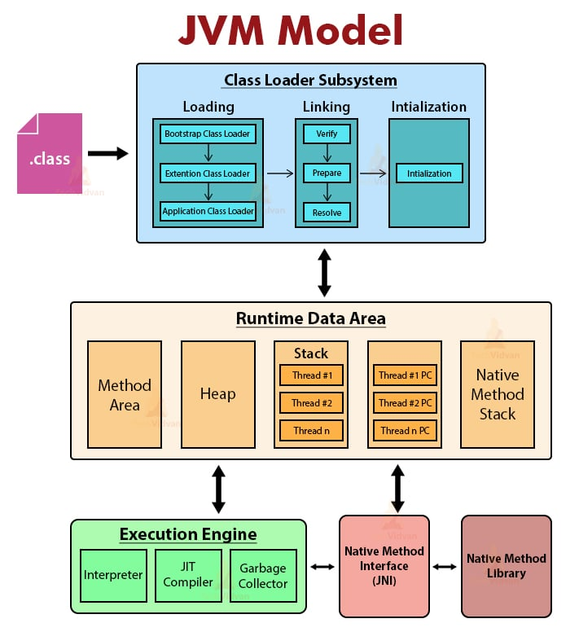

1. .class File (Input to JVM)
- When you compile a Java program (.java file), it becomes a .class file.
- This file contains bytecode, not machine code.
- JVM reads this bytecode and executes it.

2. Class Loader Subsystem
This is the first major component shown in your diagram.
Purpose:
Loads .class files into memory.
Types of Class Loaders:
1. Bootstrap Class Loader
- Loads core Java libraries (like java.lang, java.util)
- Located in rt.jar (or modules in modern Java)
- Written in native code (C/C++)
2. Extension Class Loader
- Loads classes from extension directories
- Example: lib/ext folder
3. Application Class Loader
- Loads classes from your project (classpath)
- This is the one that loads your custom code
Flow:
Bootstrap → Extension → Application
This is called Delegation Model:
- Lower loaders ask higher loaders first
- Ensures security and avoids duplicate loading

3. Linking Phase
After loading, JVM performs linking, which has 3 steps:
1. Verification
- Checks if bytecode is valid
- Ensures:
  - No illegal code
  - Proper memory access
  - No security violations
Example:
- Prevents accessing memory directly like C/C++

2. Preparation
- Allocates memory for static variables
- Assigns default values
Example:
static int x = 10;
During preparation:
x = 0 (default value, not 10 yet)

3. Resolution
- Converts symbolic references → actual memory addresses
Example:
- Method names → actual method location in memory

4. Initialization Phase
This is the final step in your diagram.
What happens here?
- Assigns actual values to static variables
- Executes static blocks
Example:
static int x = 10;
Now:
x = 10 (actual value assigned)

Complete Flow Summary
.class file
↓
Class Loader
↓
Loading (Bootstrap → Extension → Application)
↓
Linking
→ Verification
→ Preparation
→ Resolution
↓
Initialization

Real-Life Analogy
Think of JVM like a company onboarding process:
- Loading → Hiring employee (bringing into system)
- Verification → Background check
- Preparation → Assign desk (but no work yet)
- Resolution → Give access to systems
- Initialization → Employee starts actual work
Important Points for Students
- JVM ensures platform independence
- Class loading happens only once
- Static variables are handled in two steps:
  - Default value (Preparation)
  - Actual value (Initialization)
- Verification ensures security

5. JVM Memory Areas (Runtime Data Areas)
Once the class is loaded and initialized, JVM uses memory to execute the program.
1. Method Area (Shared Memory)
- Stores class-level data
- Contains:
  - Class metadata
  - Method data
  - Static variables
  - Runtime constant pool
Example:
static int x = 10;
- Stored in Method Area
2. Heap Memory (Shared Memory)
- Stores objects and instance variables
- Biggest memory area
- Managed by Garbage Collector
Example:
Student s = new Student();
- Object s is stored in Heap
3. Stack Memory (Thread-specific)
- Each thread has its own stack
- Stores:
  - Method calls
  - Local variables
  - Partial results
Example:
int a = 10;
- Stored in Stack
Key Concept:
- Works in LIFO (Last In First Out)
- When method ends → memory is removed automatically
4. PC Register (Program Counter)
- Holds address of current executing instruction
- Each thread has its own PC register
5. Native Method Stack
- Used for executing native methods (non-Java code)
Example:
- Methods written in C/C++
6. Execution Engine
This is the heart of JVM – it executes the bytecode.
It has 3 important parts:
1. Interpreter
- Executes bytecode line by line
- Simple but slow
Example:
- Reads one instruction → executes → moves to next
Problem:
- Same code executed multiple times → still interpreted again
2. JIT Compiler (Just-In-Time Compiler)
- Improves performance
- Converts bytecode → native machine code
Key Idea:
- Frequently used code = compiled once
- Then reused → faster execution
Example:
Loop running 1000 times:
- Interpreter → slow (runs 1000 times)
- JIT → compiles once → runs fast
Interpreter vs JIT
Feature | Interpreter | JIT Compiler
Speed | Slow | Fast
Execution | Line-by-line | Compiled
Optimization | No | Yes
3. Garbage Collector (GC)
- Automatically removes unused objects
- Runs in Heap Memory
Example:
Student s = new Student();
s = null;
- Object becomes eligible for GC
Benefits:
- Prevents memory leaks
- No manual memory management
Important:
- You cannot force GC, only request:
System.gc();
7. Native Method Library
- Collection of native (C/C++) libraries
- Used via JNI (Java Native Interface)
Example:
- File handling
- OS-level operations
Updated Complete JVM Flow
.class file
↓
Class Loader Subsystem
↓
Loading (Bootstrap → Extension → Application)
↓
Linking
→ Verification
→ Preparation
→ Resolution
↓
Initialization
↓
Runtime Data Areas
→ Method Area
→ Heap
→ Stack
→ PC Register
→ Native Method Stack
↓
Execution Engine
→ Interpreter
→ JIT Compiler
→ Garbage Collector
↓
Native Method Library
Real-Life Analogy (Extended)
Think of JVM like a company:
- Class Loader → HR hiring employees
- Memory Areas → Office departments
- Stack → Employee’s desk (temporary work)
- Heap → Warehouse (shared resources)
- Execution Engine → Workers doing tasks
- JIT → Experienced worker doing tasks faster
- Garbage Collector → Cleaning staff removing unused items
- Native Library → External consultants (C/C++ code)

