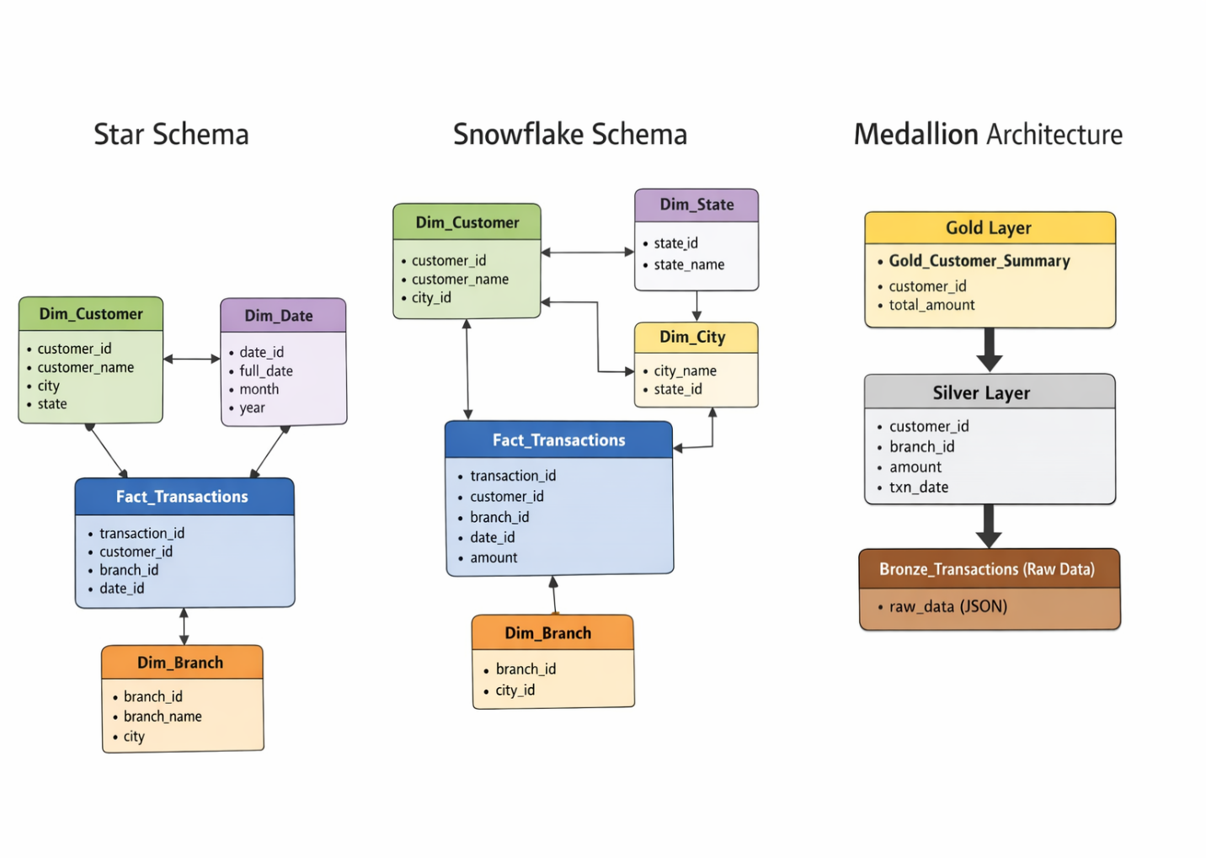
STAR SCHEMA (Simple & Fast)
1. Basic Concept
- One central Fact table
- Multiple Dimension tables
- Structure looks like a star
Fact table stores:
- Numeric data (amount, count, etc.)
Dimension tables store:
- Descriptive data (customer, branch, date)
2. Structure
dim_customer
|
dim_branch — fact_transactions — dim_date
3. Key Characteristics
Denormalized Dimensions
- Data is stored in a single table
- Example:
  - customer table has: name, city, state
Fewer Joins
- Direct connection to fact table
- Query is simple and fast
Optimized for Read Operations
- Used in:
  - Dashboards
  - BI tools
  - Reporting systems
4. Example Query
SELECT c.customer_name, SUM(f.amount)
FROM fact_transactions f
JOIN dim_customer c ON f.customer_id = c.customer_id
GROUP BY c.customer_name;
5. Advantages
Simple design (easy for students)
Fast query performance
Easy to understand relationships
Best for aggregation queries
6. Disadvantages
Data redundancy (duplicate data like city/state)
More storage required
Harder to maintain consistency
7. When to Use
Use Star Schema when:
- Reporting system
- OLAP queries
- Performance is priority
- Data size is large
2. SNOWFLAKE SCHEMA (Normalized)
1. Basic Concept
- Extension of Star Schema
- Dimension tables are normalized into multiple tables
Looks like a snowflake (spread structure)
2. Structure
dim_state
|
dim_city
|
dim_customer — fact_transactions — dim_branch
3. Key Characteristics
Normalized Dimensions
- Data split into multiple tables
- Example:
  - Customer → City → State
Reduced Redundancy
- No duplicate city/state data
More Joins Required
- Query becomes complex
4. Example Query
SELECT s.state_name, SUM(f.amount)
FROM fact_transactions f
JOIN dim_customer c ON f.customer_id = c.customer_id
JOIN dim_city ci ON c.city_id = ci.city_id
JOIN dim_state s ON ci.state_id = s.state_id
GROUP BY s.state_name;
5. Advantages
Less data redundancy
Better data integrity
Easier updates (change in one place)
Saves storage
6. Disadvantages
More joins → slower queries
Complex design
Harder for beginners
7. When to Use
Use Snowflake Schema when:
- Data consistency is important
- Storage optimization required
- Complex relationships exist
- Data warehouse is large
STAR vs SNOWFLAKE (Complete Comparison)
Feature | ⭐ Star Schema | ❄️ Snowflake Schema
Design | Simple | Complex
Normalization | Denormalized | Normalized
Joins | Fewer | More
Performance | Faster | Slightly slower
Storage | More | Less
Maintenance | Harder | Easier
Use Case | Reporting | Data warehousing
Key Interview Points (Very Important)
1. Main Difference
- Star → Denormalized
- Snowflake → Normalized
2. Performance
- Star is faster due to fewer joins
3. Storage
- Snowflake saves space
4. Complexity
- Star is beginner-friendly
- Snowflake is enterprise-level
Simple Way :
“Star Schema = Less tables, fast queries”
“Snowflake Schema = More tables, less redundancy”
Real-World Tip
Most companies:
- Start with Star Schema
- Convert to Snowflake only if needed

STEP 1: STAR SCHEMA (Banking Analytics)
Dimension Tables
CREATE TABLE dim_customer (
customer_id INT PRIMARY KEY,
customer_name VARCHAR(100),
city VARCHAR(50),
state VARCHAR(50)
);
CREATE TABLE dim_branch (
branch_id INT PRIMARY KEY,
branch_name VARCHAR(100),
city VARCHAR(50)
);
CREATE TABLE dim_date (
date_id INT PRIMARY KEY,
full_date DATE,
month INT,
year INT
);

Fact Table
CREATE TABLE fact_transactions (
transaction_id INT PRIMARY KEY,
customer_id INT,
branch_id INT,
date_id INT,
amount DECIMAL(10,2),
FOREIGN KEY (customer_id) REFERENCES dim_customer(customer_id),
FOREIGN KEY (branch_id) REFERENCES dim_branch(branch_id),
FOREIGN KEY (date_id) REFERENCES dim_date(date_id)
);

🔹 Sample Data
INSERT INTO dim_customer VALUES
(1, 'Amit', 'Mumbai', 'Maharashtra'),
(2, 'Neha', 'Pune', 'Maharashtra'),
(3, 'Rahul', 'Delhi', 'Delhi');
INSERT INTO dim_branch VALUES
(1, 'Mumbai Main', 'Mumbai'),
(2, 'Pune Branch', 'Pune');
INSERT INTO dim_date VALUES
(1, '2026-04-01', 4, 2026),
(2, '2026-04-02', 4, 2026);
INSERT INTO fact_transactions VALUES
(101, 1, 1, 1, 5000),
(102, 2, 2, 1, 7000),
(103, 1, 1, 2, 3000),
(104, 3, 2, 2, 9000);

❄️ STEP 2: CONVERT TO SNOWFLAKE SCHEMA
🔹 Normalize Location
CREATE TABLE dim_state (
state_id INT PRIMARY KEY,
state_name VARCHAR(50)
);
CREATE TABLE dim_city (
city_id INT PRIMARY KEY,
city_name VARCHAR(50),
state_id INT,
FOREIGN KEY (state_id) REFERENCES dim_state(state_id)
);

🔹 Updated Customer Table
CREATE TABLE dim_customer_sf (
customer_id INT PRIMARY KEY,
customer_name VARCHAR(100),
city_id INT,
FOREIGN KEY (city_id) REFERENCES dim_city(city_id)
);

🔹 Updated Branch Table
CREATE TABLE dim_branch_sf (
branch_id INT PRIMARY KEY,
branch_name VARCHAR(100),
city_id INT,
FOREIGN KEY (city_id) REFERENCES dim_city(city_id)
);

🔹 Sample Data
INSERT INTO dim_state VALUES
(1, 'Maharashtra'),
(2, 'Delhi');
INSERT INTO dim_city VALUES
(1, 'Mumbai', 1),
(2, 'Pune', 1),
(3, 'Delhi', 2);
INSERT INTO dim_customer_sf VALUES
(1, 'Amit', 1),
(2, 'Neha', 2),
(3, 'Rahul', 3);
INSERT INTO dim_branch_sf VALUES
(1, 'Mumbai Main', 1),
(2, 'Pune Branch', 2);

STEP 3: MEDALLION ARCHITECTURE

Bronze Layer (Raw Data)
CREATE TABLE bronze_transactions (
raw_data JSON
);
INSERT INTO bronze_transactions VALUES
('{"customer_id":1,"branch_id":1,"amount":5000,"date":"2026-04-01"}'),
('{"customer_id":2,"branch_id":2,"amount":7000,"date":"2026-04-01"}'),
('{"customer_id":1,"branch_id":1,"amount":3000,"date":"2026-04-02"}'),
('{"customer_id":3,"branch_id":2,"amount":9000,"date":"2026-04-02"}');

Silver Layer (Cleaned Data)
CREATE TABLE silver_transactions AS
SELECT
JSON_UNQUOTE(JSON_EXTRACT(raw_data, '$.customer_id')) AS customer_id,
JSON_UNQUOTE(JSON_EXTRACT(raw_data, '$.branch_id')) AS branch_id,
JSON_UNQUOTE(JSON_EXTRACT(raw_data, '$.amount')) AS amount,
STR_TO_DATE(JSON_UNQUOTE(JSON_EXTRACT(raw_data, '$.date')), '%Y-%m-%d') AS txn_date
FROM bronze_transactions;

Gold Layer (Aggregated Data)
CREATE TABLE gold_customer_summary AS
SELECT
customer_id,
SUM(amount) AS total_amount,
COUNT(*) AS total_transactions
FROM silver_transactions
GROUP BY customer_id;

FINAL QUERY: Top 5 Customers by Transaction Amount
Using Star Schema
SELECT c.customer_name, SUM(f.amount) AS total_amount
FROM fact_transactions f
JOIN dim_customer c ON f.customer_id = c.customer_id
GROUP BY c.customer_name
ORDER BY total_amount DESC
LIMIT 5;

🔹 Using Gold Layer (Fastest in Real Systems)
SELECT *
FROM gold_customer_summary
ORDER BY total_amount DESC
LIMIT 5;
Flow Summary
- Star Schema → Simple reporting ⭐
- Snowflake → Reduce redundancy ❄️
- Medallion → Real-world pipeline 🏗️
- Gold Query → Fast analytics

