**Modeling with Activity Diagram**

The following elements are available in a activity diagram.

* ActionState
* SubactivityState
* InitialState
* FinalState
* Synchronization
* Decision
* Flow Final
* Object Flow
* Signal Accept State
* Signal Send State
* Transition
* SelfTransition
* Swimlane

**ActionState**

**Semantics**

An action state represents the execution of an atomic action, typically the invocation of an operation. An action state is a simple state with an entry action whose only exit transition is triggered by the implicit event of completing the execution of the entry action. The state therefore corresponds to the execution of the entry action itself and the outgoing transition is activated as soon as the action has completed its execution.

**Procedure for creating action state**

In order to create ActionState,

1. Click **[Toolbox] -> [Activity] -> [ActionState]** button.  
   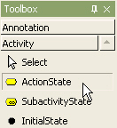
2. And click at the position where ActionState will be placed in the **[main window]**.  
   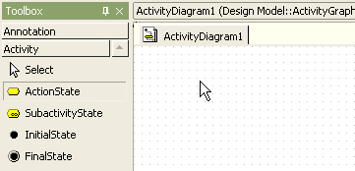
3. A action state is created on the diagram and the quick dialog is shown.  
   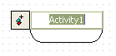
4. Enter the action state name at the quick dialog and press **[Enter]** key. The result is as follows.  
   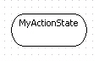

**SubactivityState**

**Semantics**

A subactivity state represents the execution of a non-atomic sequence of steps that has some duration; that is, internally it consists of a set of actions and possibly waiting for  
events. That is, a subactivity state is a “hierarchical action,” where an associated subactivity graph is executed.

**Procedure for creating subactivity state**

In order to create SubactivityState,

1. Click **[Toolbox] -> [Activity] -> [SubactivityState]** button.  
   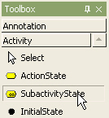
2. And click at the position where SubactivityState will be placed in the **[main window]**. A subactivity state is created and the quick dialog is shown. At the quick dialog, enter the subactivity state name and press **[Enter]** key. The result is as follows.  
   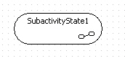

**InitialState**

**Procedure for creating initial state**

In order to create InitialState,

1. Click **[Toolbox] -> [Activity] -> [InitialState]** button.  
   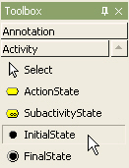
2. And click at the position where InitialState will be placed in the **[main window]**. Then a initial state is created.  
   

**FinalState**

**Procedure for creating final state**

In order to create FinalState,

1. Click **[Toolbox] -> [Activity] -> [FinalState]** button.  
   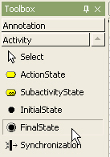
2. And click at the position where FinalState will be placed in the **[main window]**.  
   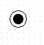

**Decision**

**Semantics**

A state diagram (and by derivation an activity diagram) expresses a decision when guard conditions are used to indicate different possible transitions that depend on Boolean conditions of the owning object.

**Procedure for creating decision**

In order to create Decision,

1. Click **[Toolbox] -> [Activity] -> [Decision]** button.  
   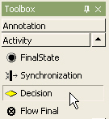
2. And click at the position where Decision will be placed in the **[main window]**. The decision is created on the diagram.  
   

**Procedure for creating decision from state**

In order to create decision with incoming transition from selected object, use shortcut creation syntax.

1. Double-click state. At the quick dialog, enter "-><>"("<-<>" for incoming from decision) string.  
   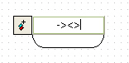
2. Press **[Enter]** key and decision with outgoing transition from selected state is created.  
   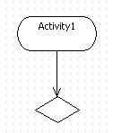

**Flow Final**

**Procedure for creating flow final**

In order to create Flow Final,

1. Click **[Toolbox] -> [Activity] -> [Flow Final]**button.  
   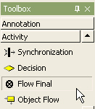
2. And click at the position where Flow Final will be placed in the **[main window]**.  
   

**Object Flow**

**Semantics**

An object flow is one of two types of activity edges, which are directed connection (flows) between activity nodes, the other being a control flow. As soon as the activity node at the source (tail) end of the flow is finished it presents tokens to the object flow at the target (arrowhead) end of the flow. An object flow can only carry object (data) tokens; it cannot carry control tokens. There are rules that specify whether tokens can flow along the object flow and these are determined by the type of activity node at the source and target of the flow. In the case of complete activities an object flow may define a weight, which specifies the minimum number of tokens that must flow along the object flow as a group.

**Procedure for creating object flow**

In order to create Object Flow,

1. Click **[Toolbox] -> [Activity] -> [Object Flow]** button.  
   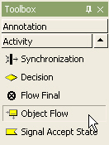
2. And click at the position where Object Flow will be placed in the **[main window]**. Then the quick dialog of object flow state is shown as follows.  
   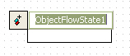
3. At the quick dialog, enter the object flow state name and press **[Enter]** key.  
   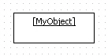

**Synchronization**

**Procedure for creating synchronization bar**

In order to create Synchronization,

1. Click **[Toolbox] -> [Activity] -> [Synchronization]** button.  
   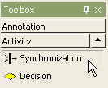
2. And click at the position where Synchronization will be placed in the**[main window]** and drag as size as you want.  
   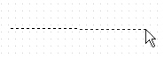
3. The following figure shows the result of this procedure.  
   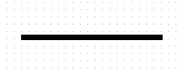

**Signal Accept State**

**Semantics**

The signal accept may be shown as a concave pentagon that looks like a rectangle with a triangular notch in its side (either side). The signature of the signal is shown inside the symbol. An unlabeled transition arrow is drawn from the previous action state to the pentagon and another unlabeled transition arrow is drawn from the pentagon to the next action state. A dashed arrow may be drawn from an object symbol to the notch on the pentagon to show the sender of the signal; this is optional.

**Procedure for creating signal accept state**

In order to create Signal Accept State,

1. Click **[Toolbox] -> [Activity] -> [Signal Accept State]** button.  
   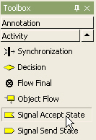
2. And click at the position where Signal Accept State will be placed in the **[main window]**.  
   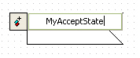
3. At the quick dialog, enter signal accept state name and press**[Enter]**key.  
   

**Signal Send State**

The sending of a signal may be shown as a convex pentagon that looks like a rectangle with a triangular point on one side (either side). The signature of the signal is shown inside the symbol. An unlabeled transition arrow is drawn from the previous action state to the pentagon and another unlabeled transition arrow is drawn from the pentagon to the next action state. A dashed arrow may be drawn from the point on the pentagon to an object symbol to show the receiver of the signal, this is optional.

**Procedure for creating signal send state**

In order to create Signal Send State,

1. Click **[Toolbox] -> [Activity] -> [Signal Send State]** button.  
   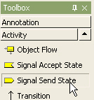
2. And click at the position where Signal Send State will be placed in the [main window]. A signal send state is created and the quick dialog is shown. Enter signal send state name and press **[Enter]** key.  
   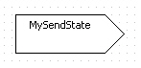

**Transition**

**Procedure for creating transition**

In order to create Transition,

1. Click **[Toolbox] -> [Activity] -> [Transition]**button.  
   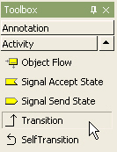
2. Drag and drop between states in transition direction in the **[main window]**.  
   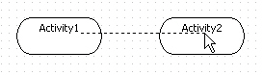
3. Then the transition is created.  
   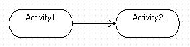

**SelfTransition**

**Procedure for creating self-transition**

In order to create self-transition,

1. Click**[Toolbox] -> [Activity] -> [SelfTransition]**button.  
   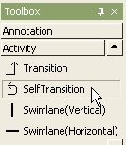
2. Click state to have self-transition in the**[main window]**. Then a self-transition is created.  
   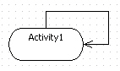

**Swimlane**

**Semantics**

Actions and subactivities may be organized into swimlanes. Swimlanes are used to organize responsibility for actions and subactivities. They often correspond to organizational units in a business model.

**Procedure for creating horizontal swimlane**

In order to create Horizontal Swimlane,

1. Click **[Toolbox] -> [Activity] -> [Horizontal Swimlane]** button.  
   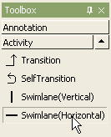
2. And drag the boundary where Horizontal Swimlane will be placed in the **[main window]**.  
   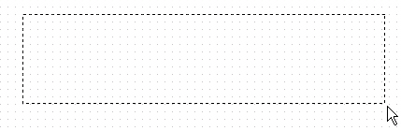
3. Then a horizontal swimlane is created on the diagram. And enter the swimlane name at the quick dialog and press **[Enter]** key.  
   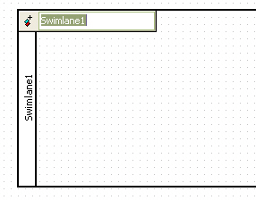

**Procedure for creating vertical swimlane**

In order to create Vertical Swimlane,

1. Click **[Toolbox] -> [Activity] -> [Vertical Swimlane]** button.  
   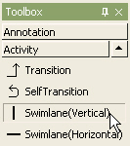
2. And drag the boundary where Vertical Swimlane will be placed in the **[main window]**.  
   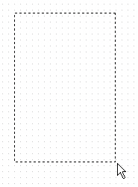
3. A swimlane is created and quick dialog is shown. At the quick dialog, enter the swimlane name and press **[Enter]** to have done this procedure.  
   