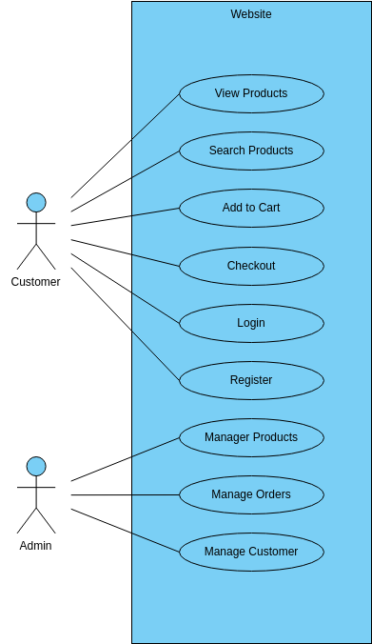

E-commerce website

The E-commerce website is an essential platform for online shopping, providing a range of features that enable customers to browse, purchase, and manage products. The website provides a **user-friendly interface** that makes it easy for customers to find what they are looking for and complete transactions quickly and securely.

One of the primary features of the website is the ability to view products. This feature allows customers to browse a **wide range of products**, including clothing, electronics, and household items. Additionally, the website provides a search function that enables customers to find specific products according to their preferences.

The website also offers the ability to add products to a cart and checkout. Customers can add products to their cart and complete transactions securely using **various payment methods,** such as credit cards, PayPal, and others. This feature ensures that customers can complete transactions quickly and conveniently, without the need to visit a physical store.

Another essential feature of the website is the ability to manage products, orders, and customers. **Website administrators** can manage product information, such as prices, descriptions, and images, ensuring that customers receive up-to-date and accurate information. Additionally, administrators can manage orders and customers, providing support for customers who have questions or issues with their orders.

Finally, the website provides the ability to register and login. Customers can register for an account, providing personal and contact information that enables them to complete transactions quickly and securely. Additionally, customers can login to their accounts, enabling them to manage their orders, track shipments, and view order history.

In conclusion, the **E-commerce website** provides a range of features that enable customers to browse, purchase, and manage products efficiently and effectively. The website supports product viewing and search, cart management, checkout, and account management, providing a seamless experience for customers. The website is designed to be user-friendly and customizable, ensuring that customers can access and manage information according to their needs and preferences. The website also provides valuable insights into customer behavior and transactions, enabling website administrators to make informed decisions and improve customer service.