In python a module means a saved python file. This file can contain a group of classes, methods, functions and variables. Every file with .py or .python extension is called a python file, in turn a module.
Example: Modules in Python (addmultiplication.py)
x = 10
def sum(a, b):
print("Sum of two values: " , (a+b))
def multiplication(a, b):
print("Multiplication of two values: " , (a*b))
Now addmultiplication.py file is a module. addmultiplication.py module contains one variable and two functions.
What is import keyword in python?
If we want to use other members(variable, function, etc) of a module in your program, then you should import that module by using the import keyword. After importing you can access members by using the name of that module.
Example: demo1.py
import addmultiplication
print(addmultiplication.x)
addmultiplication.sum(1, 2)
addmultiplication.multiplication(2, 3)
Output:
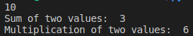
Note: Whenever we are using a module in our program, that module’s compiled file will be generated and stored in the hard disk permanently.
Renaming or Aliasing a module in Python:
The syntax for renaming or giving an alias name for the module
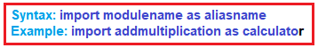
Example: Aliasing module in python (demo2.py)
import addmultiplication as calculator
print(calculator.x)
calculator.sum(1, 2)
calculator.multiplication(3, 4)
Output:
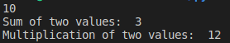
from keyword in python:
We can import some specific members of the module by using the from keyword. The main advantage of the from keyword is we can access members directly without using module names.
Example: from keyword in python (demo3.py)
from add
multiplication import x, sum
print(x)
sum(10,20)
Output:
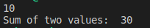
Import * in python:
We can import all members of a module as by using import * (symbol).
Example: import * in python (demo4.py)
from addmultiplication import *
print(x)
sum(10,20)
multiplication(10,20)
Output:
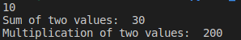
Aliasing members in Python:
We can give alias name to the members of a module as well
Example: Aliasing members of a module in Python (demo5.py)
from addmultiplication import x as y, sum as add
print(y)
add(10,20)
Output:
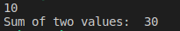
Once an alias name is given, we should use the alias name only and not the original name.
Example: Aliasing members of a module in Python (demo6.py)
from addmultiplication import x as y
print(x)
Output:
Reloading a module in Python:
By default, a module will be loaded only once even though we are importing multiple times. Let’s consider a module with name module1.
Example: Reloading (module1.py)
print(“This is from module1”)
Output:
Example: Reloading in Python (demo7.py)
import module1
import module1
import module1
import module1
print("This is test module")
Output:
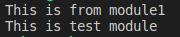
The problem in this approach is if a module is updated outside after loading it in our program, then the updated version of the module will not be available to our program. We can solve this problem by reloading modules explicitly based on our requirement wherever needed. We can reload by using the reload() function of the imp module.
Syntax:
import imp
imp.reload(module1)
Example: demo8.py
import module1
import module1
from imp import reload
reload(module1)
reload(module1)
reload(module1)
print("This is test module")
Output:
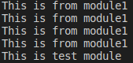
In the above program module1 will be loaded 4 times in that 1 time by default and 3 times explicitly. The main advantage of explicit module reloading is we can ensure that updated versions are always available to our program.
dir() function in Python:
We can find members of a module by using the dir() function. For every module at the time of execution, the Python interpreter will add some special properties automatically for internal use, for example
__name__
__package__
This inbuilt function dir() helps us to list out all members, including those which are included by interpreter, of the current module or a specified module.
- dir() ===> To list out all members of current module
- dir(moduleName) ===> To list out all members of specified module
Example: dir() function in python (demo9.py)
x=10
y=20
def f1():
print("Hello")
print(dir())
Output:
Example: To display members of the specific module in python (demo10.py)
import module1
import addmultiplication
print(dir(module1))
print(dir(addmultiplication))
Output:
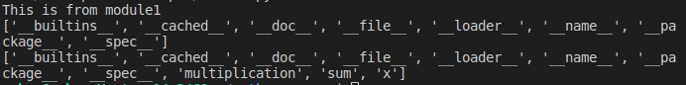
What is a Package in Python?
A package is nothing but a folder or directory which represents a collection of python modules(programs). Any folder or directory, for python to recognize as a package, should contains__init__ .py file. __init__ .py can be an empty file. A package can contain sub-packages also.
Diagrammatic representation of Package in Python:
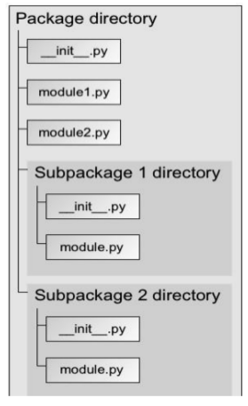
Summary of Modules and Packages in Python
- Library → A group of packages
- Package → A group of modules
- Modules → A group of functions or methods and classes.

Project Structure
ecommerce_app/
│
├── main.py
│
├── ecommerce/
│ ├── __init__.py
│ ├── products.py
│ ├── cart.py
│ └── logger.py
│
└── logs/
└── app.log

1. __init__.py
This makes ecommerce a Python package.
File: ecommerce/__init__.py
print("E-commerce package loaded")

2. Product Module
File: ecommerce/products.py
class Product:
def __init__(self, name, price):
self.name = name
self.price = price
def display_product(self):
print(f"Product: {self.name}")
print(f"Price: ₹{self.price}")

3. Cart Module
File: ecommerce/cart.py
class Cart:
def __init__(self):
self.items = []
def add_to_cart(self, product):
self.items.append(product)
print(f"{product.name} added to cart")
def show_cart(self):
total = 0
print("\nCart Items:")
for item in self.items:
print(f"{item.name} - ₹{item.price}")
total += item.price
print(f"Total Amount: ₹{total}")

4. Logger Module
File: ecommerce/logger.py
import logging
logging.basicConfig(
filename='logs/app.log',
level=logging.INFO,
format='%(asctime)s - %(levelname)s - %(message)s'
)
def log_message(message):
logging.info(message)

5. Main File
File: main.py
from ecommerce.products import Product
from ecommerce.cart import Cart
from ecommerce.logger import log_message
def main():
# Create products
p1 = Product("Laptop", 50000)
p2 = Product("Mouse", 1000)
# Display products
p1.display_product()
p2.display_product()
# Create cart
cart = Cart()
# Add products
cart.add_to_cart(p1)
log_message("Laptop added to cart")
cart.add_to_cart(p2)
log_message("Mouse added to cart")
# Show cart
cart.show_cart()
log_message("Cart displayed successfully")
# Run module as script
if __name__ == "__main__":
main()

How to Run
Open terminal inside ecommerce_app folder:
python main.py

Output Example
E-commerce package loaded
Product: Laptop
Price: ₹50000
Product: Mouse
Price: ₹1000
Laptop added to cart
Mouse added to cart
Cart Items:
Laptop - ₹50000
Mouse - ₹1000
Total Amount: ₹51000

Log File Output (logs/app.log)
2026-05-15 11:30:10,123 - INFO - Laptop added to cart
2026-05-15 11:30:10,124 - INFO - Mouse added to cart
2026-05-15 11:30:10,125 - INFO - Cart displayed successfully

Concepts Used
Concept | Used In
Package | ecommerce/
__init__.py | Package initialization
Class | Product, Cart
Function | log_message()
Logging | logging module
Module Import | from ecommerce...

