**Singleton**

**Intent**

**Singleton** is a creational design pattern that lets you ensure that a class has only one instance, while providing a global access point to this instance.

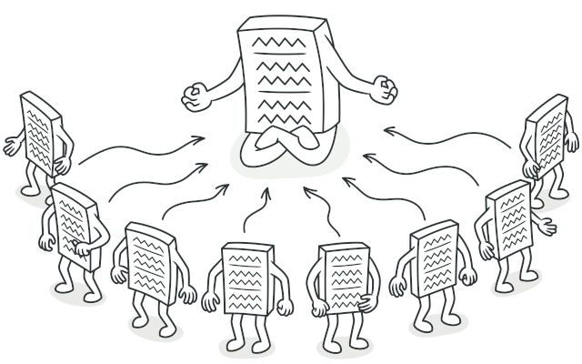

**Problem**

The Singleton pattern solves two problems at the same time, violating the *Single Responsibility Principle*:

1. **Ensure that a class has just a single instance**. Why would anyone want to control how many instances a class has? The most common reason for this is to control access to some shared resource—for example, a database or a file.

Here’s how it works: imagine that you created an object, but after a while decided to create a new one. Instead of receiving a fresh object, you’ll get the one you already created.

Note that this behavior is impossible to implement with a regular constructor since a constructor call **must** always return a new object by design.

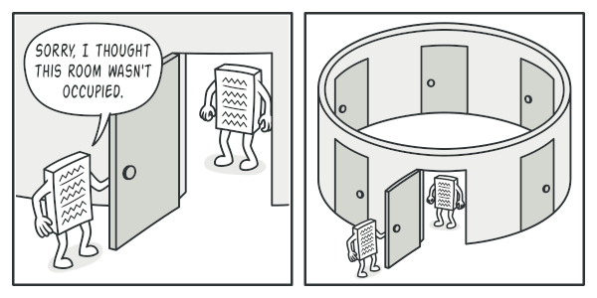

Clients may not even realize that they’re working with the same object all the time.

1. **Provide a global access point to that instance**. Remember those global variables that you (all right, me) used to store some essential objects? While they’re very handy, they’re also very unsafe since any code can potentially overwrite the contents of those variables and crash the app.

Just like a global variable, the Singleton pattern lets you access some object from anywhere in the program. However, it also protects that instance from being overwritten by other code.

There’s another side to this problem: you don’t want the code that solves problem #1 to be scattered all over your program. It’s much better to have it within one class, especially if the rest of your code already depends on it.

Nowadays, the Singleton pattern has become so popular that people may call something a *singleton* even if it solves just one of the listed problems.

**Solution**

All implementations of the Singleton have these two steps in common:

* Make the default constructor private, to prevent other objects from using the new operator with the Singleton class.
* Create a static creation method that acts as a constructor. Under the hood, this method calls the private constructor to create an object and saves it in a static field. All following calls to this method return the cached object.

If your code has access to the Singleton class, then it’s able to call the Singleton’s static method. So whenever that method is called, the same object is always returned.

**Real-World Analogy**

The government is an excellent example of the Singleton pattern. A country can have only one official government. Regardless of the personal identities of the individuals who form governments, the title, “The Government of X”, is a global point of access that identifies the group of people in charge.

**Structure**

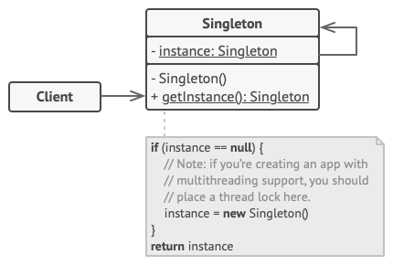

1. The **Singleton** class declares the static method getInstance that returns the same instance of its own class.

The Singleton’s constructor should be hidden from the client code. Calling the getInstance method should be the only way of getting the Singleton object.

# Builder

## Intent

**Builder** is a creational design pattern that lets you construct complex objects step by step. The pattern allows you to produce different types and representations of an object using the same construction code.

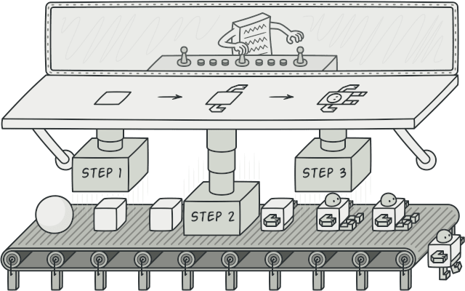

## Problem

Imagine a complex object that requires laborious, step-by-step initialization of many fields and nested objects. Such initialization code is usually buried inside a monstrous constructor with lots of parameters. Or even worse: scattered all over the client code.

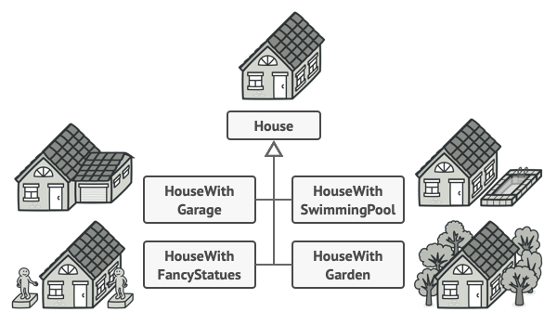

You might make the program too complex by creating a subclass for every possible configuration of an object.

For example, let’s think about how to create a House object. To build a simple house, you need to construct four walls and a floor, install a door, fit a pair of windows, and build a roof. But what if you want a bigger, brighter house, with a backyard and other goodies (like a heating system, plumbing, and electrical wiring)?

The simplest solution is to extend the base House class and create a set of subclasses to cover all combinations of the parameters. But eventually you’ll end up with a considerable number of subclasses. Any new parameter, such as the porch style, will require growing this hierarchy even more.

There’s another approach that doesn’t involve breeding subclasses. You can create a giant constructor right in the base House class with all possible parameters that control the house object. While this approach indeed eliminates the need for subclasses, it creates another problem.

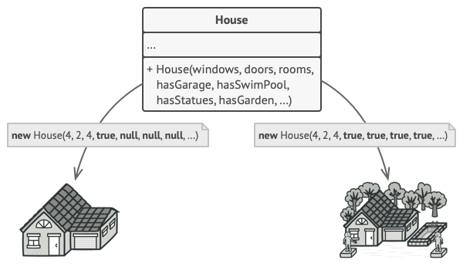

The constructor with lots of parameters has its downside: not all the parameters are needed at all times.

In most cases most of the parameters will be unused, making [**the constructor calls pretty ugly**](https://refactoring.guru/smells/long-parameter-list). For instance, only a fraction of houses have swimming pools, so the parameters related to swimming pools will be useless nine times out of ten.

## Solution

The Builder pattern suggests that you extract the object construction code out of its own class and move it to separate objects called builders.

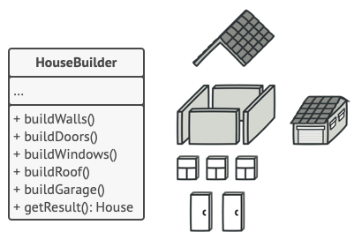

The Builder pattern lets you construct complex objects step by step. The Builder doesn’t allow other objects to access the product while it’s being built.

The pattern organizes object construction into a set of steps (buildWalls, buildDoor, etc.). To create an object, you execute a series of these steps on a builder object. The important part is that you don’t need to call all of the steps. You can call only those steps that are necessary for producing a particular configuration of an object.

Some of the construction steps might require different implementation when you need to build various representations of the product. For example, walls of a cabin may be built of wood, but the castle walls must be built with stone.

In this case, you can create several different builder classes that implement the same set of building steps, but in a different manner. Then you can use these builders in the construction process (i.e., an ordered set of calls to the building steps) to produce different kinds of objects.

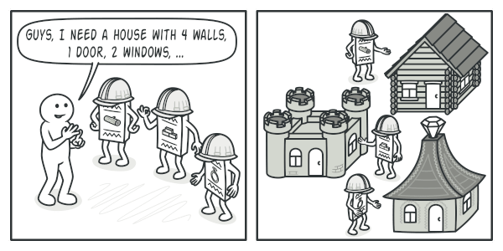

Different builders execute the same task in various ways.

For example, imagine a builder that builds everything from wood and glass, a second one that builds everything with stone and iron and a third one that uses gold and diamonds. By calling the same set of steps, you get a regular house from the first builder, a small castle from the second and a palace from the third. However, this would only work if the client code that calls the building steps is able to interact with builders using a common interface.

#### Director

You can go further and extract a series of calls to the builder steps you use to construct a product into a separate class called director. The director class defines the order in which to execute the building steps, while the builder provides the implementation for those steps.

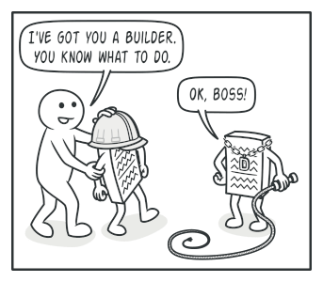

The director knows which building steps to execute to get a working product.

Having a director class in your program isn’t strictly necessary. You can always call the building steps in a specific order directly from the client code. However, the director class might be a good place to put various construction routines so you can reuse them across your program.

In addition, the director class completely hides the details of product construction from the client code. The client only needs to associate a builder with a director, launch the construction with the director, and get the result from the builder.

## Structure

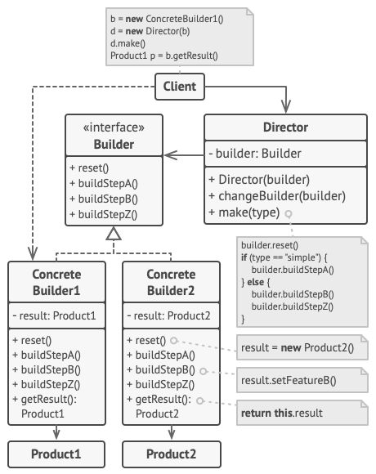

1. The **Builder** interface declares product construction steps that are common to all types of builders.
2. **Concrete Builders** provide different implementations of the construction steps. Concrete builders may produce products that don’t follow the common interface.
3. **Products** are resulting objects. Products constructed by different builders don’t have to belong to the same class hierarchy or interface.
4. The **Director** class defines the order in which to call construction steps, so you can create and reuse specific configurations of products.
5. The **Client** must associate one of the builder objects with the director. Usually, it’s done just once, via parameters of the director’s constructor. Then the director uses that builder object for all further construction. However, there’s an alternative approach for when the client passes the builder object to the production method of the director. In this case, you can use a different builder each time you produce something with the director.

**Factory Method**

**Also known as:**Virtual Constructor

**Intent**

**Factory Method** is a creational design pattern that provides an interface for creating objects in a superclass, but allows subclasses to alter the type of objects that will be created.

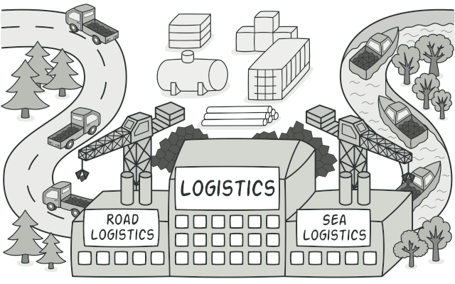

**Problem**

Imagine that you’re creating a logistics management application. The first version of your app can only handle transportation by trucks, so the bulk of your code lives inside the Truck class.

After a while, your app becomes pretty popular. Each day you receive dozens of requests from sea transportation companies to incorporate sea logistics into the app.

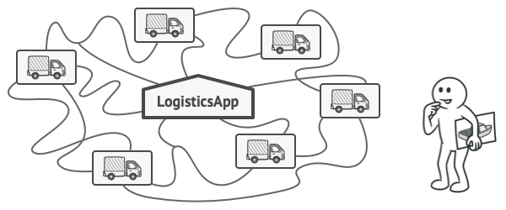

Adding a new class to the program isn’t that simple if the rest of the code is already coupled to existing classes.

Great news, right? But how about the code? At present, most of your code is coupled to the Truck class. Adding Ships into the app would require making changes to the entire codebase. Moreover, if later you decide to add another type of transportation to the app, you will probably need to make all of these changes again.

As a result, you will end up with pretty nasty code, riddled with conditionals that switch the app’s behavior depending on the class of transportation objects.

**Solution**

The Factory Method pattern suggests that you replace direct object construction calls (using the new operator) with calls to a special *factory* method. Don’t worry: the objects are still created via the new operator, but it’s being called from within the factory method. Objects returned by a factory method are often referred to as *products.*

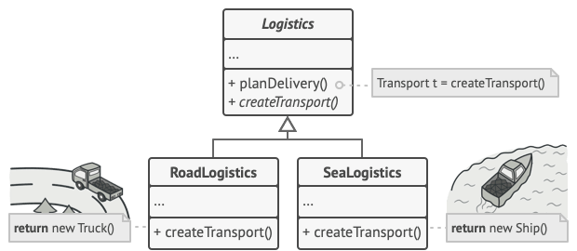

Subclasses can alter the class of objects being returned by the factory method.

At first glance, this change may look pointless: we just moved the constructor call from one part of the program to another. However, consider this: now you can override the factory method in a subclass and change the class of products being created by the method.

There’s a slight limitation though: subclasses may return different types of products only if these products have a common base class or interface. Also, the factory method in the base class should have its return type declared as this interface.

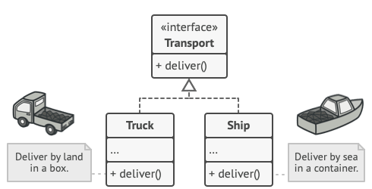

All products must follow the same interface.

For example, both Truck and Ship classes should implement the Transport interface, which declares a method called deliver. Each class implements this method differently: trucks deliver cargo by land, ships deliver cargo by sea. The factory method in the RoadLogistics class returns truck objects, whereas the factory method in the SeaLogistics class returns ships.

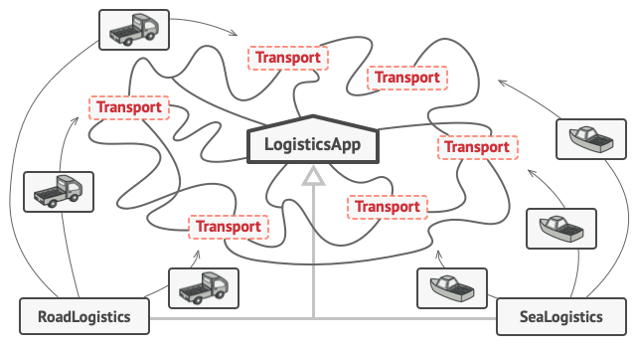

As long as all product classes implement a common interface, you can pass their objects to the client code without breaking it.

The code that uses the factory method (often called the *client* code) doesn’t see a difference between the actual products returned by various subclasses. The client treats all the products as abstract Transport. The client knows that all transport objects are supposed to have the deliver method, but exactly how it works isn’t important to the client.

**Structure**

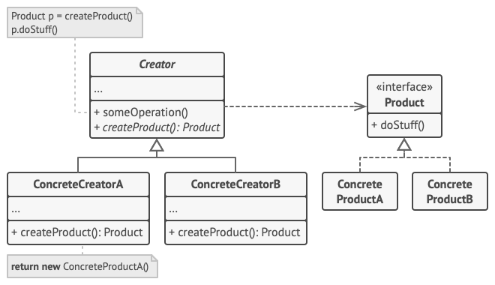

1. The **Product** declares the interface, which is common to all objects that can be produced by the creator and its subclasses.
2. **Concrete Products** are different implementations of the product interface.
3. The **Creator** class declares the factory method that returns new product objects. It’s important that the return type of this method matches the product interface.

You can declare the factory method as abstract to force all subclasses to implement their own versions of the method. As an alternative, the base factory method can return some default product type.

Note, despite its name, product creation is **not** the primary responsibility of the creator. Usually, the creator class already has some core business logic related to products. The factory method helps to decouple this logic from the concrete product classes. Here is an analogy: a large software development company can have a training department for programmers. However, the primary function of the company as a whole is still writing code, not producing programmers.

1. **Concrete Creators** override the base factory method so it returns a different type of product.

Note that the factory method doesn’t have to **create** new instances all the time. It can also return existing objects from a cache, an object pool, or another source.