Steps to Design JDBC Applications in Java:
Let us understand how to perform CRUD operations in Java Applications using JDBC step by step. The following diagram shows the different steps required to develop a JDBC application in Java.
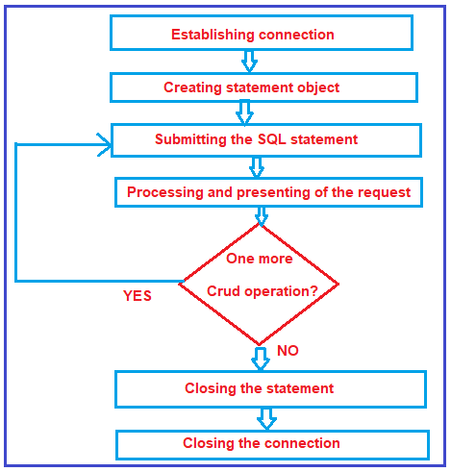
Let us discuss each step in detail.
Establishing Connection:
In the JDBC programming model, the first step is to establish the connection between the java application and the database server. Establishing the database connection in a java program involves two steps
Step1. Loading JDBC driver from secondary memory into primary memory.
First, you need to load the driver or register it before using it in the program. Registration is to be done once in your program. In java.lang.Class class, there is a static method “forName”. This method is used to load the JDBC driver into the application process space.
Syntax: public static void forName(String className) throws ClassNotFoundException
You can register the Driver by following two ways :
- Class.forName(“driver class name”) : Here we load the driver’s class file into memory at the runtime. No need of using new or creation of objects.
- DriverManager.registerDriver(): DriverManager is a Java inbuilt class with a static member register. Here we call the constructor of the driver class at compile time.
When the forName() method is successfully executed, three things happen in the background
- The driver class is loaded into memory.
- The driver class object is created.
- The driver class is registered with DriverManager.
Step2.Requesting for database connection
In order to establish a communication with the database, you must first open a JDBC connection to the database. After loading the driver, establish a connection. In java.sql.DriverManager class there is a static method “getConnection”. This method is used by the java program to request the database connection. Following are three methods of DriverManager.getConnection() :
- getConnection(String url)
- getConnection(String url, Properties prop)
- getConnection(String url, String user, String password)
Syntax :
public static Connection getConnection(String url,String name,String password) throws SQLException
Example:
Connection con = DriverManager.getConnection(“connection string”, “user name”, “password”);
Once the above statement is executed, the client connects to the database server. Object-oriented representation of JDBC client’s session with the database server is nothing but java.sql.Connection object.
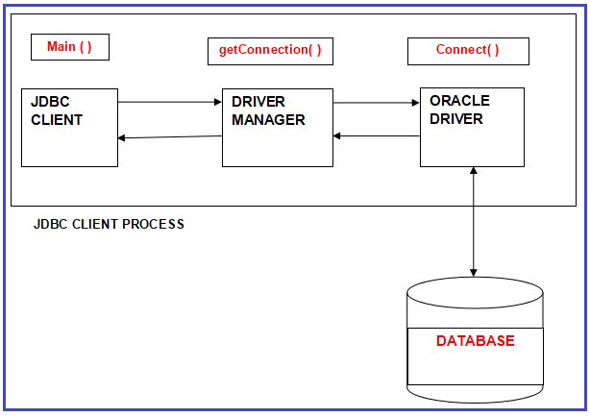
Note: Internally getConnection() method call connect method of connection class.
Creating Statement Object:
Once a connection is established you can interact with the database. The createStatement() method of the Connection interface is used to create a statement. The object of the statement is responsible to execute queries with the database.
Syntax : public Statement createStatement()throws SQLException
Example: Statement st = con.createStatement();
The Statement object is designed to submit SQL statements from the JDBC client to the DBMS (via JDBC driver).
Submitting the SQL Statement:
Now its time to process the result by executing the query. The java.sql.Statement object has two important methods to submit SQL statements to the DBMS
- executeUpdate(String dml):– The executeUpdate(SQL query) method of Statement interface is used to execute queries of updating/inserting. This method is used to submit DML (INSERT, UPDATE, and DELETE) SQL statements.
- executeQuery (String drl):– The executeQuery() method of the Statement interface is used to execute queries to the database. This method returns the object of ResultSet that can be used to get all the records of a table. This method is used to submit the SELECT statement.
Syntax : public ResultSet executeQuery(String sql) throws SQLException
Close the Connection
So finally we have sent the data to the specified location. By closing the connection object statement and ResultSet will be closed automatically. The close() method of the Connection interface is used to close the connection.
Syntax : public void close()throws SQLException
Let us understand the above-discussed steps with an example. We are going to interact with Oracle Database.
Database Connectivity with Oracle
To connect the java application with the oracle database, we need to know the following information for the oracle database:
- Driver class: The driver class for the oracle database is oracle.jdbc.driver.OracleDriver.
- Connection URL: The connection URL for the oracle10G database is jdbc:oracle:thin:@localhost:1521:xe where JDBC is the API, Oracle is the database, thin is the driver, localhost is the server name on which oracle is running, we may also use the IP address, 1521 is the port number and XE is the Oracle service name. You may get all this information from the tnsnames.ora file.
- Username: The default username for the oracle database is the system.
- Password: It is the password given by the user at the time of installing the oracle database.
Create a Table
Before establishing a connection, first, we need to create a table in the oracle database. Please execute the below SQL query to create a table:
CREATE TABLE ACCOUNT (accnonumber(8) primary key, name varchar2(12), balance number(8,2));
Sample Program to connect with Oracle database
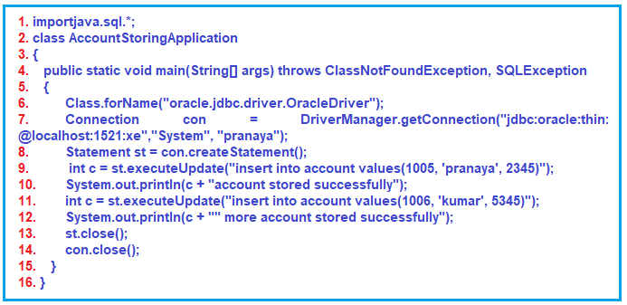
Code Explanation:
Line1: By importing the java.sql package, JDBC API is made available to the JDBC application.
Line2: A user-defined class “AccountStoringApplication” is defined here.
- This JDBC application is a standalone application.
- Every standalone application should have a main method in java.
- To encapsulate the main method, the class “AccountStoringApplication ” is defined here.
Line 4 & 5: the main method is defined as is standalone JDBC application.
Within the main method body during the forName() method call there is a chance of java.lang.ClassNotFoundException raising. During other JDBC API calls, there is a chance of java.sql.SQLException getting raised. These are checked exceptions. These checked exceptions must be handled. Non-handling of checked exceptions in a java application is a syntactical error.
To pass (temporarily handled) on the exception handling duty to the higher level and at the same to overcome the compilation error, a throws clause is written for the main method.
Line6:
The main method is calling forName() method on the Class(name of the class) class by specifying oracle corporation developed TYPE- 4 driver class as an argument. The forName() method loads the oracle driver class from secondary memory into primary memory.
In OracleDriver class (in fact in every driver class) there is a static block. In that block, two things are performed
- Driver class object creation.
- Registering it with DriverManager
Static
{
OracleDriver d = new OracleDriver();
DriverManager.registerDriver(d);
}
If the specified driver class is not found at the specified location, the forName() method causes ClassNotFoundException. In the case of OracleDriver, we need to place any one of the following jar files into the classpath.
- classes12.jar
- ojdbc14.jar
- jdbc5.jar
- ojdbc.jar
For example: set CLASSPATH = .;\ojdbc14.jar
Here dot (.) represent the current directory.
Line7:
The main method is calling the getConnection() method on DriverManager class by supplying the connection string as the first argument, username as the second, and password as the third argument. (Username and password are the database user name and password).
The connection string is “jdbc:oracle:thin:@localhost:1521:xe”
Here,
- jdbc = main protocol
- oracle = sub protocol
- thin = type of driver (here type 4)
- localhost = IP address of the current machine
- 1521 = port number
- xe = database service name.
Note: port number and database service name we have to check in the “tnsnames.ora” file
Line 8 & 9:
Creating a Statement object and executing the SQL statement against the Oracle database.
Line 13 & 14:
Closing the statement and connection object.
Note: For the insert, update, and delete operations, the DBMS returns an integer number. In the case of INSERT if the record is successfully inserted into the database then DBMS returns 1. In the case of UPDATE if the record is successfully updated then it returns the no i.e. updated number of records. And in the case of DELETE, it returns 1 if the successful record is deleted else it returns 0.
Connection Interface in JDBC
The java.sql.Connection interface represents a session between a java application and a database. All SQL statements are executed and results are returned within the context of a Connection Object. The connection interface is mainly used to create java.sql.statement, java.sql.PreparedStatement and java.sql.CallableStatement objects.
For example :
Class.forName(“sun.jdbc.odbc.JdbcOdbcDriver”);
Connection con = DriverManager.getConnection(“dbc:odbc:DSN”);
Methods of Connection Interface
- public Statement CreateStatement(): creates a statement object that can be used to execute SQL queries.
- public Statement createStatement(int resultSetType, int resultSetConcurrency): creates a statement object that will generate ResultSet objects with the given type and concurrency.
- public void setAutoCommit(boolean status): is used to set the commit status. By default it is true.
- public void comit(): saves the changes made since the previous commit/rollback permanent.
- public void rollback(): Drops all changes made since the previous commit/rollback.
- public void close(): closes the connection and releases JDBC resources immediately.
Statement Interface in JDBC
Once a connection is obtained we can interact with the database. The JDBC Statement, CallableStatement, and PreperedStatement interface define the methods and properties that enable you to send SQL or PL/SQL commands and receive data from your database. They also define methods that help bridge data type differences between Java and SQL data types used in a database.
Methods of Statement Interface
- public ResultSet executeQuery(String sql): is used to execute the SELECT query. It returns the object of ResultSet.
- public int executeUpdate(String sql): is used to execute the specified query, it may be created, drop, insert, update, delete, etc.
- public Boolean execute(String sql): is used to execute queries that may return multiple results.
- public int[] executeBatch() : is used to execute batch of commands.

JDBC Architecture:
In order to understand the JDBC Architecture, please have a look at the following image.
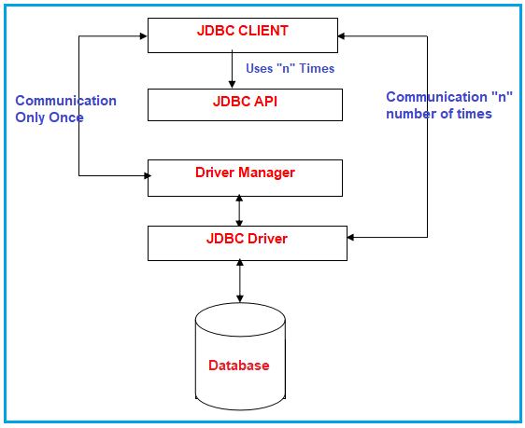
Components of JDBC
JDBC architecture is a client-server architecture. JDBC architecture has 5 elements.
- JDBC client: Here JDBC Client is nothing but a java application that wants to communicate with the database.,
- JDBC API: To write a java program that communicates with any database without changing the code Sun Microsystem has released JDBC API. By JDBC API implementation we can call JDBC Driver.
- JDBC Driver: It is a java application that acts as an interface between java applications and databases. It understands the given java calls and converts them into database calls and vice-versa.
- JDBC Driver Manager: It acts as a data structure that collects a group of JDBC Drivers and allows the programmer to select the driver dynamically for the database connection.
- Database Server: It is nothing but the Database server like Oracle, MySQL, SQL Server, etc. with which the JDBC client wants to communicate.
Let us discuss each of the above components in detail.
JDBC client:
In the context of client-server architecture, the resource which makes the request is nothing but a client. Any java application i.e. communicating with the database using JDBC is nothing but a JDBC client or we can say JDBC application.
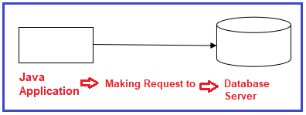
So the java program is the client. JDBC CLIENT has the following responsibility while communicating with the database.
- Requesting for the database connection.
- Submitting the appropriate SQL statements to the DBMS.
- Dealing with the exception
- Making transactions whenever required.
- Closing the connection.
JDBC API:
API (Application Programming Interface) is nothing but a collection of library methods. Library classes and interfaces contain library methods and these library classes and interfaces are present inside some predefined packages. Packages are just like a folder that contains files.
A collection of library methods of library interfaces and classes of java.sql and javax.sql packages using which database operations are performed in a JDBC application is nothing but a JDBC API.
Java.sql: It is used for advanced operations of the database, i.e., Connection pooling.
Javax.sql: Provides the API for server-side data source access and processing from the Java programming language.
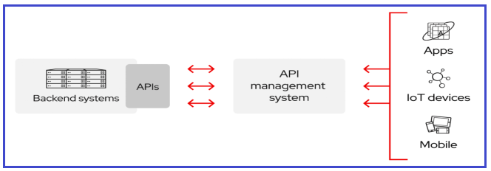

Note: API is a template or model or specification or documentation. Once an API is released then anybody can provide the implementation. API is not a software that cannot be used directly for development. We have to use the implementation of API for the development of any application. This implementation of API is called Software.
We have the following two types of API :
- Public API: Public API means anybody can implement it.
- Proprietary API: Proprietary API means the particular company that released this API can implement it.
What does API contain?
API contains a collection of classes and interfaces in the case of java related APIs but any C or C++-related APIs contain a collection of library functions. Java people have released JSP API as a public API so that anybody can implement this API and already companies like IBM, BEA, SUN, etc. are implementing this JSE API.
Understanding java.sql package
This package provides the APIs for accessing and processing data that is stored in the database especially relational databases by using the java programming language. It includes a framework where different drivers can be installed dynamically to access different databases, especially relational databases.
This java.sql package contains API for the following:
- Making a connection with a database with the help of DriverManager class
- Sending SQL parameters to a database
- Updating and retrieving the results of a query
- Providing Standard mappings for SQL types to classes and interfaces in Java programming language.
- Metadata
- Exceptions
- Custom mapping an SQL user-defined type (UDT) to a class in the java programming language.
Driver Manager:
Driver Manager is the database connection provider to the JDBC client. JDBC client requests a Driver Manager for the database connection. Driver Manager is not the database connection creator. It receives the connection request from the java application(JDBC CLIENT)and passes that connection request to JDBC Driver.
JDBC Driver creates the connection and passes that connection to the JDBC client via Driver Manager. Once the java application connects to the database server, Driver Manager rolls the end that is Driver Manager doesn’t participate in the database connection.
Let’s get into the details of the JDBC Driver Manager.
The JDBC Driver Manager is a very important class that defines objects which connect Java applications to a JDBC driver. Usually, the Driver Manager is the backbone of the JDBC architecture. It’s very simple and small that is used to provide a means of managing the different types of JDBC database drivers running on an application. The main responsibility of the JDBC database is to load all the drivers found in the system properly as well as to select the most appropriate driver from opening to a database. The Driver Manager also helps to select the most appropriate driver from the previously loaded drivers when a new open database is connected.
The Driver Manager class works between the user and the drivers. The task of the Driver Manager class is to keep track of the drivers that are available and handles establishing a connection between a database and the appropriate driver. It even keeps track of the driver login time limits and printing of log and tracing messages. This class is mainly useful for the simple application, the most frequently used method of this class is DriverManager.getConnection(). We can know by the name of the method that this method establishes a connection to a database.
The Driver Manager class maintains the list of the Driver classes. Each driver has to be get registered in the DriverManager class by calling the method DriverManager.registerDriver().
By calling the Class.forName() method the driver class gets automatically loaded. The driver is loaded by calling the Class.forName() method. JDBC drivers are designed to tell the DriverManager about themselves automatically when their driver implementation class gets loads.
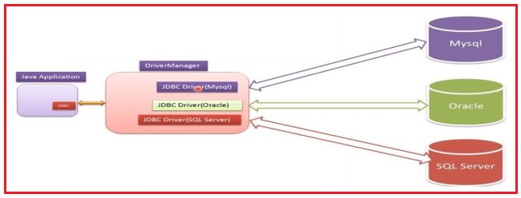
This class has many methods. Some of the commonly used methods are given below:
- deregisterDriver(Driver driver): It drops the driver from the list of drivers registered in the DriverManager class.
- registerDriver(Driver driver): It registers the driver with the DriverManager class.
- getConnection(String url): It tries to establish the connection to a given database URL.
- getConnection(String url, String user, String password): It tries to establish the connection to a given database URL.
- getConnection(String url, Properties info): It tries to establish the connection to a given database URL.
- getDriver(String url): It attempts to locate the driver by the given string.
- getDrivers(): It retrieves the enumeration of the drivers who have been registered with the DriverManager class.
JDBC Driver:
JDBC driver is a translation software written in java language according to JDBC specifications. JDBC drivers perform the following duties
- Establishing the database connection for the JDBC client with the database server.
- Receiving the JDBC method calls from the JDBC client, translating it into DBMS understandable format, and passing on the same to the database server.
- Receiving the response from the DBMS, translating it into java format, and passing on the same to the java client.
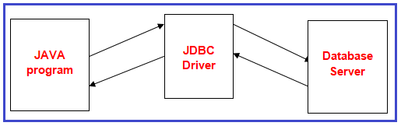
JDBC compliant drivers are used in java enterprise applications for back-end communication. There is 180+ drivers but all these drivers could be classified into the following four types :
- JDBC-ODBC bridge driver (TYPE-1)
- Native API, partly java driver (TYPE-2)
- Net protocol, All java driver(TYPE-3)
- Native protocol, All java driver (TYPE-4)
Note: In the next article, we will discuss each of the above drivers in detail with their own advantages and disadvantages.
Database Server:
In almost all the cases in a java enterprise application RDBMS implementation is used as a database server. For example. Oracle, MySQL, SQL Server, Sybase, DB2, Informix, etc

