- Student Admission Management System
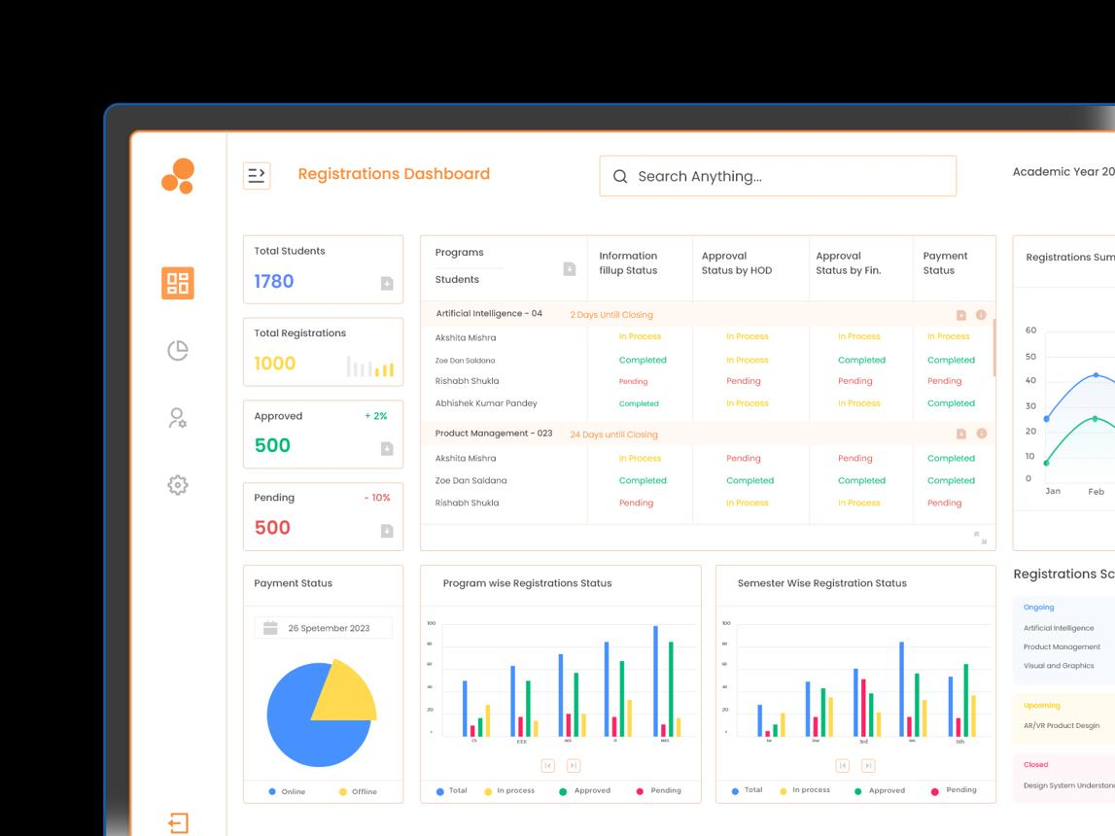
Use case: Engineering college admission process
Member 1 – Java Fundamentals and OOP
- Create a Student class with fields, constructors, getters and setters.
- Validate student age, marks and course eligibility.
- Demonstrate inheritance and method overriding.
Member 2 – Collections, Data Structures and File Handling
- Store student records using ArrayList and HashMap.
- Search students by application ID or name.
- Save student records to a file and handle exceptions.
Member 3 – HTML, CSS, Spring Boot and REST API
- Design an admission form using HTML and CSS.
- Create REST endpoints to register and view students.
- Use a Spring Boot controller and service layer.
Member 4 – SQL, JDBC and DevOps
- Store admission records in MySQL.
- Demonstrate insert, select, update and delete operations using JDBC.
- Explain Git, build, testing and Docker deployment.
Final demonstration: Register a student, check eligibility, save the record and search for the application.

2. Food Delivery Management System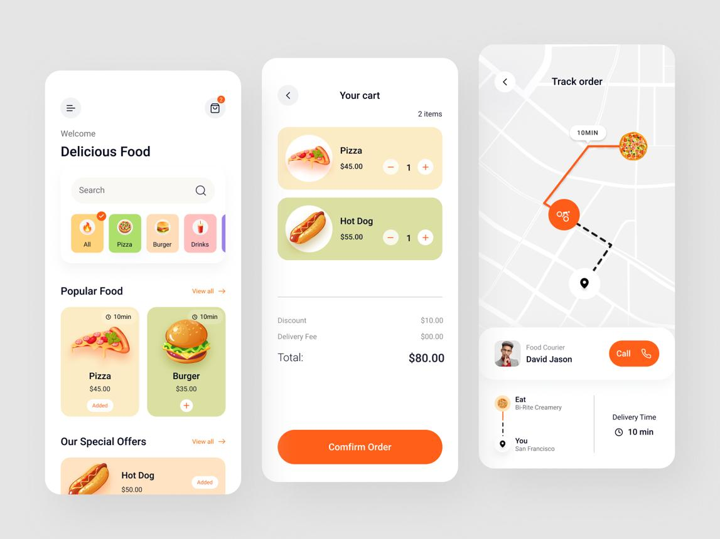
Use case: Online restaurant ordering and delivery
Member 1 – Java Fundamentals and OOP
- Create Customer, Restaurant, FoodItem and Order classes.
- Calculate the bill, taxes and delivery charges.
- Use method overloading and exception handling.
Member 2 – Collections and Data Structures
- Maintain the food menu using ArrayList.
- Use a queue to process incoming orders.
- Search menu items by name and category.
Member 3 – HTML, CSS and Spring Boot
- Create a food menu, cart and order form.
- Build REST APIs to place and track orders.
- Demonstrate GET, POST, PUT and DELETE.
Member 4 – SQL, JDBC and DevOps
- Create Customer, FoodItem and Orders tables.
- Save orders and update order status.
- Explain Git, Maven, testing and Docker.
Final demonstration: Select food, place an order, calculate the bill and track the order status.

3. Banking Account and Transaction Management System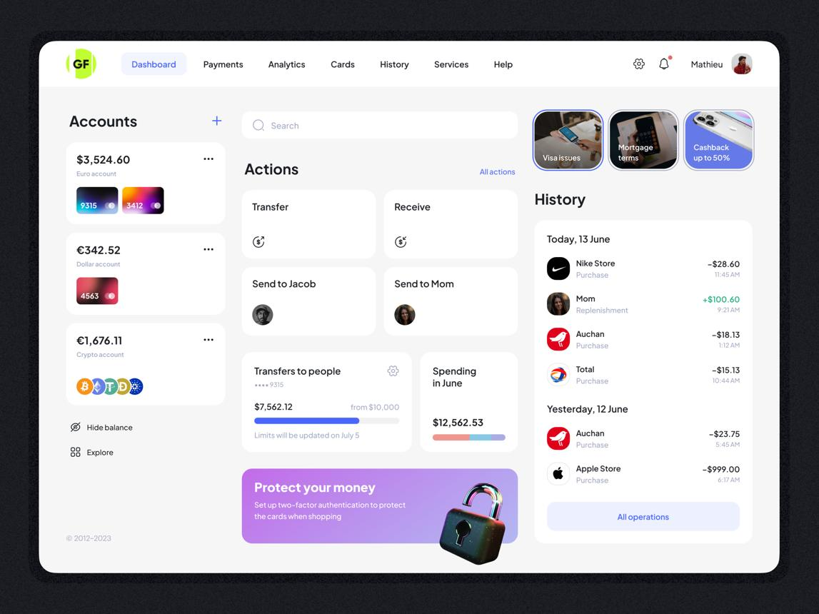
Use case: Basic banking operations
Member 1 – Java Fundamentals and OOP
- Create an Account class with account number and balance.
- Implement deposit, withdrawal and balance enquiry.
- Demonstrate encapsulation, inheritance and polymorphism.
Member 2 – Collections, Algorithms and Exceptions
- Store accounts in a HashMap.
- Search accounts using account number.
- Handle insufficient balance and invalid transactions.
Member 3 – HTML, CSS and REST API
- Design a banking form for deposits and withdrawals.
- Create APIs for account creation and transaction history.
- Return appropriate HTTP status codes.
Member 4 – SQL, JDBC and DevOps
- Create Accounts and Transactions tables.
- Use JDBC transactions to maintain data consistency.
- Explain version control, automated builds and deployment.
Final demonstration: Create an account, deposit money, withdraw money and view the transaction history.

4. Employee Management and Payroll System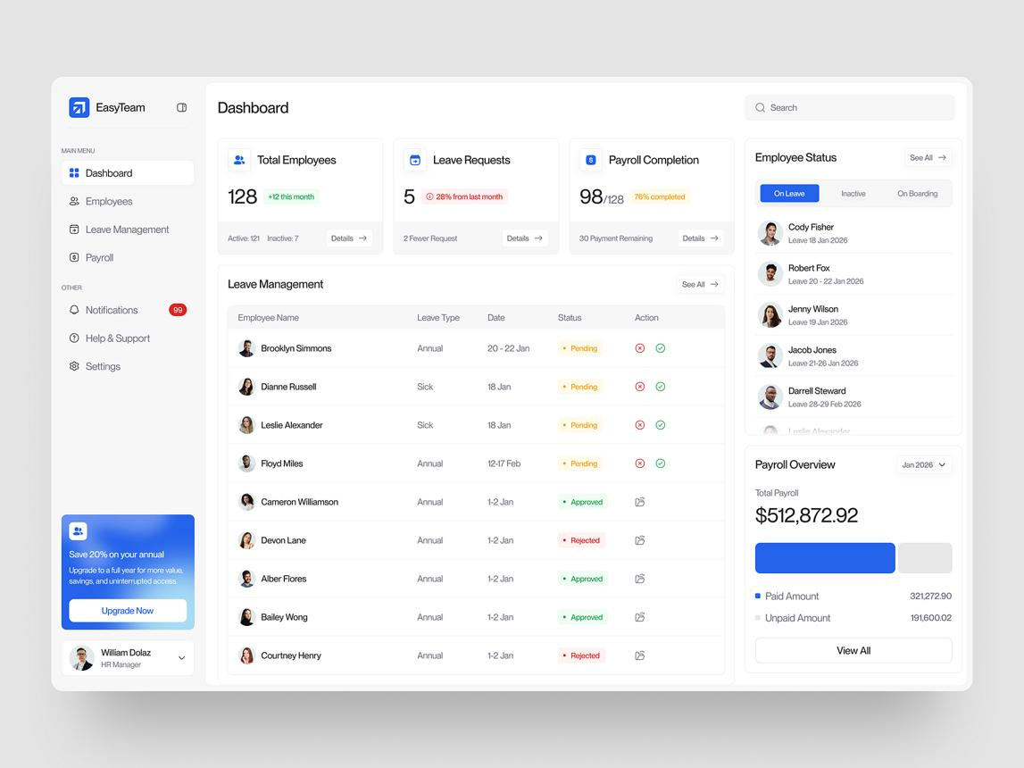
Use case: Company HR and salary processing
Member 1 – Java Fundamentals and OOP
- Create Employee, Developer and Manager classes.
- Calculate salary, bonus and deductions using methods.
- Demonstrate constructors and method overriding.
Member 2 – Collections and File Handling
- Maintain employee records using collections.
- Search employees by ID or department.
- Export employee reports to a file and handle exceptions.
Member 3 – HTML, CSS and Spring Boot
- Build an employee registration form.
- Create APIs for employee CRUD operations.
- Separate controller, service and model layers.
Member 4 – SQL, JDBC and DevOps
- Create Employee and Department tables.
- Store and update employee salary information.
- Explain Maven builds, Git and Docker deployment.
Final demonstration: Add an employee, calculate salary, update employee information and generate a report.

5. E-Commerce Product and Order Management System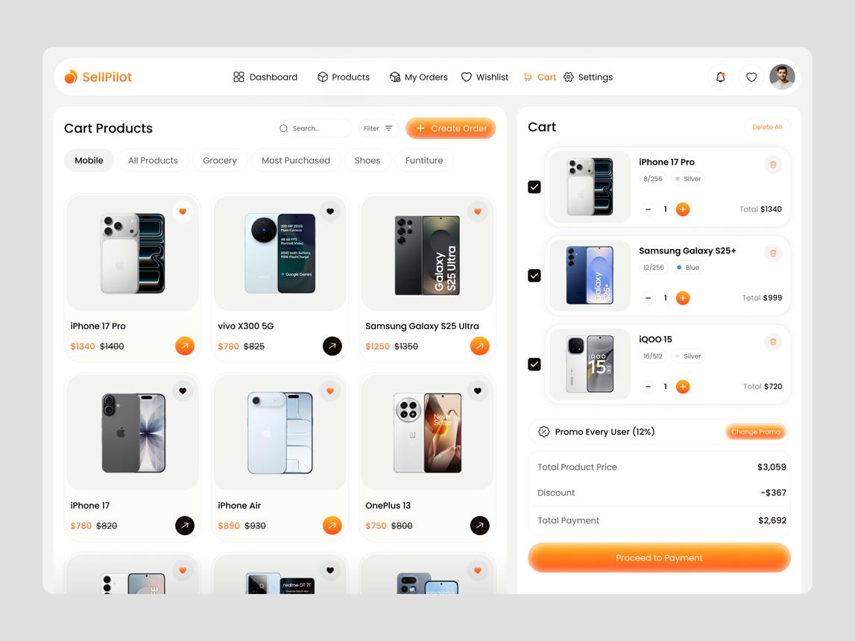
Use case: Online shopping platform
Member 1 – Java Fundamentals and OOP
- Create Product, Customer, Cart and Order classes.
- Calculate totals and discounts.
- Use inheritance and method overloading.
Member 2 – Collections and Data Structures
- Store products using ArrayList and HashMap.
- Use a queue to represent order processing.
- Implement product search and sorting.
Member 3 – HTML, CSS and Spring Boot
- Build a product catalogue and shopping cart page.
- Create product and order REST APIs.
- Demonstrate request parameters and JSON responses.
Member 4 – SQL, JDBC and DevOps
- Create Products, Customers and Orders tables.
- Implement CRUD operations and order persistence.
- Explain testing, Git, Maven and Docker.
Final demonstration: Search a product, add it to the cart, place an order and view the saved order.

