List of Docker Commands

* Build an image from the Dockerfile in the current directory and tag the image

|  |
| --- |
| docker build -t myimage:1.0 |

List all Docker images

|  |
| --- |
| docker images |

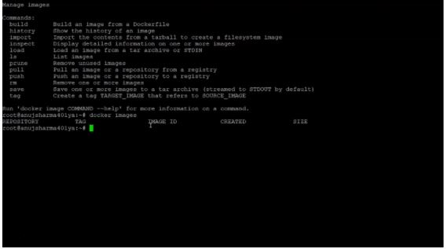

Delete an image from the docker image

|  |
| --- |
| docker image rm alpine:3.4 |

Container Commands

Mentioned below are the necessary commands for working with Docker container images.

* Create a container

|  |
| --- |
| docker create [IMAGE] |

* Run a command in a new container

|  |
| --- |
| docker run [IMAGE] [COMMAND] |

* Rename an existing container

|  |
| --- |
| docker rename [CONTAINER_NAME] [NEW_CONTAINER_NAME] |

* Removes all the stopped containers

|  |
| --- |
| docker container prune [OPTIONS] |

* Create a new image from a container’s file changes

|  |
| --- |
| docker container commit [OPTIONS] CONTAINER [REPOSITORY[:TAG]] |

* Remove an existing container

|  |
| --- |
| docker rm [CONTAINER] |

* List the running containers

|  |
| --- |
| docker container ls |

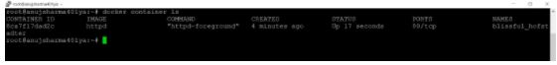

* Stop a running container

|  |
| --- |
| docker stop [CONTAINER_NAME] |

* Restart a running container

|  |
| --- |
| docker restart [CONTAINER] |

* Kill the running containers

|  |
| --- |
| docker Kill [CONTAINER] |

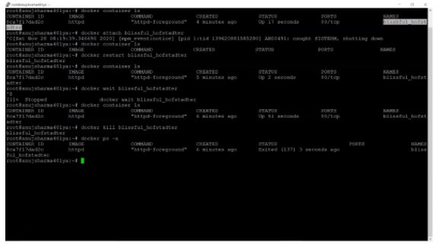

* Attach local standard input, output, and error streams to a running container

|  |
| --- |
| docker attach  [CONTAINER] |

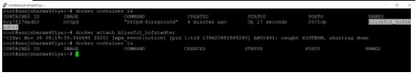

* Block a container

|  |
| --- |
| docker wait  [CONTAINER] |

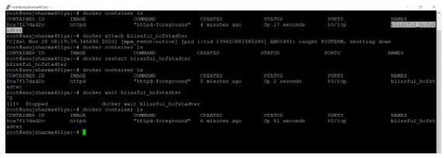

Docker Share Command

The following commands show how to share command in Docker.

* Pull an image from a registry

|  |
| --- |
| docker pull [OPTIONS] NAME[:TAG] |

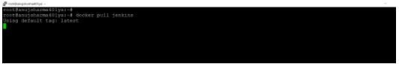

* Push an image to a registry

|  |
| --- |
| docker push [OPTIONS] NAME[:TAG] |

* Run a command in a running container

|  |
| --- |
| docker exec [OPTIONS] CONTAINER COMMAND [ARG...] |

General Commands

The following code shows the general command in Docker.

* Login into docker hub

|  |
| --- |
| docker login |

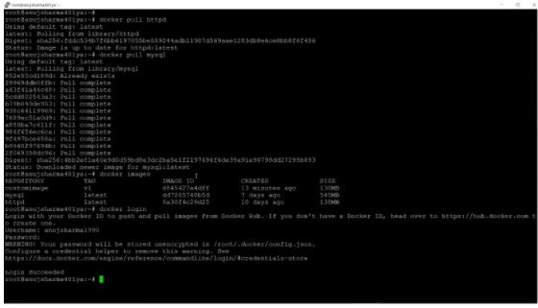

* Get information on the Docker tool

|  |
| --- |
| docker info |

* Display the history of an image with the image name mentioned in the command

|  |
| --- |
| docker history httpd |

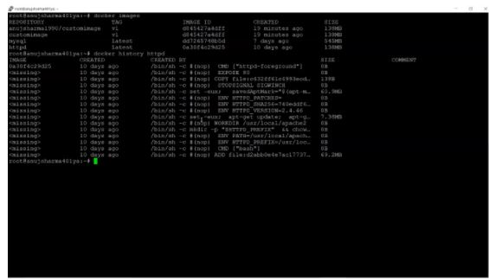

* Create a volume for containers

|  |
| --- |
| docker volume create |

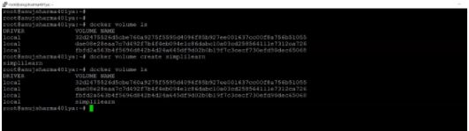

Docker Swarm Commands

Below you will find all the frequently used Docker Swarm commands.

* Create a Docker Swarm

|  |
| --- |
| docker swarm init --advertise-addr [IP ADDRESS] |

* Joins nodes in the swarm

|  |
| --- |
| docker swarm join --advertise-addr HOST:PORT |

* Execute this command to leave docker swarm

|  |
| --- |
| docker swarm leave [OPTIONS] |

Docker Compose Commands

Below you will find all the frequently used Docker Compose commands.

* Display docker-compose version

|  |
| --- |
| docker-compose -version |

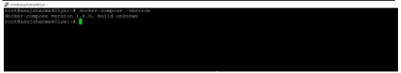

* Creating your first Docker-Compose File

|  |
| --- |
| vi docker-compose.yml |

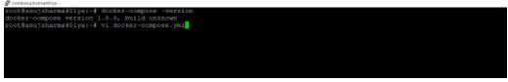

* Run our Docker Compose file

|  |
| --- |
| docker-compose up |