Who Uses Cloud Services?

There are several well-known organizations across the world that have already migrated to the cloud environment. Some of the examples include:

* Pinterest

Uses the AWS cloud environment to manage multiple petabytes of data that are generated by its users every day.

* Spotify

Uses the AWS cloud environment to store its vast repository of songs.

* Netflix

One of the largest video streaming services, it uses AWS to allow users to stream shows from anywhere in the world.

* Expedia

Uses AWS cloud services to accommodate a highly scalable infrastructure.

# **What Is Cloud Computing Architecture: Benefits, Components & More**

Cloud computing architecture is simple; it clearly states the components and subcomponents embedded in it There’s no question that [cloud computing](https://www.simplilearn.com/tutorials/cloud-computing-tutorial/what-is-cloud-computing) is here to stay. It touches every part of our lives today, offering many advantages in terms of flexibility, storage, sharing, maintenance, and much more.

A standard internet connection or a virtual network provides us access to cloud-based applications and services like Google Docs, Skype, and Netflix. Most companies are shifting their businesses into the cloud as they require significant storage, which [cloud platforms](https://www.simplilearn.com/top-cloud-platforms-article) provide. A cloud computing architecture provides higher bandwidth to its users due to which data over the cloud can be used from anywhere across the world at any time. Due to its architecture, it not only shares resources among client source consumers but also with open source communities like Microsoft and Red hat.

But how exactly does cloud computing work? In our guide, we explain everything there is to know about cloud computing architecture.

**What is Cloud Computing?**

[Cloud computing](https://www.simplilearn.com/tutorials/cloud-computing-tutorial) refers to services like storage, databases, software, analytics, and other platforms that are accessible via the internet. It is any service that can be delivered without being physically close to the hardware. For example, Netflix uses cloud computing for its video streaming services. Another example is G Suite, which runs entirely on the cloud.

Simply put, Cloud Computing refers to the delivery of on-demand resources (such as a  server, database, software, etc.) over the internet. It also gives the ability to build, design, and manage applications on the cloud platform.

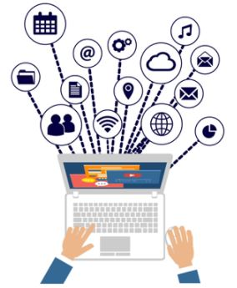

Note: Companies offering these computing services are referred to as cloud providers.

## Cloud Computing Service Providers

A few of the most popular cloud computing service providers include:

* [Microsoft Azure](https://www.simplilearn.com/tutorials/azure-tutorial/what-is-azure)
* [Amazon Web Services (AWS)](https://www.simplilearn.com/tutorials/aws-tutorial/what-is-aws)
* [Google Cloud](https://www.simplilearn.com/tutorials/cloud-computing-tutorial/google-cloud-vs-aws)
* Alibaba Cloud
* IBM Cloud
* Oracle
* Salesforce
* SAP
* Rackspace Cloud
* [VMWare](https://www.simplilearn.com/tutorials/cloud-computing-tutorial/vmware-workstation)

Cloud Computing Architecture

Cloud Computing Architecture is divided into two parts, i.e., front-end and back-end. Front-end and back-end communicate via a network or internet. A diagrammatic representation of cloud computing architecture is shown below:

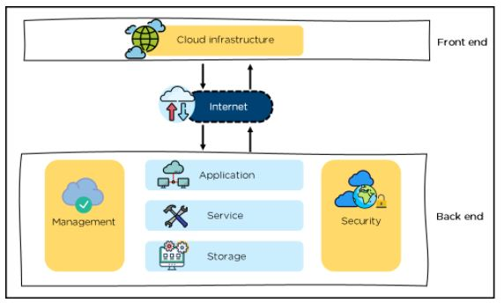

Cloud Computing Architecture

Front-End

* It provides applications and the interfaces that are required for the cloud-based service.
* It consists of client’s side applications, which are web browsers such as Google Chrome and Internet Explorer.
* Cloud infrastructure is the only component of the front-end. Let's understand it in detail.

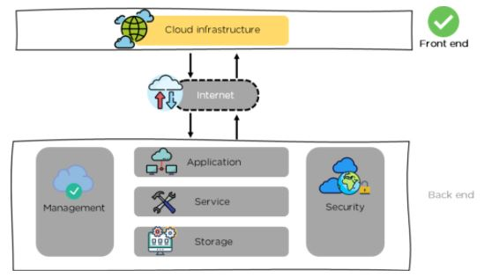

Front-end - Cloud Computing Architecture

* Cloud infrastructure consists of hardware and software components such as data storage, server, virtualization software, etc.
* It also provides a Graphical User Interface to the end-users to perform respective tasks.

Moving ahead, let’s understand what the back-end is.

Back-End

It is responsible for monitoring all the programs that run the application on the front-end

It has a large number of data storage systems and servers. The back-end is an important and huge part of the whole cloud computing architecture, as shown below:

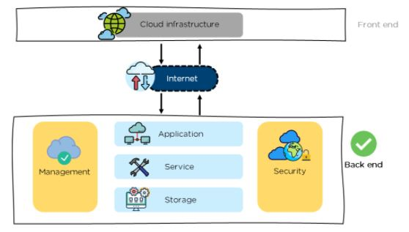

Back-end - Cloud Computing Architecture

The components of the back-end cloud architecture are mentioned below. Let's understand them in detail one by one.

Application

* It can either be a software or a platform
* Depending upon the client requirement, the application provides the result to the end-user (with resources) in the back end

Service

* Service is an essential component in cloud architecture
* Its responsibility is to provide utility in the architecture
* In a Cloud, few widely used services among the end-users are storage application development environments and web services

Storage

* It stores and maintains data like files, videos, documents, etc. over the internet
* Some of the popular examples of storage services are below:
  + [Amazon S3](https://www.simplilearn.com/tutorials/aws-tutorial/aws-s3)
  + Oracle Cloud-Storage
  + Microsoft Azure Storage
* Its capacity varies depending upon the service providers available in the market

Management

* Its task is to allot specific resources to a specific task, it simultaneously performs various functions of the cloud environment
* It helps in the management of components like application, task, service, security, data storage, and cloud infrastructure
* In simple terms, it establishes coordination among the cloud resources

Security

* Security is an integral part of back-end cloud infrastructure
* It provides secure cloud resources, systems, files, and infrastructure to end-users
* Also, it implements security management to the cloud server with virtual firewalls which results in preventing data loss

Now, that we know the architecture of cloud computing, let’s move on and learn about the benefits of the architecture.

Benefits of Cloud Computing Architecture

The cloud computing architecture is designed in such a way that:

* It solves latency issues and improves data processing requirements
* It reduces IT operating costs and gives good accessibility to access data and digital tools
* It helps businesses to easily scale up and scale down their cloud resources
* It has a flexibility feature which gives businesses a competitive advantage
* It results in better disaster recovery and  provides high security
* It automatically updates its services
* It encourages remote working and promotes team collaboration

Going ahead, let’s have a look at the components of cloud computing architecture.

# **What Is Cloud Computing Architecture: Benefits, Components & More**

Cloud computing architecture is simple; it clearly states the components and subcomponents embedded in it There’s no question that [cloud computing](https://www.simplilearn.com/tutorials/cloud-computing-tutorial/what-is-cloud-computing) is here to stay. It touches every part of our lives today, offering many advantages in terms of flexibility, storage, sharing, maintenance, and much more.

A standard internet connection or a virtual network provides us access to cloud-based applications and services like Google Docs, Skype, and Netflix. Most companies are shifting their businesses into the cloud as they require significant storage, which [cloud platforms](https://www.simplilearn.com/top-cloud-platforms-article) provide. A cloud computing architecture provides higher bandwidth to its users due to which data over the cloud can be used from anywhere across the world at any time. Due to its architecture, it not only shares resources among client source consumers but also with open source communities like Microsoft and Red hat.

But how exactly does cloud computing work? In our guide, we explain everything there is to know about cloud computing architecture.

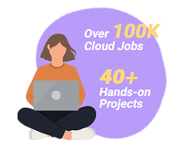

## What is Cloud Computing?

[Cloud computing](https://www.simplilearn.com/tutorials/cloud-computing-tutorial) refers to services like storage, databases, software, analytics, and other platforms that are accessible via the internet. It is any service that can be delivered without being physically close to the hardware. For example, Netflix uses cloud computing for its video streaming services. Another example is G Suite, which runs entirely on the cloud.

Simply put, Cloud Computing refers to the delivery of on-demand resources (such as a  server, database, software, etc.) over the internet. It also gives the ability to build, design, and manage applications on the cloud platform.



Note: Companies offering these computing services are referred to as cloud providers.

## Cloud Computing Service Providers

A few of the most popular cloud computing service providers include:

* [Microsoft Azure](https://www.simplilearn.com/tutorials/azure-tutorial/what-is-azure)
* [Amazon Web Services (AWS)](https://www.simplilearn.com/tutorials/aws-tutorial/what-is-aws)
* [Google Cloud](https://www.simplilearn.com/tutorials/cloud-computing-tutorial/google-cloud-vs-aws)
* Alibaba Cloud
* IBM Cloud
* Oracle
* Salesforce
* SAP
* Rackspace Cloud
* [VMWare](https://www.simplilearn.com/tutorials/cloud-computing-tutorial/vmware-workstation)

## popular-cloud-provider

Now, that we know the basics of cloud computing, let’s move on and learn about cloud computing architecture.

**Cloud Computing Architecture**

Cloud Computing Architecture is divided into two parts, i.e., front-end and back-end. Front-end and back-end communicate via a network or internet. A diagrammatic representation of cloud computing architecture is shown below:



Cloud Computing Architecture

### Front-End

* It provides applications and the interfaces that are required for the cloud-based service.
* It consists of client’s side applications, which are web browsers such as Google Chrome and Internet Explorer.
* Cloud infrastructure is the only component of the front-end. Let's understand it in detail.



Front-end - Cloud Computing Architecture

* Cloud infrastructure consists of hardware and software components such as data storage, server, virtualization software, etc.
* It also provides a Graphical User Interface to the end-users to perform respective tasks.

Moving ahead, let’s understand what the back-end

**Back-End**

It is responsible for monitoring all the programs that run the application on the front-end

It has a large number of data storage systems and servers. The back-end is an important and huge part of the whole cloud computing architecture, as shown below:



Back-end - Cloud Computing Architecture

The components of the back-end cloud architecture are mentioned below. Let's understand them in detail one by one.

### Application

* It can either be a software or a platform
* Depending upon the client requirement, the application provides the result to the end-user (with resources) in the back end

### Service

* Service is an essential component in cloud architecture
* Its responsibility is to provide utility in the architecture
* In a Cloud, few widely used services among the end-users are storage application development environments and web services

### Storage

* It stores and maintains data like files, videos, documents, etc. over the internet
* Some of the popular examples of storage services are below:
  + [Amazon S3](https://www.simplilearn.com/tutorials/aws-tutorial/aws-s3)
  + Oracle Cloud-Storage
  + Microsoft Azure Storage
* Its capacity varies depending upon the service providers available in the market

### Management

* Its task is to allot specific resources to a specific task, it simultaneously performs various functions of the cloud environment
* It helps in the management of components like application, task, service, security, data storage, and cloud infrastructure
* In simple terms, it establishes coordination among the cloud resources

### Security

* Security is an integral part of back-end cloud infrastructure
* It provdes secure cloud resources, systems, files, and infrastructure to end-users
* Also, it implements security management to the cloud server with virtual firewalls which results in preventing data loss

Now, that we know the architecture of cloud computing, let’s move on and learn about the benefits of the architecture.

**Benefits of Cloud Computing Architecture**

The cloud computing architecture is designed in such a way that:

* It solves latency issues and improves data processing requirements
* It reduces IT operating costs and gives good accessibility to access data and digital tools
* It helps businesses to easily scale up and scale down their cloud resources
* It has a flexibility feature which gives businesses a competitive advantage
* It results in better disaster recovery and  provides high security
* It automatically updates its services
* It encourages remote working and promotes team collaboration

Going ahead, let’s have a look at the components of cloud computing architecture.

## Cloud Computing Architecture Components

Some of the important components of Cloud Computing architecture that we will be looking into are as follows:

* Hypervisor
* Management Software
* Deployment Software
* Network
* Cloud Server
* Cloud Storage

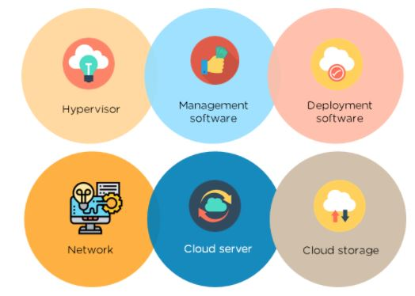

Components of Cloud architecture

### Hypervisor

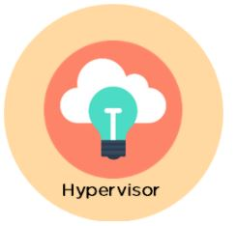

* It is a virtual machine monitor which provides Virtual Operating Platforms to every user
* It also manages guest operating systems in the cloud
* It runs a separate virtual machine on the back end which consists of software and hardware
* Its main objective is to divide and allocate resources

Management Software



* Its responsibility is to manage and monitor cloud operations with various strategies to increase the performance of the cloud
* Some of the operations performed by the management software are:
  + compliance auditing
  + management of overseeing disaster
  + contingency plans

Deployment Software

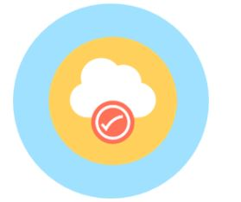

* It consists of all the mandatory installations and configurations required to run a cloud service
* Every deployment of cloud services are performed using a deployment software
* The three different models which can be deployed are the following:
* [SaaS](https://www.simplilearn.com/what-is-saas-article) - Software as a service hosts and manages applications of the end-user.

Example: Gmail

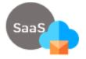

Image_Name: PaaS

* [PaaS](https://www.simplilearn.com/what-is-paas-article) - Platform as a service helps developers to build, create, and manage applications.

Example: [Microsoft Azure](https://www.simplilearn.com/tutorials/cloud-computing-tutorial/aws-vs-azure)

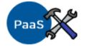

* [IaaS](https://www.simplilearn.com/saas-paas-iaas-quick-comparison-article) - Infrastructure as a service provides services on a pay-as-you-go pricing model.



### Network

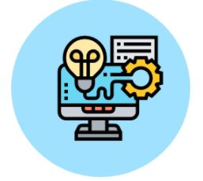

* It connects the front-end and back-end. Also, allows every user to access cloud resources
* It helps users to connect and customize the route and protocol
* It is a virtual server which is hosted on the cloud computing platform
* It is highly flexible, secure, and cost-effective

Cloud Storage

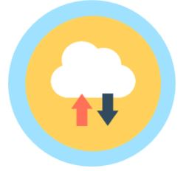

* Here, every bit of data is stored and accessed by a user from anywhere over the internet
* It is scalable at run-time and is automatically accessed
* Data can be modified and retrieved from [cloud storage](https://www.simplilearn.com/cloud-storage-article) over the web

# **Virtualization in Cloud Computing**

**Virtualization** is the "creation of a virtual (rather than actual) version of something, such as a server, a desktop, a storage device, an operating system or network resources".

In other words, Virtualization is a technique, which allows to share a single physical instance of a resource or an application among multiple customers and organizations. It does by assigning a logical name to a physical storage and providing a pointer to that physical resource when demanded.

## What is the concept behind the Virtualization?

Creation of a virtual machine over existing operating system and hardware is known as Hardware Virtualization. A Virtual machine provides an environment that is logically separated from the underlying hardware.

The machine on which the virtual machine is going to create is known as **Host Machine** and that virtual machine is referred as a **Guest Machine**

Types of Virtualization:

1. Hardware Virtualization.
2. Operating system Virtualization.
3. Server Virtualization.
4. Storage Virtualization.

1) Hardware Virtualization:

When the virtual machine software or virtual machine manager *(VMM) is directly installed on the hardware system* is known as hardware virtualization.

The main job of hypervisor is to control and monitoring the processor, memory and other hardware resources.

After virtualization of hardware system we can install different operating system on it and run different applications on those OS.

**Usage:**

Hardware virtualization is mainly done for the server platforms, because controlling virtual machines is much easier than controlling a physical server.

2) Operating System Virtualization:

When the virtual machine software or virtual machine manager *(VMM) is installed on the Host operating system* instead of directly on the hardware system is known as operating system virtualization.

**Usage:**

Operating System Virtualization is mainly used for testing the applications on different platforms of OS.

### 3) Server Virtualization:

When the virtual machine software or virtual machine manager *(VMM) is directly installed on the Server system* is known as server virtualization.

**Usage:**

Server virtualization is done because a single physical server can be divided into multiple servers on the demand basis and for balancing the load.

### 4) Storage Virtualization:

Storage virtualization is the *process of grouping the physical storage from multiple network storage devices so that it looks like a single storage device*.

Storage virtualization is also implemented by using software applications.

**Usage:**

Storage virtualization is mainly done for back-up and recovery purposes.

## How does virtualization work in cloud computing?

**Virtualization** plays a very important role in the cloud computing technology, normally in the cloud computing, users share the data present in the clouds like application etc, but actually with the help of virtualization users shares the Infrastructure.

The **main usage of Virtualization Technology** is to provide the applications with the standard versions to their cloud users, suppose if the next version of that application is released, then cloud provider has to provide the latest version to their cloud users and practically it is possible because it is more expensive.

To overcome this problem we use basically virtualization technology, By using virtualization, all severs and the software application which are required by other cloud providers are maintained by the third party people, and the cloud providers has to pay the money on monthly or annual basis.

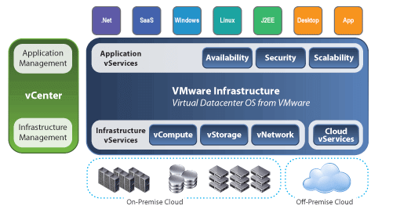

Mainly Virtualization means, running multiple operating systems on a single machine but sharing all the hardware resources. And it helps us to provide the pool of IT resources so that we can share these IT resources in order get benefits in the business.

# **What are the Security Risks of Cloud Computing**

Cloud computing provides various advantages, such as improved collaboration, excellent accessibility, Mobility, Storage capacity, etc. But there are also security risks in cloud computing.

Some most common Security Risks of Cloud Computing are given below-

### Data Loss

Data loss is the most common cloud security risks of cloud computing. It is also known as data leakage. Data loss is the process in which data is being deleted, corrupted, and unreadable by a user, software, or application. In a cloud computing environment, data loss occurs when our sensitive data is somebody else's hands, one or more data elements can not be utilized by the data owner, hard disk is not working properly, and software is not updated.

### Hacked Interfaces and Insecure APIs

As we all know, cloud computing is completely depends on Internet, so it is compulsory to protect interfaces and APIs that are used by external users. APIs are the easiest way to communicate with most of the cloud services. In cloud computing, few services are available in the public domain. These services can be accessed by third parties, so there may be a chance that these services easily harmed and hacked by hackers.

### Data Breach

Data Breach is the process in which the confidential data is viewed, accessed, or stolen by the third party without any authorization, so organization's data is hacked by the hackers.

### Vendor lock-in

Vendor lock-in is the of the biggest security risks in cloud computing. Organizations may face problems when transferring their services from one vendor to another. As different vendors provide different platforms, that can cause difficulty moving one cloud to another.

### Increased complexity strains IT staff

Migrating, integrating, and operating the cloud services is complex for the IT staff. IT staff must require the extra capability and skills to manage, integrate, and maintain the data to the cloud.

### Denial of Service (DoS) attacks

Denial of service (DoS) attacks occur when the system receives too much traffic to buffer the server. Mostly, DoS attackers target web servers of large organizations such as banking sectors, media companies, and government organizations. To recover the lost data, DoS attackers charge a great deal of time and money to handle the data.

### Account hijacking

Account hijacking is a serious security risk in cloud computing. It is the process in which individual user's or organization's cloud account (bank account, e-mail account, and social media account) is stolen by hackers. The hackers use the stolen account to perform unauthorized activities.

What is a Data Center?

A data center - also known as a *data center* or *data center* - is a facility made up of networked computers, storage systems, and computing infrastructure that businesses and other organizations use to organize, process, store large amounts of data. And to broadcast. A business typically relies heavily on applications, services, and data within a data center, making it a focal point and critical asset for everyday operations.

Enterprise data centers increasingly incorporate cloud computing resources and facilities to secure and protect in-house, onsite resources. As enterprises increasingly turn to cloud computing, the boundaries between cloud providers' data centers and enterprise data centers become less clear.

How do Data Centers work?

A data center facility enables an organization to assemble its resources and infrastructure for data processing, storage, and communication, including:

* systems for storing, sharing, accessing, and processing data across the organization;
* physical infrastructure to support data processing and data communication; And
* Utilities such as cooling, electricity, network access, and uninterruptible power supplies (UPS).

**Gathering all these resources in one data center enables the organization to:**

* protect proprietary systems and data;
* Centralizing IT and data processing employees, contractors, and vendors;
* Enforcing information security controls on proprietary systems and data; And
* Realize economies of scale by integrating sensitive systems in one place.

Why are data centers important?

Data centers support almost all enterprise computing, storage, and business applications. To the extent that the business of a modern enterprise runs on computers, the data center *is* business.

Data centers enable organizations to concentrate their processing power, which in turn enables the organization to focus its attention on:

* IT and data processing personnel;
* computing and network connectivity infrastructure; And
* Computing Facility Security.

What are the main components of Data Centers?

Elements of a data center are generally divided into three categories:

1. Calculation
2. enterprise data storage
3. networking

**A modern data center concentrates an organization's data systems in a well-protected physical infrastructure, which includes:**

* Server;
* storage subsystems;
* networking switches, routers, and firewalls;
* cabling; And
* Physical racks for organizing and interconnecting IT equipment.

**Datacenter Resources typically include:**

* power distribution and supplementary power subsystems;
* electrical switching;
* UPS;
* backup generator;
* ventilation and data center cooling systems, such as in-row cooling configurations and computer room air conditioners; And
* Adequate provision for network carrier (telecom) connectivity.

It demands a physical facility with physical security access controls and sufficient square footage to hold the entire collection of infrastructure and equipment.

How are Datacenters managed?

Datacenter management is required to administer many different topics related to the data center, including:

* **Facilities Management**. Management of a physical data center facility may include duties related to the facility's real estate, utilities, access control, and personnel.
* **Datacenter inventory or asset management**. Datacenter features include hardware assets and software licensing, and release management.
* **Datacenter Infrastructure Management**. DCIM lies at the intersection of IT and facility management and is typically accomplished by monitoring data center performance to optimize energy, equipment, and floor use.
* **Technical support**. The data center provides technical services to the organization, and as such, it should also provide technical support to the end-users of the enterprise.
* Datacenter management includes the day-to-day processes and services provided by the data center.

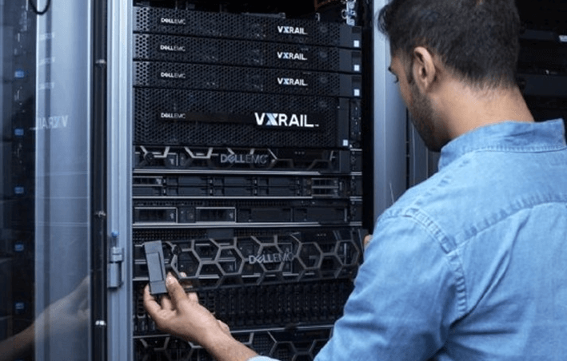

The image shows an **IT professional** installing and maintaining a high-capacity rack-mounted system in a data center.

Datacenter Infrastructure Management and Monitoring

Modern data centers make extensive use of monitoring and management software. Software, including DCIM tools, allows remote IT data center administrators to monitor facility and equipment, measure performance, detect failures and implement a wide range of corrective actions without ever physically entering the data center room.

The development of virtualization has added another important dimension to data center infrastructure management. Virtualization now supports the abstraction of servers, networks, and storage, allowing each computing resource to be organized into pools regardless of their physical location.

Action Network, storage and server virtualization can be implemented through software, giving software-defined data centers traction. Administrators can then provision workloads, storage instances, and even network configurations from those common resource pools. When administrators no longer need those resources, they can return them to the pool for reuse.

Energy Consumption and Efficiency

Datacenter designs also recognize the importance of energy efficiency. A simple data center may require only a few kilowatts of energy, but enterprise data centers may require more than 100 megawatts. Today, green data centers with minimal environmental impact through low-emission building materials, catalytic converters, and alternative energy technologies are growing in popularity.

Data centers can maximize efficiency through physical layouts, known as hot aisle and cold isle layouts. The server racks are lined up in alternating rows, with cold air intakes on one side and hot air exhausts. The result is alternating hot and cold aisles, with the exhaust forming a hot aisle and the intake forming a cold aisle. Exhausts are pointing to air conditioning equipment. The equipment is often placed between the server cabinets in the row or aisle and distributes the cold air back into the cold aisle. This configuration of air conditioning equipment is known as in-row cooling.

Organizations often measure data center energy efficiency through power usage effectiveness (PUE), which represents the ratio of the total power entering the data center divided by the power used by IT equipment.

However, the subsequent rise of virtualization has allowed for more productive use of IT equipment, resulting in much higher efficiency, lower energy usage, and reduced energy costs. Metrics such as PUE are no longer central to energy efficiency goals. However, organizations can still assess PUE and use comprehensive power and cooling analysis to understand better and manage energy efficiency.

Datacenter Level

Data centers are not defined by their physical size or style. Small businesses can operate successfully with multiple servers and storage arrays networked within a closet or small room. At the same time, major computing organizations -- such as Facebook, Amazon, or Google -- can fill a vast warehouse space with data center equipment and infrastructure.

In other cases, data centers may be assembled into mobile installations, such as shipping containers, also known as data centers in a box, that can be moved and deployed.

However, data centers can be defined by different levels of reliability or flexibility, sometimes referred to as data center tiers.

In 2005, the American National Standards Institute (ANSI) and the Telecommunications Industry Association (TIA) published the standard ANSI/TIA-942, "Telecommunications Infrastructure Standards for Data Centers", which defined four levels of data center design and implementation guidelines.

Each subsequent level aims to provide greater flexibility, security, and reliability than the previous level. For example, a Tier I data center is little more than a server room, while a Tier IV data center provides redundant subsystems and higher security.

Levels can be differentiated by available resources, data center capabilities, or uptime guarantees. **The Uptime Institute defines data center levels as:**

* **Tier I.** These are the most basic types of data centers, including UPS. Tier I data centers do not provide redundant systems but must guarantee at least 99.671% uptime.
* **Tier II.**These data centers include system, power and cooling redundancy and guarantee at least 99.741% uptime.
* **Tier III.** These data centers offer partial fault tolerance, 72-hour outage protection, full redundancy, and a 99.982% uptime guarantee.
* **Tier IV.** These data centers guarantee 99.995% uptime - or no more than 26.3 minutes of downtime per year - as well as full fault tolerance, system redundancy, and 96 hours of outage protection.

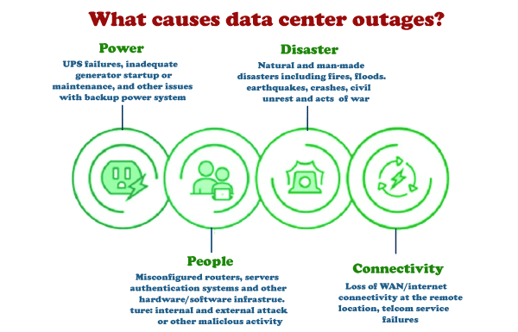

Most data center outages can be attributed to these four general categories.

Datacenter Architecture and Design

Although almost any suitable location can serve as a data center, a data center's deliberate design and implementation require careful consideration. Beyond the basic issues of cost and taxes, sites are selected based on several criteria: geographic location, seismic and meteorological stability, access to roads and airports, availability of energy and telecommunications, and even the prevailing political environment.

Once the site is secured, the data center architecture can be designed to focus on the structure and layout of mechanical and electrical infrastructure and IT equipment. These issues are guided by the availability and efficiency goals of the desired data center tier.

Datacenter Security

Datacenter designs must also implement sound security and security practices. For example, security is often reflected in the layout of doors and access corridors, which must accommodate the movement of large, cumbersome IT equipment and allow employees to access and repair infrastructure.

Fire fighting is another major safety area, and the widespread use of sensitive, high-energy electrical and electronic equipment precludes common sprinklers. Instead, data centers often use environmentally friendly chemical fire suppression systems, which effectively oxygenate fires while minimizing collateral damage to equipment. Comprehensive security measures and access controls are needed as the data center is also a core business asset. These may include:

* **Badge Access;**
* **biometric access control, and**
* **video surveillance.**

These security measures can help detect and prevent employee, contractor, and intruder misconduct.

What is Data Center Consolidation?

There is no need for a single data center. Modern businesses can use two or more data center installations in multiple locations for greater flexibility and better application performance, reducing latency by locating workloads closer to users.

Conversely, a business with multiple data centers may choose to consolidate data centers while reducing the number of locations to reduce the cost of IT operations. Consolidation typically occurs during mergers and acquisitions when most businesses no longer need data centers owned by the subordinate business.

What is Data Center Colocation?

Datacenter operators may also pay a fee to rent server space in a colocation facility. A colocation is an attractive option for organizations that want to avoid the large capital expenditure associated with building and maintaining their data centers.

Today, colocation providers are expanding their offerings to include managed services such as interconnectivity, allowing customers to connect to the public cloud.

Because many service providers today offer managed services and their colocation features, the definition of *managed services* becomes hazy, as all vendors market the term slightly differently. The important distinction to make is:

* The organization pays a vendor to place their hardware in a facility. The customer is paying for the location alone.
* **Managed services.** The organization pays the vendor to *actively* maintain or monitor the hardware through performance reports, interconnectivity, technical support, or disaster recovery.

What is the difference between Data Center vs. Cloud?

Cloud computing vendors offer similar features to enterprise data centers. The biggest difference between a cloud data center and a typical enterprise data center is scale. Because cloud data centers serve many different organizations, they can become very large. And cloud computing vendors offer these services through their data centers.

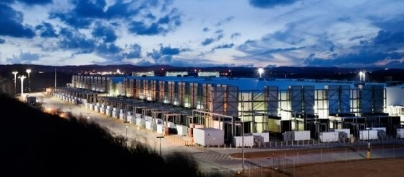

Large enterprises such as Google may require very large data centers, such as the Google data center in Douglas County, Ga.

Because enterprise data centers increasingly implement private cloud software, they increasingly see end-users, like the services provided by commercial cloud providers.

Private cloud software builds on virtualization to connect cloud-like services, including:

* system automation;
* user self-service; And
* Billing/Charge Refund to Data Center Administration.

The goal is to allow individual users to provide on-demand workloads and other computing resources without IT administrative intervention.

Further blurring the lines between the enterprise data center and cloud computing is the development of hybrid cloud environments. As enterprises increasingly rely on public cloud providers, they must incorporate connectivity between their data centers and cloud providers.

For example, platforms such as Microsoft Azure emphasize hybrid use of local data centers with Azure or other public cloud resources. The result is not the elimination of data centers but the creation of a dynamic environment that allows organizations to run workloads locally or in the cloud or move those instances to or from the cloud as desired.

Evolution of Data Centers

The origins of the first data centers can be traced back to the 1940s and the existence of early computer systems such as the Electronic Numerical Integrator and Computer (ENIAC). These early machines were complicated to maintain and operate and had cables connecting all the necessary components. They were also in use by the military - meaning special computer rooms with racks, cable trays, cooling mechanisms, and access restrictions were necessary to accommodate all equipment and implement appropriate safety measures.

However, it was not until the 1990s, when IT operations began to gain complexity and cheap networking equipment became available, that the term *data center* first came into use. It became possible to store all the necessary servers in one room within the company. These specialized computer rooms gained traction, dubbed data centers within organizations.

At the time of the dot-com bubble in the late 1990s, the need for Internet speed and a constant Internet presence for companies required large amounts of networking equipment required large facilities. At this point, data centers became popular and began to look similar to those described above.

In the history of computing, as computers get smaller and networks get bigger, the data center has evolved and shifted to accommodate the necessary technology of the day.

Difference between Cloud and Data Center

Most organizations rely heavily on data for their respective day-to-day operations, irrespective of the industry or the nature of the data. This data can range from making business decisions, identifying patterns to improving the services provided, or analyzing weak links in a workflow.

Cloud

Cloud may be a term used to describe a group of services, either a global or individual network of servers, that have a unique function. Cloud is not a physical entity, but they are a group or network of remote servers arched together to operate as a single unit for an assigned task.

In short, a cloud is a building containing many computer systems. We access the cloud through the Internet because cloud providers provide the cloud as a service.

One of the many confusions we have is whether the cloud is the same as cloud computing? The answer is no. Cloud services like Compute run in the cloud. The computing service offered by the cloud lets users' rent' computer systems in a data center over the Internet.

Another example of a cloud service is storage. AWS says, "Cloud computing is the on-demand delivery of IT resources over the Internet with pay-as-you-go pricing. Instead of buying, owning, and maintaining physical data centers and servers, you can access technology services, such as computing power, storage, and databases, from a cloud provider such as Amazon Web Services (AWS)."

**Types of Cloud:**

Businesses use cloud resources in different ways. There are mainly four of them:

* **Public Cloud:** The cloud method is open to all with the Internet on a pay-per-use method.
* **Private Cloud:** This is a cloud method used by organizations to make their data centers accessible only with the organization's permission.
* **Hybrid cloud:** It is a cloud method that combines public and private clouds. It caters to the various needs of an organization for its services.
* **Community cloud** is a cloud method that provides services to an organization or a group of people within a single community.

Data Center

A data center can be described as a facility/location of networked computers and associated components (such as telecommunications and storage) that help businesses and organizations handle large amounts of data. These data centers allow data to be organized, processed, stored, and transmitted across applications used by businesses.

**Types of Data Center:**

Businesses use different types of data centers, including:

* **Telecom Data Center:** It is a type of data center operated by telecommunications or service providers. It requires high-speed connectivity to work.
* **Enterprise** **data center**: This is a type of data center built and owned by a company that may or may not be onsite.
* **Colocation Data Center:** This type of data center consists of a single data center owner's location, providing cooling to multiple enterprises and hyper-scale their customers.
* **Hyper-Scale Data Center:** This is a type of data center owned and operated by the company itself.

Difference between Cloud and Data Center:

|  |  |  |
| --- | --- | --- |
| **S.No** | **Cloud** | **Data Center** |
| 1. | Cloud is a virtual resource that helps businesses store, organize, and operate data efficiently. | Data Center is a physical resource that helps businesses store, organize, and operate data efficiently. |
| 2. | The scalability of the cloud required less amount of investment. | The scalability of the Data Center is huge in investment compared to the cloud. |
| 3. | Maintenance cost is less as compared to service providers. | Maintenance cost is high because the developers of the organization do the maintenance. |
| 4. | The organization needs to rely on third parties to store its data. | The organization's developers are trusted for the data stored in the data centers. |
| 5. | The performance is huge compared to the investment. | The performance is less than the investment. |
| 6. | This requires a plan for optimizing the cloud. | It is easily customizable without any hard planning. |
| 7. | It requires a stable internet connection to provide the function. | This may or may not require an internet connection. |
| 8. | The cloud is easy to operate and is considered a viable option. | Data centers require experienced developers to operate and are not considered a viable option. |