**Public Cloud** allows systems and services to be easily accessible to general public. The IT giants such as **Google, Amazon** and **Microsoft** offer cloud services via Internet. The Public Cloud Model is shown in the diagram below.

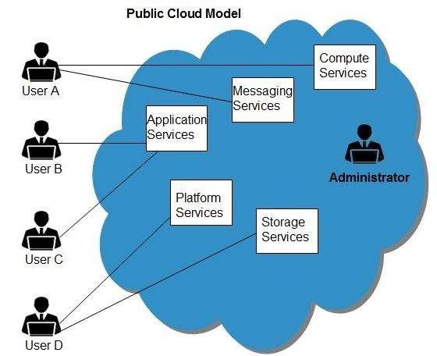

Benefits

There are many benefits of deploying cloud as public cloud model. The following diagram shows some of those benefits:

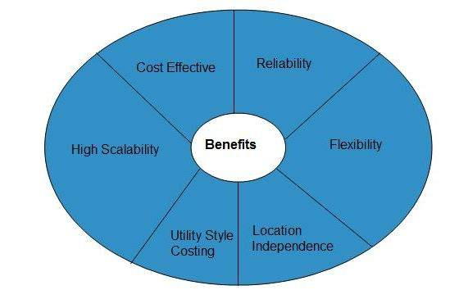

Cost Effective

Since **public cloud** shares same resources with large number of customers it turns out inexpensive.

Reliability

The **public cloud** employs large number of resources from different locations. If any of the resources fails, public cloud can employ another one.

Flexibility

The public cloud can smoothly integrate with private cloud, which gives customers a flexible approach.

Location Independence

**Public cloud** services are delivered through Internet, ensuring location independence.

Utility Style Costing

Public cloud is also based on **pay-per-use** model and resources are accessible whenever customer needs them.

High Scalability

Cloud resources are made available on demand from a pool of resources, i.e., they can be scaled up or down according the requirement.

Disadvantages

Here are some disadvantages of public cloud model:

Low Security

In **public cloud model,** data is hosted off-site and resources are shared publicly, therefore does not ensure higher level of security.

Less Customizable

It is comparatively less customizable than private cloud

**Private Cloud** allows systems and services to be accessible within an organization. The Private Cloud is operated only within a single organization. However, it may be managed internally by the organization itself or by third-party. The private cloud model is shown in the diagram below.

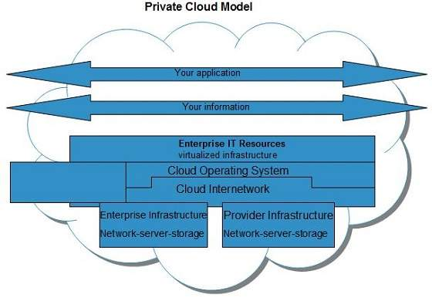

Benefits

There are many benefits of deploying cloud as private cloud model. The following diagram shows some of those benefits:

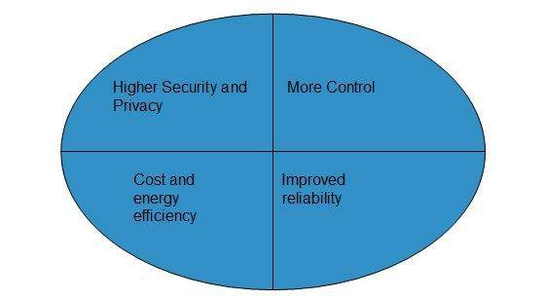

High Security and Privacy

**Private cloud** operations are not available to general public and resources are shared from distinct pool of resources. Therefore, it ensures high **security** and **privacy.**

More Control

The **private cloud** has more control on its resources and hardware than public cloud because it is accessed only within an organization.

Cost and Energy Efficiency

The **private cloud** resources are not as cost effective as resources in public clouds but they offer more efficiency than public cloud resources.

Disadvantages

Here are the disadvantages of using private cloud model:

Restricted Area of Operation

The private cloud is only accessible locally and is very difficult to deploy globally.

High Priced

Purchasing new hardware in order to fulfill the demand is a costly transaction.

Limited Scalability

The private cloud can be scaled only within capacity of internal hosted resources.

Additional Skills

In order to maintain cloud deployment, organization requires skilled expertise.

**Hybrid Cloud** is a mixture of **public** and **private** cloud. Non-critical activities are performed using public cloud while the critical activities are performed using private cloud. The Hybrid Cloud Model is shown in the diagram below.

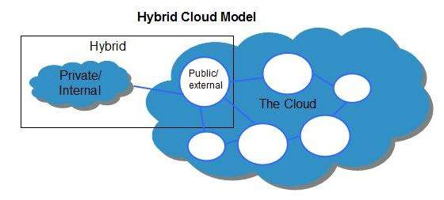

Benefits

There are many benefits of deploying cloud as hybrid cloud model. The following diagram shows some of those benefits:

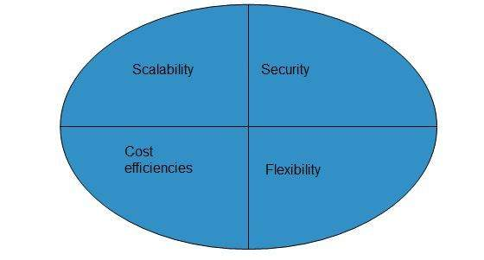

Scalability

It offers features of both, the public cloud scalability and the private cloud scalability.

Flexibility

It offers secure resources and scalable public resources.

Cost Efficiency

Public clouds are more cost effective than private ones. Therefore, hybrid clouds can be cost saving.

Security

The private cloud in hybrid cloud ensures higher degree of security.

Disadvantages

Networking Issues

Networking becomes complex due to presence of private and public cloud.

Security Compliance

It is necessary to ensure that cloud services are compliant with security policies of the organization.

Infrastructure Dependency

The **hybrid cloud model** is dependent on internal IT infrastructure, therefore it is necessary to ensure redundancy across data centers.