**Who Uses Cloud Services?**

There are several well-known organizations across the world that have already migrated to the cloud environment. Some of the examples include:

* Pinterest

Uses the AWS cloud environment to manage multiple petabytes of data that are generated by its users every day.

* Spotify

Uses the AWS cloud environment to store its vast repository of songs.

* Netflix

One of the largest video streaming services, it uses AWS to allow users to stream shows from anywhere in the world.

* Expedia

Uses AWS cloud services to accommodate a highly scalable infrastructure.

# **What Is Cloud Computing Architecture: Benefits, Components & More**

Cloud computing architecture is simple; it clearly states the components and subcomponents embedded in it There’s no question that [cloud computing](https://www.simplilearn.com/tutorials/cloud-computing-tutorial/what-is-cloud-computing) is here to stay. It touches every part of our lives today, offering many advantages in terms of flexibility, storage, sharing, maintenance, and much more.

A standard internet connection or a virtual network provides us access to cloud-based applications and services like Google Docs, Skype, and Netflix. Most companies are shifting their businesses into the cloud as they require significant storage, which [cloud platforms](https://www.simplilearn.com/top-cloud-platforms-article) provide. A cloud computing architecture provides higher bandwidth to its users due to which data over the cloud can be used from anywhere across the world at any time. Due to its architecture, it not only shares resources among client source consumers but also with open source communities like Microsoft and Red hat.

But how exactly does cloud computing work? In our guide, we explain everything there is to know about cloud computing architecture.

**What is Cloud Computing?**

[Cloud computing](https://www.simplilearn.com/tutorials/cloud-computing-tutorial) refers to services like storage, databases, software, analytics, and other platforms that are accessible via the internet. It is any service that can be delivered without being physically close to the hardware. For example, Netflix uses cloud computing for its video streaming services. Another example is G Suite, which runs entirely on the cloud.

Simply put, Cloud Computing refers to the delivery of on-demand resources (such as a  server, database, software, etc.) over the internet. It also gives the ability to build, design, and manage applications on the cloud platform.



Note: Companies offering these computing services are referred to as cloud providers.

## Cloud Computing Service Providers

A few of the most popular cloud computing service providers include:

* [Microsoft Azure](https://www.simplilearn.com/tutorials/azure-tutorial/what-is-azure)
* [Amazon Web Services (AWS)](https://www.simplilearn.com/tutorials/aws-tutorial/what-is-aws)
* [Google Cloud](https://www.simplilearn.com/tutorials/cloud-computing-tutorial/google-cloud-vs-aws)
* Alibaba Cloud
* IBM Cloud
* Oracle
* Salesforce
* SAP
* Rackspace Cloud
* [VMWare](https://www.simplilearn.com/tutorials/cloud-computing-tutorial/vmware-workstation)

Cloud Computing Architecture

Cloud Computing Architecture is divided into two parts, i.e., front-end and back-end. Front-end and back-end communicate via a network or internet. A diagrammatic representation of cloud computing architecture is shown below:

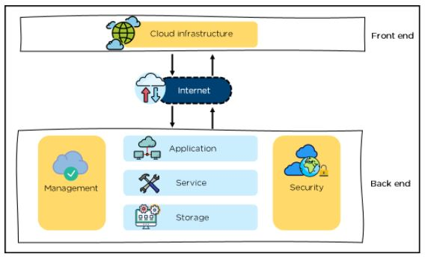

Cloud Computing Architecture

Front-End

* It provides applications and the interfaces that are required for the cloud-based service.
* It consists of client’s side applications, which are web browsers such as Google Chrome and Internet Explorer.
* Cloud infrastructure is the only component of the front-end. Let's understand it in detail.

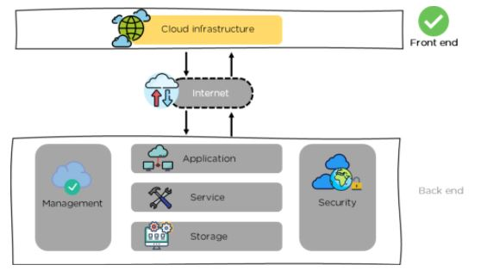

Front-end - Cloud Computing Architecture

* Cloud infrastructure consists of hardware and software components such as data storage, server, virtualization software, etc.
* It also provides a Graphical User Interface to the end-users to perform respective tasks.

Moving ahead, let’s understand what the back-end is.

Back-End

It is responsible for monitoring all the programs that run the application on the front-end

It has a large number of data storage systems and servers. The back-end is an important and huge part of the whole cloud computing architecture, as shown below:

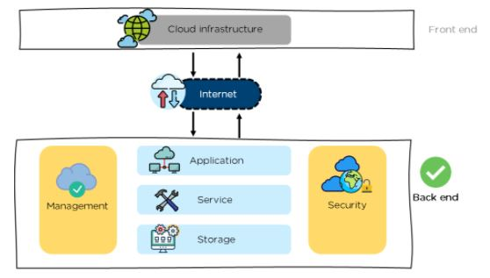

Back-end - Cloud Computing Architecture

The components of the back-end cloud architecture are mentioned below. Let's understand them in detail one by one.

**Application**

* It can either be a software or a platform
* Depending upon the client requirement, the application provides the result to the end-user (with resources) in the back end

**Service**

* Service is an essential component in cloud architecture
* Its responsibility is to provide utility in the architecture
* In a Cloud, few widely used services among the end-users are storage application development environments and web services

**Storage**

* It stores and maintains data like files, videos, documents, etc. over the internet
* Some of the popular examples of storage services are below:
  + [Amazon S3](https://www.simplilearn.com/tutorials/aws-tutorial/aws-s3)
  + Oracle Cloud-Storage
  + Microsoft Azure Storage
* Its capacity varies depending upon the service providers available in the market

**Management**

* Its task is to allot specific resources to a specific task, it simultaneously performs various functions of the cloud environment
* It helps in the management of components like application, task, service, security, data storage, and cloud infrastructure
* In simple terms, it establishes coordination among the cloud resources

**Security**

* Security is an integral part of back-end cloud infrastructure
* It provides secure cloud resources, systems, files, and infrastructure to end-users
* Also, it implements security management to the cloud server with virtual firewalls which results in preventing data loss

Now, that we know the architecture of cloud computing, let’s move on and learn about the benefits of the architecture.