**What is Stack?**

*A stack is a linear data structure in which the insertion of a new element and removal of an existing element takes place at the same end represented as the top of the stack.*

To implement the stack, it is required to maintain the **pointer to the top of the stack**, which is the last element to be inserted because **we can access the elements only on the top of the stack.**

**LIFO( Last In First Out ):**

*This strategy states that the element that is inserted last will come out first. You can take a pile of plates kept on top of each other as a real-life example. The plate which we put last is on the top and since we remove the plate that is at the top, we can say that the plate that was put last comes out first.*

**Basic Operations on Stack**

In order to make manipulations in a stack, there are certain operations provided to us.

* **push()** to insert an element into the stack
* **pop()**to remove an element from the stack
* **top()** Returns the top element of the stack.
* **isEmpty()**returns true if stack is empty else false.
* **size()** returns the size of stack.

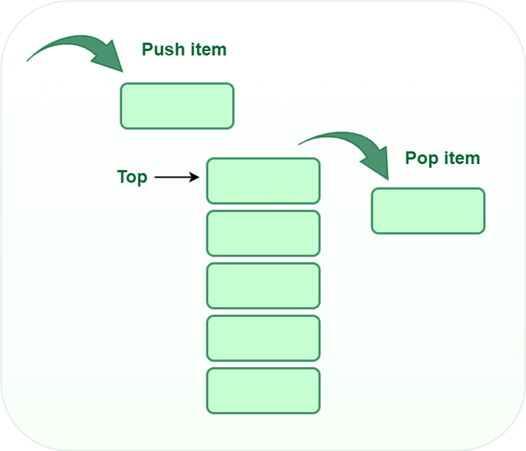

*Stack*

**Push:**

Adds an item to the stack. If the stack is full, then it is said to be an**Overflow condition.**

**Algorithm for push:**

begin

if stack is full

return

endif

else

increment top

stack[top] assign value

end else

end procedure

**Pop:**

Removes an item from the stack. The items are popped in the reversed order in which they are pushed. If the stack is empty, then it is said to be an **Underflow** **condition.**

**Algorithm for pop:**

begin

if stack is empty

return

endif

else

store value of stack[top]

decrement top

return value

end else

end procedure

**Top:**

Returns the top element of the stack.

**Algorithm for Top:**

begin

return stack[top]

end procedure

**isEmpty:**

Returns true if the stack is empty, else false.

**Algorithm for isEmpty**:

begin

if top < 1

return true

else

return false

end procedure

**Understanding stack practically:**

*There are many real-life examples of a stack. Consider the simple example of plates stacked over one another in a canteen. The plate which is at the top is the first one to be removed, i.e. the plate which has been placed at the bottommost position remains in the stack for the longest period of time. So, it can be simply seen to follow the LIFO/FILO order.*

**Complexity Analysis:**

* **Time Complexity**

| **Operations** | **Complexity** |
| --- | --- |
| push() | O(1) |
| pop() | O(1) |
| isEmpty() | O(1) |
| size() | O(1) |

**Types of Stacks:**

* **Fixed Size Stack**: As the name suggests, a fixed size stack has a fixed size and cannot grow or shrink dynamically. If the stack is full and an attempt is made to add an element to it, an overflow error occurs. If the stack is empty and an attempt is made to remove an element from it, an underflow error occurs.
* **Dynamic Size Stack**: A dynamic size stack can grow or shrink dynamically. When the stack is full, it automatically increases its size to accommodate the new element, and when the stack is empty, it decreases its size. This type of stack is implemented using a linked list, as it allows for easy resizing of the stack.

In addition to these two main types, there are several other variations of Stacks, including:

1. **Infix to Postfix Stack**: This type of stack is used to convert infix expressions to postfix expressions.
2. **Expression Evaluation Stack**: This type of stack is used to evaluate postfix expressions.
3. **Recursion Stack**: This type of stack is used to keep track of function calls in a computer program and to return control to the correct function when a function returns.
4. **Memory Management Stack**: This type of stack is used to store the values of the program counter and the values of the registers in a computer program, allowing the program to return to the previous state when a function returns.
5. **Balanced Parenthesis Stack**: This type of stack is used to check the balance of parentheses in an expression.
6. **Undo-Redo Stack**: This type of stack is used in computer programs to allow users to undo and redo actions.

**Applications of the stack:**

* [Infix to Postfix](https://www.geeksforgeeks.org/stack-set-2-infix-to-postfix/) /Prefix conversion
* Redo-undo features at many places like editors, photoshop.
* Forward and backward features in web browsers
* Used in many algorithms like [Tower of Hanoi,](https://www.geeksforgeeks.org/recursive-functions/)[tree traversals](https://www.geeksforgeeks.org/618/), [stock span problems](https://www.geeksforgeeks.org/the-stock-span-problem/), and [histogram problems](https://www.geeksforgeeks.org/largest-rectangular-area-in-a-histogram-set-1/).
* Backtracking is one of the algorithm designing techniques. Some examples of backtracking are the Knight-Tour problem, N-Queen problem, find your way through a maze, and game-like chess or checkers in all these problems we dive into someway if that way is not efficient we come back to the previous state and go into some another path. To get back from a current state we need to store the previous state for that purpose we need a stack.
* In Graph Algorithms like [Topological Sorting](https://www.geeksforgeeks.org/topological-sorting/) and [Strongly Connected Components](https://www.geeksforgeeks.org/strongly-connected-components/)
* In Memory management, any modern computer uses a stack as the primary management for a running purpose. Each program that is running in a computer system has its own memory allocations
* String reversal is also another application of stack. Here one by one each character gets inserted into the stack. So the first character of the string is on the bottom of the stack and the last element of a string is on the top of the stack. After Performing the pop operations on the stack we get a string in reverse order.
* Stack also helps in implementing function call in computers. The last called function is always completed first.
* Stacks are also used to implement the undo/redo operation in text editor.

**Implementation of Stack:**

A stack can be implemented using an array or a linked list. In an array-based implementation, the push operation is implemented by incrementing the index of the top element and storing the new element at that index. The pop operation is implemented by decrementing the index of the top element and returning the value stored at that index. In a linked list-based implementation, the push operation is implemented by creating a new node with the new element and setting the next pointer of the current top node to the new node. The pop operation is implemented by setting the next pointer of the current top node to the next node and returning the value of the current top node.

Stacks are commonly used in computer science for a variety of applications, including the evaluation of expressions, function calls, and memory management. In the evaluation of expressions, a stack can be used to store operands and operators as they are processed. In function calls, a stack can be used to keep track of the order in which functions are called and to return control to the correct function when a function returns. In memory management, a stack can be used to store the values of the program counter and the values of the registers in a computer program, allowing the program to return to the previous state when a function returns.

In conclusion, a Stack is a linear data structure that operates on the LIFO principle and can be implemented using an array or a linked list. The basic operations that can be performed on a stack include push, pop, and peek, and stacks are commonly used in computer science for a variety of applications, including the evaluation of expressions, function calls, and memory management.There are two ways to implement a stack –

* Using array
* Using linked list

**Implementing Stack using Arrays:**

|  |
| --- |
| /* Java program to implement basic stack  operations */  **class** Stack {  **static** **final** **int** MAX = 1000;  **int** top;  **int** a[] = **new** **int**[MAX]; // Maximum size of Stack    **boolean** isEmpty()      {  **return** (top < 0);      }      Stack()      {          top = -1;      }    **boolean** push(**int** x)      {  **if** (top >= (MAX - 1)) {              System.out.println("Stack Overflow");  **return** **false**;          }  **else** {              a[++top] = x;              System.out.println(x + " pushed into stack");  **return** **true**;          }      }    **int** pop()      {  **if** (top < 0) {              System.out.println("Stack Underflow");  **return** 0;          }  **else** {  **int** x = a[top--];  **return** x;          }      }    **int** peek()      {  **if** (top < 0) {              System.out.println("Stack Underflow");  **return** 0;          }  **else** {  **int** x = a[top];  **return** x;          }      }    **void** print(){  **for**(**int** i = top;i>-1;i--){        System.out.print(" "+ a[i]);      }    }  }    // Driver code  **class** Main {  **public** **static** **void** main(String args[])      {          Stack s = **new** Stack();          s.push(10);          s.push(20);          s.push(30);          System.out.println(s.pop() + " Popped from stack");          System.out.println("Top element is :" + s.peek());          System.out.print("Elements present in stack :");          s.print();      }  } |

**Output**

10 pushed into stack

20 pushed into stack

30 pushed into stack

30 Popped from stack

Top element is : 20

Elements present in stack : 20 10

**Advantages of array implementation:**

* Easy to implement.
* Memory is saved as pointers are not involved.

**Disadvantages of array implementation:**

* It is not dynamic i.e., it doesn’t grow and shrink depending on needs at runtime. [But in case of dynamic sized arrays like vector in C++, list in Python, ArrayList in Java, stacks can grow and shrink with array implementation as well].
* The total size of the stack must be defined beforehand.

**Implementing Stack using Linked List:**

|  |
| --- |
| // Java Code for Linked List Implementation    **public** **class** StackAsLinkedList {        StackNode root;    **static** **class** StackNode {  **int** data;          StackNode next;            StackNode(**int** data) { **this**.data = data; }      }    **public** **boolean** isEmpty()      {  **if** (root == **null**) {  **return** **true**;          }  **else**  **return** **false**;      }    **public** **void** push(**int** data)      {          StackNode newNode = **new** StackNode(data);    **if** (root == **null**) {              root = newNode;          }  **else** {              StackNode temp = root;              root = newNode;              newNode.next = temp;          }          System.out.println(data + " pushed to stack");      }    **public** **int** pop()      {  **int** popped = Integer.MIN_VALUE;  **if** (root == **null**) {              System.out.println("Stack is Empty");          }  **else** {              popped = root.data;              root = root.next;          }  **return** popped;      }    **public** **int** peek()      {  **if** (root == **null**) {              System.out.println("Stack is empty");  **return** Integer.MIN_VALUE;          }  **else** {  **return** root.data;          }      }        // Driver code  **public** **static** **void** main(String[] args)      {            StackAsLinkedList sll = **new** StackAsLinkedList();            sll.push(10);          sll.push(20);          sll.push(30);            System.out.println(sll.pop()                             + " popped from stack");            System.out.println("Top element is " + sll.peek());      }  } |

**Output**

10 pushed to stack

20 pushed to stack

30 pushed to stack

30 popped from stack

Top element is 20

Elements present in stack : 20 10

**Advantages of Linked List implementation:**

* The linked list implementation of a stack can grow and shrink according to the needs at runtime.
* It is used in many virtual machines like JVM.

**Disadvantages of Linked List implementation:**

* Requires extra memory due to the involvement of pointers.
* Random accessing is not possible in stack.