**Demo: Creating, Inserting And Querying A Table In DynamoDB**

Let’s find out how to create a table in DynamoDB.

**Step 1:** Navigate to the DynamoDB section in AWS . Select “*Create Table*“.

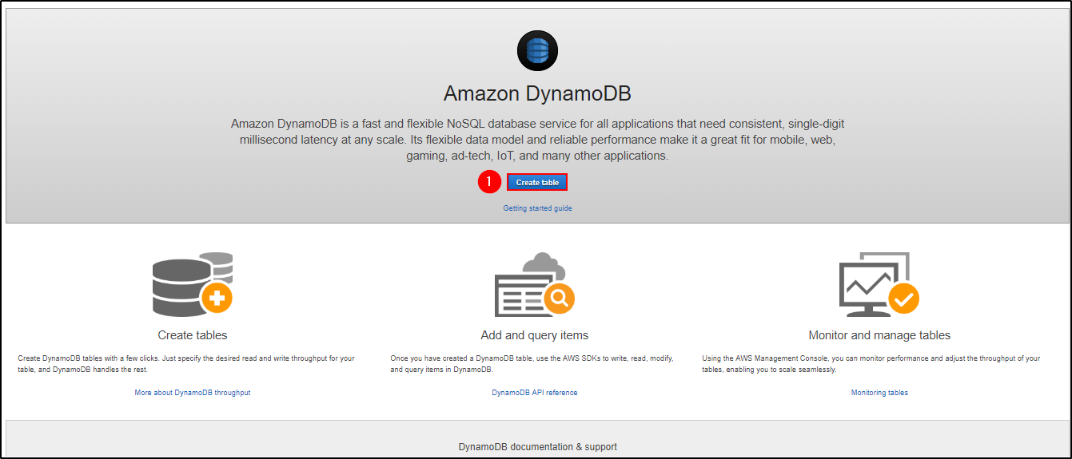

***Create Table – Amazon DynamoDB Tutorial***

**Step 2:**Fill in with the necessary details and click on “*Create*“.

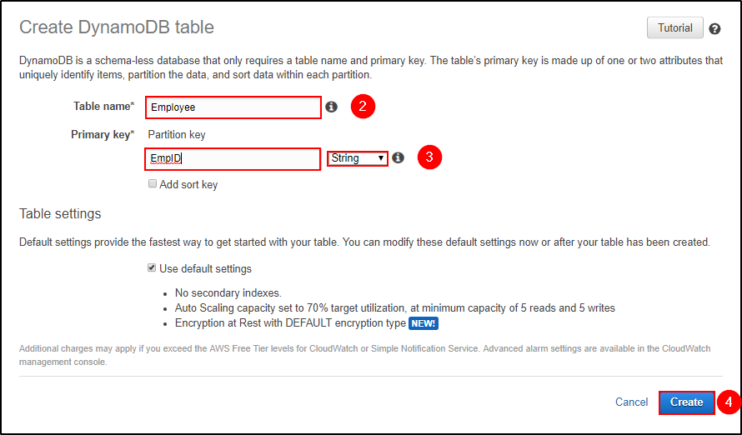

***Create Table – Amazon DynamoDB Tutorial***

**Step 3:**You can view your table being created. Click on “*Overview*” to understand your table, click on “*Items*” to edit, insert and query on the table. There are many more options you can use to understand your table better.

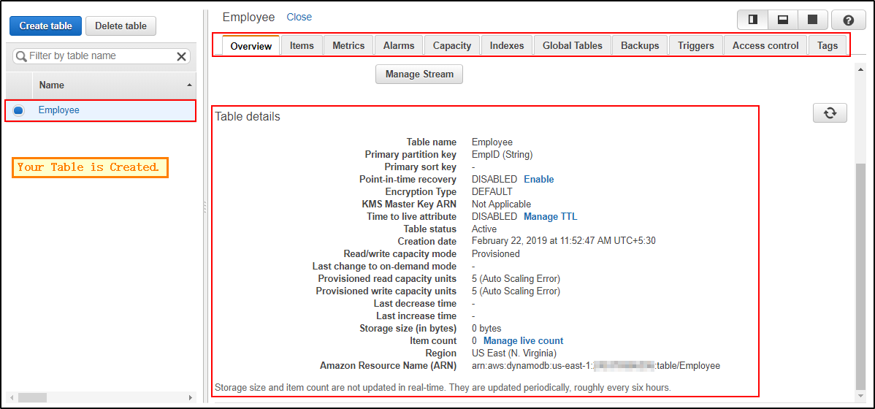

***Table Description – Amazon DynamoDB Tutorial***

Now that you have created a table, let’s go ahead and insert a few items and understand how NoSQL works.

**Step 1:**Navigate to “*Items*” and click on “*Create item*“.

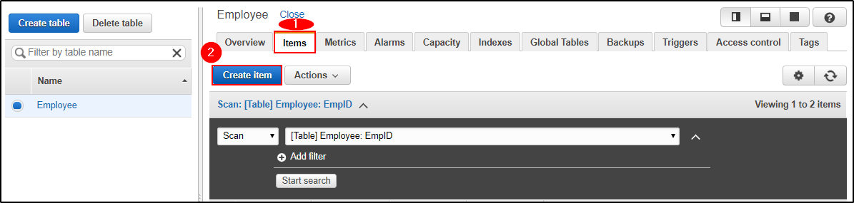

***Create Item – Amazon DynamoDB Tutorial***

**Step 2:**It will open a JSON file where you can add different items. Click on the “+” symbol and select “*Append*” and select what type of data you want to enter.

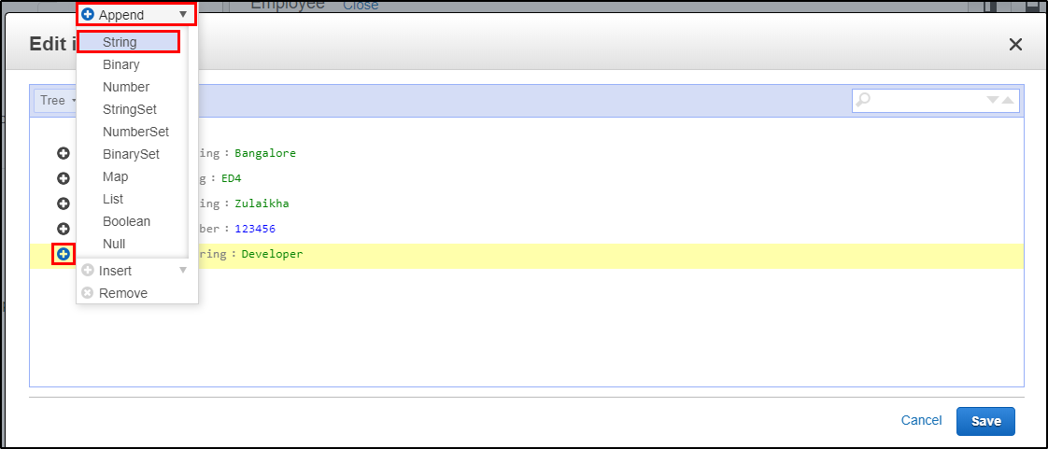

***Insert Item – Amazon DynamoDB Tutorial***

**Step 3:**This is what it looks like after adding multiple columns to your table. Click on “*Save*“.

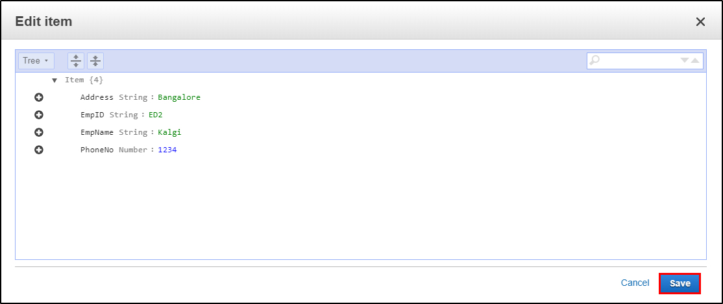

***Insert Item – Amazon DynamoDB Tutorial***

**Step 4:**Since it is a NoSQL architecture, you can play around with the columns you add to the table. E.g. “*Position*“.

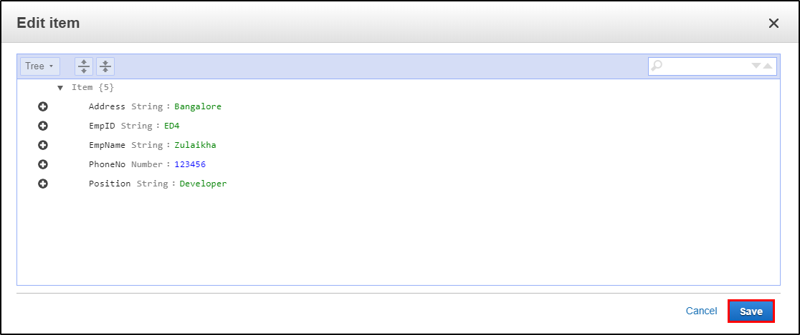

***Insert Item – Amazon DynamoDB Tutorial***

**Step 5:**This is how your table will look like once you have inserted the data.

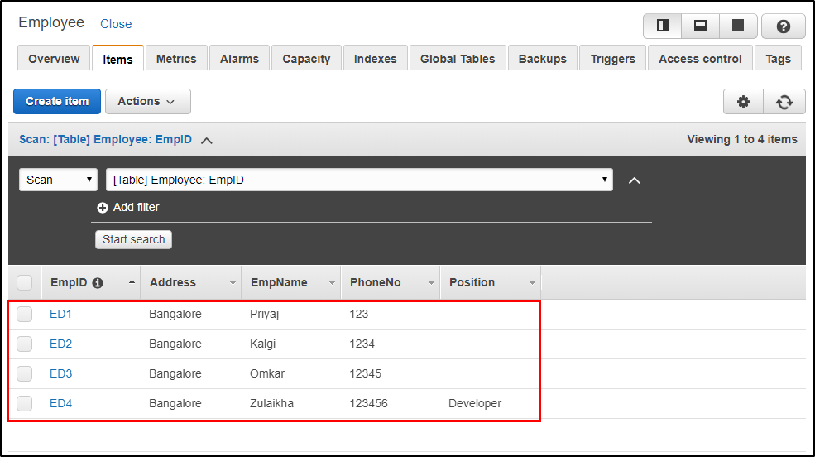

***Display Table Content – Amazon DynamoDB Tutorial***

Now that we have a table ready, let’s go ahead and look at some basic queries.

**Step 1:**Here you can frame your query and click on “*Start Search*” to get the desired result.

E.g. I am searching for all the mobile numbers that are greater than or equals to “*1234*“.

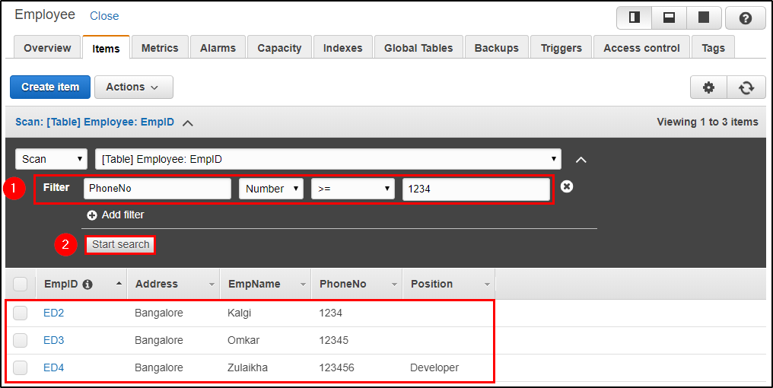

***Search Table – Amazon DynamoDB Tutorial***

**Step 2:**Here, I am searching for the record which has *EmpId* as “*ED4*“.

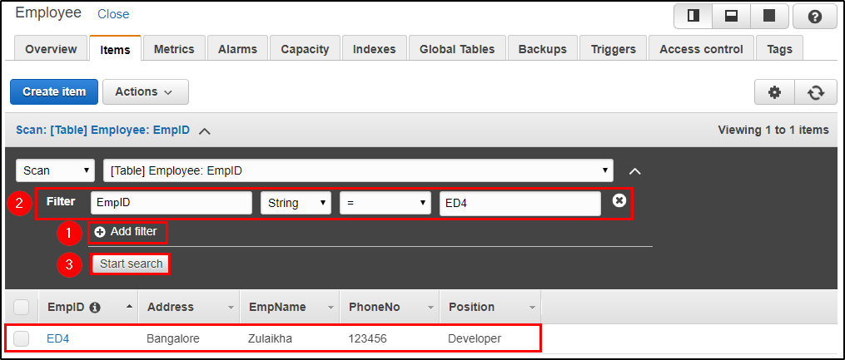

***Search Table – Amazon DynamoDB Tutorial***