**Introduction to Amazon Elastic Container Service (ECS)**

**Amazon Elastic Container Service (ECS)**, also known as [Amazon EC2](https://www.geeksforgeeks.org/what-is-elastic-compute-cloud-ec2/amp/)Container Service, is a managed service that allows users to run Docker-based applications packaged as containers across a cluster of EC2 instances. Running simple containers on a single EC2 instance is simple but running these applications on a cluster of instances and managing the cluster is being administratively heavy process. With ECS, Fargate launch type, the load, and responsibility of managing the EC2 cluster is transferred over to the AWS and you can focus on application development rather than management of your cluster architecture.[AWS  Fargate](https://www.geeksforgeeks.org/introduction-to-aws-fargate/amp/)is the AWS service that allows ECS to run containers without having to manage and provision the resources required for running these applications.

**How Elastic Container Service Works?**

Amazon elastic container service is a fully managed service which is provided by AWS it is mainly used to deploy containers that are docker based by which you scale up and down depending on the traffic you’re going to get. The containers will run inside the Amazon elastic cloud (EC2) instance.

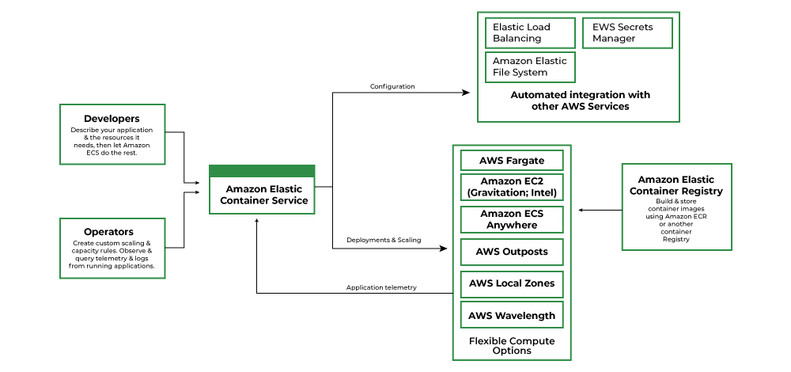

1. **Container:**A container is a package that holds an application and everything dependencies, libraries, etc.) the application requires to run. Containers are independent of the underlying operating system and hence container applications are fairly portable, flexible, and scalable. This ensures the application will run always as expected irrespective of the system and environment in which a container is run.
2. **Docker:**[Docker](https://https/www.geeksforgeeks.org/introduction-to-docker/amp/)is software that facilitates and automates the installation and deployment of applications inside [Linux](https://www.geeksforgeeks.org/introduction-to-linux-operating-system/amp/) containers.
3. **Cluster:**A logic group of EC2 instances running as a single application.
4. **Container Instance:**Each EC2 in an ECS Cluster is called a container instance.

**Autoscaling With AWS ECS**

Autoscaling is an AWS Compute service that allows your application to scale up/down according to EC2 instance CPU usage or some other criteria (Autoscaling policies) set by the user.   For example: For a web application, you can set an [Autoscaling](https://www.geeksforgeeks.org/amazon-web-services-scaling-amazon-ec2/amp/)Policy like, when CPU usage exceeds 80% for five minutes add another EC2 instance with the same configurations. This will add another instance behind the [Amazon ELB](https://www.geeksforgeeks.org/elastic-load-balancer-in-aws/amp/) and allow requests divided into EC2 instances now. Earlier, the Autoscaling feature was only provided with AWS EC2 service, in the year 2016, it started to support ECS clusters as well.

1. Autoscaling for ECS Clusters can be set up from AWS-CLI, AWS-Console and AWS SDKs as well.
2. You can choose the number of starting tasks for the application, and attach one or more policies to the Autoscaling Group and AWS handles the rest.
3. Autoscaling for ECS also manages the Multi-AZ presence of your ECS cluster. That is, you can attach policies to have a minimum of one or more instances in each Availability Zone to make your application highly available.

**Features of ECS**

Some of the features of ECS are listed below:

1. Removes the need for users to manage their **CPU type cluster**the management system by interacting with AWS Fargate.
2. Allows seamless deployment of container-based applications. This can be scheduled or done by simple API calls.
3. AWS ECS takes care of the management and monitoring of the application cluster.
4. Amazon ECS is *region specific.*This means that a cluster can only scale up/down (start-up or shut-down container instances) in a single region.
5. Clusters are dynamically scalable.