AI/ML FOUNDATIONS · CHAPTER 1
Linear Regression, MSE
and Gradient Descent
  - An end-to-end visual learning chapter with NumPy, worked examples, diagnostics and interview preparation
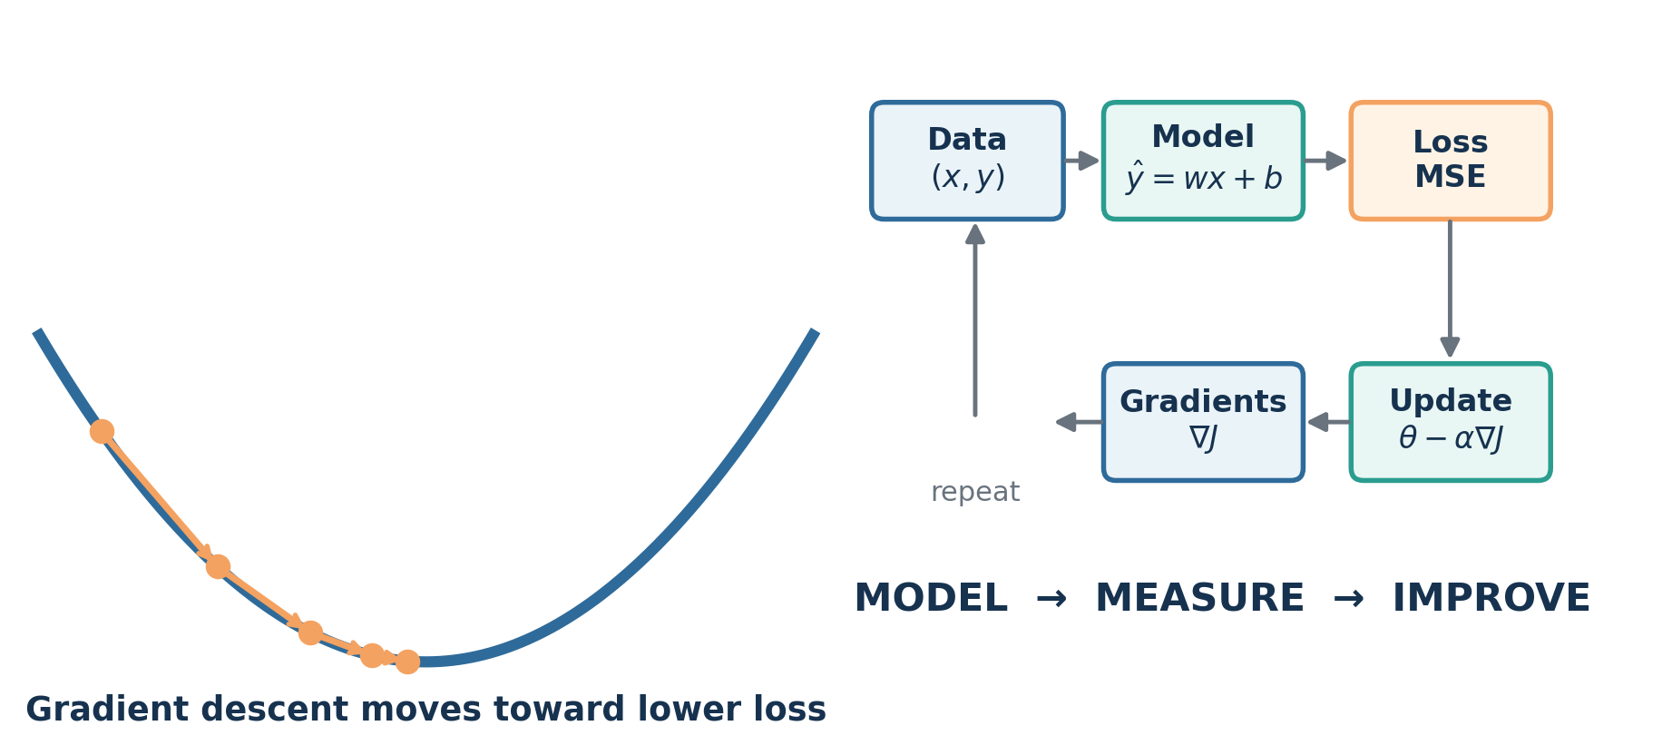
From data to a fitted line: model, measure the error, and iteratively improve.
PREPARED FOR  Rajni Singh | CAREER TARGET  Google / top-tier AI & ML leadership roles
Includes a separate executable Jupyter notebook

How to use this chapter
This chapter is designed as both a learning resource and an interview workbook. Read each concept, reproduce the calculation without looking, execute the notebook, and then answer the interview questions aloud.
Why this matters for your target role
At AI Director level, you will not be evaluated only on whether you can name an algorithm. You must connect model choice, data quality, metrics, operational risk, business decisions and team guidance. Linear regression is the cleanest environment for mastering that complete reasoning loop.

Learning outcomes
- Explain linear regression intuitively to an executive and mathematically to an ML engineer.
- Write the prediction equation for simple and multiple linear regression.
- Calculate residuals, MSE, RMSE, MAE and R², and choose an appropriate metric.
- Derive the gradients of MSE with respect to the slope and intercept.
- Implement batch gradient descent from scratch using vectorized NumPy.
- Diagnose learning-rate, scaling, leakage, outlier and residual-pattern problems.
- Frame a production regression system for incident-resolution forecasting.
- Answer fundamental, mathematical, coding and leadership-level interview questions.

Recommended depth for you
Depth | What you should be able to do
Executive | Explain what the model predicts, what an error means, why a baseline matters, and how the output changes a decision.
Technical | Derive the MSE gradients, implement vectorized gradient descent, and explain convergence.
Diagnostic | Recognize nonlinearity, heteroscedasticity, multicollinearity, leakage, outliers and drift.
Director | Define success metrics, deployment controls, monitoring, ownership and a build-versus-buy decision.

Chapter map
Part | Focus
1 | Linear regression intuition and vocabulary
2 | The mathematical model and a worked calculation
3 | Mean Squared Error and evaluation metrics
4 | Gradient descent and derivative intuition
5 | NumPy implementation from scratch
6 | Model diagnostics, assumptions and failure modes
7 | Enterprise incident-resolution case study
8 | Interview questions with model answers
9 | Exercises, answer key and seven-day study plan
10 | One-page revision cheat sheet and resources

1. Linear regression intuition
Linear regression models the average relationship between one or more input features and a continuous numerical target. It chooses coefficients that make predictions as close as possible to the observed values under a defined loss function.
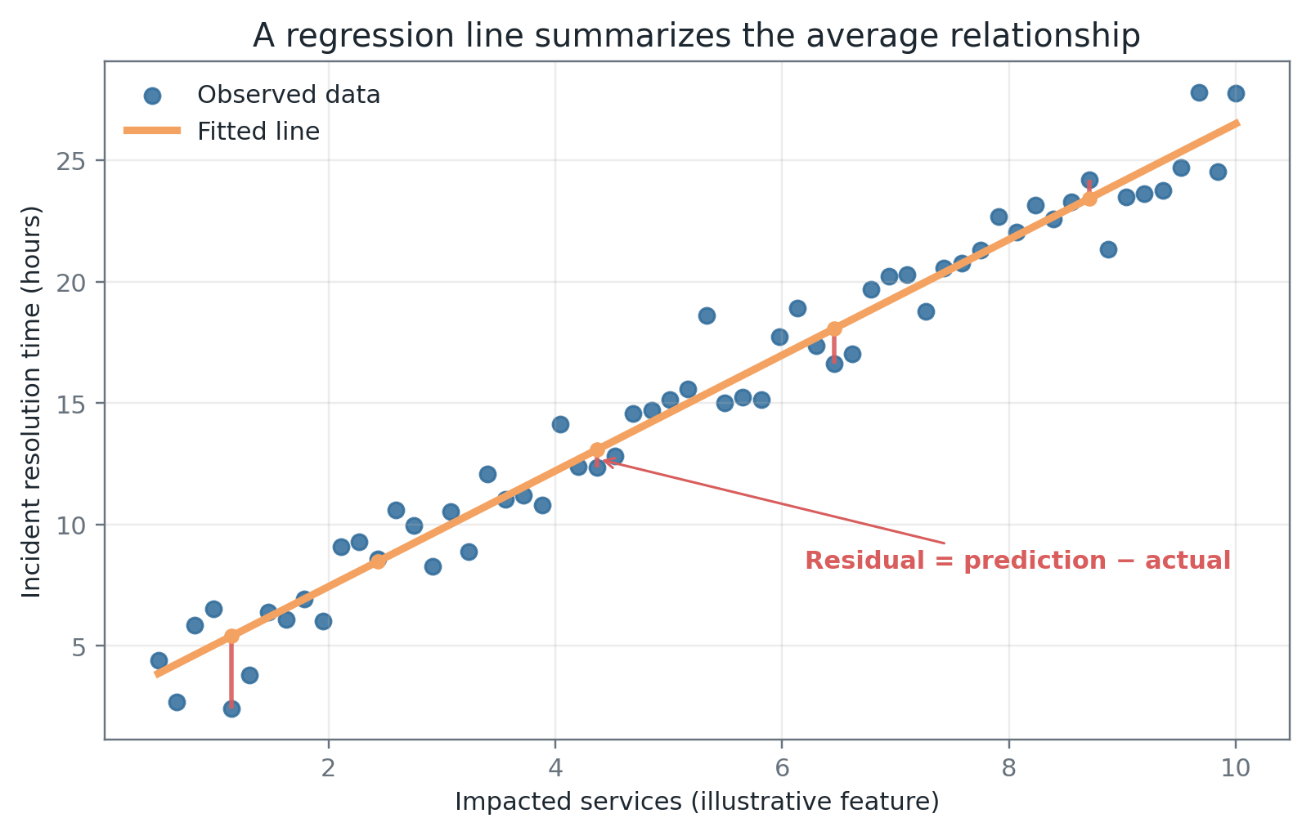
Figure 1. Each red vertical segment is a residual. The fitted line is chosen to make the squared residuals collectively small.

1.1 The simplest model
ŷᵢ = w xᵢ + b
prediction = slope × feature + intercept

Term | Meaning
xᵢ | The input feature for observation i.
yᵢ | The actual observed target.
ŷᵢ | The model prediction.
w | The slope: expected change in prediction for a one-unit change in x.
b | The intercept: predicted value when x = 0.
eᵢ | The residual or prediction error, commonly defined as ŷᵢ − yᵢ.

Interpret coefficients carefully
A slope describes an association learned from the data. It is not automatically causal. “One additional impacted service is associated with 2.35 more resolution hours” is safer than “one additional service causes 2.35 more hours” unless the study design supports causality.

1.2 Simple versus multiple linear regression
Model | Equation | Use
Simple | ŷ = b + w₁x₁ | One feature; excellent for intuition and visualization.
Multiple | ŷ = b + w₁x₁ + … + wₚxₚ | Several features; each coefficient is interpreted while holding the others constant.
Polynomial features | ŷ = b + w₁x + w₂x² + … | The model is still linear in the parameters even though the curve is nonlinear in x.

1.3 What linear regression is really doing
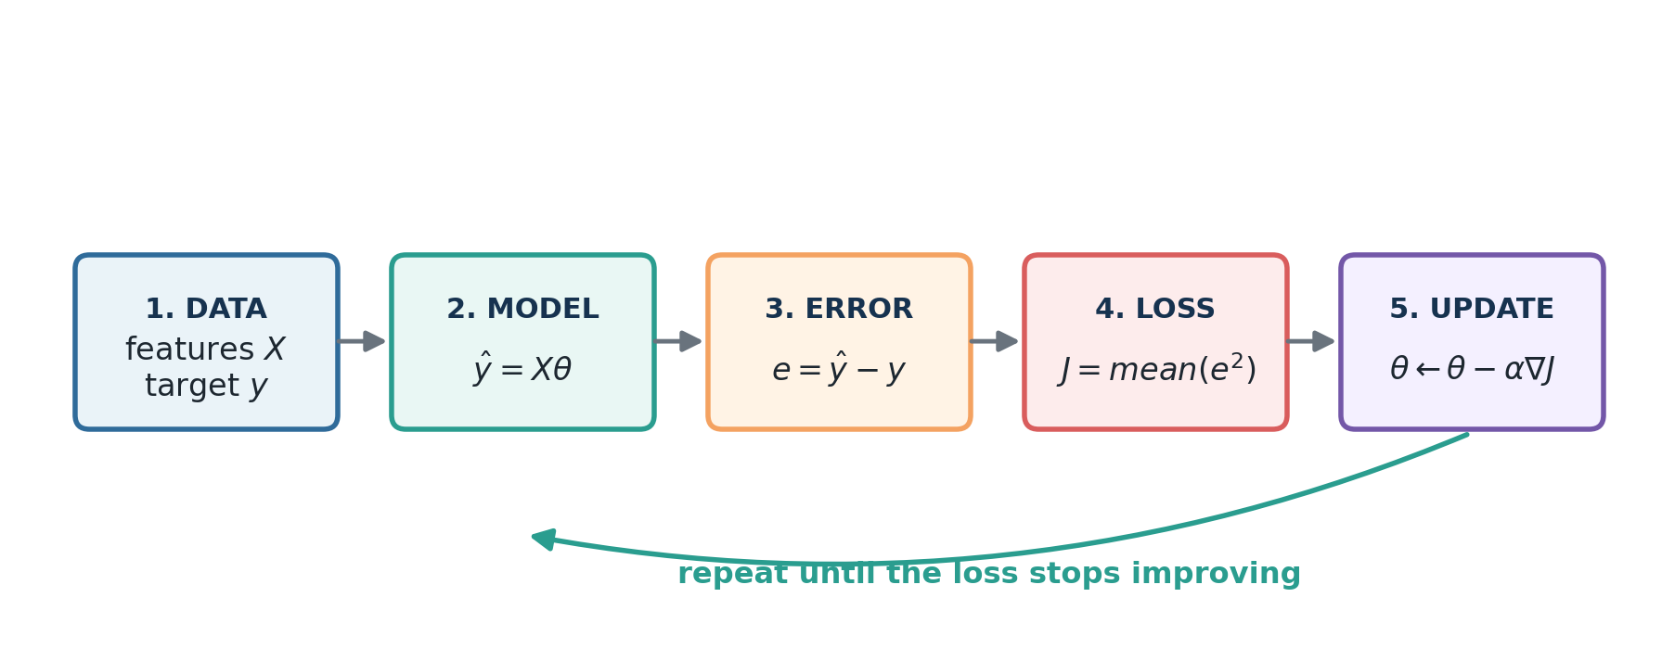
Figure 2. Training is a feedback loop: predict, measure the error, compute a direction of improvement, and update the parameters.
1. The model converts features into predictions.
2. The residual measures how far each prediction is from its actual value.
3. The loss combines all residuals into one optimization objective.
4. The optimizer changes the parameters to reduce the loss.
5. Evaluation checks whether the learned relationship generalizes to unseen data.

1.4 A baseline, not a final answer by default
Linear regression is often the right first model because it is fast, transparent and difficult to hide behind. Even when a more complex model eventually wins, the linear baseline reveals whether the extra complexity creates meaningful incremental value.
Director question to ask the team
What performance improvement did the complex model deliver over the simplest credible baseline, and was that improvement worth the added latency, cost, operational risk and explainability burden?

2. Mathematical model and worked calculation

2.1 Vector and matrix form
ŷ = Xθ
X contains the features; θ contains the intercept and coefficients

For n observations and p features, X has shape n × (p + 1) when the first column is a column of ones for the intercept. The parameter vector θ has shape (p + 1), and the prediction vector ŷ has shape n.
Object | Shape | Example meaning
X | n × (p + 1) | Rows are incidents; columns are intercept, severity, backlog and other features.
θ | (p + 1) | Intercept plus one coefficient per feature.
ŷ | n | Predicted resolution time for each incident.
y | n | Observed resolution time for each incident.

2.2 Worked prediction example
Suppose an illustrative model predicts incident-resolution time using the number of impacted services:
predicted hours = 2.75 + 2.35 × impacted services

For six impacted services:
ŷ = 2.75 + 2.35 × 6 = 16.85 hours

If the actual time was 18.10 hours, then the residual using e = ŷ − y is −1.25 hours. The negative sign means the model underpredicted.

2.3 The ordinary least-squares solution
θ* = (XᵀX)⁻¹Xᵀy
conceptual normal equation; use a numerically stable solver in code

The closed-form solution directly identifies the coefficient vector that minimizes squared error. In practice, avoid explicitly computing a matrix inverse. Use a least-squares solver or the pseudoinverse, such as np.linalg.lstsq or np.linalg.pinv.
Stable NumPy comparison solution
X_design = np.column_stack([np.ones_like(x), x])
theta_closed = np.linalg.pinv(X_design) @ y
intercept, slope = theta_closed

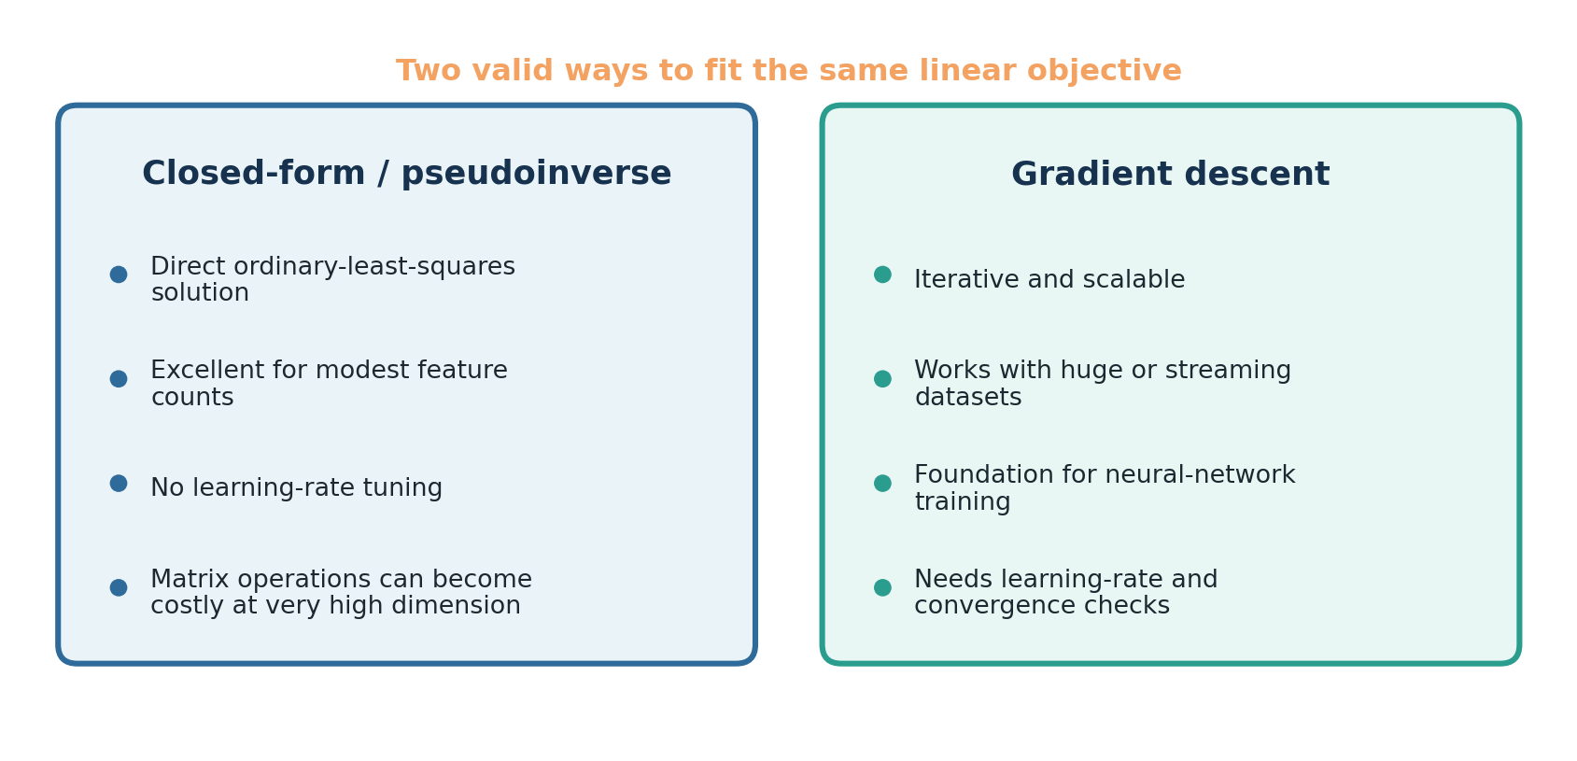
Figure 3. Closed-form and gradient descent solve the same ordinary least-squares objective but have different operational characteristics.

2.4 Why learn gradient descent when a direct solution exists?
- It is the optimization foundation for neural networks and most modern deep-learning systems.
- It scales better when the number of rows or features makes matrix factorization expensive.
- It works naturally with mini-batches, streaming data and many regularized objectives.
- It builds the intuition required to debug exploding loss, poor scaling and unstable training.

3. Mean Squared Error (MSE)

3.1 Definition
MSE = (1/n) Σᵢ (ŷᵢ − yᵢ)²
average squared residual

MSE is the average of the squared prediction errors. A perfect model on the evaluated data has MSE = 0. The unit is the square of the target unit, which is why RMSE is often easier to communicate.

3.2 Why square the residuals?
Reason | Implication
Positive contributions | Positive and negative residuals cannot cancel each other.
Large-error penalty | A residual twice as large contributes four times the squared penalty.
Smooth objective | The derivative exists everywhere and gives a clean optimization direction.
Statistical interpretation | Minimizing MSE corresponds to maximum likelihood under independent Gaussian errors with constant variance.

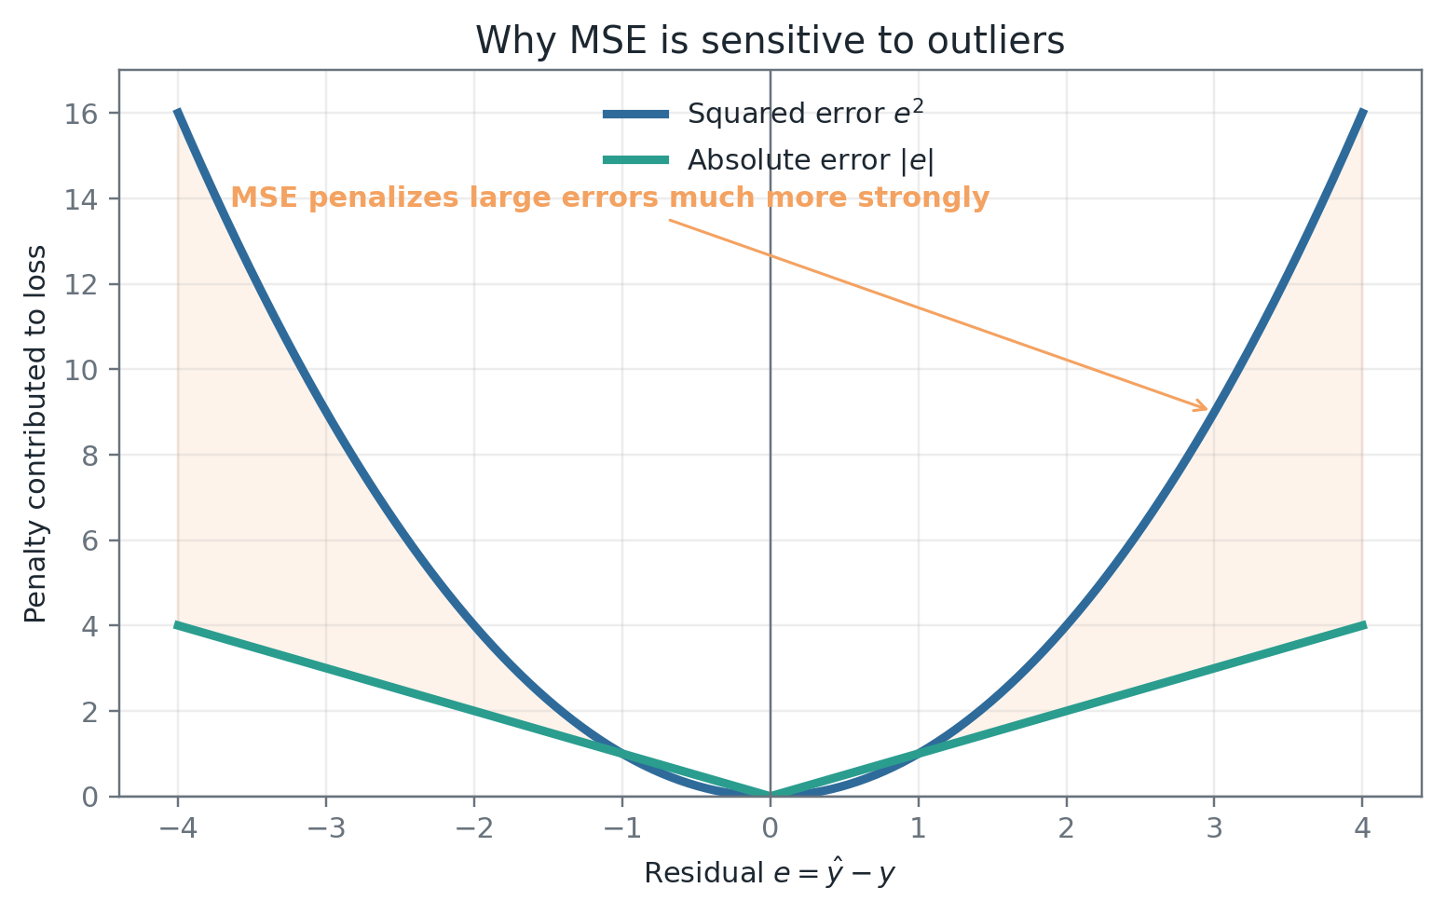
Figure 4. Squaring gives MSE a strong preference for avoiding large errors, which is useful in some applications and dangerous in the presence of outliers.

3.3 Manual MSE calculation
x | Actual y | Prediction ŷ | Residual ŷ − y | Squared residual
1 | 2 | 1.5 | −0.5 | 0.25
2 | 4 | 3.8 | −0.2 | 0.04
3 | 5 | 5.6 | +0.6 | 0.36

MSE = (0.25 + 0.04 + 0.36) / 3 = 0.2167

3.4 MSE, RMSE, MAE and R²
Metric | Best use | Caution
MSE | Optimization and cases where large errors deserve a strong penalty. | Squared units; highly sensitive to outliers.
RMSE | Communication in the target unit while retaining MSE’s large-error penalty. | Still outlier-sensitive.
MAE | Robust business interpretation when each unit of error has similar cost. | Less sensitive to rare large misses; gradient is not smooth at zero.
R² | Share of variance explained relative to predicting the mean. | Can mislead, can be negative on test data, and does not measure operational value.

Metric selection principle
Choose the metric that reflects the decision cost. If a five-hour underprediction creates a major service-risk escalation, plain average error may be insufficient. Consider asymmetric costs, quantile regression or explicit business-cost functions.

4. Gradient descent

4.1 Core idea
Gradient descent starts with initial parameter values, calculates the direction in which the loss increases most rapidly, and then takes a step in the opposite direction. Repeating the process moves the parameters toward a minimum.
θ ← θ − α ∇J(θ)
new parameters = old parameters − learning rate × gradient

Term | Meaning
θ | The current parameter vector.
J(θ) | The loss as a function of the parameters.
∇J(θ) | The vector of partial derivatives; it points uphill.
α | The learning rate; it controls the step size.

4.2 Gradients for simple linear regression
J(w,b) = (1/n) Σᵢ (w xᵢ + b − yᵢ)²

∂J/∂w = (2/n) Σᵢ (ŷᵢ − yᵢ) xᵢ

∂J/∂b = (2/n) Σᵢ (ŷᵢ − yᵢ)

The factor xᵢ appears in the slope gradient because changing the slope affects a prediction in proportion to the feature value. The intercept shifts every prediction equally, so its gradient contains only the residuals.

4.3 Derivation using the chain rule
Step | Expression | Reasoning
1 | eᵢ = wxᵢ + b − yᵢ | Define the residual.
2 | J = (1/n)Σeᵢ² | MSE objective.
3 | ∂(eᵢ²)/∂eᵢ = 2eᵢ | Differentiate the square.
4 | ∂eᵢ/∂w = xᵢ; ∂eᵢ/∂b = 1 | Differentiate the linear prediction.
5 | Multiply using the chain rule | Produces the two gradient formulas above.

4.4 One complete numerical update
Use x = [1, 2, 3], y = [2, 4, 5], start with w = 0 and b = 0, and choose learning rate α = 0.05.
Quantity | Value
Initial predictions | [0, 0, 0]
Initial residuals ŷ − y | [−2, −4, −5]
Initial MSE | 15.000
∂J/∂w | -16.667
∂J/∂b | -7.333
Updated slope w | 0 − 0.05 × (-16.667) = 0.833
Updated intercept b | 0 − 0.05 × (-7.333) = 0.367
MSE after one update | 3.020

Read the signs, not just the arithmetic
Both gradients are negative, so subtracting them increases w and b. That is sensible because the current model predicts zero for every point and is systematically too low.

4.5 Loss landscape and convergence
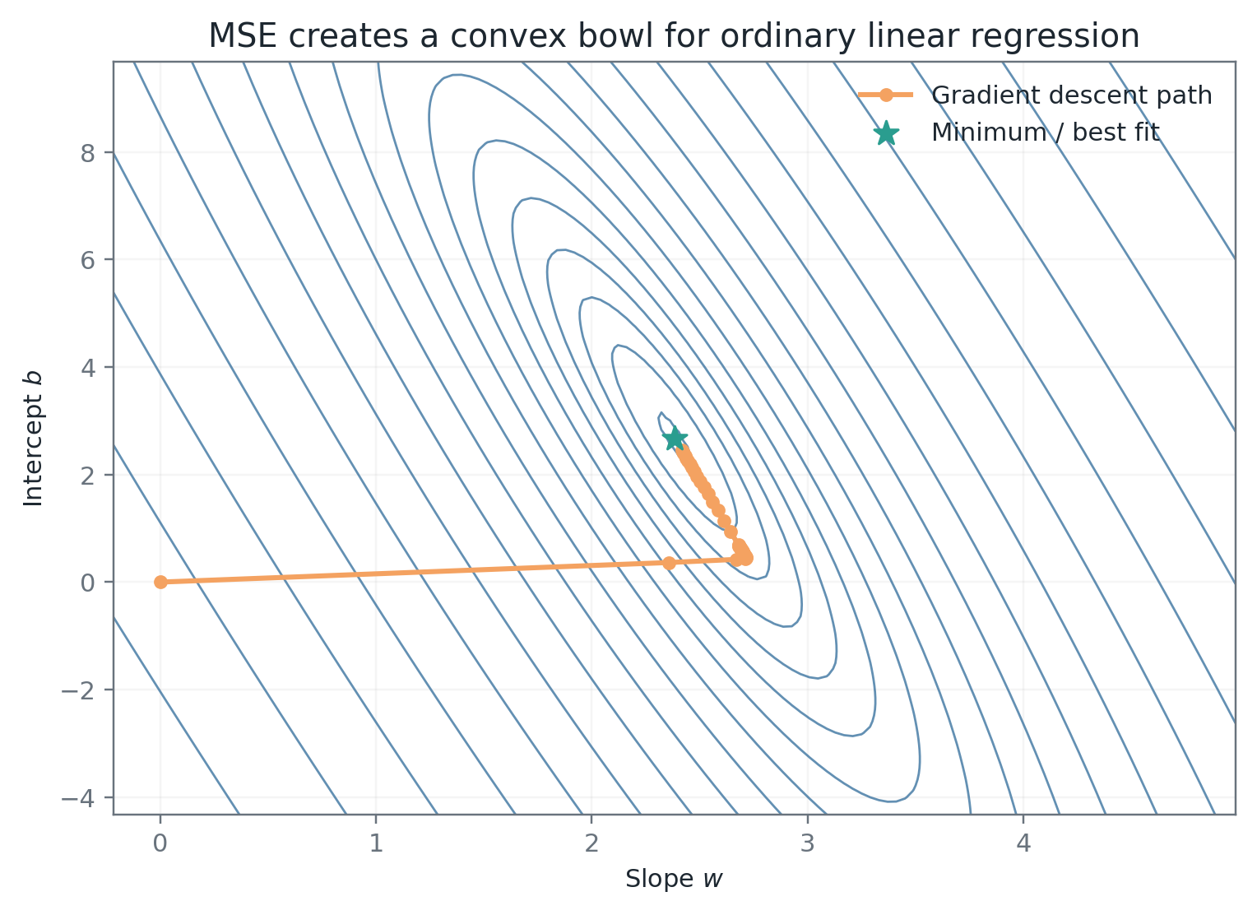
Figure 5. For ordinary linear regression with MSE, the loss is convex. There is one global minimum, so a stable gradient-descent configuration can reach the best fit.

4.6 Learning rate
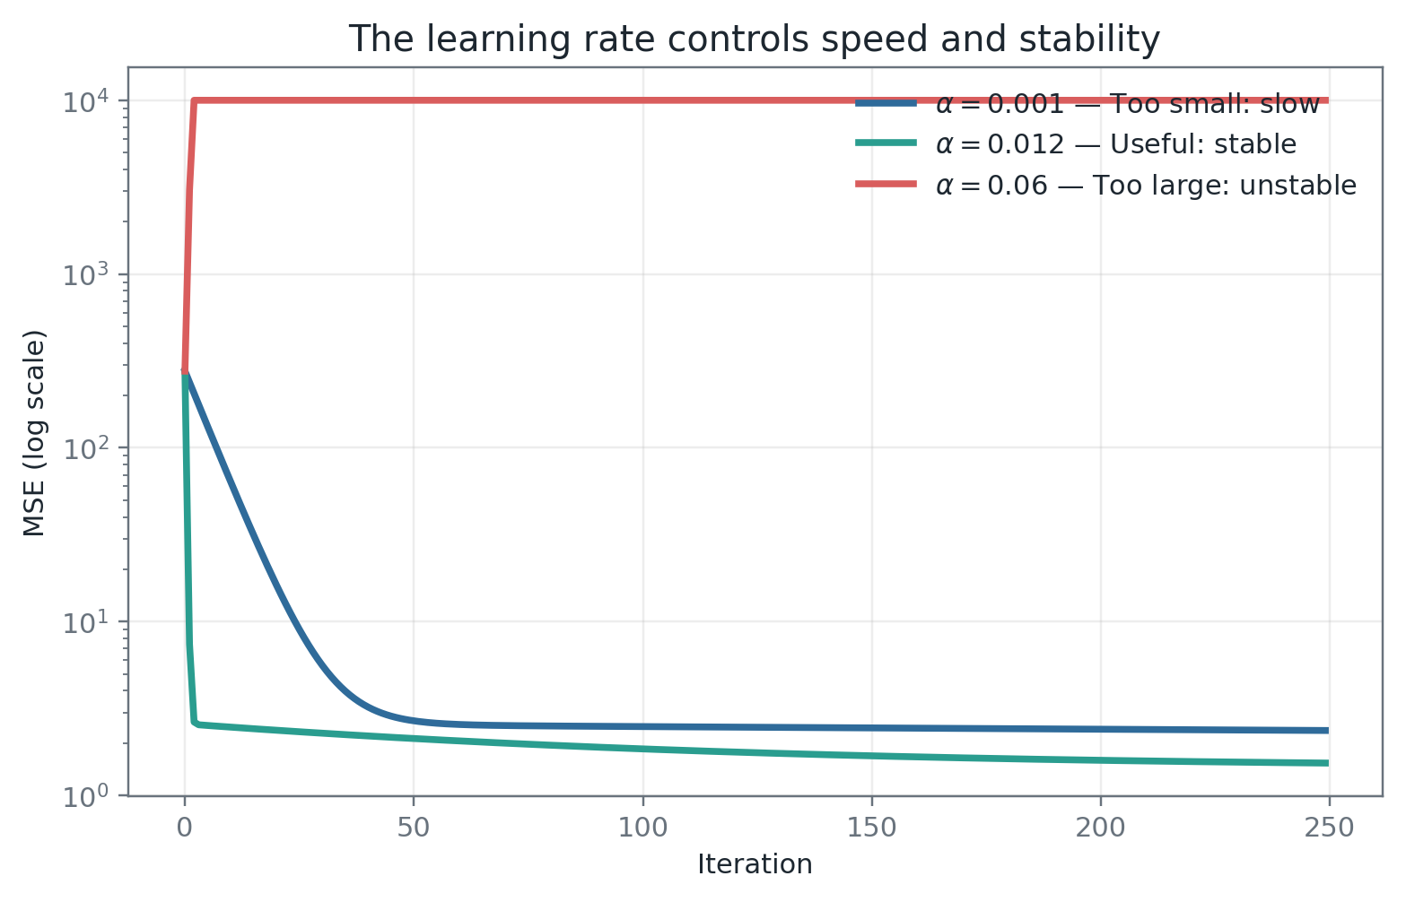
Figure 6. A very small learning rate wastes iterations; a very large rate can oscillate or diverge.
Symptom | Likely cause | Response
Loss decreases extremely slowly | Learning rate too small; poor feature scaling. | Scale features; increase α carefully; use a schedule.
Loss jumps or becomes NaN | Learning rate too large; extreme features; numerical overflow. | Reduce α; standardize; inspect data and gradients.
Loss plateaus above a good solution | Insufficient iterations; poor conditioning; implementation bug. | Check gradient formula, scaling and convergence tolerance.
Training loss improves but validation worsens | Overfitting, leakage or distribution mismatch. | Improve split design; regularize; simplify; audit leakage.

4.7 Batch, stochastic and mini-batch descent
Variant | Gradient uses | Strength | Trade-off
Batch GD | All training rows | Stable, exact gradient for the dataset. | Can be slow for very large data.
SGD | One row | Fast updates and useful noise. | Noisy path; sensitive to schedule.
Mini-batch GD | A small batch | Efficient matrix operations; standard for deep learning. | Batch size is another tuning decision.

5. NumPy implementation from scratch
Implementation goal
Do not use scikit-learn for the training loop. We will use only NumPy matrix operations so every step corresponds directly to the equations.

5.1 Create an illustrative dataset
Step 1 — data and design matrix
import numpy as np
rng = np.random.default_rng(42)
x = np.linspace(0.5, 10.0, 60)
y = 2.75 + 2.35 * x + rng.normal(0, 1.55, size=x.shape)
# Add a column of ones so theta[0] acts as the intercept.
X = np.column_stack([np.ones_like(x), x])

The design matrix has 60 rows and two columns: one intercept column and one feature column. The parameter vector will therefore contain two values: [intercept, slope].

5.2 Prediction and loss functions
Step 2 — model and MSE
def predict(X: np.ndarray, theta: np.ndarray) -> np.ndarray:
return X @ theta
def mse(y: np.ndarray, y_hat: np.ndarray) -> float:
return float(np.mean((y_hat - y) ** 2))

5.3 Vectorized gradient-descent loop
Step 3 — training loop
def fit_linear_regression_gd(
X: np.ndarray,
y: np.ndarray,
learning_rate: float = 0.012,
steps: int = 1800,
) -> tuple[np.ndarray, np.ndarray]:
theta = np.zeros(X.shape[1], dtype=float)
history = np.empty(steps, dtype=float)
n = len(y)
for step in range(steps):
y_hat = X @ theta
error = y_hat - y
gradient = (2.0 / n) * (X.T @ error)
theta -= learning_rate * gradient
history[step] = np.mean(error ** 2)
return theta, history

5.4 Train, inspect and compare
Step 4 — results and correctness check
theta, history = fit_linear_regression_gd(X, y)
y_hat = predict(X, theta)
print(f"intercept: {theta[0]:.3f}")
print(f"slope: {theta[1]:.3f}")
print(f"RMSE: {np.sqrt(mse(y, y_hat)):.3f}")
# Closed-form comparison
closed = np.linalg.pinv(X) @ y
print("closed-form:", closed)

Output | Result from the included dataset
Gradient-descent intercept | 2.676
Gradient-descent slope | 2.383
Pseudoinverse intercept | 2.676
Pseudoinverse slope | 2.383
Training RMSE | 1.204 hours
Training R² | 0.968

The gradient-descent and pseudoinverse coefficients should be very close. That comparison is a powerful unit test for a from-scratch implementation.

5.5 What each matrix operation means
Code | Shape | Meaning
X @ theta | (n,) | Generate one prediction per row.
error = y_hat − y | (n,) | Measure signed prediction errors.
X.T @ error | (p+1,) | Aggregate how each parameter contributed to the errors.
(2/n) × … | (p+1,) | Scale the aggregate into the MSE gradient.
theta −= α × gradient | (p+1,) | Move parameters downhill.

5.6 Production-quality improvements
- Validate shapes, finite values and numeric data types.
- Separate train, validation and test data before any data-dependent transformation.
- Standardize features with statistics learned only from the training set.
- Track training and validation metrics, not training loss alone.
- Use an early-stopping tolerance and a maximum iteration count.
- Log versions and metrics, validate against np.linalg.lstsq, and add regularization when needed.

5.7 Multiple linear regression
The same vectorized algorithm supports many features
# Example features: severity, impacted_services, backlog, automation_flag
X_raw = np.column_stack([
severity,
impacted_services,
backlog,
automation_flag,
])
# Learn mean and standard deviation only on training data.
mu = X_raw.mean(axis=0)
sigma = X_raw.std(axis=0)
X_scaled = (X_raw - mu) / sigma
X = np.column_stack([np.ones(len(X_scaled)), X_scaled])
theta, history = fit_linear_regression_gd(X, y_hours)

Why scaling matters
Without scaling, a backlog feature ranging from 0–10,000 may dominate a binary feature ranging from 0–1 in the gradient magnitude. Standardization improves conditioning and lets one learning rate work more reliably across parameters.

5.8 Common implementation bugs
Bug | What you observe | Correction
Wrong residual sign | The update may move uphill if the sign and update convention are inconsistent. | Use error = prediction − actual with theta -= α × gradient.
Missing factor of 2 | Usually still converges; effective learning rate changes. | Be internally consistent with the definition of loss.
No intercept column | Line is forced through zero. | Add a ones column or maintain b separately.
Mean taken over wrong axis | Wrong gradient shape or incorrect loss. | Check dimensions after every matrix expression.
Scaling before splitting | Validation/test information leaks into training. | Fit transformations on training data only.
Explicit matrix inverse | Numerical instability or failure with collinearity. | Use pinv or lstsq.

6. Evaluation, assumptions and diagnostics

6.1 Split before you learn
A model should be evaluated on data it did not use to learn parameters or preprocessing statistics. For time-dependent enterprise data, use a temporal split rather than randomly mixing future and past incidents.
Partition | Purpose | Typical misuse
Training | Fit model parameters and training-only transformations. | Reporting training performance as proof of generalization.
Validation | Choose features, regularization, learning rate and model family. | Repeatedly tuning until it effectively becomes training data.
Test | One final unbiased estimate before release. | Using it during model selection.

6.2 Assumptions and their practical meaning
Assumption | What it means | What to inspect or do
Linearity / additive form | Expected target is represented adequately by the chosen features and transformations. | Residual pattern, partial plots, interactions, nonlinear features.
Independent errors | Residuals are not strongly correlated across observations. | Time ordering, grouped data, repeated entities, autocorrelation.
Constant variance | Residual spread is approximately stable across prediction levels. | Residual-vs-predicted plot; transformations; robust errors.
Exogeneity | Unobserved factors correlated with a feature do not drive the residual. | Domain review, omitted-variable analysis, causal caution.
Limited multicollinearity | Features are not near-duplicates of each other. | Correlation, VIF, unstable coefficients; regularization.
Normal residuals | Residuals are approximately normal when classical confidence intervals/tests are required. | Q-Q plot; less critical for pure prediction with enough data.

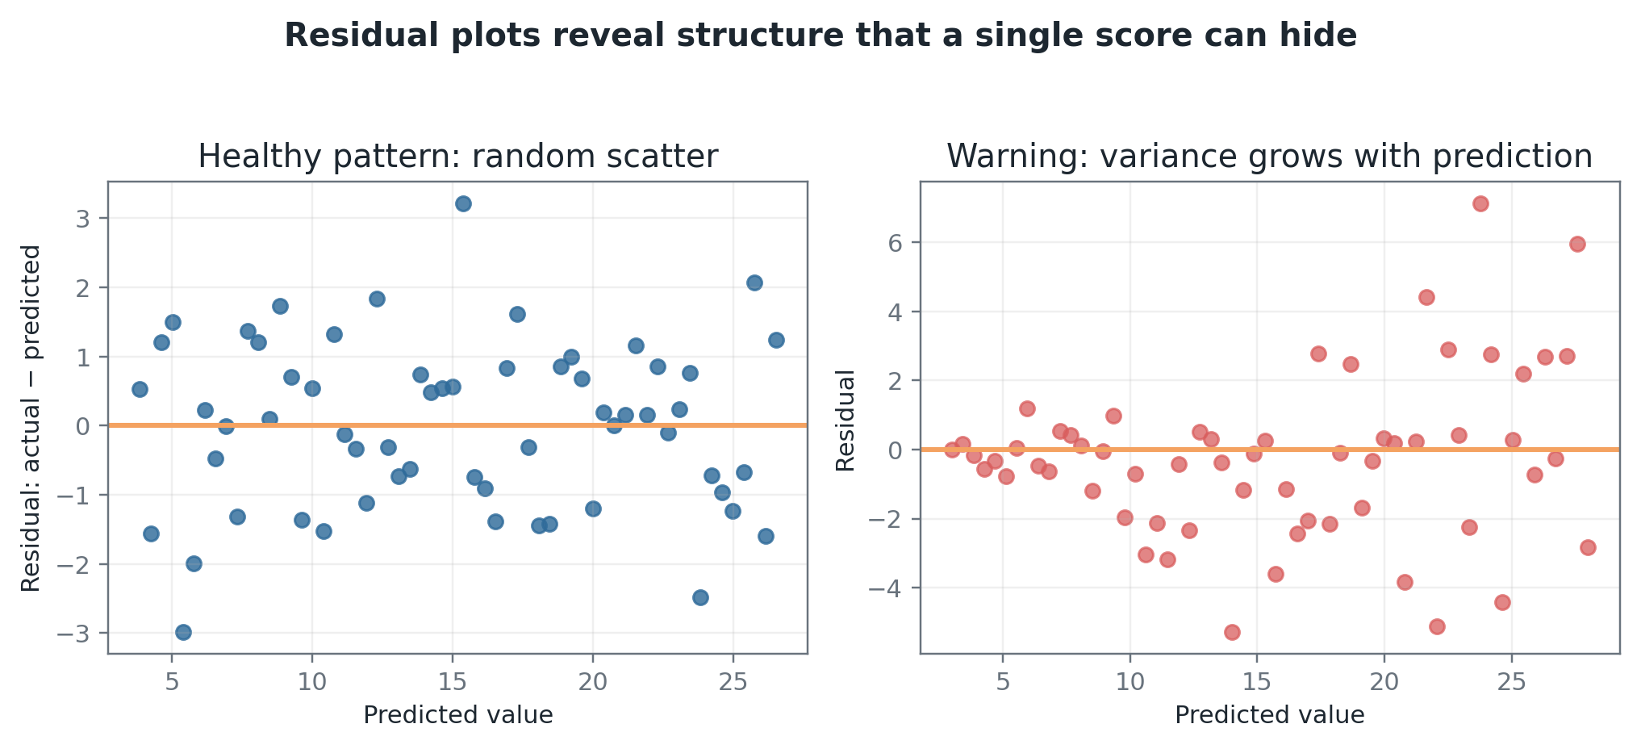
Figure 7. A residual plot can expose heteroscedasticity, nonlinearity, segmentation problems or missing features.

6.3 Outliers and influential points
Because MSE squares errors, unusual observations can strongly influence the fitted line. Do not automatically delete them. Determine whether they are data errors, rare but valid events, a distinct operating regime, or the most important risk cases in the business.
Action | When appropriate
Correct or remove | Verified data corruption, impossible values or duplicated records.
Transform | Skewed target or feature where a log or other transformation matches the process.
Robust loss/model | Valid extreme values should not dominate every coefficient.
Segment | Different populations follow materially different relationships.
Keep and weight | Rare cases are business-critical and deserve explicit attention.

6.4 Regularization preview
Ridge: J(θ) = MSE + λ Σⱼ wⱼ²

Lasso: J(θ) = MSE + λ Σⱼ |wⱼ|

Ridge shrinks coefficients smoothly and helps with multicollinearity. Lasso can drive some coefficients to zero and therefore performs a form of feature selection. Do not penalize the intercept unless there is a deliberate reason.

6.5 Production monitoring
Layer | Examples
Data | Schema, missingness, range, category changes, feature drift and freshness.
Model | RMSE, MAE, segment error, residual distribution, calibration of intervals.
System | Latency, availability, throughput, failed predictions and rollback readiness.
Business | Planning accuracy, SLA breaches, staffing efficiency, adoption and overrides.
Governance | Data access, privacy, audit trail, documented limitations and ownership.

7. Enterprise case study: predicting incident-resolution time
The objective is to estimate resolution time at incident creation and update the estimate as new information arrives. The prediction may support staffing, escalation, user communication and prioritization. It should not silently become an automatic decision without controls.
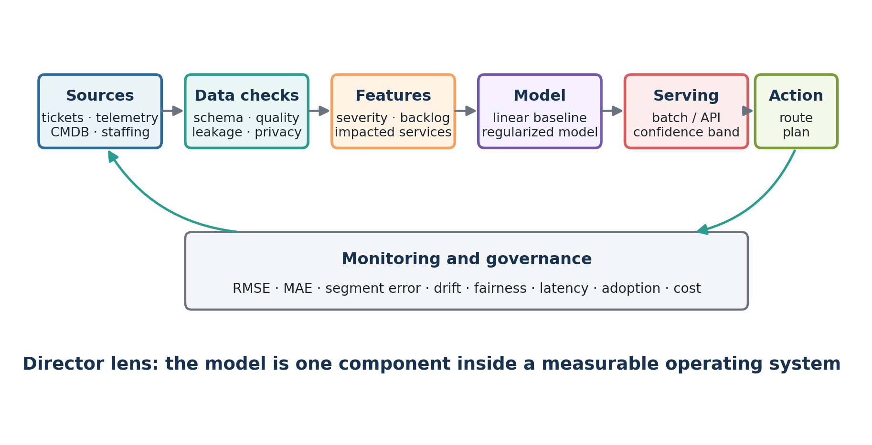
Figure 8. A production regression model is embedded in a governed data, serving, monitoring and decision workflow.

7.1 Problem framing
Decision | Design question
Target | Elapsed resolution time, remaining time, probability of breaching an SLA, or a quantile?
Prediction moment | At creation, after triage, or continuously updated?
Users | Incident commander, service owner, support agent, staffing manager, or customer?
Action | Escalate, allocate staff, communicate ETA, trigger diagnostics, or only inform?
Cost of error | Is underprediction worse than overprediction? Does the cost vary by severity?

7.2 Candidate features
- Severity and service criticality.
- Number of impacted services, users or regions.
- Current backlog and on-call staffing.
- Time of day, day of week and holiday indicators.
- Historical service reliability and recent incident frequency.
- Availability of a verified runbook or automated remediation.
- Text-derived features from the incident description, with strict leakage review.
- Current diagnostic stage when the estimate is updated over time.

7.3 Leakage traps
Critical leakage example
A feature such as “number of teams eventually involved” may be highly predictive but unavailable at incident creation. Using it for an initial estimate leaks future information and creates an unrealistically strong offline model.

- Resolution-code fields populated after closure.
- Post-incident review text.
- Final root-cause category.
- Number of comments accumulated over the full incident lifetime.
- A future staffing or escalation decision caused by the target itself.

7.4 Metrics and rollout
Stage | What to require
Offline | Temporal validation, RMSE/MAE, error by severity/service/region, residual analysis, baseline comparison.
Shadow | Generate predictions without changing operations; inspect errors, latency and workflow fit.
Pilot | Limited teams; human review; log overrides and reasons; monitor harm and adoption.
Scaled release | SLOs, alerts, drift checks, owner, retraining criteria, rollback and audit evidence.

7.5 Director-level architecture answer
A strong interview answer should make the following sequence explicit:
1. Clarify the decision, user, target and prediction time.
2. Define the baseline and business cost of different errors.
3. Design data contracts and eliminate future-data leakage.
4. Train a transparent linear baseline before adding complexity.
5. Evaluate globally and by risk-relevant segment.
6. Deploy first in shadow mode, then a controlled human-reviewed pilot.
7. Monitor data, model, system, business and governance metrics.
8. Assign ownership, incident response, retraining and retirement criteria.

8. Interview questions with model answers
Practice method
Cover the answer, speak for 60–120 seconds, then compare. A strong answer starts with a direct definition, adds the important trade-off, and finishes with an applied example.

1. What is linear regression?
It is a supervised-learning method for predicting a continuous target as a weighted sum of input features. Ordinary least squares chooses coefficients that minimize the sum or mean of squared residuals. I use it both as an interpretable model and as a baseline against which more complex models must prove incremental value.
2. What is the difference between a residual and an error term?
The theoretical error term is the unobserved noise in the population model. A residual is the observed difference between a fitted prediction and an actual sample value. Residuals are estimates of the unobserved errors and are used for diagnostics.
3. Why is MSE commonly used?
MSE prevents signed errors from canceling, penalizes large misses strongly, is differentiable, and has a maximum-likelihood interpretation under Gaussian constant-variance noise. Its weakness is strong sensitivity to outliers, so the business cost and data distribution must justify it.
4. MSE or MAE?
MSE is appropriate when large errors are disproportionately costly or when smooth optimization is valuable. MAE is more robust and directly communicates average absolute error. I select between them based on the cost of error, not habit, and often report both.
5. Derive the slope gradient.
Start with J=(1/n)Σ(wx+b−y)². Let e=wx+b−y. By the chain rule, d(e²)/dw=2e·x. Averaging across observations gives ∂J/∂w=(2/n)Σeᵢxᵢ.
6. What does the gradient tell you?
It is a vector of local slopes of the loss with respect to the parameters. It points in the direction of fastest increase, so gradient descent subtracts a learning-rate-scaled gradient to move downhill.
7. What happens if the learning rate is too high or too low?
Too low produces slow convergence. Too high can overshoot, oscillate or diverge. I inspect the loss curve, standardize features, reduce or schedule the learning rate, and add numerical checks for NaN or exploding gradients.
8. Why scale features for gradient descent?
Features on very different scales create an elongated loss surface and gradients with very different magnitudes. Standardization improves conditioning, speeds convergence and makes one learning rate work more consistently across coefficients.
9. Closed-form solution or gradient descent?
For small-to-medium ordinary least-squares problems, a stable least-squares solver is direct and convenient. Gradient descent is preferable for very large data, mini-batch or streaming settings, and objectives that do not have a simple closed form. Learning it is also essential for deep learning.
10. Is linear regression only capable of straight lines?
It is linear in the parameters, not necessarily in the raw feature. Polynomial, spline, interaction and transformed features allow nonlinear shapes while retaining a linear combination of coefficients.
11. What assumptions matter?
The core concerns are adequate functional form, independent errors, stable variance, limited collinearity and exogeneity. Normal residuals are especially important for classical statistical inference; they are not a strict requirement for generating predictions.
12. What is multicollinearity?
It occurs when features contain highly overlapping information. Predictions may remain acceptable, but individual coefficients become unstable and hard to interpret. I diagnose it with domain knowledge, correlations or VIF and respond with feature redesign, regularization or dimensionality reduction.
13. What is heteroscedasticity?
It means residual variance changes with the prediction or feature level. It can make uncertainty estimates unreliable and indicates that one global error scale is inadequate. I inspect residual plots and consider transformations, robust standard errors, weighted regression or segmentation.
14. Can R² be negative?
Yes, especially on validation or test data. A negative R² means the model performs worse than simply predicting the evaluation-set mean under the R² definition.
15. Does a high R² prove a good model?
No. R² can be high because of leakage, trend, a narrow operating range or irrelevant correlation. It says nothing by itself about causal validity, fairness, latency, stability, cost or whether errors are acceptable for the decision.
16. How do outliers affect linear regression?
Squared loss gives large residuals high leverage, and extreme feature values can strongly rotate the line. I verify whether points are errors or valid rare events, use influence diagnostics, and choose correction, robust loss, transformation, segmentation or explicit weighting based on the business.
17. How do you handle categorical variables?
Encode categories using one-hot or another justified representation, keep a reference category to avoid perfect collinearity with an intercept, handle unseen categories, and prevent high-cardinality encodings from leaking target information.
18. What is data leakage in this context?
Leakage occurs when training uses information unavailable at the real prediction moment or derived from the target. In incident prediction, final resolution code or total comments at closure would leak future information into an initial estimate.
19. How do you know gradient descent has converged?
I monitor loss improvement, gradient norm or parameter change against a tolerance, while enforcing a maximum iteration count. I also compare against a trusted solver on a small dataset and verify validation performance.
20. Batch versus stochastic versus mini-batch descent?
Batch uses the entire dataset and gives a stable exact dataset gradient. Stochastic uses one observation and is noisy but updates quickly. Mini-batch balances efficient vectorized computation with frequent updates and is the standard for deep-learning systems.
21. How would you explain a coefficient to an executive?
I would translate it into the target unit and state the conditions: holding other model features constant, a one-unit increase in the feature is associated with an expected change of the coefficient in the prediction. I would explicitly avoid causal language unless the design supports causality.
22. When would you reject linear regression?
I would reject or extend it when residuals show strong nonlinear structure, relationships differ materially by segment, outliers dominate, the decision needs asymmetric uncertainty, or a validated alternative creates meaningful business value that justifies added complexity.
23. How would you monitor a production regression model?
I would monitor data contracts and drift, RMSE/MAE and residuals by segment, system SLOs, business outcomes and overrides, plus governance controls. I would define thresholds, owners, retraining criteria, rollback and retirement conditions before release.
24. Why start with a linear baseline for an AI platform use case?
It creates a transparent reference point, exposes data and metric problems early, is cheap to operate, and forces the team to quantify the incremental value of complexity. A sophisticated model that barely beats the baseline may not be an economically sound production choice.
25. Design question: predict incident-resolution time.
I would first clarify the target, prediction moment, users and cost of under- versus overprediction. Then I would create a temporal split, eliminate future-data leakage, build a mean/median and linear baseline, evaluate by severity and service, deploy in shadow mode, pilot with human review, and monitor accuracy, operational value, drift, adoption and overrides.

8.1 Coding prompts to practice
- Implement MSE without using np.mean.
- Implement a vectorized gradient function and verify it with finite differences.
- Add early stopping when improvement is smaller than a tolerance for 20 iterations.
- Standardize multiple features without leaking validation statistics.
- Add Ridge regularization but do not penalize the intercept.
- Write tests for shapes, NaN values, convergence and agreement with np.linalg.lstsq.
- Plot training and validation loss and diagnose three possible curve patterns.

9. Exercises and answer key

9.1 Concept questions
1. Why can positive and negative residuals not simply be averaged?
2. Why is RMSE easier to communicate than MSE?
3. What does a negative residual mean under e = ŷ − y?
4. Why does a temporal split matter for incident data?
5. Why is a coefficient not automatically causal?
6. What does it mean for the loss surface to be convex?

9.2 Calculation exercise
Given x = [0, 1, 2], y = [1, 3, 5], w = 1, b = 0:
- Calculate the three predictions.
- Calculate the residuals using e = ŷ − y.
- Calculate the MSE.
- Calculate ∂J/∂w and ∂J/∂b.
- Perform one update using α = 0.1.

9.3 Coding exercise
Modify the included notebook to create 300 synthetic incidents with four features. Add one irrelevant random feature and compare its coefficient with and without Ridge regularization. Evaluate on a temporal holdout and report RMSE, MAE and error by severity.

9.4 Director exercise
Prepare a five-minute answer to this prompt: “Your team proposes a gradient-boosted model that improves RMSE by 3% over linear regression but triples serving cost and is harder to explain to operations. What do you do?”
What a strong answer includes
Decision cost, error distribution rather than average alone, segment impact, explainability needs, latency and cost, pilot evidence, adoption, reliability, compliance, and whether the 3% improvement changes an actual business decision.

9.5 Answer key
Question | Answer
Concept 1 | Signed residuals can cancel even when predictions are poor; use absolute or squared magnitudes.
Concept 2 | RMSE is in the same unit as the target.
Concept 3 | The prediction is lower than the actual value: the model underpredicted.
Concept 4 | Random splitting can train on future operating conditions and test on the past, producing an unrealistic estimate.
Concept 5 | Association may reflect confounding, selection or omitted variables.
Concept 6 | Any local minimum is also the global minimum for the objective.

Calculation | Result
Predictions | [0, 1, 2]
Residuals | [-1, -2, -3]
MSE | 4.667
∂J/∂w | -5.333
∂J/∂b | -4.000
Updated w | 1.533
Updated b | 0.400

9.6 Seven-day mastery plan
Day | Study | Output
1 | Intuition, equation, residuals and coefficient interpretation. | Explain the model in 90 seconds; calculate five predictions by hand.
2 | MSE, RMSE, MAE and R². | Solve three metric calculations; choose a metric for two business scenarios.
3 | Gradient and chain-rule derivation. | Derive both gradients from memory and perform one manual update.
4 | Execute and rewrite the NumPy implementation. | Train from scratch without copying; compare with pinv/lstsq.
5 | Scaling, learning rate and convergence. | Run three learning rates; annotate the resulting curves.
6 | Assumptions, diagnostics and leakage. | Audit the incident case and identify at least five failure risks.
7 | Interview and director synthesis. | Complete a 30-minute mock: 10 technical questions plus the system-design case.

10. Revision cheat sheet
Prediction: ŷ = Xθ

Residual: e = ŷ − y

Loss: J(θ) = (1/n) ‖Xθ − y‖²

Gradient: ∇J(θ) = (2/n) Xᵀ(Xθ − y)

Update: θ ← θ − α∇J(θ)

Remember | One-line explanation
Slope | Expected change in prediction for one unit of a feature, holding other modeled features constant.
Intercept | Prediction when all modeled features are zero; may or may not be operationally meaningful.
MSE | Average squared residual; smooth and outlier-sensitive.
RMSE | Square root of MSE; same unit as the target.
MAE | Average absolute residual; more robust.
R² | Improvement over predicting the mean, expressed as explained variance.
Learning rate | Controls optimizer step size.
Scaling | Improves conditioning and convergence.
Leakage | Uses information unavailable at the true prediction moment.
Residual plot | Checks whether error still contains systematic structure.

10.1 The 60-second interview answer
Model answer
Linear regression predicts a continuous target as a weighted sum of features. Ordinary least squares chooses the coefficients that minimize squared residuals. With gradient descent, I repeatedly compute predictions, residuals, the MSE gradient, and update the coefficients in the opposite direction of the gradient. I use it as an interpretable baseline, validate on unseen data, inspect residuals and leakage, and select metrics based on the business cost of errors.

10.2 Structured study materials
Primary structured course: Google Machine Learning Crash Course — Linear Regression, Loss and Gradient Descent
https://developers.google.com/machine-learning/crash-course
Practical textbook: Hands-On Machine Learning with Scikit-Learn, Keras & TensorFlow — training models chapter
https://www.oreilly.com/library/view/hands-on-machine-learning/9781098125967/
Statistical depth: An Introduction to Statistical Learning — Linear Regression chapter and exercises
https://www.statlearning.com/
Mathematical lecture notes: Stanford CS229 notes — supervised learning and linear regression
https://cs229.stanford.edu/
Implementation reference: NumPy documentation — arrays, matrix multiplication and linear algebra
https://numpy.org/doc/stable/

10.3 Completion standard
You are ready to move to logistic regression when you can complete all five items below without notes:
- Derive both simple-regression gradients.
- Write the vectorized NumPy training loop from memory.
- Explain MSE versus MAE using business cost.
- Diagnose a loss curve and a residual plot.
- Answer the incident-resolution system case in five structured minutes.
Daily progress commitment
Record the concept learned, code produced, quiz score, interview answer practiced, weakness found and tomorrow’s first task. Consistency matters more than watching more content.

Appendix A. Complete reference implementation
The separate Python file and Jupyter notebook contain an executable version with input validation, feature scaling, early stopping, plots, finite-difference gradient checking and multiple-regression practice. The compact core is reproduced below.
import numpy as np
def fit_gd(X, y, lr=0.01, steps=2000, tol=1e-10):
X = np.asarray(X, dtype=float)
y = np.asarray(y, dtype=float).reshape(-1)
if X.ndim != 2 or len(X) != len(y):
raise ValueError("X must be 2-D and align with y")
if not np.isfinite(X).all() or not np.isfinite(y).all():
raise ValueError("X and y must contain finite values")
theta = np.zeros(X.shape[1])
history = []
previous = np.inf
for _ in range(steps):
pred = X @ theta
error = pred - y
loss = float(np.mean(error ** 2))
gradient = (2.0 / len(y)) * (X.T @ error)
theta -= lr * gradient
history.append(loss)
if abs(previous - loss) < tol:
break
previous = loss
return theta, np.asarray(history)

Appendix B. Self-assessment rubric
Score | Evidence
0 — Not started | Cannot yet define the model or loss.
1 — Aware | Can describe linear regression but cannot calculate or implement it.
2 — Working | Can calculate predictions/MSE and execute the provided code.
3 — Interview-ready | Can derive gradients, implement from memory and diagnose common failures.
4 — Director-ready | Can connect the model to decision cost, architecture, rollout, governance and operating ownership.

