**MINI PROJECT REPORT**

**ON**

**ONLINE MAGAZINE READER**

**Submitted by**

**Vishal Agrawal(171500384)**

**Saurabh Singh(171500303)**

**Saurabh Tyagi(171500306)**

**Project Mentor-**

**Mr. Anand Parkash Gupta**

**(Technical Trainer)**

Department of Computer Engineering and Applications

**Institute of Engineering & Technology**



**GLA UNIVERSITY**

**MATHURA-281406,INDIA**

**2019-2020**

**GLA University**

**Mathura-281406, INDIA**

**2019**-**2020**

**ABSTRACT**

**Magazine reader** is a web application where user can read online magazines uploaded by developer or other users. This will provide content in an attractive way which will enhance the interest of reader in reading newspapers, magazines of general interest category wise trending news.

The main purpose of this project is to give its advertisers a chance to share with its readers about their products (which are things those readers want). It's the same purpose every business website has.The main reason for understanding the distinctions is that in a library you will find newspapers and magazines even digitalized newspapers and magazines in different places. In general, the purpose of a magazine reader is to convey, as efficiently as possible, current information, or "news", to a particular audience.

**CONTENTS**

1. Introduction
   1. General Introduction to the topic
   2. Area of Computer Science

1.3 Hardware and Software requirements

2. Problem Defintion

3. Objectives

4. Methodology

5. Implementation Details

6. Contribution Summary

7. Progress till date & the Remaining work.

8. References

**CHAPTER 1**

**INTRODUCTION**

* 1. General Introduction

Magazine is a periodical publication, generally consisting of sheets of paper folded in half and stapled at fold or a periodic publication containing pictures and stories and articles of interest to those who purchase it or subscribe to it; magazines contains longer articles on a variety of subjects. Magazines are meant to be read, but they're also a visual experience.

Magazine reader is a web application where user can read online magazines. Magazine will display in

an attractive way to the users. Here user can also see the content uploaded by the other users. Firstly the user has to signup for the system then after login , they can see covers of various magazines and

articles. When user click on any cover,finds related content in an attractive way.

* 1. Area of Computer Science

This project mainly covers the Area of Web Development of Computer Science. Through this project, we are trying to climb one step in this vast field of Computer Science. It is totally of web development project.

Web development is a specialized type of computer programming focused on websites and web applications. Web development deals with building technical front-end and/or back-end code that informs site function. Web developers may work exclusively on front-end code, back-end code, or both. Employment can involve independent freelance work or working in an organization's marketing or IT department.

1.3 Hardware and Software Requirements

* Hardware

1. Personal computer with 2GB RAM
2. Internet Connection

* Software

1. Bracket(Text Editor)
2. XAMPP Server

**CHAPTER 2**

**PROBLEM DEFINITION**

The motivation for the problems faced for this project came from our self experience. When we read magazines, we feel bored because there is no attractiveness in these magazines which can enhance the interest of reader, so we are developing this project**.** Digital magazines are increasingly capturing the attention of the media industry due to their ability to attract readers through interactive content, without involving high costs.

Magazine reader is increasingly attracting media industries because they have ability to attract different types of reader through interacting content, so this project will minimize the cost of purchasing magazines in future.

The digital version of a magazine has the ability to engage readers in different ways; most notably interactivity (with the content), social engagement (reader to reader) and video. And as mentioned in another answer, the content can be updated continuously.Problem in printed magazines is that you need to buy a magazine to read and you may not carry all the time with you. If we like something in the magazine it cannot be shared to your friends. And it is not flexible to reach the audience.The single biggest difference is that a print magazine is outdated before it’s even done being printed and it’s a static snapshot of a defined point in time, while it’s digital counterpart can be continuously updated and therefore never is “outdated” like it’s print counterpart. A paper magazine has to be printed, distributed and finally sold by the newsagents. These three processes, of course, incur a cost. Moreover, unsold copies of the magazine represent a loss for the publisher.Buying a **digital magazine is way more convenient** than buying a printed one. It can be done at home, at the office, on the bus. Pretty much everywhere. And the same goes for the consumption of the product: it can be read everywhere, anytime.This is made possible by the constant presence of Internet connections that characterise our world. Moreover, thanks to the huge increase in smartphone usage, **people can get access at all times**, even if they aren’t at home.

**CHAPTER 3**

**OBJECTIVES OF THE PROJECT**

Magazine reader is increasingly attracting media industries because they have ability to attract different types of reader through interacting content, so this project will minimize the cost of purchasing magazines in future. Basically the main objective of the project is to develop a website named magazine reader where user can access the magazines and even update it efficiently.The project aims to fulfill all the requirements from user side which could minimize the dependency of people on printed magazines. It also aims to **reach readers beyond regional boundaries.**

**The following objectives could be fulfill by this project**

1. **Through this online magazine reader user can access various magazines efficiently in a more attractive manner just by visiting on the website.**
2. **User can share their own content on the website like uploading their own magazines.**
3. **User do not need to buy magazines as they will get both free and paid on internet.**
4. **It will be flexible to the audience.**
5. **The production can saves lot of money.**
6. It is easy to reach masses. You can easily reach a huge audience.
7. It will be more convenient for the reader. **It will be more sustainable as** digital magazines play a big role in the fight against paper-waste and deforestation.

**CHAPTER 4**

**METHODOLOGY**

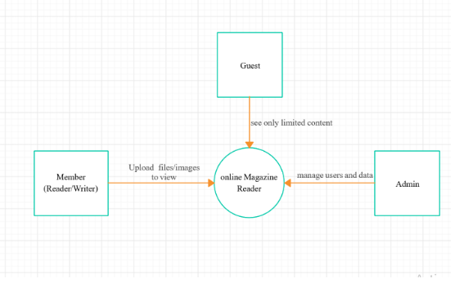Context Diagram

Flow-chart

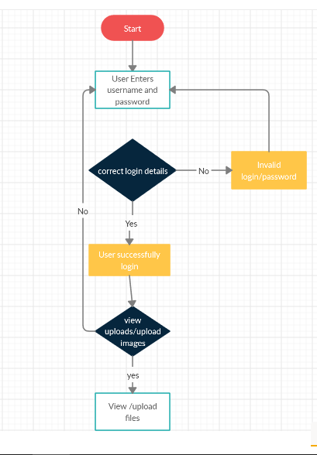

**CHAPTER 5**

**IMPLEMENTATION DETAILS**

Till now we have implemented user panel which consist of Login page ,sign up page which will allow users to enter their accounts.after giving their credentials they can log into their accounts and can find covers of different magazines.

We have used mysql as database where we created tables so that we can store login and sign-up data related to users and admin data.

**Tables created for sign-up purpose:**

|  |  |
| --- | --- |
| **Fields** | **Datatype** |
| Name | Varchar |
| Email | Varchar |
| Address | Varchar |
| Contact | Int |
| password | Varchar |

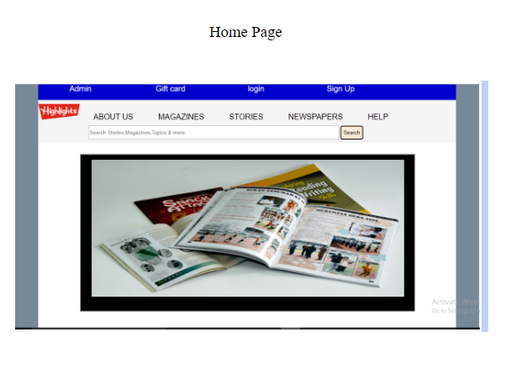

**Some glimpse from the project-**



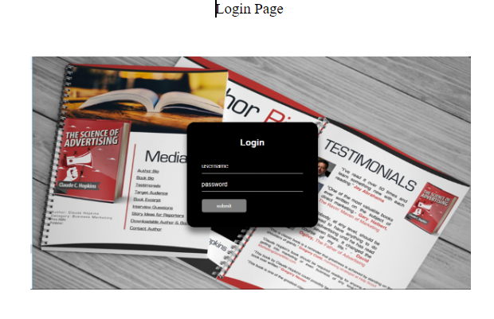

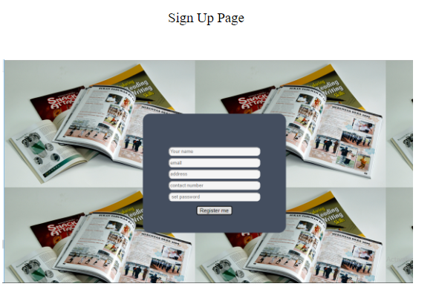

**CHAPTER 6**

**CONTRIBUTION SUMMARY**

There are mainly two panels in this project. All the two pannels are connected and interdependent on each other.All the contribution and panel related information given in table.

|  |  |  |
| --- | --- | --- |
| **Panels** | **Contributed by** | **Introduction to panel** |
| Admin | Saurabh Singh,  Saurabh Tyagi | This panel consist of different components like admin login ,admin sign-up etc where admin can uploads various magazines and articles through the accessibility of various features by the admin itself. The other facilities provided to the admin through this pannel is that he can even add the magazines of various categories like trending magazines, sports magazines,and user interested magazines. |
| User | Vishal Agrawal | This panel consist of different components like User login ,User sign-up which deals with the accessibility of various features by the users ie. User can access all content related magazines uploaded by the admin and also upload their own content through the accessibility of their own features.It includes how the magazines would be displayed to the user like the flipping concept used in the magazine pages. |

**CHAPTER 7**

**PROGRESS TILL DATE**

Complete: Front-end development of the project is mostly completed for all components.

Back-end implementation of signup and login of user panel has been completed through which user can login and access the content of magazines. Front-end implementation of flipping of pages have been completed.

Remaining: Back-end implementation of admin panel is still incomplete.where admin can delete the user and can add magazines. Also the concept of uploading the magazines by users is incomplete.

**CHAPTER 8**

**REFERENCES**

1. [www.google.com](http://www.google.com)
2. <https://www.w3schools.com/>
3. www.javatpoint.com