IBM INTERNSHIP PROJECT
Data Analytics & Machine Learning Internship
Bank Marketing & Customer
Behavior Analysis
Customer Subscription Prediction using Machine Learning

Submitted by
Shakshi Singh
Dataset: Bank Marketing Dataset — UCI Machine Learning Repository
45,211 Records • 16 Input Features • Binary Classification (Term Deposit Subscription)

1. Project Overview
For this project, I analyzed customer demographics, financial information, and telemarketing campaign data from a Portuguese banking institution. My objective was to identify the factors influencing customer subscription to term deposits and to build predictive models that could help improve marketing effectiveness.

Business Problem
Banks spend significant resources on telemarketing campaigns to promote financial products such as term deposits. However, only a small percentage of customers subscribe to these products, resulting in low campaign efficiency and high marketing costs. The business challenge is to identify customers who are more likely to subscribe so that future marketing campaigns can become more targeted and cost-effective.

Objectives
- Understand customer demographics and financial characteristics.
- Analyze marketing campaign performance.
- Identify factors affecting customer subscription.
- Perform exploratory data analysis.
- Build predictive machine learning models.
- Compare different classification algorithms.
- Generate business recommendations.

2. Dataset Information
Attribute | Details
Source | UCI Machine Learning Repository
Number of Records | 45,211
Number of Features | 16 Input Features
Target Variable | y (Yes / No subscription)
Missing Values | None
Duplicate Records | None

Four categorical columns contain "unknown" as a category, representing hidden missing data: job (288 records), education (1,857), contact (13,020), and poutcome (36,959 — about 81%, mostly because customers were never contacted in a previous campaign). These were retained as a separate category rather than removed.

3. Exploratory Data Analysis — Key Observations

Target Variable Distribution
The majority of customers did not subscribe to the term deposit, while only 11.7% subscribed — indicating a significant class imbalance in the dataset.

Age Distribution
Most customers are between 30 and 50 years old, with the distribution slightly right-skewed. A few customers above age 80 appear as outliers in the boxplot, but these are valid ages rather than data errors. Middle-aged customers (30-50) form the bulk of the customer base.

Job, Marital Status & Education vs Subscription
- Students (28.7%) and retired customers (22.8%) have the highest subscription rates, while blue-collar (7.3%) and entrepreneur (8.3%) customers have the lowest — despite blue-collar being the largest job group by count.
- Single customers (14.9%) subscribe more than married (10.1%) or divorced (11.9%) customers.
- Customers with tertiary education (15.0%) subscribe more than those with secondary (10.6%) or primary (8.6%) education.

Balance, Campaign Contacts & Call Duration
Metric | Non-subscribers (No) | Subscribers (Yes)
Average Balance | 1,303.71 | 1,804.27
Average Campaign Contacts | 2.85 | 2.14
Average Call Duration (sec) | 221.18 | 537.29

Customers who subscribed have a noticeably higher average balance and a much longer average call duration compared to those who didn't. Interestingly, subscribers were contacted fewer times on average — suggesting repeated calling doesn't necessarily improve conversion.

Correlation Analysis
Call duration has the strongest positive correlation with subscription (0.39) — by far the most important predictor. pdays and previous show a weak positive correlation, while campaign (number of contacts) has a slight negative correlation, confirming that more calls don't mean better results.

4. Feature Engineering
Before building machine learning models, categorical variables were converted into numerical form using Label Encoding. The pdays column required special handling since -1 represents "never contacted before" rather than an actual day count — a new binary flag column, was_contacted_before, was created to avoid treating -1 as a genuine numeric distance in later models.
The dataset was split into 80% training data and 20% testing data using stratified sampling to maintain the same class imbalance ratio (No/Yes) in both sets.

5. Machine Learning Models
Three classification models were trained and compared to predict customer subscription:
- Logistic Regression — baseline linear model
- Decision Tree (max depth = 6)
- Random Forest (200 estimators)
Since only ~12% of customers subscribed, accuracy alone can be misleading (a model predicting "No" for everyone would still achieve ~88% accuracy). Precision, recall, F1-score, and ROC-AUC were therefore used alongside accuracy for a fair evaluation.

Model Comparison Summary
Random Forest generally achieved the best balance of precision and recall among the three models, while Logistic Regression provided a simple, interpretable baseline. Decision Tree tended to have lower recall for the minority ("Yes") class due to the imbalance. Recall for the "Yes" class remained a challenge across all models because subscribers make up only about 12% of the data.

6. Interactive Dashboard
The insights from this analysis were also visualized as an interactive Power BI dashboard, allowing stakeholders to explore subscription patterns by occupation, education, marital status, and campaign attributes in real time.
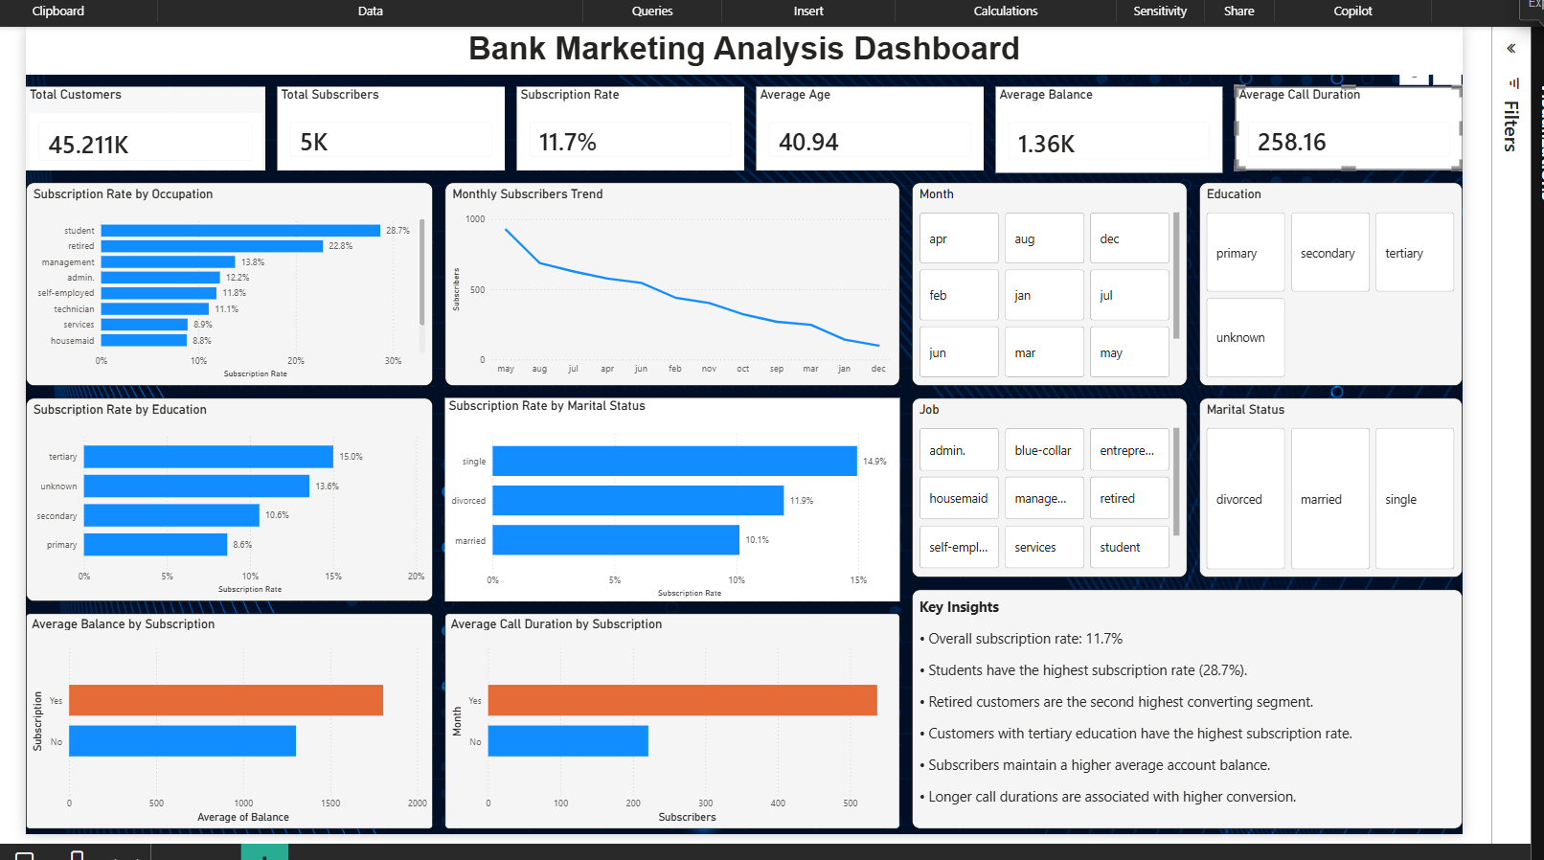
Figure 1: Bank Marketing Analysis Dashboard — KPI summary, subscription-rate breakdowns by demographic segment, and campaign performance indicators.

7. Final Business Insights & Recommendations

Key Findings
● Only ~11.7% of customers subscribed to a term deposit, showing significant class imbalance.
● Call duration is the single strongest predictor of subscription — longer calls are strongly associated with a "Yes" outcome.
● Students and retired customers have the highest subscription rates (28.7% and 22.8% respectively).
● Single customers and those with tertiary education subscribe at higher rates than married or primary-education customers.
● Customers with higher account balances and fewer contact attempts were more likely to subscribe.
● Random Forest achieved the best overall balance of precision and recall among the three models tested.

Business Recommendations
- Prioritize marketing efforts toward students, retired individuals, and single, well-educated customers — these segments show the highest conversion rates.
- Reduce excessive repeated calling; focus instead on improving the quality and relevance of each call, since longer, more meaningful conversations correlate with higher subscriptions.
- Use the Random Forest model to score and prioritize leads before each campaign, allowing the bank to focus resources on customers most likely to convert.
- Since blue-collar and married customers show lower conversion, consider a different messaging strategy for these segments (e.g., emphasizing long-term financial security) rather than the standard pitch.

8. Conclusion
Through this project, I studied the Bank Marketing dataset to understand what drives term deposit subscriptions and built machine learning models to predict customer behavior. The Random Forest model performed best among the three I tested, and my analysis revealed clear customer segments and calling patterns that the bank can use to design more targeted, cost-effective marketing campaigns going forward.

