PROJECT ID: PR12
PROJECT TITLE:
IIT Jammu Student Affairs Section Automation System
Allotted TA: ADITYA YADAV
Submitted By:
1. Reeva Gadhavi (2023UMA0231)
2. Shreya Singh (203UMT0194)
3. Vipasha Bharti (2023UMA0238)
4. Prateek Goswami( 2025CCS1002)
5. Harshit Patidar (2025CCS1006)
INTRODUCTION
The Student Affairs Management System is designed to streamline and manage various non-academic and academic support services for students within an educational institution. The system covers:
- Student academic tracking (course registrations, achievements, scholarships)
- Student well-being (counseling, wellness programs, disciplinary actions)
- Administration of extracurricular activities (clubs, events, organizations)
- Hostel & Mess management
- Feedback collection and review
The database ensures efficient data retrieval, eliminates redundancy, and maintains referential integrity across different student-related functionalities.

OBJECTIVES OF THE DATABASE SYSTEM:
- Maintain centralized student-related records.
- Link students with courses, organizations, events, and feedback.
- Reduce redundancy using normalization principles.
- Provide secure and consistent retrieval and manipulation of data.

E-R Diagram :
Student Affairs Management System
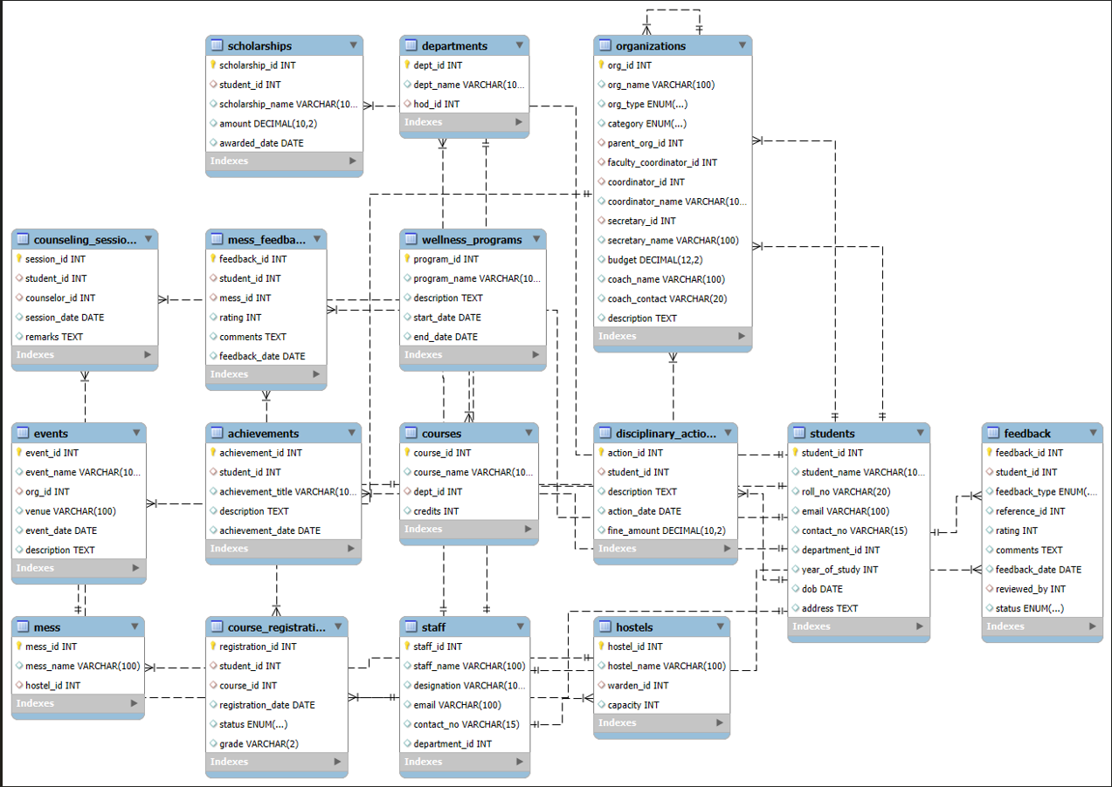
Schemas of the relational tables obtained from the E-R diagram:
- Students :
Students(student_id PK, student_name, roll_no UNIQUE, email, contact_no, department_id FK, year_of_study, dob, address)
- Staff :
Staff(staff_id PK, staff_name, designation, email, contact_no, department_id FK)
- Departments:
Departments(dept_id PK, dept_name, hod_id FK)
- Courses:
Courses(course_id PK, course_name, dept_id FK, credits)
- Course_Registration :
Course_Registration(registration_id PK, student_id FK, course_id FK,
registration_date, status, grade)
- Disciplinary_Actions :
Disciplinary_Actions(action_id PK, student_id FK, description,
action_date, fine_amount)
- Organizations :
Organizations(org_id PK, org_name, org_type, category,
parent_org_id FK, faculty_coordinator_id FK,
coordinator_id FK, coordinator_name,
secretary_id FK, secretary_name, budget,
coach_name, coach_contact, description)
- Events :
Events(event_id PK, event_name, org_id FK, venue, event_date, description)
- Wellness_Programs :
Wellness_Programs(program_id PK, program_name, description, start_date, end_date)
10.Counseling_Sessions :
Counseling_Sessions(session_id PK, student_id FK,
counselor_id FK, session_date, remarks)
11. Hostels :
Hostels(hostel_id PK, hostel_name, warden_id FK, capacity)
12. Mess :
Mess(mess_id PK, mess_name, hostel_id FK)
13. Mess_Feedback:
Mess_Feedback(feedback_id PK, student_id FK, mess_id FK,
rating, comments, feedback_date)
14.Feedback:
Feedback(feedback_id PK, student_id FK, feedback_type, reference_id,
rating, comments, feedback_date, reviewed_by FK, status)
15. Scholarships:
Scholarships(scholarship_id PK, student_id FK, scholarship_name, amount, awarded_date)
16. Achievements:
Achievements(achievement_id PK, student_id FK,
achievement_title, description, achievement_date)

Normalization Analysis :
Normalization was carried out during the database design to reduce redundancy, improve data consistency, and avoid anomalies. The Student Affairs System was evaluated against three levels of normalization: First Normal Form (1NF), Third Normal Form (3NF), and Boyce-Codd Normal Form (BCNF).

First Normal Form (1NF)
The database satisfies 1NF because:
- Each table stores data in a structured tabular format.
- All attributes hold atomic (indivisible) values.
- There are no repeating groups or multivalued attributes.
For example, in the Students table, every student has one roll number, one email, one contact number, etc. Likewise, course registrations are stored one per row rather than storing multiple course IDs inside a single student record.
Third Normal Form (3NF)
The database also meets 3NF, which ensures that:
- Every non-key attribute depends directly on the primary key.
- There are no transitive dependencies (i.e., no non-key attribute depends on another non-key attribute).
Examples of how 3NF is applied:
- The Departments table stores only the hod_id (Head of Department ID) and not the entire staff details. Staff information is stored separately in the Staff table.
- In the Organizations table, student or faculty references are maintained via foreign keys rather than storing their names repeatedly.
Boyce-Codd Normal Form (BCNF)
BCNF is a stronger version of 3NF and requires that:
For every functional dependency (X → Y), X must be a super key.
The schema satisfies BCNF because:
- In every table, the determinant (the attribute that determines others) is a primary key.
- No non-primary attribute functionally determines a primary key.
- Relationship-heavy entities (like Course_Registration, Mess_Feedback, and Feedback) rely on foreign keys and unique identifiers, ensuring that no improper dependencies exist.
Example:
- In the Course_Registration table, registration_id uniquely determines student ID, course ID, status, etc., and no other attribute or combination acts as a determinant.

Table | 1NF | 3NF | BCNF | Comments
Students | YES | YES | YES | All attributes depend only on student_id; no transitive dependencies.
Departments | YES | YES | YES | hod_id references staff; no staff details stored redundantly.
Courses & Course_Registration | YES | YES | YES | M:N resolved via junction table; every functional dependency has a key as determinant.
Organizations | YES | YES | YES | All non-key attributes depend on org_id; foreign keys prevent redundancy.
Feedback & Mess_Feedback | YES | YES | YES | Separate tables avoid mixed dependencies and prevent anomalies.
Scholarships | YES | YES | YES | Each scholarship is uniquely tied to a student; no dependency violations.
Achievements | YES | YES | YES | Attributes depend solely on achievement_id, satisfying BCNF.

Future Enhancements (Optional Normalization Improvements)
Although the database already satisfies BCNF and is structurally efficient, there are a few areas that could be improved further as the system grows:
- Reduce minor redundancy in the Organizations table
Currently, the table stores both student IDs (coordinator_id, secretary_id) and their corresponding names (coordinator_name, secretary_name). Since names can be fetched from the Students table using the student ID, storing them here leads to duplication. Removing the name attributes would make the table cleaner and ensure that any update to a student's details automatically reflects everywhere.
- Introduce a User/Login table for authentication
At present, the database controls access implicitly through roles like student or staff. A dedicated Users table with role-based authentication (admin / staff / student) would improve security and support real-world application needs.
- Add triggers or stored procedures to prevent inconsistent data
For example, triggers can ensure:
  - A student cannot register for the same course twice.
  - Feedback is only submitted for valid events, mess, or faculty.
- Possible future separation of feedback categories into individual tables
Although the current unified Feedback table works well, if the system expands heavily in the future, separate tables for different feedback types (Event Feedback, Organization Feedback, etc.) could make querying more intuitive.

