Steps to create teams

- To access Teams in Microsoft Teams, follow these steps:
  - Open Microsoft Teams.
  - In the left navigation pane, click on Teams, as shown in the image below.
This will take you to the Teams section, where you can view and manage your teams.
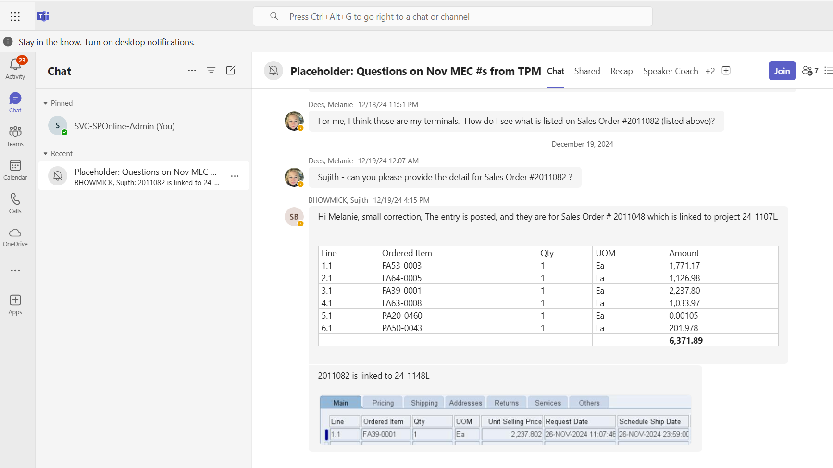

- Click on the "+" (Create or Join a Team) button to add a new team. 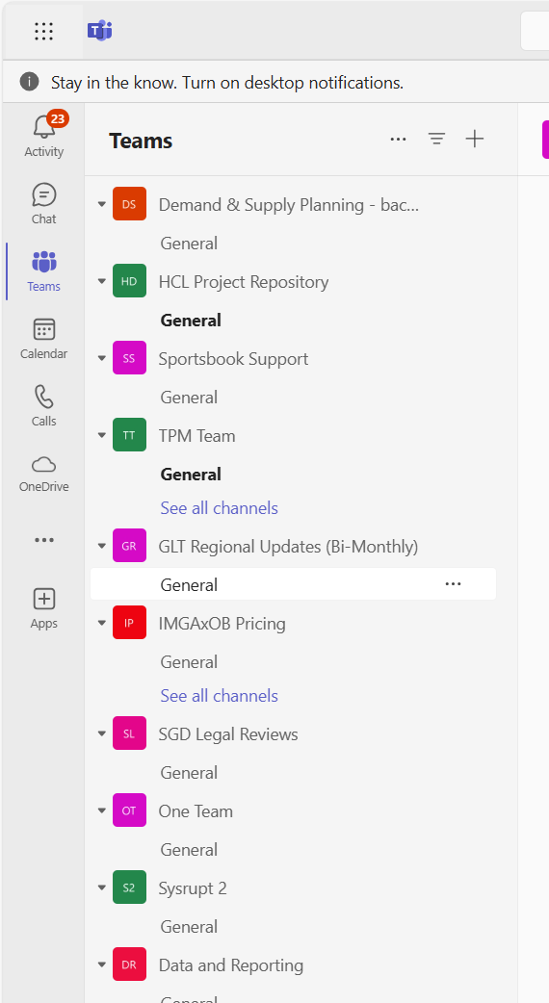

- Click on "Create Team" from the dropdown menu.
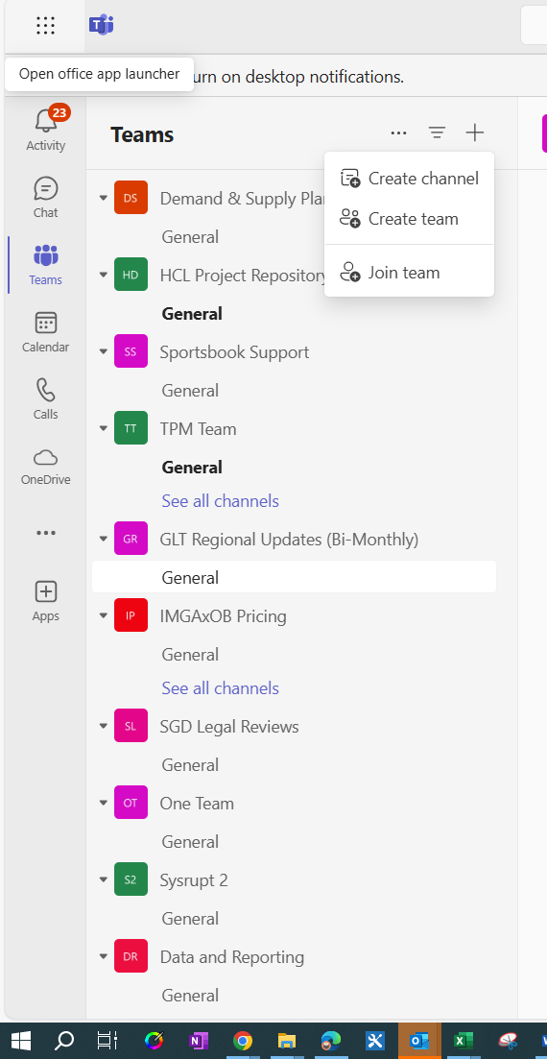

- A popup box will come, where you need to provide the required details and then click on create button.
- Team Name
- Description
- Team Type – Please Select Private
- Name of the first channel

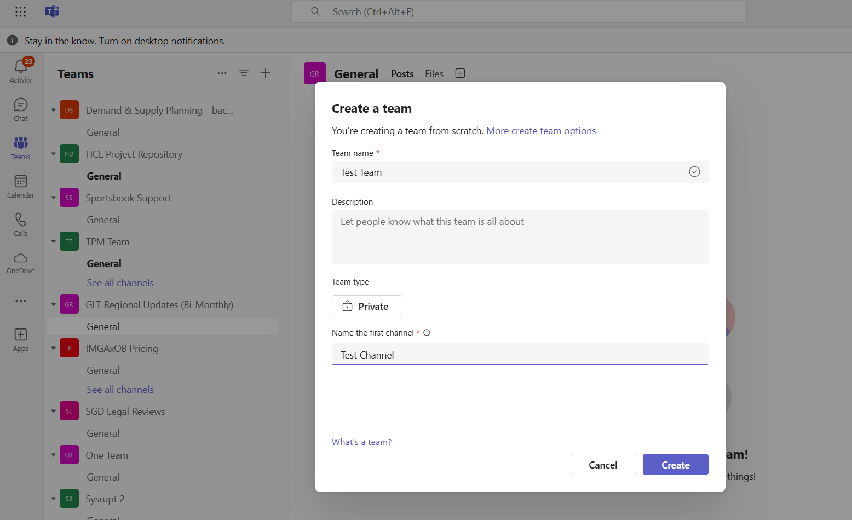

- Now, add members to your team. In this case, please add "Member" to the team.
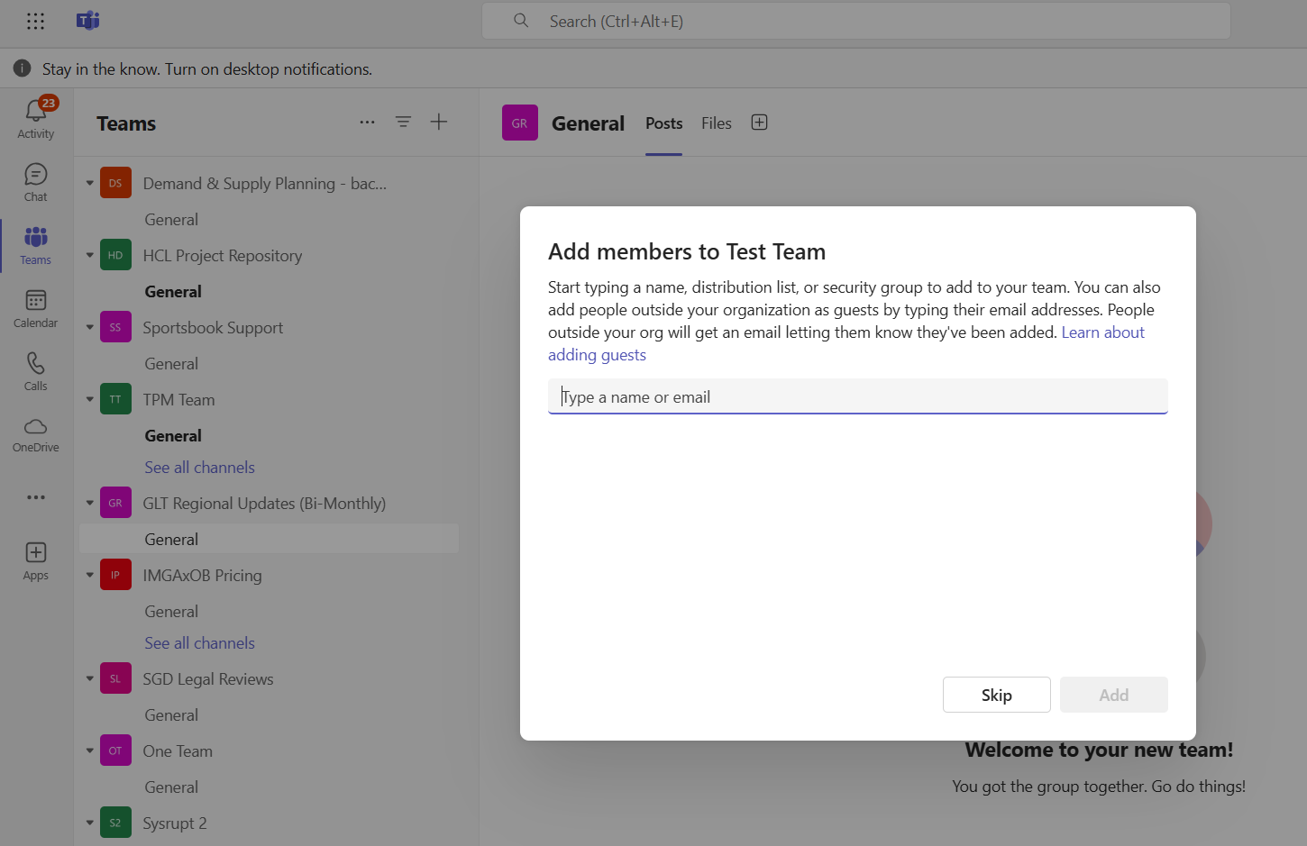

- When adding a member to the team, select "Member" as the role option and then click on "Add". This will create a team with the specified name and include the selected member.
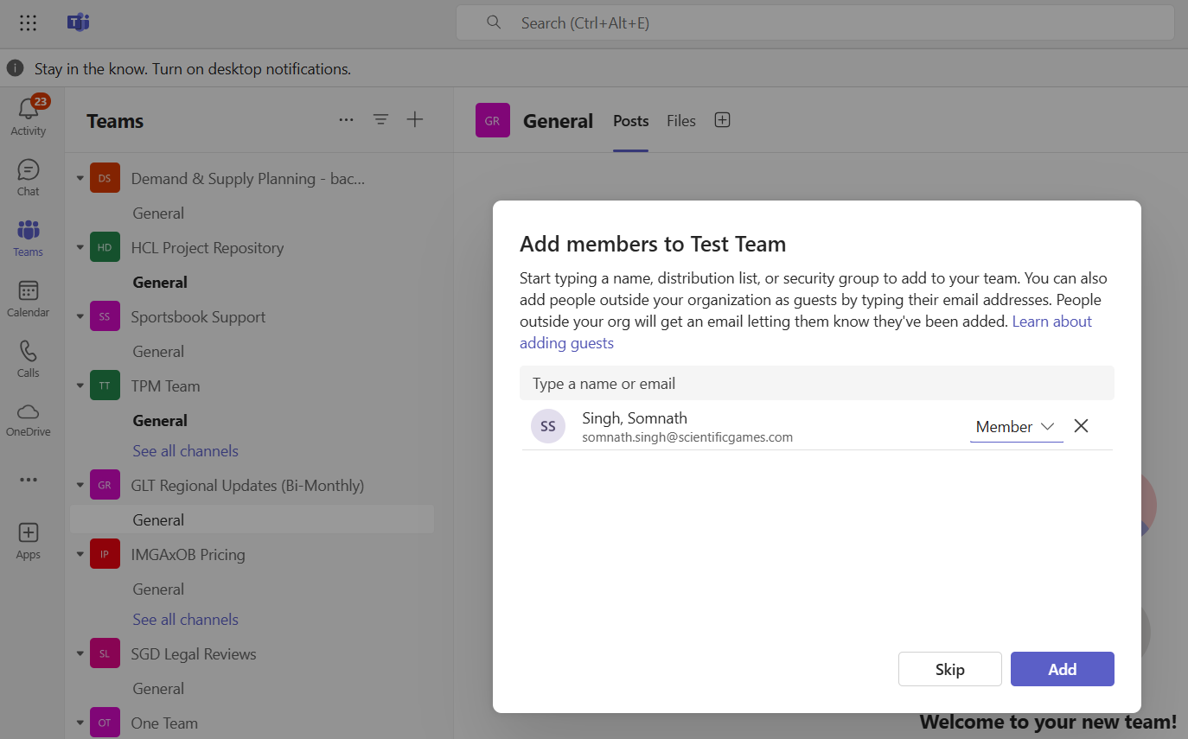
- The system will now create a team with the specified name. You can navigate to the Teams section to access it directly.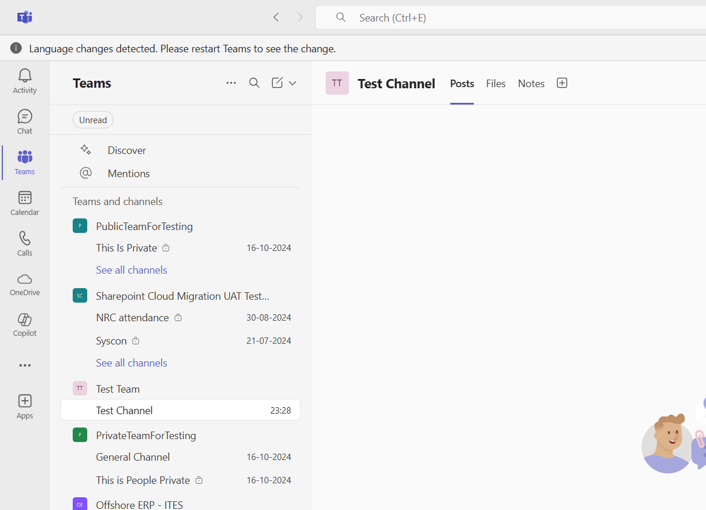
- Now, navigate to the team's channel "Test Channel" and upload all your files in the Files section.
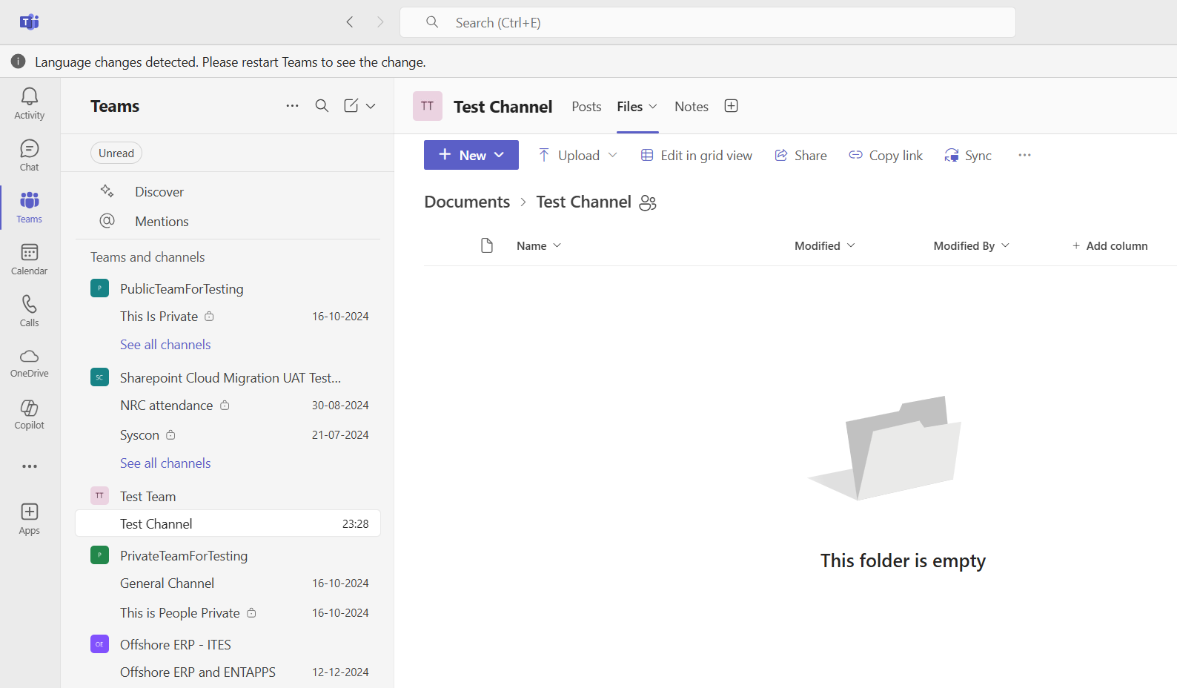
Now, the added member will be able to see all the uploaded files in the Files section of the specified channel.

