**SWOT Analysis:**

SWOT Analysis plays a vital role in any business and planning management. SWOT means Strengths, Weaknesses, Opportunities, and Threats. Strengths and Weaknesses are used for Internal perspective and opportunities and threats are external perspective. We can directly influence is internal, we can influence but not directly which is external.

SWOT diagrams can be particularly helpful when trying to determine whether or not to embark on a specific venture or plan by clearly analyzing and outlining the pros and cons of a project [4]. For maintaining business to remain successful in the long term, which is necessary to look at things from a broader perspective. It needs to look at how your business is performing at the moment and how you expect it to perform in the future. On this scenario a SWOT analysis comes in. Strengths apply to things that are done well by your company. Weaknesses are negative factors that make it difficult for your organization to achieve its objectives. Opportunities are the variables within market environment that can contribute to better business success and take advantage of it. Everything which poses a threat to either your business itself or its rate of success or growth.

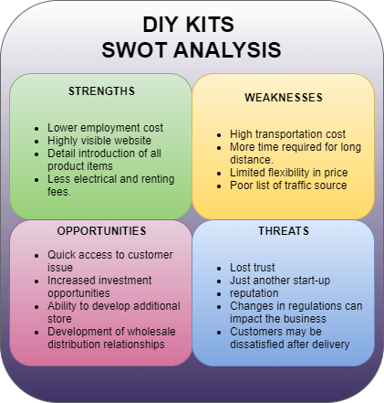

Figure: SWOT Analysis of the company

reference

[4] D. Shewan, “How to do a swot analysis for your small business (with examples),” 2017.