Test Case Number | Details
1 | Using all X and Y features, showing CP table before pruning and image of pruned tree based on minimum xerror
2 | Using all X features, showing CP table before pruning and image of pruned tree based on minimum xerror
3 | Using all Y features, showing CP table before pruning and image of pruned tree based on minimum xerror
4 | Using all X and Y features for Group =0 only, showing CP table before pruning and image of pruned tree based on minimum xerror
5 | Using all X for Group =0 only, showing CP table before pruning and image of pruned tree based on minimum xerror
6 | Using all Y features for Group =0 only, showing CP table before pruning and image of pruned tree based on minimum xerror
7 | Using all X and Y features for Group =1 only, showing CP table before pruning and image of pruned tree based on minimum xerror
8 | Using all X for Group =1 only, showing CP table before pruning and image of pruned tree based on minimum xerror
9 | Using all Y features for Group =1 only, showing CP table before pruning and image of pruned tree based on minimum xerror

Test case 1:

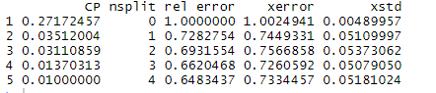
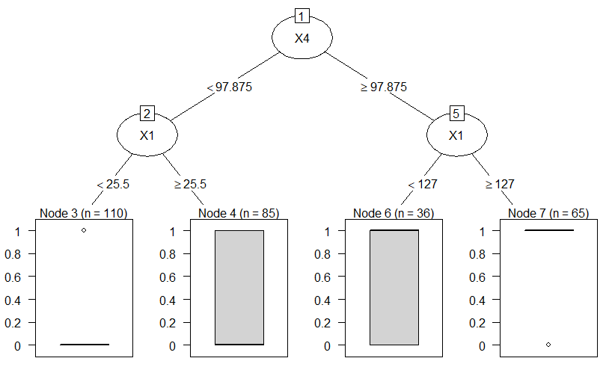

Test Case 2:

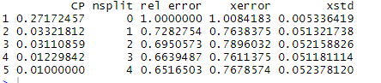
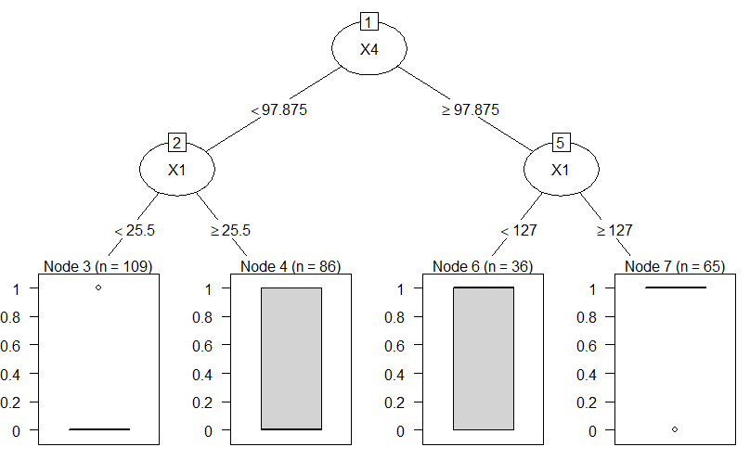

Test Case 3:

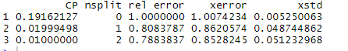

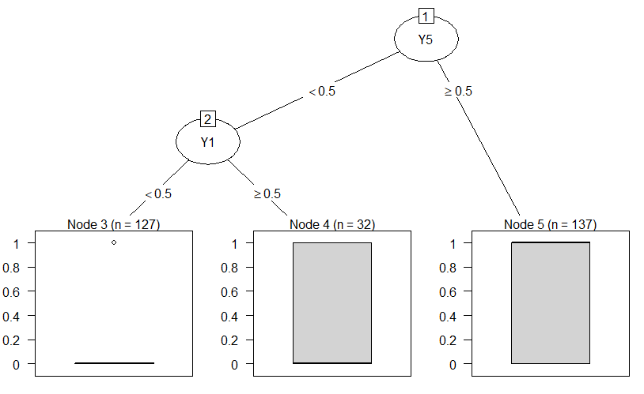

Test Case 4:

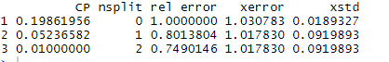
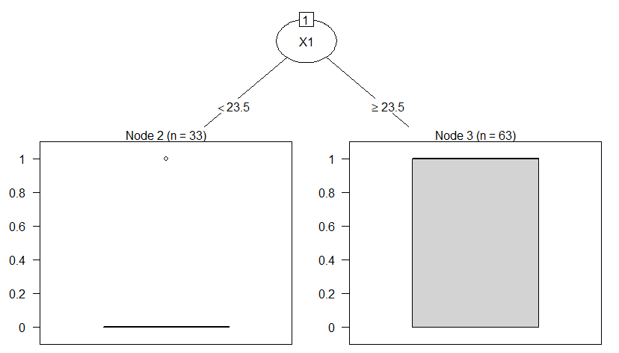

Test Case 5:

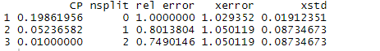

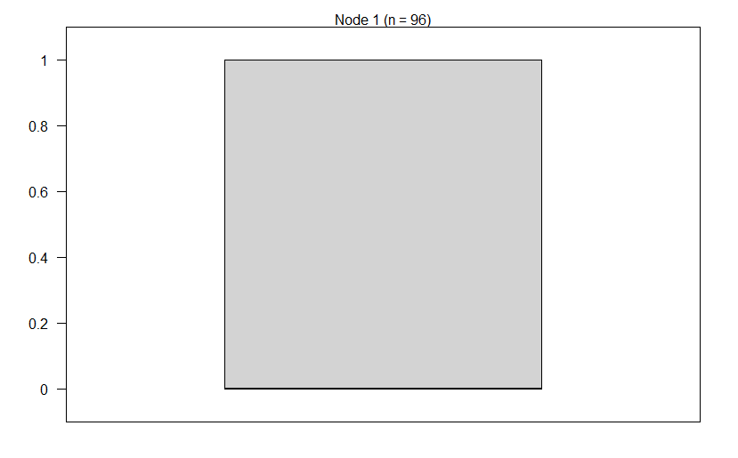

Test Case 6:

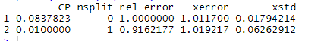

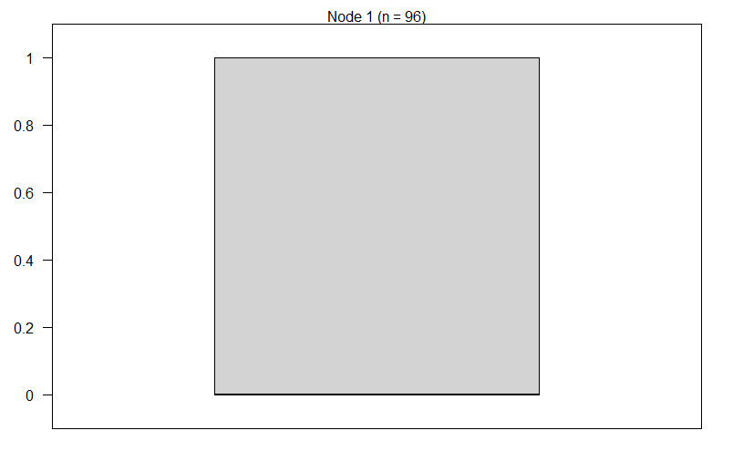

Test Case 7:

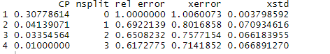
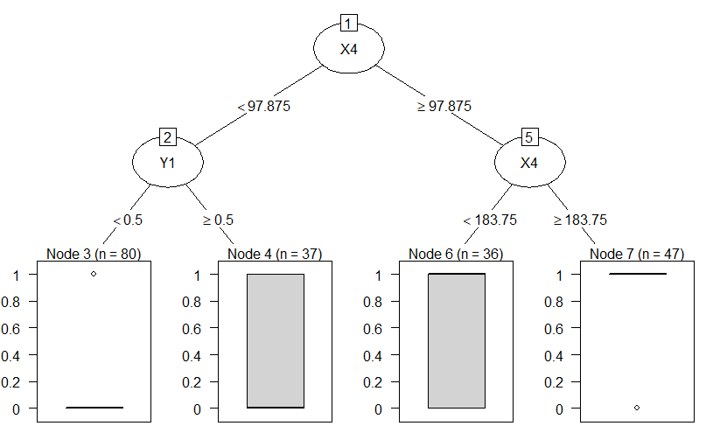

Test Case 8:
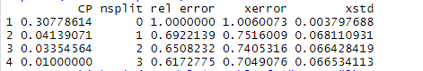

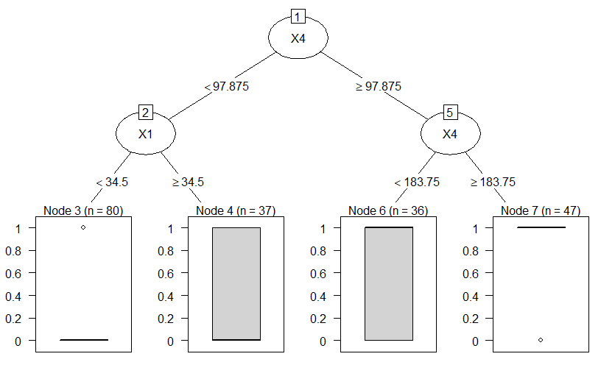
Test Case 9:
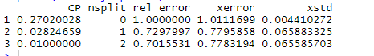
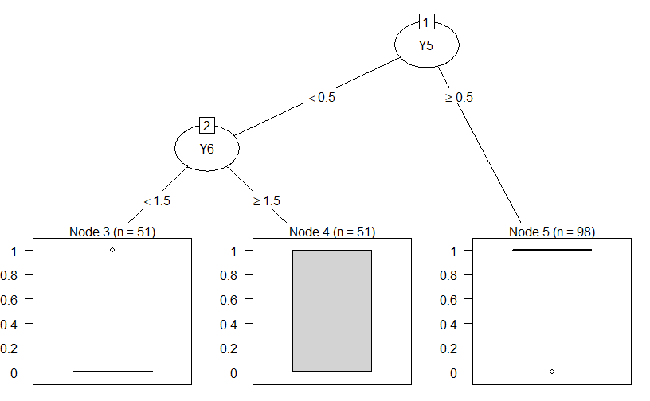

Conclusion: Rel Error got reduced when we only train Model for Group 1 only with either X & Y together or X alone.

