**Experiment**

**Aim:** Design an obstacle detector and distance measuring device

**Apparatus:**

Arduino Board, Breadboard, Wires, ultrasonic sensor.

**Circuit Diagram:**

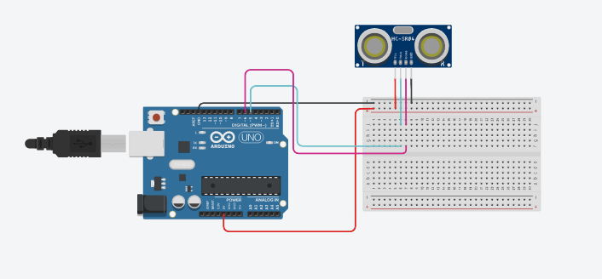

**Theory:**

**CONCEPTS USED**

An Ultrasonic sensor is a device that can measure the distance to an object by using sound waves.  
Speed=distance/time, formula is used in this experiment in the sound wave, with already known properties of sound wave.

**Learning and Observations**

We are able to understand that how sound wave is used to measure the distance between the source and any object placed in path where sound wave is targeted.

We just simply half the time that is taken by the sound wave to travel back to the source after starting and as we know the speed of sound, we can easily calculate the desired distance.

**Problems and Troubleshooting:**

The range of ultrasonic that is given in the lab is very low so it is not able to measured large distances but for learning purpose we are able to perform several tasks by small distance also.

**Precautions:**

1. The Arduino and its cable should be working properly.
2. Proper port of the Arduino should be selected.
3. The connections should be made neat and clean.
4. Desired resistance should be used.

**Result:**

Distance measurement is verified by ultrasonic sensor.