**3 :: Config Jenkins in Windows**

* <http://localhost:8080/>
* Jenkin Plugin & Job folder :: C:\ProgramData\Jenkins\.jenkins\workspace
* Config.xml file :: C:\ProgramData\Jenkins\.jenkins
* Manage Jenkins >> Config system.
  + System Message
    - Plain Text :: <b> welcome to jenkins</b>
    - Html Text
      * Manage Jenkins >> Config Global Security >> Marker Formatter
  + # of Executor :: No . of build can be run in parallely
  + Labels :: Name of the particular node
  + Quite Period :: Will run build for & wait for this much of time
  + Jenkin URL :: <http://localhost:8080/>
  + System Admin e-mail address
  + Extended E-mail Notification(Plugin Email Extension)
    - Default Subject
    - Default Content
    - Default Trigger
  + E-mail Notification
* Manage Jenkins >> Global Tool Configuration .(for python , C# install plugin)
  + JDK
    - Add JDK
      * Install automatically
      * Name
      * JAVA_HOME :: provide home directory path
  + Git
    - Name
    - Path to Git Executable
  + Gradle
  + Ant
  + Maven

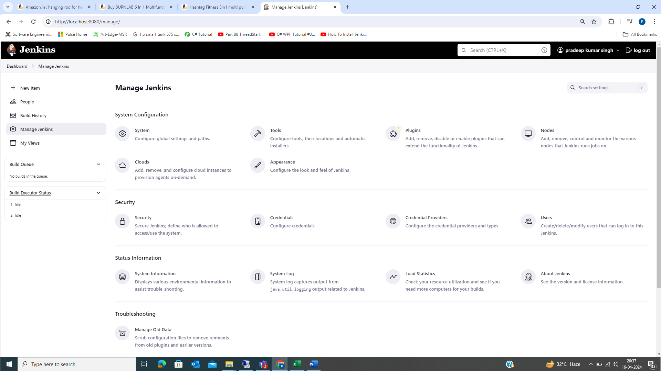

**4_Create Jenkins Job**

* Dashboard >> New Item >> Create First Job
  + Freestyle Project
  + Pipeline
  + Multi-configuration project
  + Folder
  + Multibranch Pipeline
  + Organization Folder
* Freestyle Project >> Name : FirstJenkinJob
  + General :: Job Description
  + Source Code Management
    - None
    - Git
  + Build Triggers :: How to trigger the build
  + Build Environment
  + Build
    - Execute Windows batch command
      * Command
        + Java -version
      * Command
        + Python -version
    - Execute shell
    - Invoke Ant
    - Invoke Gradle Script
    - Invoke top-level Maven targets
    - Run with timeout
    - Set build status to “pending” on GitHub commit
  + Post-build Actions
  + Save the job
* Dashboard >> Build Now
* Dashboard >> Build History >> Console Output
* Create Own View
  + Dashboard >> All +

**4.1_Create View in Jenkins**

* Dashboard >> Add view( +)
  + Name :: Give name to view
  + Type >> List View >> Create
  + Job >> Add existing Job to view
  + Columns >> Select Columns to add
  + Add Colums >> To add new filter values

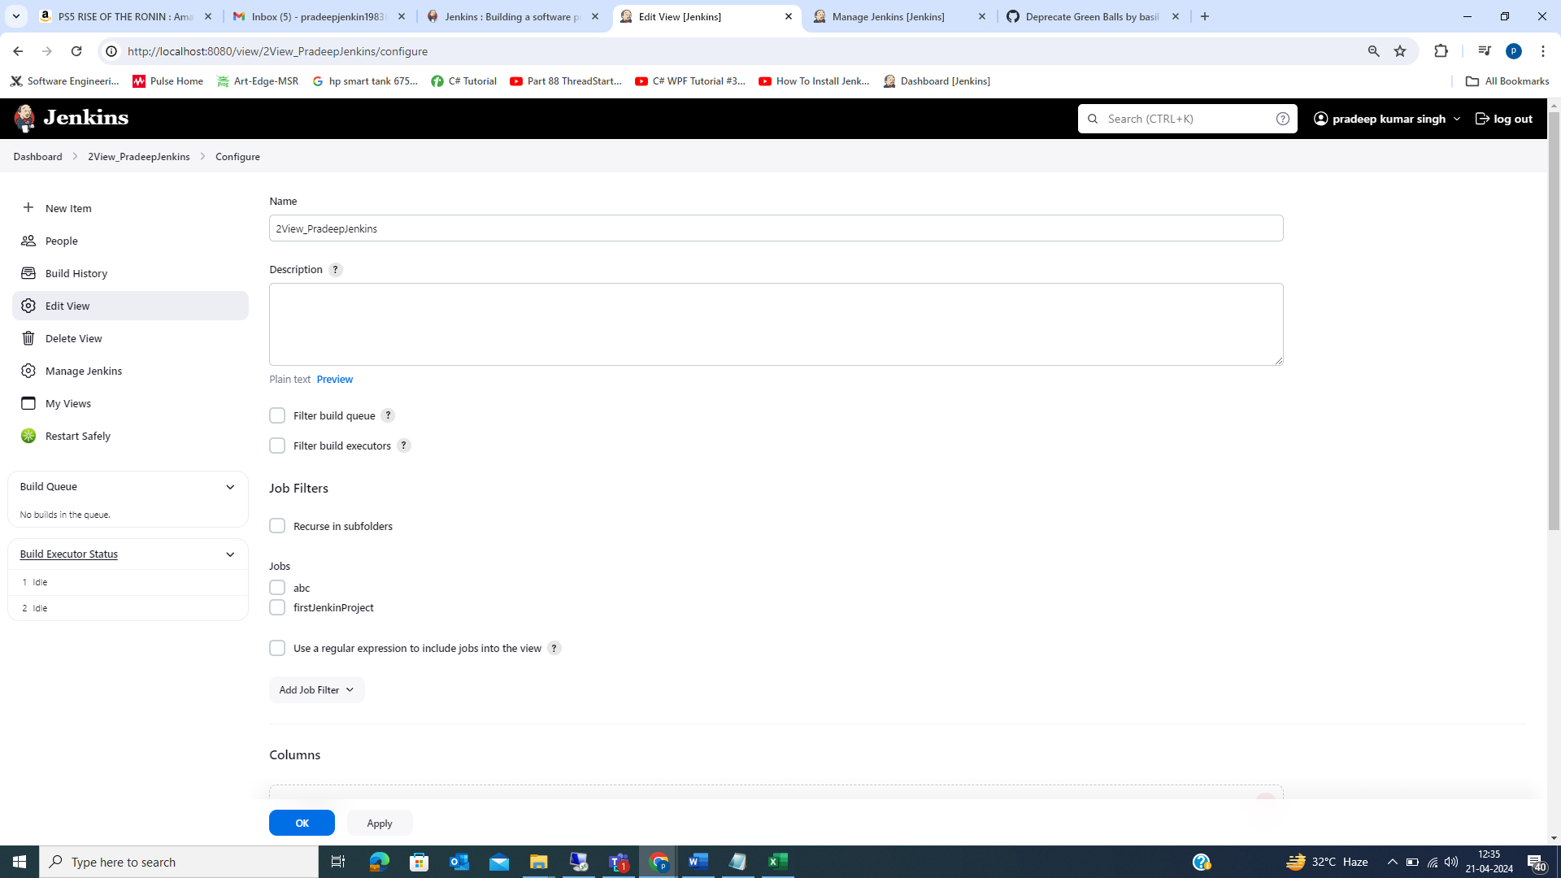

**5_Email Configuration in Jenkins**

* Dashboard >> Mange Jenkins >> **System Configuration** >> Config System
  + E-mail Notification
    - SMPT server:: smtp.gmail.com
    - Use SMPT Authentication :: Enable
      * User Name :: [pradeepjenkin1983@gmail.com](mailto:pradeepjenkin1983@gmail.com) , pradeepJenkin1983
      * Password :: pfpp stxr nxex mosi/PKSQ1w2e3r4
    - Use SSL :: Enable
      * SMTP Port ::465(for gmail)
    - Test Config by sending Email
      * Test Email Recipient :: pradeepjenkin1983@gmail.com
      * Test Configuration by sending test e-mail :: Click
    - Gmail setting preferable :: Create fresh mail id
    - If getting issue with “Test Configuration by sending test e-mail”
      * Disable 2 step authentication
      * Allow less secure :: ON
      * No "App passwords" under "Security" -> "Signing in to Google" panel
        + <https://support.google.com/mail/thread/4477145/no-app-passwords-under-security-signing-in-to-google-panel?hl=en>
        + In <https://myaccount.google.com/security>, do you see 2-step verification set to ON? If yes, then visiting <https://myaccount.google.com/apppasswords> should allow you to set up application specific passwords.
        + Jenkins :: pfpp stxr nxex mosi >> Add this in “Use SMTP Authentication >> Password”
  + Extended E-mail notification
    - SMPT Server :: smtp.gmail.com
    - SMPRT Port :: 465
    - SMPT Username :: pradeepjenkin1983@gmail.com
    - SMPT Password ::
    - Use SSL :: Enable
    - Default Content Type :: HTML
    - Default Recipient ::
    - Default Subject :: (Not Changing)
    - Default Content :: (Not Changing)
    - Default Trigger :: Always
* Dashboard >> “Click On Created Job” (firstJenkinProject) >>Configure >> Post -Build Actions
  + Enable :: Editable Email Notification Or Email Notification
* Then “firstJenkinProject >> Build Now ” & mail will be send to register mail id.
* Jenkins Environments Variables :: <https://wiki.jenkins.io/display/JENKINS/Building+a+software+project>

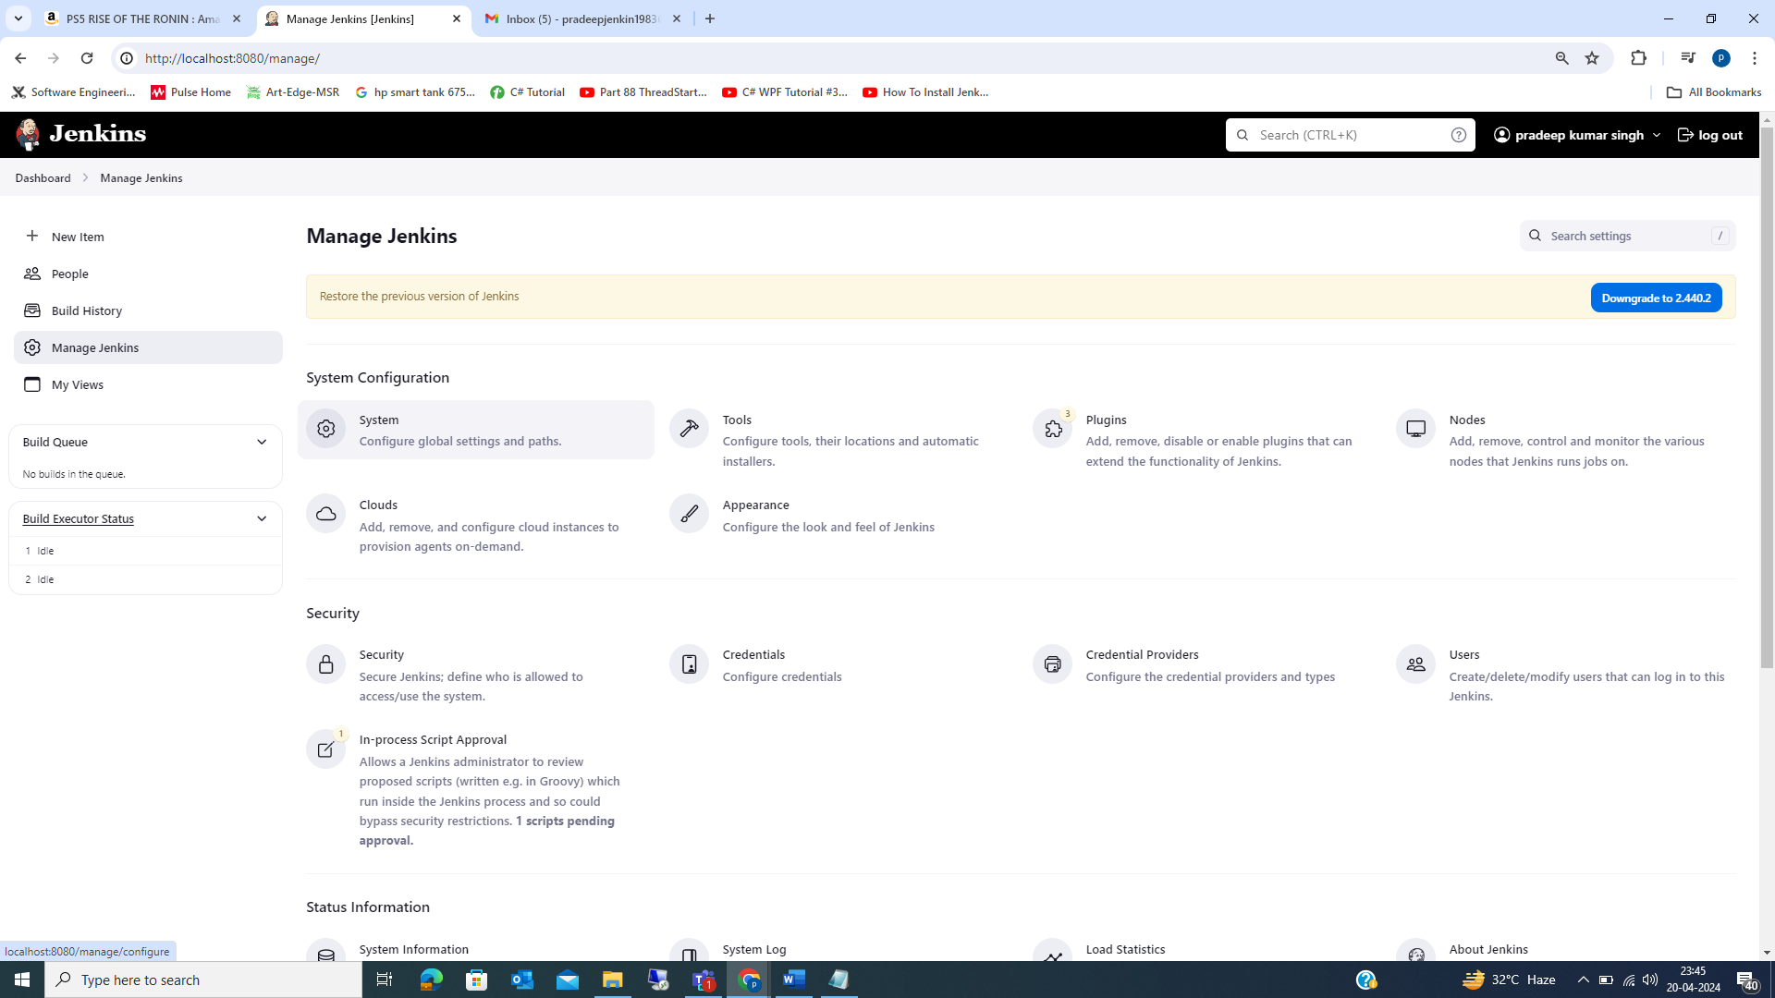

6 :: Install Plugins in Jenkins

* Plugin :: Meas adding new functionality to SW
* Dashboard >> Manage Jenkins >> Manage Plugins
  + Updates :: Updates available of already installed on your PC.
  + Available :: Available for you
  + Installed :: Already Installed on your PC
  + Advanced :: Trying to update or installed new pluging & failing due to proxy issue.
* To install new plugin >> Goto “Available” >> Search >> eg “green ball”
* All plugin in Jenkin have extension of “.hpi”.
* Download new plugin >> Goto “Available” >> Search >> eg “green ball” download same.
  + Go to “new plugin” >> Advanced >> Upload Plugin >> Choose Plugin.
  + Try “restart Plugin” >> Safe Restart
    - Install using “.hpi” file
    - Upload Plugin
    - Installing
    - Dashboard >> Uncategorized >> Restart Safely
* Plugin Store Location ::
  + C:\ProgramData\Jenkins\.jenkins\plugins
  + Download Plugin >> Dump at Plugin Store location



